HRA Key Performance Indicators

March 2014  
(Quarter 4 report – 2013/14)

Draft, v 2

09/05/2014

Summary dashboard

## RAG status of 2013/14 Business Plan KPIs

|  |  |  |  |  |  |  |  |  |  |  |  |  |
| --- | --- | --- | --- | --- | --- | --- | --- | --- | --- | --- | --- | --- |
|  | | |  |  | | --- | --- | | **No. of KPIs met** | | | Objective has serious delays in achieving | 6 | | Objective has some delays, expect to achieve by year end | 0 | | Objective on target | 13 | | Completed | 5 | |
| **Objective has serious delays in achieving (red)** | | |
| * 95% of applications to full research ethics committee meetings to receive final decision within 40 calendar days *(SOP requirement is 60 calendar days; the HRA has set stretched targets of 95% within 40 calendar days for applications going through full committee)* | 75% compliance year to date cumulative figure, March 2014 (77% in Quarter 3 report)  2013/14 has seen continuing improvement in the number of applications reviewed within statutory timelines (60 calendar days)  98% of applications reviewed in 60 days (England average)  *See p.23* | |
| * 95% of amendments, on approved applications, to receive a decision within 28 calendar days *(SOP requirement is 35 calendar days; the HRA has set a stretched target of 28 days)* | 89% compliance year to date cumulative figure, March 2014 (88% in Quarter 3 report)  Individual committees have met the stretched target  98% of amendments reviewed in 35 days (England average)  *See p.25* | |
| * To consolidate the HRA corporate and visual identity | Visual identity agreed; final development of guidelines/ templates almost complete but not fully adopted for use by end March 2014 | |
| * Publish 50% of research summaries (from the current 15%) of applications receiving review at full committee | Owing to technical difficulties of linking the current RED (research ethics database) feed to the new website, management decision taken to hold publication until the streamlined functionality on new research ethics database (HARP) is available. With the delivery of HARP and purchase of additional modules for the HRA website, it is anticipated that research summaries will be published in Quarter 1 2014/15 | |
| * Demonstrate improved website user satisfaction | User satisfaction survey still to be undertaken. Anticipate results being available before end of June 2014 | |
| * Reduce S251 approval timelines in line with other approvals within HRA | Since January 2014 and the recruitment of a new staff member, there has been a reduction in processing times.  The most significant increase involves review of Precedent Set review applications which has reduced by 40%.  *See pp.27-28* | |

|  |  |
| --- | --- |
| Objectives on target (green) | |
| * Create a common language and understanding within regulation, governance and compliance of quality, risks and standards; seek researcher feedback on how this leads to improved understanding of requirements for regulation and governance | A plan for the work on replacing the Research Governance Framework has been completed. A number of projects are underway, and some already completed, that will inform the principles for the new framework. These projects include seeking input from the research community, patients and the public |
| * Monitor REC membership and demonstrate greater diversity in REC member profile so greater alignment with that of the general population | The survey went to the HRA Executive Management Team in February and was approved with no major issues identified. The survey to be published on the HRA website shortly |
| * Determine baseline timeline across full integrated approval pathway to final approval | The plans for HRA Assessment and Approval have been approved and funding agreed. Initial explorations of data from NIHR benchmark returns and HRA data show no pattern in relation to timing of applications or duration of process, confirming absence of clear guidance on expectations for all parties. Future plans include whole system measurement as new systems are implemented |
| * Set target to reduce the timeline UK-wide | The plans for HRA Assessment and Approval have been approved and funding agreed. The plans include performance metrics that will be based not only on time to navigate the whole approval pathway, but also on predictability and consistency of timing against targets |
| * Reduce GTAC timelines in line with other HRA RECs *(Legal requirement is 90 calendar days; the HRA has stretched targets of 100% in 60 calendar days (previous data shows over 100 days))* | GTAC (Gene Therapy Advisory Committee) has transferred to the HRA  Mean review time has reduced from 180 days to 40 days |
| * Maintain IRAS as an available system 24 hours a day, 7 days per week (to 99%) | 100% compliance |
| * Maintain current 4 working days response times to requests for advice (90%) *(Quarterly report)* | For this final quarter, rather than sampling the KPI reflects 100% of the enquiries received; even with an increasing number of enquiries, the average response time was 0.38 days, or less  *See p.12 for full metrics* |
| * 95% of applications to research ethics proportionate review service to receive decision within 14 calendar days | 90% compliance year to date cumulative figure, March 2014 (97% Quarter 3 report)  Proportionate sub-committee review for low-risk studies has a target of 14 days |
| * 100% of audit action plans from the accreditation of research ethics committees to be completed within agreed timeframes | 100% compliance for quarter.  *See p.26* |
| * Responding to complaints within 25 working days *(Half yearly report)* | 89% compliance *(see p.10)* |
| * 100% of all FOI requests (valid and invalid) acknowledged and additional clarification sought within 10 working days  *(Half yearly report)* | 100% compliance *(see p.11)* |
| * 100% of valid FOI requests to receive final response within 20 working days of receipt (where qualified exemption does not apply)  *(Half yearly report)* | 100% compliance *(see p.11)* |
| * 100% of valid FOI requests where qualified exemption applies, and a public interest test may be required, to receive a final response within 40 working days of receipt  *(Half yearly report)* | N/A – none received |

|  |  |
| --- | --- |
| Completed | |
| * Publish trends on number of individual applications to IRAS and individual IRAS partners, including NRES  *Many IRAS partners now publish data on numbers of applications, with explanation.  HRA routinely publishes management information for NRES and CAG on the website and in this report* | * Publish all REC decisions   *Annual Reports for RECs in England for the period April 2012 - March 2013 formally adopted by the HRA Board on 29 October 2013 and published on HRA website* |
| * Determine baseline and set target to increase no. of applications through IRAS  *Agreement has been achieved that HFEA (Human Fertilisation and Embryology Authority) will be a new partner and NOMS (National Offender Management Service) will increase their use of IRAS rather than off-line versions. (Implementation not possible until IRAS4 developed)* | * Develop a fit-for-purpose website  *New website went live first week of October. Ongoing improvements include a consultation area and revised CAG/s251 section* |
| * Publish advice from the Confidentiality Advisory Group and decisions made by the HRA on access to confidential data under Section 251 of the NHS act *Detailed CAG advice, HRA and Secretary of State approval decisions published in minutes on the HRA website* |  |

# Section 1: Organisation metrics

|  |
| --- |
| FINANCE METRICS |
| * HRA is reporting an underspend of £937k at the end of March – £914k less than expenditure budgets and £23k more income * 91% (£8.8million) of the annual budget has been spent * The Better Payment Practice Code (BPPC) compliance for April to March maintained the performance levels of 97% for the number of invoices paid and 98% for value of invoices paid. This is within the 95% target set. The HRA is aiming to pay 60% of invoices within 10 days – current performance has increased slightly in March and shows 38% (34% March) on the number of invoices and 48% (39% March) based on invoice values. Performance is published on our website * Internal team objective set: to achieve month end close in 4 days from a start point of 7 days. The finance team has worked steadily throughout the year to reduce the number of working days to complete month end to a target of 4 days. This target was achieved in February and the finance team met the agreed timetable deadlines set for the year end process |

## HRA Better Payment Practice Code for the period 1 April 2013 to 31 March 2014

|  |  |  |  |  |
| --- | --- | --- | --- | --- |
|  | **Number** | **%** | **Value (£)** | **%** |
| 0-5 Days | 201 | 4% | 661,970 | 15% |
| 6-10 Days | 1584 | 33% | 1,455,661 | 33% |
| 11-20 Days | 2530 | 53% | 1,864,823 | 42% |
| 21-30 Days | 293 | 6% | 345,855 | 8% |
| Over 30 Days | 146 | 3% | 90,134 | 2% |
| Total | 4,754 | 100% | 4,418,443 | 100% |
|  |  |  |  |  |
| **BPPC achieved** | 97% | 97% | 98% | 98% |

Aged Creditors at 31 March 2014

**Headlines – clock start date is the invoice date (regardless of when the invoice is received in the system)**

**Non-NHS Trade**

Only significant item in 60+ days is an invoice to Calder Conferences (£3,096), which was paid on the 1st April 2014.

|  |  |  |  |
| --- | --- | --- | --- |
|  | **Aged Creditors – (£) amounts past due date** | | |
|  | **1-30 days** | **31-60 days** | **60 + days** |
| **Non NHS Trade** | 4,068 | 1,419 | 3,882 |
| **Non NHS Other** | 2,027 | 23 | 1,025 |
| **NHS** | 0 | 0 | 0 |
|  |  |  |  |
| **Total** | 6,096 | 1,443 | 4,907 |

|  |
| --- |
| HR / STAFF METRICS |

## Profile of staff headcount 2013-14

* Staff headcount for 2013-14 shows a fairly static position throughout the year to date (pay represents 64% of the costs incurred year to date)
* The HRA is continuing to work to reduce the number of agency staff employed and is implementing a staff bank which will assist with this work

## Demographic breakdown – HRA staff *(updated quarterly)*

|  |  |
| --- | --- |
| **Quarter 4** |  |
| Ethnicity | **%** |
| White – British / Irish | 75% |
| White - Any other White background | 4.5% |
| Mixed - Any other mixed background | 2% |
| Asian or Asian British | 4.5% |
| Black or Black British | 7% |
| Other / Undefined | 2% |
| Not Stated | 5% |
|  |  |
| Age | % |
| <20 | 0% |
| 20-30 | 30% |
| 31-40 | 23% |
| 41-50 | 25% |
| 51-60 | 19% |
| 60+ | 3% |
|  |  |
| Full-Time/Part Time | % |
| Full-Time | 81% |
| Part-time | 19% |
|  |  |
| Gender | % |
| Female | 76% |
| Male | 24% |
|  |  |

## Staff sickness absence 2013/14 (year to date)

Long-term sickness:

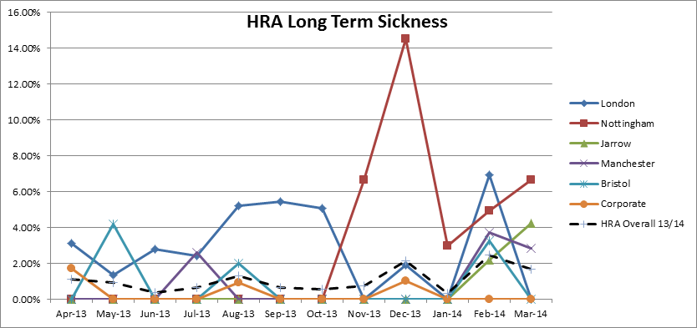

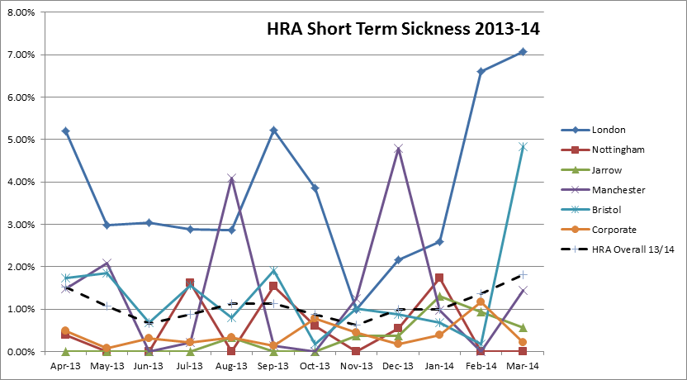Short-term sickness:

## The combined average figure for NHS sickness absence for 2012/13 was 4.24%

|  |
| --- |
| Staff turnover 2013/14 (year to date) |
| cid:image003.png@01CF59A6.45466C00 |

* Includes staff on payroll only (ie excludes secondments and temporary staff)
* Annual rate is projected for months Sep 13 through to Feb 14. March 14 is actual turnover rate for period April 2013 to March 2014

|  |
| --- |
| Response metrics |
| * Target for responding to complaints, 25 working days * Statutory target for responding to Freedom of Information (FOI) requests, 20 working days |

## Summary of Complaints received (April - September 2013) *(half yearly reporting)*

* The HRA considers a complaint relates to the standard or quality of services provided by the HRA; divergence from procedures by staff; the behaviour of HRA staff; and the behaviour of volunteer committee members, including Research Ethics Committees (RECs), the National Research Ethics Advisors’ Panel (NREAP) and the Confidentiality Advisory Group (CAG).    
  (A complaint does not apply where: matters have already been thoroughly and fully investigated; legal proceedings are already underway; appeals against the decision of a REC are covered by the NRES Appeals process; behaviour of committee members are addressed under the member management policy and procedures; alleged failure by a responsible body to comply with a request under the Data Protection Act 1998 and the Freedom of Information Act 2000.)

|  |  |  |
| --- | --- | --- |
|  | Apr - Sep 2013 | Oct 2013 - Mar 2014 |
| No. of complaints received | 7 | 9 |
| No. of complaints upheld | 4 (1 partially) | 1 (partially) |
| Average response time | 11 days | 14.8 days |
| No. of complaints responded to within 25 days | 7 | 4 |
| Categories:   * Corporate * NRES * TOPS * NREAP * CAG * Other | 5  2 | 8  1 |

* A total of 9 complaints were received for the 1 October 2013 to 31 March 2014 period
* One complaint was responded to and dealt with within 35 days. The complainant was kept updated regarding the status of the complaint throughout the investigation. The outcome of the investigation concluded that the complaint in fact related to a third party

## Summary of FOI requests (April - September 2013) *(half yearly reporting)*

|  |  |  |
| --- | --- | --- |
|  | Apr - Sep 2013 | Oct 2013 - March 2014 |
| No. of FOI requests received | 22 | 20 |
| Average acknowledgement time | 3.1 days | 2.4 days |
| No. of FOIs acknowledged within 10 days | 100% | 100% |
| Average response time | 11.2 days | 8.6 days |
| No. of FOIs responded to within 20 days | 100% | 100% |
| No. of requests where information not held by HRA | 4 | 1 |
| No. of requests where Section 21 exemption applied (information available by other means) | 4 |  |
| No. of request where Section 41 exemption applied (breach of confidence) | 1 |  |
| No. of request where Section 43 exemption applied (commercial interests) | 4 |  |
| Categories:   * Corporate * NRES * TOPS * NREAP * CAG * Other | 5  11  2  1  1  2 | 7  10  0  0  2  0 |

## Response to Parliamentary Question (PQ) requests

* All PQs have been responded to within stipulated time period

|  |  |  |  |  |  |  |  |  |  |  |  |
| --- | --- | --- | --- | --- | --- | --- | --- | --- | --- | --- | --- |
| No. Parliamentary Questions received per month | | | | | | | | | | | |
| Apr | May | Jun | Jul | Aug | Sep | Oct | Nov | Dec | Jan | Feb | Mar |
| 1 | 1 | 2 | 2 | 0 | 1 | 0 | 1 | 0 | 0 | 3 | 1 |

# Section 2: Queries line metrics

|  |
| --- |
| QUERIES LINE METRICS |
| * Metrics are produced on a quarterly basis – Quarter 4 position is shown below. * For Quarters 1-3, measurement was based on a sample (first 10 queries in a day; days selected so that every month, week in the month and day in the week are covered) – the sampling procedure was established by the Quality Assurance Audit of the NRES Queries line in 2008. However, for Quarter 4, the KPI reflects 100% of the enquiries received where, even with an increasing number of enquiries, the average response time was 0.38 days, or less * The majority of enquiries submitted to the Queries line seek advice on whether the study is research and/or research requiring ethical review. Two linked decision tools were launched by the HRA in May 2013 to assist with these types of queries * The Queries line traffic for quarter 4, however, has continued to increase (previously a downward trend from October 2011) and has risen by 49% in comparison with the same period in 2012/13. The increased traffic may be accounted for by the decision tools, with clients seeking confirmation of the outcome of the decision tools (although it is now made clear to researchers that the decision is an authoritative source that can be relied on), or may be as a result of the launch of the new HRA website (early October) and an inability for clients to find the relevant information and thus resorting to an email enquiry |

|  |  |  |  |  |  |  |  |  |  |
| --- | --- | --- | --- | --- | --- | --- | --- | --- | --- |
| **Queries per month in 2013-14** | | | | | | | |  | **Year Total** |
| **Quarter 1** | | **Quarter 2** | | **Quarter 3** | | **Quarter 4** | |  |
| Apr-13 | 144 | Jul-13 | 199 | Oct-13 | 284 | Jan-14 | 195 |  |  |
| May-13 | 160 | Aug-13 | 174 | Nov-13 | 268 | Feb-14 | 234 |  |  |
| Jun-13 | 131 | Sep-13 | 126 | Dec-13 | 161 | Mar-14 | 242 |  |  |
|  | **435** |  | **499** |  | **713** |  | **671** |  | **2,318** |
| **Comparison with 2012-13** | -108 |  | 86 |  | 275 |  | 221 |  | 1,844 |
| -20% |  | +21% |  | +63% |  | +49% |  | +26% |

|  |  |  |
| --- | --- | --- |
| **Time taken to respond to sampled queries per month 2013-14** | | |
|  | **% of queries responded to within 4 working days** | **Mean average response time** |
| Apr-13 | 100% | 0.9 |
| May-13 | 90% | 0.6 |
| Jun-13 | 100% | 0.5 |
| Jul-13 | 100% | 0.7 |
| Aug-13 | 100% | 1.1 |
| Sep-13 | 100% | 0.7 |
| Oct -13 | 90% | 1.0 |
| Nov-13 | 70% | 1.9 |
| Dec-13 | 100% | 0.2 |
| Jan-14 | 96% | 0.38 |
| Feb-14 | 98% | 0.32 |
| Mar-14 | 99% | 0.18 |

* The missed target, and apparent poor performance, in November 2013 was investigated. The data for the entire month was analysed and is summarised in the table below:

|  |  |
| --- | --- |
| **Summary** | |
| Total queries | 262 |
| In target | 246 |
| Out of target | 16 |
| Percent complete within 4 days | 94% |
| Mean average response time | 1.02 |
| Modal response time | 0 |
| Longest response time | 28 |
| Shortest response time | 0 |

Please note: the apparent difference in the no. of queries received for November is due to the above figure indicating the total no. of enquiries received, while the figure included in the Queries per month table includes all traffic (where there may have been subsequent follow up emails from the enquirer)

* It would appear that a number of complex queries were received and a breakdown of the reasons for delay is shown below:

# Section 3: Systems metrics

|  |
| --- |
| SYSTEMS METRICS |
| * The HRA receives a separate IRAS helpdesk report and no major issues to note this year to date * The HRA now receives monthly performance metrics on Open Service (DH-managed IT system) |

## Provision of the Integrated Research Application System (IRAS)

* 100% achievement, with IRAS available 24 hours/day, 7 days per week

## Provision of website

* 100% achievement, with the current website available 24 hours/day, 7 days per week

## Open Service dashboard

* Please see *Appendix 1* for the Open Service performance metrics for the period January - March 2014

# Section 4: Training

|  |
| --- |
| TRAINING METRICS |
| * 43 unique courses delivered * 85 events provided between April - March 2014 |

## All Training:

|  |  |  |  |
| --- | --- | --- | --- |
| **Total Seats provided** | 1,893 |  |  |
| **Total Registrations** | 1,588 | 84% | of seats provided were booked |
| **Total Attendances** | 1,399 | 88% | of bookings were attended |
|  |  | 74% | of seats provided were filled |

## Staff Training

|  |  |  |
| --- | --- | --- |
| **% of available places booked** | **% of bookings attended** | **% of available places attended** |
| 69% | 96% | 66% |

* The peak in events in July was due to a country-wide programme of appraisal training for all staff.
* There were no staff training events in December.
* The apparent low uptake showing for some events is caused by having set the total room capacity as the maximum number of places, which sometimes exceeds the expected number of delegates by a considerable margin. This practice has now been changed so future reports will more accurately reflect attendance compared with provision of places

## Non-Staff (REC Members and Research Community)

|  |  |  |
| --- | --- | --- |
| **% of available places booked** | **% of bookings attended** | **% of available places attended** |
| 95% | 85% | 81% |

* There was no non-staff training in August

## Geographical distribution of all training provided

|  |  |  |  |  |  |  |  |
| --- | --- | --- | --- | --- | --- | --- | --- |
| **Location** | **Events** | **Seats available** | **Registrations** | **Uptake %** | **Attendance figure** | **Bookings attended %** | **Bookings not attended %** |
| London | 40 | 931 | 842 | 90% | 711 | 84% | 16% |
| Manchester | 19 | 451 | 380 | 84% | 355 | 93% | 7% |
| Bristol | 8 | 134 | 94 | 70% | 91 | 97% | 3% |
| Jarrow | 6 | 125 | 88 | 70% | 87 | 99% | 1% |
| Nottingham | 6 | 119 | 57 | 48% | 54 | 95% | 5% |
| Leeds | 1 | 58 | 55 | 95% | 53 | 96% | 4% |
| Edinburgh | 1 | 26 | 26 | 100% | 20 | 77% | 23% |
| Glasgow | 1 | 21 | 20 | 95% | 19 | 95% | 5% |
| Dundee | 1 | 12 | 10 | 83% | 9 | 90% | 10% |

* The apparent low uptake showing for some events is caused by having set the total room capacity as the maximum number of places, which sometimes exceeds the expected number of delegates by a considerable margin. This practice has now been changed so future reports will more accurately reflect attendance compared with provision of places
* The majority of events are held in London and Manchester because those HRA offices have the largest in-house meeting rooms and are easily accessible via main rail routes

# Section 5: Research Ethics Committee metrics

|  |
| --- |
| REC METRICS |
| * SOP (Standard Operating Procedure) requirement is 60 calendar days; the HRA has set stretched targets of 95% within 40 calendar days for applications going through full committee. 2013/14 has seen a continuing improvement in the number of applications reviewed within statutory timelines, despite ongoing IT issues which have seriously comprised work output on many occasions. 98% of applications reviewed in 60 days (England cumulative figure) * Proportionate sub-committee review for low-risk studies has a target of 14 days. The cumulative figure at March 2014 is 90% compliance (England) * GTAC (Gene Therapy Advisory Committee) has transferred to the HRA and timelines have reduced significantly. Legal requirement is 90 calendar days; the HRA has stretched targets of 100% in 60 days. Previous data was over 100 days * Reduction of applications year-on-year has in part been due to service improvements, including database and tissue bank approvals which removed the need for individual applications, and policy changes to REC remit * SOP requirement for amendments is 35 calendar days and the HRA has set a stretched target of 28 days. Individual committees have met the stretched target. 98% of amendments reviewed in 35 days (England cumulative figure) |

## Time to complete ethical review – all application types, England (year to date)

|  |
| --- |
|  |

## Applications to RECs in England (year to date)

|  |  |  |  |  |  |  |  |
| --- | --- | --- | --- | --- | --- | --- | --- |
|  | All applications | CTIMPs | Other (full review) | Research Tissue Bank | Research Databases | Proportionate review | Full review (inc. CTIMPs) |
| **Apr-13** | 433 | 58 | 283 | 3 | 1 | 88 | 345 |
| **May-13** | 431 | 62 | 252 | 3 | 4 | 110 | 321 |
| **Jun-13** | 378 | 56 | 251 | 5 | 2 | 64 | 314 |
| **Jul-13** | 449 | 83 | 261 | 5 | 5 | 95 | 354 |
| **Aug-13** | 352 | 55 | 207 | 3 | 0 | 87 | 265 |
| **Sep-13** | 364 | 66 | 206 | 4 | 4 | 84 | 280 |
| **Oct-13** | 452 | 99 | 257 | 3 | 1 | 92 | 360 |
| **Nov-13** | 380 | 80 | 221 | 5 | 3 | 71 | 309 |
| **Dec-13** | 398 | 75 | 240 | 4 | 4 | 75 | 323 |
| **Jan-14** | 415 | 69 | 240 | 2 | 2 | 102 | 313 |
| **Feb-14** | 358 | 55 | 210 | 3 | 2 | 88 | 270 |
| **Mar-14** | 422 | 62 | 244 | 4 | 5 | 107 | 315 |

CTIMP: Clinical Trial of Investigational Medicinal Product

## Total applications reviewed in England (year on year)

|  |
| --- |
|  |

## Review of full applications – comparison of Centres, England (year to date)

|  |
| --- |
| Statutory timeline is 60 calendar days – Business Plan KPI objective is 40 calendar days |

|  |  |  |  |  |
| --- | --- | --- | --- | --- |
| REC Centre | Total no. applications (year to date) | Mean average time to process | Complete within 40 days (%) | Complete within 60 days (%) |
| **Bristol** | 1,055 | 34.51 | 73% | 99% |
| **Jarrow** | 477 | 31.18 | 80% | 100% |
| **London** | 682 | 37.96 | 60% | 94% |
| **Manchester** | 769 | 29.11 | 86% | 100% |
| **Nottingham** | 741 | 33.64 | 75% | 99% |

## Types of applications reviewed per month, England (rolling 2 years showing trend)

|  |
| --- |
|  |

## Trends in REC opinion types at first review, England (rolling 3 years)

|  |
| --- |
| The 2012 HRA Business Plan determined that the use of Provisional opinions at first review should be reduced in favour of Favourable with Additional Conditions (AC). The downward trend in Provisional opinions and the upward trend in Favourable AC reflect progress in this. Other opinion types remain stable |

## Review of amendments per REC Centre, England (year to date)

|  |  |  |  |  |
| --- | --- | --- | --- | --- |
| REC Centre | Number of amendments | Mean average time to process | Complete within 28 days (%) | Complete within 35 days (%) |
| Bristol | 2,060 | 16.76 | 87% | 98% |
| Jarrow | 850 | 18.24 | 91% | 100% |
| London | 1,244 | 18.91 | 80% | 96% |
| Manchester | 1,365 | 16.40 | 91% | 98% |
| Nottingham | 1,620 | 15.62 | 96% | 100% |
| **England** | **7,141** | **16.98** | **89%** | **98%** |

## Review of amendments in target per REC Centre, England (year to date)

|  |
| --- |
| Statutory timeline is 35 calendar days – Business Plan KPI objective is 28 calendar days |

## Action Plans from accreditation of RECs, England

|  |  |  |
| --- | --- | --- |
| Month | No of action plans received | % in target |
| April 2013 | 2 | 100% |
| May 2013 | 2 | 100% |
| June 2013 | 1 | 100% |
| July 2013 | 0 | N/A |
| August 2013 | 0 | N/A |
| September 2013 | 1 | 100% |
| October 2013 | 1 | 100% |
| November 2013 | 1 | 100% |
| December 2013 | 0 | N/A |
| January 2014 | 1 | 100% |
| February 2014 | 1 | 100% |
| March 2014 | 1 | 100% |

# Section 6: Confidentiality Advisory Group (CAG) metrics

|  |
| --- |
| CAG METRICS |
| * CAG was established in April 2013 when the function transferred to the HRA. During this reporting period CAG meetings were bi-monthly. From April 2014 CAG will meet monthly, which will improve timelines. * Additional resource secured in December 2013 has assisted in reducing timelines. Since January 2014 there has been a reduction in processing times as follows: * new applications: 10% decrease * precedent set review: 40% decrease (please see comment below) * amendments: 23% decrease * Unlike applications submitted to NHS Research Ethics Committees, whether an application submitted to CAG is suitable for Precedent Set review is determined by whether precedent advice has been set in relation to the key issues engaged by the application, rather than by the application itself raising no material issues. As with review of new applications submitted to the full Confidentiality Advisory Group, applications for consideration through Precedent Set review are subject to an office assessment stage, as well as review by a sub-group of members, and precedent advice will be reviewed and applied where relevant |

## Summary of applications reviewed by CAG (year to date)

|  |  |  |  |  |  |  |  |  |
| --- | --- | --- | --- | --- | --- | --- | --- | --- |
| **Application type** | **Apr-13** | **Jun-13** | **Aug-13** | **Oct-13** | **Nov-13** | **Jan-14** | **Mar-14** | **Total** |
| New full CAG applications reported | 8 | 6 | 10 | 14 | 4 | 7 | 5 | **54** |
| Precedent Set reviews reported | 7 | 5 | 6 | 5 | 11 | 7 | 4 | **45** |
| Amendments reported | 7 | 2 | 3 | 4 | 9 | 4 | 13 | **42** |
|  |  |  |  |  |  |  |  |  |
| **Mean processing time in calendar days** | **Apr-13** | **Jun-13** | **Aug-13** | **Oct-13** | **Nov-13** | **Jan-14** | **Mar-14** | **Target** |
| New applications | 49 | 44 | 46 | 45 | 31 | 40 | 36 | **60** |
| Precedent Set reviews | 57 | 52 | 48 | 49 | 58 | 47 | 28 | **30** |
| Amendments | 72 | 52 | 34 | 88 | 52 | 35 | 27 | **30** |
|  |  |  |  |  |  |  |  |  |
| **No. of applications meeting target processing time** | **Apr-13** | **Jun-13** | **Aug-13** | **Oct-13** | **Nov-13** | **Jan-14** | **Mar-14** | **Target** |
| New applications | 7 | 6 | 8 | 13 | 4 | 7 | 5 | **60** |
| Precedent Set reviews | 0 | 0 | 0 | 1 | 0 | 0 | 2 | **30** |
| Amendments | 2 | 0 | 2 | 0 | 2 | 1 | 11 | **30** |
|  |  |  |  |  |  |  |  |  |
| **Proportion of applications meeting target processing time** | **Apr-13** | **Jun-13** | **Aug-13** | **Oct-13** | **Nov-13** | **Jan-14** | **Mar-14** | **Target** |
| New applications | 88% | 100% | 80% | 93% | 100% | 100% | 100% | **100%** |
| Precedent Set reviews | 0% | 0% | 0% | 20% | 0% | 0% | 50% | **100%** |
| Amendments | 29% | 0% | 67% | 0% | 22% | 85% | 85% | **100%** |

## Review of applications by CAG (year to date)

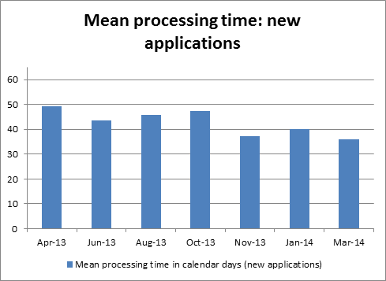

|  |
| --- |
|  |
|  |
|  |

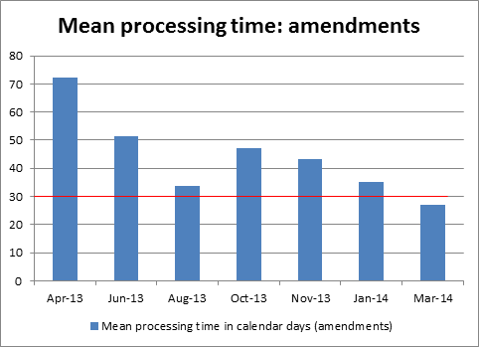

*APPENDIX 1*

## Open Service dashboard

|  |  |  |  |  |  |
| --- | --- | --- | --- | --- | --- |
| **SLA/KPIs\*** | *Jan-14* | *Feb-14* | *Mar-14* |  |  |
| No. of SLAs met | 4 | 5 | **5** |  |  |
| No. of SLAs missed | 8 | 7 | **7** |  |  |
| No requests/no incidents | 5 | 6 | **6** |  |  |
| Total | 17 | 18 | **18** |  |  |
|  |  |  |  |  |  |
| *\*more SLA/KPIs will be added to future Service Review reports* | | | |  |  |
| |  | | --- | |  | |  |  |  |  |  |

|  |  |  |  |
| --- | --- | --- | --- |
| **INCIDENTS** | *Jan-14* | *Feb-14* | *Mar-14* |
| No. of Major Incidents | 3 | 3 | **2** |
| No. of new calls | 76 | 82 | **62** |
| No. of open calls as 31/03 | 7 | 9 | **6** |
| No. of days of oldest call* | 66 | 47 | **75** |
|  |  |  |  |
| *\*the oldest call refers to the wider NHS mail / Outlook issues which has now been closed. These issues have been recognised as a high priority and there is an ongoing project in place to improve performance.* | | | |

|  |  |  |  |  |  |
| --- | --- | --- | --- | --- | --- |
|  |  |  |  |  |  |
| **Top Issues** | **Details** | | **Result** | | **No.** |
| VDI - unresponsive | VDI sessions become unresponsive | | Sessions reset by 1st Line support enabling users to log back in | | 9 |
| Printers | Users unable to print or print quality issue | | Printers fixed by Ricoh engineers | | 6 |
| Outlook / NHSmail | Users unable to access Outlook or Outlook becomes unresponsive | | Resolved by Atos and NHSmail support | | 4 |
| VDI - log in | Users unable to log in to Thin Client | | Access restored within SLA | | 4 |
|  |  |  |  |  |  |
| **Top Requests** | **Details** | | **Result** | | **No.** |
| Shared Drive | Request for shared drive access | | Access given within agreed SLAs | | 8 |
| Passwords | Requests to have any of the passwords reset | | Passwords reset by 1st or 2nd line support | | 4 |
| New Accounts | Requests for new user IT accounts | | Accounts created within SLA | | 3 |
| Software | Request for additional software | | Software installed within agreed SLA | | 3 |