HRA Key Performance Indicators

December 2013  
(Quarter 3 report – 2013/14)

Final v 1.0

14/02/2014

Summary dashboard

## RAG status of 2013/14 Business Plan KPIs

|  |  |  |  |  |  |  |  |  |  |  |  |  |
| --- | --- | --- | --- | --- | --- | --- | --- | --- | --- | --- | --- | --- |
|  | | |  |  | | --- | --- | | **No. of KPIs met** | | | Objective has serious delays in achieving | 5 | | Objective has some delays, expect to achieve by year end | 0 | | Objective on target | 15 | | Completed | 4 | |
| **Objective has serious delays in achieving (red)** | | |
| * 95% of applications to full research ethics committee meetings to receive final decision within 40 calendar days *(REC requirement is 60 calendar days; the HRA has set stretched targets of 95% within 40 calendar days for applications going through full committee)* | 77% compliance in December (75% in November)   2013/14 has seen an ongoing improvement in the number of applications reviewed within statutory timelines (60 calendar days)  *(See p.22)* | |
| * 95% of amendments, on approved applications, to receive a decision within 28 calendar days *(REC requirement is 35 calendar days; the HRA has set a stretched target of 28 days)* | 88% compliance in December (87% in November)  *(See p.24)* | |
| * Reduce S251 approval timelines in line with other approvals within HRA | Reduction in processing timescales for CAG activities is expected to be reduced from January 2014 following successful recruitment to the team | |
| * Publish 50% of research summaries (from the current 15%) of applications receiving review at full committee | Technical difficulties will preclude HRA from publishing 50% by the end of March 2014. Delivery of a new research ethics database (HARP) and enhancements to the HRA website will enable all research summaries to be published early in the new financial year and moving forward | |
| * Demonstrate improved website user satisfaction | User satisfaction survey still to be undertaken. Anticipate results being available before end of June 2014 | |

|  |  |
| --- | --- |
| Objectives on target (green) | |
| * To consolidate the HRA corporate and visual identity | Visual identity agreed; final development of guidelines/ templates still in progress. To be completed by end March 2014 |
| * Create a common language and understanding within regulation, governance and compliance of quality, risks and standards; seek researcher feedback on how this leads to improved understanding of requirements for regulation and governance | Projects within collaboration & development informing preparation for review of Research Governance Framework now brought together with other projects under a new UK-wide steering group |
| * Monitor REC membership and demonstrate greater diversity in REC member profile so greater alignment with that of the general population | Survey of REC membership completed and report produced. Awaiting management approval, prior to publication on HRA website |
| * Publish advice from the Confidentiality Advisory Group and decisions made by the HRA on access to confidential data under Section 251 of the NHS act | Detailed CAG advice, HRA and Secretary of State approval decisions published in minutes on the HRA website |
| * Determine baseline timeline across full integrated approval pathway to final approval | Proposals for timelines incorporated into business case for HRA Assessment and Approval. Business case under discussion with DH and outcome awaited |
| * Set target to reduce the timeline UK-wide | Proposals for HRA Assessment and Approval include performance management based on percentage meeting planned timelines – DH decision required for implementation |
| * Reduce GTAC timelines in line with other HRA RECs *(GTAC requirement is 90 calendar days; the HRA has stretched targets of 100% in 60 calendar days (previous data shows over 100 days))* | GTAC (Gene Therapy Advisory Committee) has transferred to the HRA and timelines have reduced significantly, but numbers are small so it is too soon to average |
| * Maintain IRAS as an available system 24 hours a day, 7 days per week (to 99%) | 100% compliance |
| * Maintain current 4 working days response times to requests for advice (90%) *(Quarterly report)* | Quarter 3 report – *p. 11* |
| * 95% of applications to research ethics proportionate review service to receive decision within 14 calendar days | 97% compliance in December (96% in November) |
| * 100% of audit action plans from the accreditation of research ethics committees to be completed within agreed timeframes | 100% compliance for quarter.  *(See p. 25)* |
| * Responding to complaints within 25 working days *(Half yearly report)* | 100% compliance.  *(See p.9)* |
| * 100% of all FOI requests (valid and invalid) acknowledged and additional clarification sought within 10 working days  *(Half yearly report)* | 100% compliance.  *(See p.10)* |
| * 100% of valid FOI requests to receive final response within 20 working days of receipt (where qualified exemption does not apply)  *(Half yearly report)* | 100% compliance.  *(See p.10)* |
| * 100% of valid FOI requests where qualified exemption applies, and a public interest test may be required, to receive a final response within 40 working days of receipt  *(Half yearly report)* | N/A |

|  |  |
| --- | --- |
| Completed | |
| * Publish trends on number of individual applications to IRAS and individual IRAS partners, including NRES *Many IRAS partners now publish data on numbers of applications, with explanation.  HRA routinely publishes management information for NRES and CAG on the website and in this report* | * Publish all REC decisions   *Annual Reports for RECs in England for the period April 2012 - March 2013 formally adopted by the HRA Board on 29 October 2013 and published on HRA website* |
| * Determine baseline and set target to increase no. of applications through IRAS *Agreement has been achieved that HFEA (Human Fertilisation and Embryology Authority) will be a new partner and NOMS (National Offender Management Service) will increase their use of IRAS rather than off-line versions. (Implementation not possible until IRAS4 developed)* | * Develop a fit-for-purpose website *New website went live first week of October. Ongoing improvements include a consultation area and revised CAG/s251 section* |

# Section 1: Organisation metrics

|  |
| --- |
| FINANCE METRICS |
| * The HRA is reporting an under spend against expenditure plans of £213k at the end of December * 67% (£6.5million) of the annual budget has been spent * Revised forecasts point to an under spend of between £280k to £384k * The Better Payment Practice Code (BPPC) compliance for April to December maintained the performance levels of 97% for both the number and value of invoices paid. This is within the 95% target set. The HRA is aiming to pay 60% of invoices within 10 days – current performance has dipped slightly and shows 32% (33% November) on the number of invoices and 37% (39% November) based on invoice values. All approvers are asked to note this and to approve invoices promptly or place on hold if there is a dispute. Performance is published on our website * Internal team objective set: to achieve month end close in 4 days from a start point of 7 days. To date the team has managed to reduce the close period from 7 days to 6 days in September (a quarter end) and 6 days in October (a day was lost due to IT problems). The finance team achieved a 5 day close at December quarter end and is on track to achieve a 4 day close in January 2014 |

## HRA Better Payment Practice Code for the period 1 April to 31 December 2013

|  |  |  |  |  |
| --- | --- | --- | --- | --- |
|  | **Number** | **%** | **Value (£)** | **%** |
| 0-5 Days | 115 | 3% | 195,989 | 7% |
| 6-10 Days | 1005 | 29% | 884,704 | 30% |
| 11-20 Days | 1992 | 58% | 1,438,180 | 50% |
| 21-30 Days | 227 | 7% | 296,549 | 10% |
| Over 30 Days | 112 | 3% | 81,147 | 3% |
| Total | 3,451 | 100% | 2,896,570 | 100% |
|  |  |  |  |  |
| **BPPC achieved** | **97%** | **97%** | **97%** | **97%** |

Aged Creditors at 31 December 2013

**Headlines**

**Non-NHS Trade**

Only significant items in 60+ days are credit notes £1,470 from Riverside Centre and £544 from Park Hotel. Repayment is being sought in respect of all items through NHS SBS.

**NHS**

60+ day item is an invoice from the Oxford University Hospitals NHS Trust for £38,484 which was dated 14October 2013 but which did not get onto the SBS system until the 18 December and was approved the same day. There were no RFT payment runs until 2 January 2014 when it was then cleared. The lack of RFT payment run is also the explanation for the number of NHS invoices remaining unpaid in the 30 days.

|  |  |  |  |
| --- | --- | --- | --- |
|  | **Aged Creditors – (£) amounts past due date** | | |
|  | **1-30 days** | **31-60 days** | **60 + days** |
| **Non NHS Trade** | 6,475 | 2,750 | -2,160 |
| **Non NHS Other** | 551 | 114 | 358 |
| **NHS** | 30,198 | 150 | 38,485 |
|  |  |  |  |
| **Total** | **37,224** | **3,014** | **36,683** |

|  |
| --- |
| HR / STAFF METRICS |

## Profile of staff headcount 2013-14

* Staff headcount for 2013-14 shows a fairly static position throughout the year to date (pay represents 64% of the costs incurred year to date)
* The HRA is continuing to work to reduce the number of agency staff employed

## Demographic breakdown – HRA staff *(updated quarterly)*

|  |  |
| --- | --- |
| **Quarter 3** |  |
| Ethnicity | **%** |
| White – British / Irish | 70% |
| White - Any other White background | 4.5% |
| Mixed - Any other mixed background | 1% |
| Asian or Asian British | 4.5% |
| Black or Black British | 7% |
| Other / Undefined | 6% |
| Not Stated | 7% |
|  |  |
| Age | % |
| <20 | 0% |
| 20-30 | 30% |
| 31-40 | 22% |
| 41-50 | 24% |
| 51-60 | 20% |
| 60+ | 4% |
|  |  |
| Full-Time/Part Time | % |
| Full-Time | 79% |
| Part-time | 21% |
|  |  |
| Gender | % |
| Female | 74% |
| Male | 26% |
|  |  |

## Staff sickness absence 2013/14 (year to date)

Long-term sickness:

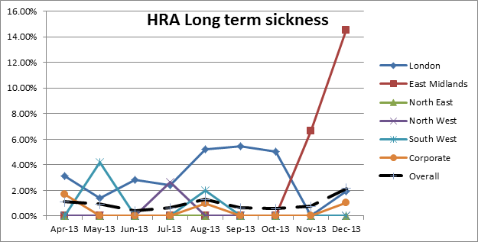

Short-term sickness:

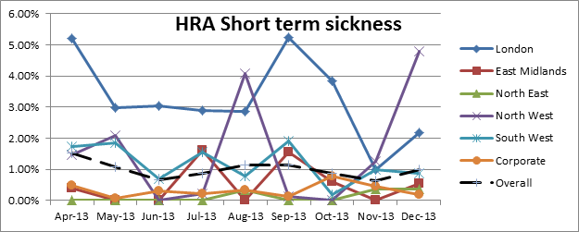

## The combined average figure for NHS sickness absence for 2012/13 was 4.24%

|  |
| --- |
| Staff turnover 2013/14 (year to date) |
| cid:image007.png@01CF175F.14EF1AE0 |

* Includes staff on payroll only (ie excludes secondments and temporary staff)

|  |
| --- |
| Response metrics |
| * Target for responding to complaints, 25 working days * Statutory target for responding to Freedom of Information (FOI) requests, 20 working days |

## Summary of Complaints received (April - September 2013) *(half yearly reporting)*

* The HRA considers a complaint relates to the standard or quality of services provided by the HRA; divergence from procedures by staff; the behaviour of HRA staff; and the behaviour of volunteer committee members, including Research Ethics Committees (RECs), the National Research Ethics Advisors’ Panel (NREAP) and the Confidentiality Advisory Group (CAG).    
  (A complaint does not apply where: matters have already been thoroughly and fully investigated; legal proceedings are already underway; appeals against the decision of a REC are covered by the NRES Appeals process; behaviour of committee members are addressed under the member management policy and procedures; alleged failure by a responsible body to comply with a request under the Data Protection Act 1998 and the Freedom of Information Act 2000.)

|  |  |  |
| --- | --- | --- |
|  | Apr - Sep 2013 | Oct 2013 - March 2014 |
| No. of complaints received | 2 |  |
| No. of complaints upheld | 2 |  |
| Average response time | 5.5 days |  |
| No. of complaints responded to within 25 days | 2 |  |
| Categories:   * Corporate * NRES * TOPS * NREAP * CAG * Other | 2 |  |

## Summary of FOI requests (April - September 2013) *(half yearly reporting)*

|  |  |  |
| --- | --- | --- |
|  | Apr - Sep 2013 | Oct 2013 - March 2014 |
| No. of FOI requests received | 22 |  |
| Average acknowledgement time | 3.1 days |  |
| No. of FOIs acknowledged within 10 days | 100% |  |
| Average response time | 11.2 days |  |
| No. of FOIs responded to within 20 days | 100% |  |
| No. of requests where information not held | 4 |  |
| No. of requests where Section 21 exemption applied (information available by other means) | 4 |  |
| No. of request where Section 41 exemption applied (breach of confidence) | 1 |  |
| No. of request where Section 43 exemption applied (commercial interests) | 4 |  |
| Categories:   * Corporate * NRES * TOPS * NREAP * CAG * Other | 5  11  2  1  1  2 |  |

## Response to Parliamentary Question (PQ) requests

* All PQs have been responded to within stipulated time period

|  |  |  |  |  |  |  |  |  |  |  |  |
| --- | --- | --- | --- | --- | --- | --- | --- | --- | --- | --- | --- |
| No. Parliamentary Questions received per month | | | | | | | | | | | |
| Apr | May | Jun | Jul | Aug | Sep | Oct | Nov | Dec | Jan | Feb | Mar |
| 1 | 1 | 2 | 2 | 0 | 1 | 0 | 1 | 0 |  |  |  |

# Section 2: Queries line metrics

|  |
| --- |
| QUERIES LINE METRICS |
| * Measurement is based on a sample (first 10 queries in a day; days selected so that every month, week in the month and day in the week are covered) – the sampling procedure was established by the Quality Assurance Audit of the NRES Queries line in 2008 and is to be revisited in Quarter 4 * Metrics are produced on a quarterly basis – Quarter 3 position is shown below * The Queries line traffic for quarter 3 has increased by 63% in comparison with the same period in 2012/13. This is the first change from the downward trend since October 2011. The increased traffic may be as a result of the launch of the new HRA website (early October) with an inability of clients finding the relevant information and thus resorting to an email enquiry * The majority of enquiries submitted to the Queries line seek advice on whether the study is research and/or research requiring ethical review. The two linked decision tools were launched by the HRA in May 2013. These may have accounted for a portion of the rise in email traffic as the HRA was being asked to confirm the decision outcome (approx. 144 emails received between October-December, equating to 20% of the email traffic). It is now made clear to researchers that the decision is an authoritative source that can be relied on |

|  |  |  |  |  |  |  |  |  |  |
| --- | --- | --- | --- | --- | --- | --- | --- | --- | --- |
| **Queries per month in 2013-14** | | | | | | | |  | **Year Total** |
| **Quarter 1** | | **Quarter 2** | | **Quarter 3** | | **Quarter 4** | |  |
| Apr-13 | 144 | Jul-13 | 199 | Oct-13 | 284 | Jan-14 | 0 |  |  |
| May-13 | 160 | Aug-13 | 174 | Nov-13 | 268 | Feb-14 | 0 |  |  |
| Jun-13 | 131 | Sep-13 | 126 | Dec-13 | 161 | Mar-14 | 0 |  |  |
|  | **435** |  | **499** |  | **713** |  | **0** |  | **1,844** |
| **Comparison with 2012-13** | -108 |  | 86 |  | 275 |  |  |  |  |
| -20% |  | 21% |  | 63% |  |  |  |  |

|  |  |  |
| --- | --- | --- |
| **Time taken to respond to sampled queries per month 2013-14** | | |
|  | **% of queries responded to within 4 working days** | **Mean average response time** |
| Apr-13 | 100% | 0.9 |
| May-13 | 90% | 0.6 |
| Jun-13 | 100% | 0.5 |
| Jul-13 | 100% | 0.7 |
| Aug-13 | 100% | 1.1 |
| Sep-13 | 100% | 0.7 |
| Oct -13 | 90% | 1.0 |
| Nov-13 | 70% | 1.9 |
| Dec-13 | 100% | 0.2 |

* The missed target, and apparent poor performance, in November 2013 has been investigated. The data for the entire month has been analysed and is summarised in the table below:

|  |  |
| --- | --- |
| **Summary** | |
| Total queries | 262 |
| In target | 246 |
| Out of target | 16 |
| Percent complete within 4 days | 94% |
| Mean average response time | 1.02 |
| Modal response time | 0 |
| Longest response time | 28 |
| Shortest response time | 0 |

Please note: the apparent difference in the no. of queries received for November is due to the above figure indicating the total no. of enquiries received, while the figure included in the Queries per month table includes all traffic (where there may have been subsequent follow up emails from the enquirer)

* It would appear that a number of complex queries were received, of which some may have been inappropriate to manage through the queries line channel. A breakdown of the reasons for delay is shown below:

# Section 3: Systems metrics

|  |
| --- |
| SYSTEMS METRICS |
| * The HRA receives a separate IRAS helpdesk report and no major issues to note this year to date * The HRA has received initial performance metrics on Open Service (DH-managed IT system). A summary of the December metrics is reported below and relate to the service delivered to the HRA |

## Provision of the Integrated Research Application System (IRAS)

* 100% achievement, with IRAS available 24 hours/day, 7 days per week

## Provision of website

* 100% achievement, with the current website available 24 hours/day, 7 days per week

## Open Service dashboard

|  |
| --- |
|  |

|  |  |  |  |  |  |  |  |  |  |  |  |  |  |  |  |  |  |  |  |  |  |  |  |  |  |  |  |  |  |  |
| --- | --- | --- | --- | --- | --- | --- | --- | --- | --- | --- | --- | --- | --- | --- | --- | --- | --- | --- | --- | --- | --- | --- | --- | --- | --- | --- | --- | --- | --- | --- |
| |  |  |  |  |  | | --- | --- | --- | --- | --- | | **Main SLAs/KPIs** | **Target** | **Perf. Threshold** | **Performance** | **Missed/Met** | | Call Answering - Average Wait Time (seconds) | 20 | 97% | 79.3% | Missed | | First Call Resolution (%) | 70 | 70% | 42.5% | Missed | | Incident Resolution - Priority 1 (core hours) | 24 | 95% | 67% | Missed | | Request Type 1 (core hours) | 12 | 99% | 90% | Missed | | Aged Incidents (%) | 5 | 95% | 52% | Missed | |
|  |
| |  |  |  |  |  | | --- | --- | --- | --- | --- | | **Top Issues** | **Details** | | **Result** | **No.** | | VDI (Thin Client) | Users getting error messages when logging in/ sessions ending | | Resetting VDI account - resolved same day | 18 | | Remote access | User unable to login to network connect | | Issues resolved by 1st or 2nd Line Support | 5 | | Outlook | General Outlook issues | | Issues resolved by 1st or 2nd Line Support | 4 | |  |  |  |  |  | | **Top Requests** | **Details** | | **Result** | **No.** | | Accounts | Requests for new IT accounts | | Accounts created within agreed SLAs | 5 | | Software | Requests for additional software | | Software installed within agreed SLAs | 3 | | Shared Drives | Requests for shared drive access | | Access granted within agreed SLAs | 3 | |

# Section 4: Training

|  |
| --- |
| TRAINING METRICS |
| * 34 unique courses / 62 events provided between April - December 2013 |

## All Training:

|  |  |  |  |
| --- | --- | --- | --- |
| **Total Seats provided** | 1,559 |  |  |
| **Total Registrations** | 1,295 | 83% | of seats provided were booked |
| **Total Attendances** | 1,100 | 85% | of bookings were attended |
|  |  | 71% | of seats provided were filled |

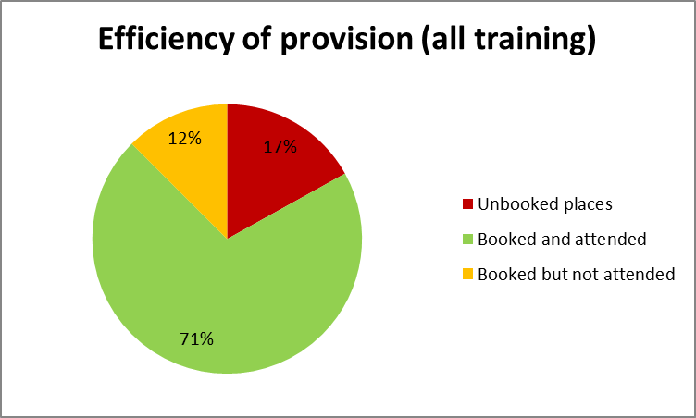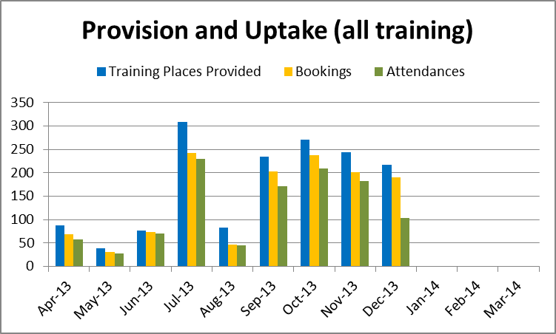

## Staff Training

|  |  |  |  |
| --- | --- | --- | --- |
| **% of available places booked** | | **% of bookings attended** | **% of available places attended** |
| 69% | 96% | 66% | |

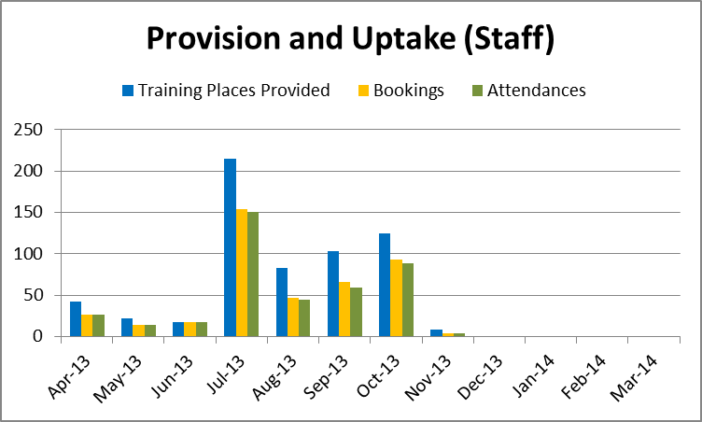

* The peak in events in July was due to a country-wide programme of appraisal training for all staff.
* There were no staff training events in December.

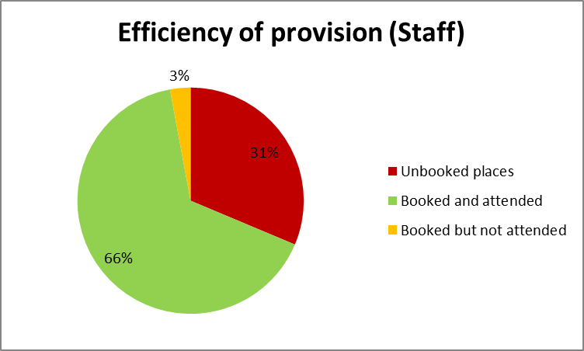

* The apparent over-provision will be explored in more detail on an event by event basis.

## Non-Staff (REC Members and Research Community)

|  |  |  |
| --- | --- | --- |
| **% of available places booked** | **% of bookings attended** | **% of available places attended** |
| 92% | 80% | 74% |

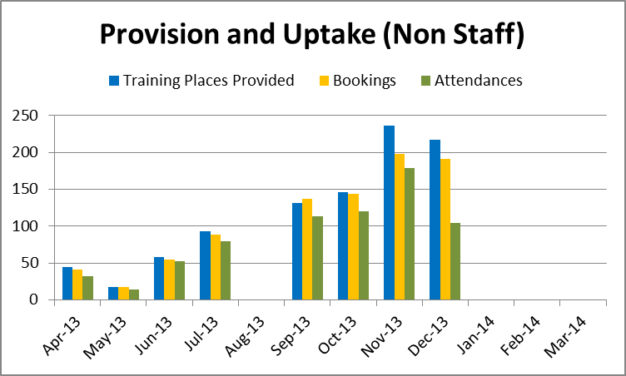

* There was no non-staff training in August.

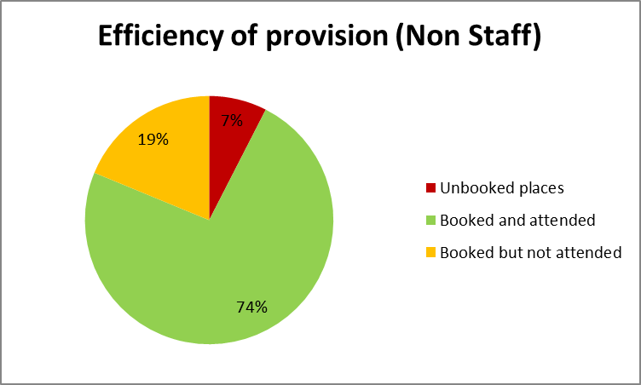

* The provision matches demand more closely for non-staff training. The broadening of audiences beyond REC members, to include researchers and other members of the research community, has increased demand for places.

## Geographical distribution of all training provided

|  |  |  |  |  |  |  |  |
| --- | --- | --- | --- | --- | --- | --- | --- |
| **Location** | **Events** | **Seats** | **Registrations** | **Attendances** | **Uptake %** | **Bookings Attended %** | **Bookings not attended %** |
| London | 28 | 774 | 693 | 532 | 90% | 69% | 23% |
| Manchester | 14 | 354 | 289 | 271 | 82% | 77% | 6% |
| Bristol | 6 | 125 | 88 | 87 | 70% | 70% | 1% |
| Jarrow | 5 | 101 | 48 | 46 | 48% | 46% | 4% |
| Nottingham | 5 | 88 | 66 | 63 | 75% | 72% | 5% |
| Leeds | 1 | 58 | 55 | 53 | 95% | 91% | 4% |
| Edinburgh | 1 | 26 | 26 | 20 | 100% | 77% | 23% |
| Glasgow | 1 | 21 | 20 | 19 | 95% | 90% | 5% |
| Dundee | 1 | 12 | 10 | 9 | 83% | 75% | 10% |

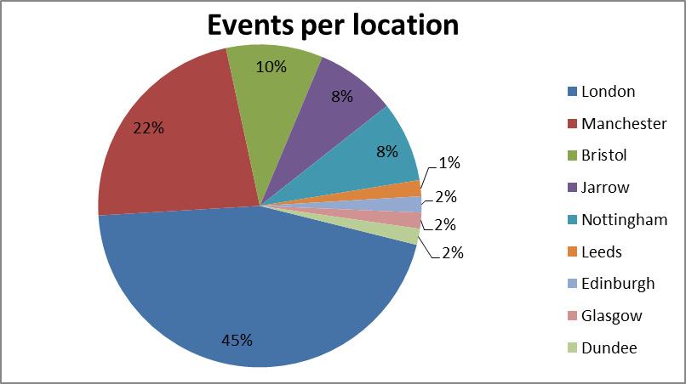

* The majority of events are held in London and Manchester because those HRA offices have the largest in-house meeting rooms and are easily accessible via main rail routes.

# Section 5: Research Ethics Committee metrics

|  |
| --- |
| REC METRICS |
| * REC requirement is 60 calendar days; the HRA has set stretched targets of 95% within 40 calendar days for applications going through full committee. 2013/14 has seen a continuing improvement in the number of applications reviewed within statutory timelines, despite ongoing IT issues which have seriously comprised work output on many occasions * Proportionate sub-committee review for low-risk studies has a target of 14 days * GTAC (Gene Therapy Advisory Committee) has transferred to the HRA and timelines have reduced significantly, but numbers are small so it is too soon to average. GTAC requirement is 90 calendar days; the HRA has stretched targets of 100% in 60 days. Previous data was over 100 days * Reduction of applications year-on-year has been due to service improvements, including database and tissue bank approvals which removed the need for individual applications, and policy changes to REC remit * Amendment requirements are 35 calendar days and the HRA has set a stretched target of 28 days |

## Time to complete ethical review – all application types, England (year to date)

|  |
| --- |
|  |

## Applications to RECs in England (year to date)

|  |  |  |  |  |  |  |  |
| --- | --- | --- | --- | --- | --- | --- | --- |
|  | All applications | CTIMPs | Other (full review) | Research Tissue Bank | Research Databases | Proportionate review | Full review (inc. CTIMPs) |
| **Apr-13** | 433 | 58 | 283 | 3 | 1 | 88 | 345 |
| **May-13** | 431 | 62 | 252 | 3 | 4 | 110 | 321 |
| **Jun-13** | 378 | 56 | 251 | 5 | 2 | 64 | 314 |
| **Jul-13** | 449 | 83 | 261 | 5 | 5 | 95 | 354 |
| **Aug-13** | 352 | 55 | 207 | 3 | 0 | 87 | 265 |
| **Sep-13** | 364 | 66 | 206 | 4 | 4 | 84 | 280 |
| **Oct-13** | 452 | 99 | 257 | 3 | 1 | 92 | 360 |
| **Nov-13** | 380 | 80 | 221 | 5 | 3 | 71 | 309 |
| **Dec-13** | 398 | 75 | 240 | 4 | 4 | 75 | 323 |

CTIMP: Clinical Trial of Investigational Medicinal Product

## Total applications reviewed in England (year on year)

|  |
| --- |
|  |

## Review of full applications – comparison of Centres, England (year to date)

|  |
| --- |
| Statutory timeline is 60 calendar days – Business Plan KPI objective is 40 calendar days |

|  |  |  |  |  |
| --- | --- | --- | --- | --- |
| REC Centre | Total no. applications (year to date) | Mean average time to process | Complete within 40 days (%) | Complete within 60 days (%) |
| **Bristol** | 786 | 34.93 | 71% | 99% |
| **Jarrow** | 366 | 31.15 | 81% | 100% |
| **London** | 545 | 37.79 | 59% | 94% |
| **Manchester** | 580 | 29.59 | 84% | 99% |
| **Nottingham** | 562 | 34.21 | 74% | 99% |

## Types of applications reviewed per month, England (rolling 2 years showing trend)

|  |
| --- |
|  |

## Trends in REC opinion types at first review, England (rolling 3 years)

|  |
| --- |
| The 2012 HRA Business Plan determined that the use of Provisional opinions at first review should be reduced in favour of Favourable with Additional Conditions (AC). The downward trend in Provisional opinions and the upward trend in Favourable AC reflect progress in this. Other opinion types remain stable |

## Review of amendments per REC Centre, England (year to date)

|  |  |  |  |  |
| --- | --- | --- | --- | --- |
| REC Centre | Number of amendments | Mean average time to process | % in 35 day limit | % in 28 day target |
| Bristol | 1,560 | 17.44 | 98% | 86% |
| Jarrow | 642 | 18.50 | 99% | 90% |
| London | 930 | 18.58 | 96% | 81% |
| Manchester | 1,015 | 16.90 | 98% | 90% |
| Nottingham | 1,228 | 15.92 | 100% | 95% |
| **England** | **5,375** | **17.31** | **98%** | **88%** |

## Review of amendments in target per REC Centre, England (year to date)

|  |
| --- |
| Statutory timeline is 35 calendar days – Business Plan KPI objective is 28 calendar days |

## Action Plans from accreditation of RECs, England

|  |  |  |
| --- | --- | --- |
| Month | No of action plans received | % in target |
| April | 2 | 100% |
| May | 2 | 100% |
| June | 1 | 100% |
| July | 0 | N/A |
| August | 0 | N/A |
| September | 1 | 100% |
| October | 1 | 100% |
| November | 1 | 100% |
| December | 0 | N/A |

# Section 6: Confidentiality Advisory Group (CAG) metrics

|  |
| --- |
| CAG METRICS |
| * CAG was established in April 2013 when the function transferred to the HRA * CAG will meet monthly (currently every 2 months) from April 2014 which will improve timelines. Additional resource secured in December 2013 will also reduce timelines |

## Summary of applications reviewed by CAG (year to date)

|  |  |  |  |  |  |  |
| --- | --- | --- | --- | --- | --- | --- |
| **Application type** | **Apr-13** | **Jun-13** | **Aug-13** | **Oct-13** | **Nov-13** | **Total** |
| New full CAG applications reported | 8 | 6 | 10 | 14 | 4 | **42** |
| Proportionate reviews reported | 7 | 5 | 6 | 5 | 11 | **34** |
| Amendments reported | 7 | 2 | 3 | 4 | 9 | **25** |
|  |  |  |  |  |  |  |
| **Mean processing time in calendar days** | **Apr-13** | **Jun-13** | **Aug-13** | **Oct-13** | **Nov-13** | **Target** |
| New applications | 49 | 44 | 46 | 45 | 31 | **60** |
| Proportionate reviews | 57 | 52 | 48 | 49 | 58 | **30** |
| Amendments | 72 | 52 | 34 | 88 | 52 | **30** |
|  |  |  |  |  |  |  |
| **No. of applications meeting target processing time** | **Apr-13** | **Jun-13** | **Aug-13** | **Oct-13** | **Nov-13** | **Target** |
| New applications | 7 | 6 | 8 | 13 | 4 | **60** |
| Proportionate reviews | 0 | 0 | 0 | 1 | 0 | **30** |
| Amendments | 2 | 0 | 2 | 0 | 2 | **30** |
|  |  |  |  |  |  |  |
| **Proportion of applications meeting target processing time** | **Apr-13** | **Jun-13** | **Aug-13** | **Oct-13** | **Nov-13** | **Target** |
| New applications | 88% | 100% | 80% | 93% | 100% | **100%** |
| Proportionate reviews | 0% | 0% | 0% | 20% | 0% | **100%** |
| Amendments | 29% | 0% | 67% | 0% | 22% | **100%** |

## Review of applications by CAG (year to date)

|  |
| --- |
|  |
|  |
|  |