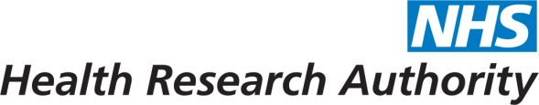

Agenda item: | 8
Attachment: | B

HRA BOARD COVER SHEET

Date of Meeting: | 22/01/2014

Title of Paper: | A proposal to collaborate in the development of the “Testing Treatments interactive” website
Purpose of Paper: | A short description of ideas for potential collaboration between HRA and TTi, specifically helping to write a section for Research Ethics Committees under the TTi “For Patient Representatives” column
Reason for Submission: | Board approval required
Details: | EMT has reviewed the document and made the following comments / suggestions:  - Minimal staff input time required  - Little extra cost required - events and expenses for members  - Events will support not just the development of content but reinforce effective collaboration including NIHR  - James Lind under Iain leadership an influential partner  - Iain more widely influential  - James Lind nonprofit making - funded via NIHR  - James Lind influences HTA ( Health Technology Assessment) funding priorities through their patient priorities work and seen as leading edge  - Testing Treatments is free to all  - Testing Treatments been translated in to 7 languages  - Website receives 3,300 unique visits a month with around 8,500 page views  - PDF downloads of English version of book are 4,500 since October 2012  - James Lind will provide editorial input  - Consistent with wider ambition for RECs to focus on genuine ethical issues from patient perspective  - Need to complete work on own website regarding public involvement first but this work would help enrich our own website
Suitable for wider circulation? | Yes

Recommendation / Proposed Actions: | To Approve |  | Yes
 | To Note
 | Comments

Name: | Hugh Davies
Job Title: | Ethics Advisor
Date: | 06/01/2014

A proposal to collaborate in the development of the “Testing Treatments interactive” website
http://www.testingtreatments.org/
Testing Treatments interactive – TTi - is a well-established non-commercial venture that is a widely accepted source of information and guidance for all parties interested in clinical trials. Iain Chalmers and Hugh Davies met recently to discuss possible collaboration between HRA and TTi, specifically helping write a section for Research Ethics Committees under their “For Patient Representatives” column (see attached screen shot of current draft of forthcoming modified home page).
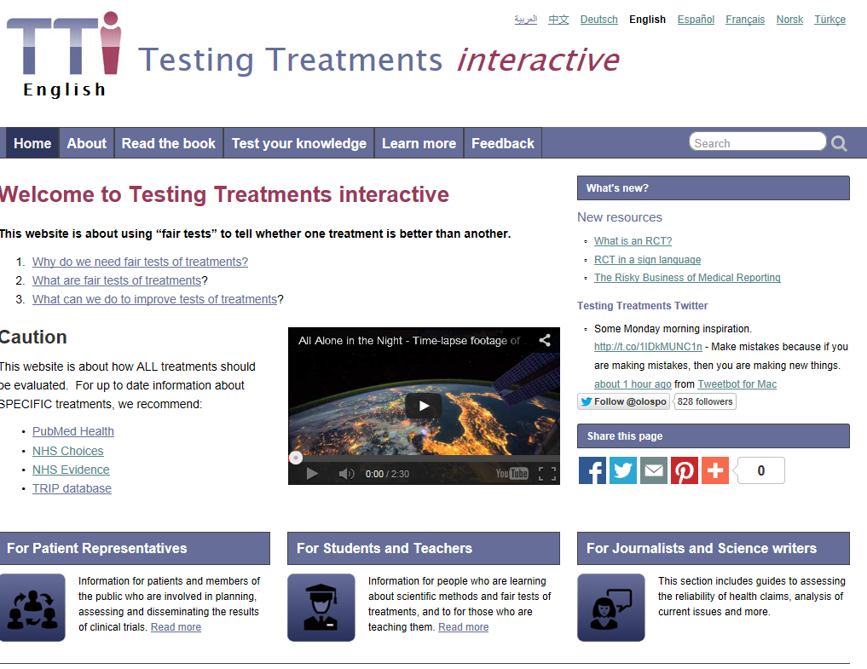
This paper is a short description of our ideas, for which we seek support.
Why should the HRA collaborate with Testing Treatments interactive (TTi)?
Since 2003, the preparation for the public of two editions of the book Testing Treatments (2006 and 2011), and the launch and development of TTi (since 2012), have been supported by the National Institute for Health Research through the James Lind Initiative (coordinator: Iain Chalmers). The James Lind initiative is non-profit making, free of commercial influence, independent, and committed to promoting open access to the results of its work.
Testing Treatments has been enthusiastically reviewed (see http://www.testingtreatments.org/the-book/reviews/). The first edition of the book was translated into 6 other languages; the second edition has so far been translated into 8 other languages, with other translations currently being prepared. The original English text and those of all the translations can be downloaded from TTi free of charge and reused under a Creative Commons Licence.
Testing Treatments interactive (TTi) has been and continues to be developed to enhance the text of the book using audio, video, games, cartoons and other material to help explain why fair tests of treatment are needed; the characteristics of fair tests; and why everyone has a role to play in promoting better research for better health care. There are currently 7 sibling sites in languages other than English, with others being prepared.
The three key target users of TTi English are: (i) patient representatives (including those serving on research ethics committees); (ii) students and teachers; and (iii) journalists and science writers.
Collaboration with TTi will raise the profile of the HRA and promote its transparency agenda, and sharing resources will allow HRA to put its message out in a modern, engaging format. HRA collaboration will give TTi even further authority and a wider audience and strengthen developing links with NIHR.
What would it involve for HRA?
Our initial idea is to involve a small group (4/5 max, 2 clinicians, 2 REC lay members and Amanda Hunn inputting the work HRA has done in this area) to draw up a plan for a REC page in TTi. Hugh has offered to lead this group. A small amount of money may be needed for travel and we would use HRA rooms for the meetings.
We’d then present the output of this group to an HRA training workshop in 2014 (other opportunities would of course be considered).
Our early ideas for this page are (details would be developed by the working party and other ideas are welcome):-
- An outline of current public and patient understanding of clinical trials. Here we would work with Amanda Hunn, using data from Ipsos MORI surveys of public general knowledge about health research and the HRA’s response to the findings.
- What history teaches us – James Lind Library, etc - the place of research and evidence in health care.
- Leading to the current position - that testing treatments is a requirement. No testing - No option (examples when we didn’t test). (The diagram below is from p 55 of the 2nd edition of Testing Treatments, p 55)
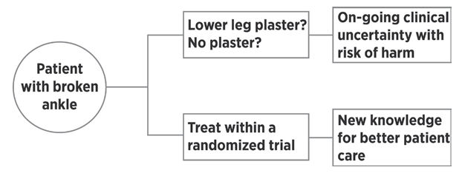
3. Key questions to ask about a treatment test.
4. Real risks of testing and not testing – 2x2 tables.
Benefits
 | Research participants | Patients
Test the treatment
Don’t test the treatment
Harms
 | Research participants | Patients
Test the treatment
Don’t test the treatment
5. Separately, “Talking heads”
· Researchers – why I research
· Clinicians – why research is important to my practice (see ADC)
· Patients – Healthtalk on line
· REC members - why I am a member of an REC
Hugh Davies, Amanda Hunn, Janet Wisely and Iain Chalmers
6 January 2014

