

|  |  |
| --- | --- |
| **Agenda item:** | **9** |
| **Attachment:** | **D** |

**HRA BOARD COVER SHEET**

|  |  |
| --- | --- |
| **Date of Meeting:** | 16th September 2015 |

|  |  |
| --- | --- |
| **Title of Paper:** | Financial report - July 2015 |
| **Purpose of Paper:** | To report on the financial position of the Authority for the year to date as at 31st July 2015 |
| **Reason for Submission:** | To ensure the EMT and the Board, are aware of the financial position of the HRA as at the end of July 2015 with an early indication of the end of year financial position. |
| **Lead Reviewer:** | Tom Smith, Director of Quality, Standards & Information |
| **Details:** | This paper presents the financial position as at the end of July 2015.  Main points to note:   * The HRA is living within its means. * 26% of the financial plan has been spent after 33% of the financial year has passed. * There is a £208k under spend as at the end of July 2015 (£181k June 2015), largely within the Operations and Approval Directorate and mostly due to the number of vacancies that have arisen either because of successful applications for roles linked to HRA Approval or due to the move of RECs between HRA Offices in order to spread the support more equitably. * The under spend is being actively tracked and managed to ensure that business requirements are being met. Recruitment plans have been brought forward and an initial review of requirements relating to Research Information Systems (RIS) posts has been completed and a case to extend contractors made. Further work is required and will form part of the RIS strategy. * Early forecasting work points to a break even position. |
| **Suitable for wider circulation?** | **Yes, following Board** |
| **Time required for item:** | **15 minutes** |

|  |  |  |  |
| --- | --- | --- | --- |
| **Recommendation / Proposed Actions:** | **To Approve** | |  |
| **To Note** | | **Yes** |
| **For discussion** | |  |
| **Comments** |  | |

|  |  |
| --- | --- |
| **Name:** | Debbie Corrigan |
| **Job Title:** | Director of Finance |
| **Date:** | 10 August 2015 |

**Finance Report - Financial Year 2015/16**

**Health Research Authority as at 31 July 2015**

1. **Introduction**

This report outlines the financial position of the Authority in respect of revenue and capital expenditure for the month ended 31 July 2015 and the expected full year 2015/16.

**2. Revenue Resource Limit**

The HRA initial grant in aid/ opening revenue resource limit for 2015/16 has been confirmed as expected at £13,346k. Confirmation on funding for CAG2 (second committee for review of applications) has now been communicated and a £65k adjustment to grant in aid will be actioned along with confirmation of the final non cash revenue resource limit. The whole of this sum is classified as administration funding under HM Treasury definitions and this sum represents HRA annual statutory funding from the Department of Health (DH) for the year. It excludes income from other government departments or income from the Devolved Administrations, the planning assumptions for which amount to a sum of £196k.

**3. Revenue expenditure position at 31 July 2015**

The revenue position of the Authority is summarised in the table on the next page with further performance detail in Appendix A.

The Authority has spent £3.69 million (£2.74m June 15) year to date. This represents a £208k under spend against expenditure budgets.

A summary of the overall position by Directorate is presented in table 1 below.

|  |  |  |  |  |  |
| --- | --- | --- | --- | --- | --- |
| **Table 1 :Summary of financial outturn 31 July 15** | |  |  |  |  |
|  |  |  |  |  |  |
|  | **Description** | **Initial Annual Budget** | **Budget for period to** | **Outturn as at** | **Variance** |
|  | **31 July 2015** | **31 July 2015** |
|  |  | **(£'000)** | **(£'000)** | **(£'000)** | **(£'000)** |
| **Income** | |  |  |  |  |
|  | HRA income | 196 | 0 | 0 | 0 |
|  | Grant in aid (confirmed) | 13,346 | 3,851 | 3,643 | (208) |
|  | Grant in aid (CAG2 to be confirmed) | 139 | 0 | 0 | 0 |
|  | Non cash revenue resource limit | 270 | 50 | 50 | 0 |
|  | **Total** | **13,951** | **3,901** | **3,693** | **(208)** |
| **Expenditure** | |  |  |  |  |
|  | Operations and Approval -Research Ethics Service England incl CAG | 4,794 | 1,596 | 1,429 | (167) |
|  | Chief Exec - Team, Board and Corporate Secretary | 1,560 | 557 | 572 | 15 |
|  | Corporate Services incl Communications, staff training, public involvement, programme office, HR services, IT contract | 1,731 | 509 | 514 | 5 |
|  | Finance incl Estates and Procurement and Reserves | 3,153 | 190 | 191 | 1 |
|  | Systems and Development incl HRA Approval programme activity, Quality Assurance, Guidance advice and learning | 2,713 | 1,049 | 987 | (62) |
|  | **Total** | **13,951** | **3,901** | **3,693** | **(208)** |
|  |  |  |  |  |  |
| **Surplus/(Deficit)** | | **0** | **0** | **0** | **0** |

The main points to note in the outturn expenditure position as at 31 July 2015 of £3.69m are:

1. Total pay costs incurred to date are £2.53m (68% of total expenditure costs).
2. Of this, £259k relates to agency costs. These costs include key research information systems staff who are progressing critical work which in July alone represented 56% of the monthly agency costs.
3. £4k of the July pay costs relates to overtime that staff have worked to help cover vacancies for which we are extremely grateful. Year to date, overtime costs amount to £26k.
4. The largest element of the underspend year to date relates to Operations and Approval with a further underspend relating to Systems and Development, table 2 overleaf helps to illustrate the latter.
5. Considerable work continues to be deployed into the recruitment phases supporting the HRA Approval programme. The final stages are underway. The profile of starters is set out in the Table 2 below, along with high level plans for phases 4 to 6. Reserves are not released for posts until approvals for grading’s, recruitment and timing are clear and in place.

**Table 2: HRA Recruitment phases**



1. After just 4 months or 33% of the financial year, a total of 26% of the total expenditure budget has been spent within the year.
2. The overall underspend of £167k within **Operations and Approval** directorate is largely broken down as follows. HRA Office Jarrow (£27k), HRA Office Manchester (£31k), HRA Office Bristol (£21k), Regional Manager North and South (£22k), HRA Office London of (£25k) and HRA Office Nottingham (£30k).
3. £143k of the £167k underspend within Operations & Approval, is pay related and due to vacancies that have arisen since the budgets were set and which are in the process of recruitment following the movement of some RECs between centres and the success of Operations and Approval staff obtaining posts supporting the HRA Approval programme. A contributing factor is thought to be related to the level of service being received from our out sourced HR recruitment service via NHS Business Services Authority which is leading to delays in the actual recruitment of staff. Urgent action is being taken to try to mitigate this with consideration being given to the level of resources required.
4. Meeting expenses and catering costs account for an under spend of £23k largely due to the fact that the budgets have not yet been reduced to reflect the move to 10 meetings per year. Budgets will be reduced in August. Additionally, further work is required to finesse the periodic payments register that finance is setting up to ensure that required accruals are actioned each month, along with realignment of RECs to HRA Centres which will also incur savings due to reduced associated travel costs. Travel is underspent by £1.1k and stationery £9k.
5. A final review of all Operations and Approval budgets will now take place to adjust for agreed efficiencies and a meeting to finalise will be held during August.
6. Within the **Systems and Development Directorate** there is an under spend of £62k. External facing and member training is now managed from within the Systems and Development Directorate, £14k of the under spend relates to this service and again the contributing factor is thought to be the accounting treatment for training related travel which will be corrected. The remainder of the underspend relates to vacancies that have either been recruited to or will be very shortly. These non recurrent under spends will be captured for deployment in areas of pressure.
7. Overall expenditure year to date is below that expected at the time the Financial Plan was presented. A comparison of the expected profiled plan against the actual year to date expenditure can be seen in the graph overleaf. The main reasons for the variance highlighted in the graph for non pay are due to
   1. Quarterly non pay property costs – mainly due to the successful lease exemption case agreed in Manchester and the negotiated rent free period from June not being profiled to correctly ahead of that decision – the profile will be reviewed.
   2. Profiling non pay areas of earmarked reserves quarterly in the plan which we now have a clearer picture of such as estates strategy related spend.
   3. Incorrect profiling of external training – members - £50k planned in quarter one originally which has now been re-profiled following discussion and agreement with the budget manager.
   4. Table 3 and 4 below set out separate graphical presentations of pay and non pay including the updated and revised profiled plan to the original profile of the plan in light of new information. These illustrate that the monthly spend is much closer to this revised plan.
8. Corrective action is being taken by the Executive Management Team to re-profile HR recruitment plans. Prudent investments will be made to support key areas of the business to mitigate the risks to maintaining our delivery of key performance indicators. Recruitment will be brought forward.

**Table 3: Profile of planned and actual Pay costs 2015/16**

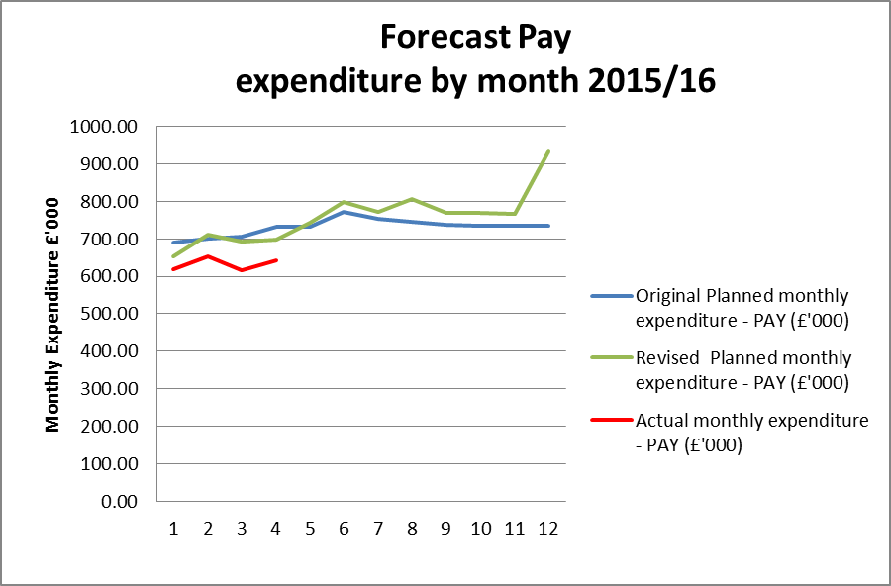

**Table 4: Profile of planned and actual Non Pay costs 2015/16**

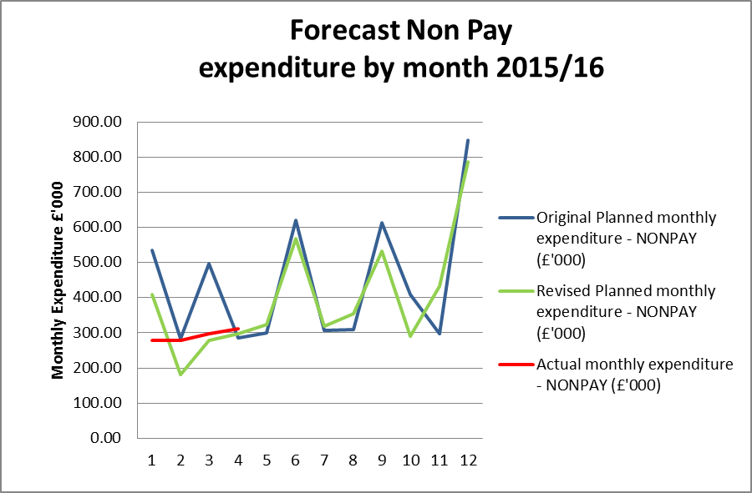

**4. Forecast outturn 2015/16**

Early forecasts point to a break even position. Risks to the position relate to any further unexpected delays to expected recruitment plans, any additional resource requirements linked to CAG2 actual activity and the extent to which decisions on estates lease exemption cases impact on current plans

**5. Better payments performance**

Better payment performance has met the duty to pay 95% of invoices in 30 days achieving 98% based on number of invoices, and achieved the target based on value by achieving 99%. HRA are committed to paying suppliers promptly and have increased the target of paying suppliers within 10 days to 60% for 2015/16. The performance at the end of July 2015 for payments made within 10 days is 59% (number of invoices), which is broadly in line with the stretched 60% target, and 54% based on value. Additional actions are underway to further improve performance in 2015/16.

**6. Travel costs**

Over £500k has been allocated for planned travel costs in 2015/16. Travel continues to be an area which is being intentionally monitored and managed with a view to a reduction in staff costs per head (given that costs are likely to increase overall as a result of more posts with a requirement for travel). The graph below shows that we are achieving this aim compared to a benchmark of 2013/14.

Table 5 below sets out the total travel costs position (staff, members inclusive) at the end of July and reflects an overspend of £15.7k (£15.5k overspend June). It should be noted that one explanation for the overspend is due to the number of update meetings being held to discuss HRA Approval with every Research Ethics Committee. Another is due to face to face meetings being held to discuss and clarify new processes and build new teams now that recruitment to posts is well underway. The treatment of travel costs associated with training is being investigated and could be one explanation for the over spends within Directorates as there have been staff related training (Arbinger development day across the organisation, training for new staff relating to HRA Approval and workshops for the first cohort, plus interviews ). Additionally, the arrangements for staff training are being reviewed to see if any savings can be realised from the choice of venue and methods of training provision. The estates strategy work is also encouraging greater use of video conferencing or “Lync” meetings.

A contributing factor to the position within Operations and Approval may be the minimal member related training events in the first 2 months of the year.

There are a number of new starters within Systems and Development and travel budgets have not yet been released from reserves for the travel element to these posts. The budget requirement for these new areas of work continue to be assessed and will be released from reserves once the travel requirements are agreed.

**Table 5: Travel costs and budget across the HRA by Directorate**



Year to date staff travel costs for 2015/16 are presented in Table 6 overleaf allowing comparison with the average cost per head in 2014/15 and 2013/14.

The lower travel costs in April and May is likely to be linked to fewer training events being held in these months. Efforts continue with staff and line managers working hard to ensure costs are minimised wherever possible, for example use of telephone or video conference calls, tickets booked in advance and on timed trains.

**Table 6: Staff travel costs per head**

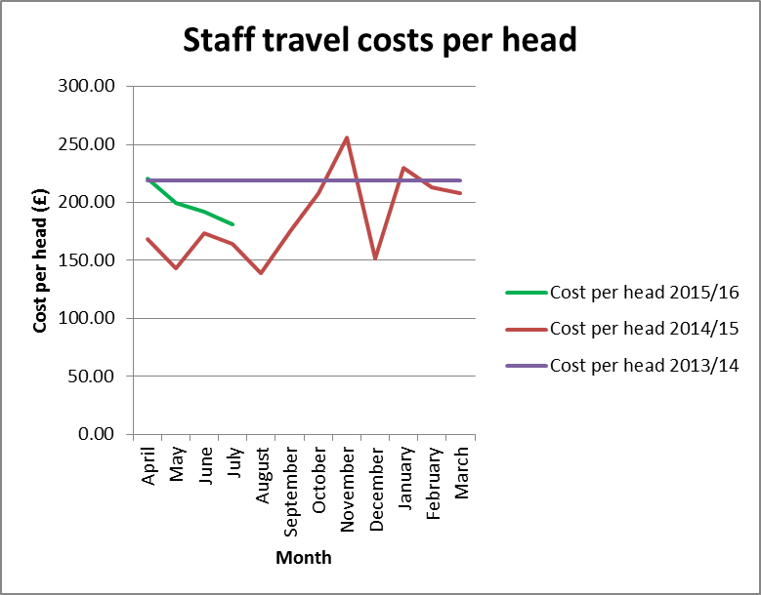

**7. Staff numbers**

Pay represents 68% of the costs incurred so far in year. The profile of our staff headcount is presented in Table 7 below for information and despite the vacancies continues to show an increasing trajectory.

**Table 7: Chart to show actual staff headcount so far in 2015**

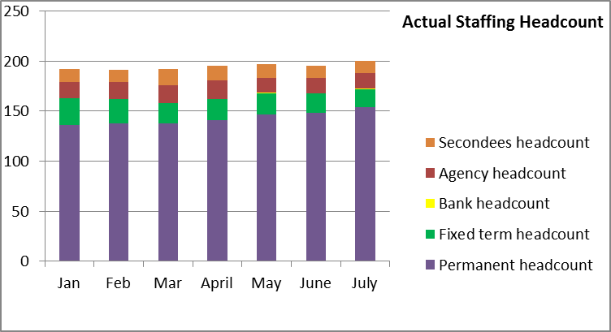

**8. Month end faster close**

The internal finance team objective to complete the management accounts within 4 days was achieved in July. All agreed deadlines for completion of required returns and reports for EMT and Board were achieved.

**9. Capital**

The capital expenditure position is presented below for July 2015. The capital plan includes budget for those Information Systems posts which include an element of development or capital work within their roles. A total of 24.7% of the capital budget has been spent at the end of July 2015.

The HRA received confirmation of the capital funding of £1.060m from the Department of Health on the 25th June 2015. The research information systems strategy is under development and is due to be reported to the Board in September. Additionally, the required investment in digital telephony has led to a review of cost treatments which will impact on the capital plan. Decisions on lease exemption cases may also impact. HRA is working with colleagues in the Sponsor and DH Finance departments to notify requirements in advance.

Further improvements are being developed to report on the monthly spend against budget for each of the capital programmes. This will enable us to highlight any potential forecast underspend or overspend at an early stage.

**Capital expenditure 2015/16**

|  |  |  |  |  |
| --- | --- | --- | --- | --- |
| **Plan initiative** |  | **2015/16 plan** | **2015/16 actual** | **2015/16 to go** |
|  | **£ '000** | **£ '000** | **£ '000** |
| HARP Developments |  | 275.00 | 80.2 | 194.8 |
| IRAS Developments |  | 542.00 | 136.0 | 406.0 |
| IS Team – capitalised salaries |  | 243.00 | 45.2 | 197.8 |
| **TOTAL** |  | **1,060.00** | **261.4** | **798.6** |

**10. Statement of Financial Position and cash**

To align with the quarterly accountability meetings with the Department of Health, during 2015/16 a quarterly Statement of Financial Position (formerly balance sheet) and cashflow forecast will be produced and reported to EMT. The next Statement of Financial Position and cash flow therefore will be produced for the end of September 2015.

At the end of the reporting period, the cash balance was £2.721m, which is a reduction compared to the balance of £3.025m held at the end of June 2015, and the balance of £3.741m held at the end of the 2014/15 financial year. In order to fulfil the duty to avoid holding excess levels of cash, the HRA will continue to monitor the cash position during 2015/16 to ensure that sufficient cash is held for future needs, but will aim to reduce the cash balances held.

**11. Recommendations**

That the Board notes the final financial position and to particularly note the following:

* The under spend year to date and the ongoing work required by finance to present the under spends relating to vacancies year to date and likely forecast for the year.
* The amended presentation of the profiled planned expenditure as requested by the Board and the closer match between actual monthly spend and this revised profile
* The maintained Better Payments Practice Code position to meet the 95% target based on number of invoices and the value, and the continued requirement to review invoices in the workflow on a daily basis, put invoices on hold if under dispute or set up a substitute.
* The cash position of £2.721m.
* The capital position and further work required.

**Debbie Corrigan**

**Director of Finance**

**11 August 2015**

**Health Research Authority – Financial position as at 31 July 2015 Appendix A**

|  |  |
| --- | --- |
| **FINANCIAL RESULTS**  **HEADLINES** | * HRA is reporting an expenditure budget underspend of £208k at the end of July (£181k end of June) * 26% (£3.69million) of the annual budget has been spent after 33% of the year has passed. * Further work is required to finesse some areas of budget and to start to prepare forecasts for the year end. * The largest variance at month 4 (July) is the under spend within the Operations and Approval directorate cost centres. * The under spend within Operations largely relates to pay costs. Some may also link to the efficiencies made as a result of reducing the number of RECs and a further budget adjustment is required. * Work is required during August to analyse the training related travel costs and to transfer them to the training cost centres which are currently underspent along with a revised process for administering these travel costs. * The Better Payment Practice Code (BPPC) compliance for April to July was 98% for the number of invoices paid, which is in line with the overall performance for 2014/15, and is reporting 99% for value of invoices paid, which is a slight improvement against the previous year 2014/15. Having achieved the 50% target of paying invoices within 10 days during 2014/15, the HRA is aiming to pay 60% of invoices within 10 days – current performance shows 59% on the number of invoices and 54% based on invoice values. All approvers are asked to note this and to approve invoices promptly or place on hold if there is a dispute. Performance is published on our website. * The cash balance at the end of July 2015 was £2.721m, which is a reduction on the balance held at the end of June of £3.025m. An updated cash flow forecast will be produced for the end of September 2015. |

**Health Research Authority – Non Pay Expenditure Year to end July 2015 Appendix B**

|  |  |  |  |  |  |  |  |  |  |  |  |  |  |  |  |  |  |  |  |  |  |  |  |  |  |  |  |  |  |  |  |  |  |  |  |  |  |  |  |  |  |  |  |  |  |  |  |  |  |  |  |  |  |  |  |  |  |  |  |  |  |  |  |  |  |  |  |  |  |  |  |  |  |  |  |  |  |  |  |  |  |  |  |  |  |  |  |  |  |  |  |  |  |  |  |  |  |  |  |  |  |  |  |  |  |  |  |  |  |  |  |  |  |  |  |  |  |  |  |  |  |  |  |  |  |  |  |  |  |  |  |  |  |  |  |  |  |  |  |  |  |  |  |  |  |  |  |  |  |  |  |  |  |  |  |  |  |  |  |  |  |  |  |  |  |  |  |  |  |  |  |  |  |  |  |  |  |  |  |  |  |  |  |  |  |  |  |  |  |  |  |  |  |  |  |  |  |  |  |
| --- | --- | --- | --- | --- | --- | --- | --- | --- | --- | --- | --- | --- | --- | --- | --- | --- | --- | --- | --- | --- | --- | --- | --- | --- | --- | --- | --- | --- | --- | --- | --- | --- | --- | --- | --- | --- | --- | --- | --- | --- | --- | --- | --- | --- | --- | --- | --- | --- | --- | --- | --- | --- | --- | --- | --- | --- | --- | --- | --- | --- | --- | --- | --- | --- | --- | --- | --- | --- | --- | --- | --- | --- | --- | --- | --- | --- | --- | --- | --- | --- | --- | --- | --- | --- | --- | --- | --- | --- | --- | --- | --- | --- | --- | --- | --- | --- | --- | --- | --- | --- | --- | --- | --- | --- | --- | --- | --- | --- | --- | --- | --- | --- | --- | --- | --- | --- | --- | --- | --- | --- | --- | --- | --- | --- | --- | --- | --- | --- | --- | --- | --- | --- | --- | --- | --- | --- | --- | --- | --- | --- | --- | --- | --- | --- | --- | --- | --- | --- | --- | --- | --- | --- | --- | --- | --- | --- | --- | --- | --- | --- | --- | --- | --- | --- | --- | --- | --- | --- | --- | --- | --- | --- | --- | --- | --- | --- | --- | --- | --- | --- | --- | --- | --- | --- | --- | --- | --- | --- | --- | --- | --- | --- | --- | --- | --- | --- | --- | --- | --- |
| **Areas of Non- Pay Expenditure** | |  |  |  |  |  |  |  |  |  | | --- | --- | --- | --- | --- | --- | --- | --- | --- | | **Subjective** | **Annual** | **Next year** | **In month (£)** | | | **Year to date (£)** | | | | **Name** | **budget (£)** | **plan (£)** | **Budget** | **Actual** | **Variance** | **Budget** | **Actual** | **Variance** | | **1 Meeting Rooms/Catering** | 233,518 | 200,729 | 21,657 | 5,077 | (16,580) | 64,881 | 30,870 | (34,012) | | **2 Office equipment/Stationery/Furniture/Consumable** | 64,582 | 64,382 | 5,378 | 2,792 | (2,586) | 21,512 | (709) | (22,221) | | **3 Photocopying/Printing/Postage/Storage/Waste** | 169,601 | 167,101 | 12,893 | 21,828 | 8,935 | 54,416 | 63,560 | 9,144 | | **4 Premises - inc premise removal costs** | 794,882 | 781,772 | 11,380 | 38,571 | 27,190 | 230,030 | 248,264 | 18,235 | | **5 Training Expenses - expenses/materials , conferences, workshops** | 128,900 | 82,300 | 13,362 | 9,292 | (4,070) | 20,247 | 39,623 | 19,376 | | **7 Other Staff costs - Recruitment/adverts/redundancy/PILON** | 6,000 | 6,000 | 6,000 | 6,775 | 775 | 6,000 | 6,775 | 775 | | **8 Travel costs - include excess mileage/interview expenses** | 540,795 | 466,669 | 50,741 | 51,315 | 574 | 176,185 | 193,506 | 17,321 | | **9 Chairs/Members/Participation - activity costs** | 286,421 | 272,271 | 21,736 | 19,505 | (2,231) | 89,692 | 83,840 | (5,852) | | **10 Publications** | 3,500 | 1,500 | 125 | (375) | (500) | 500 | 0 | (500) | | **11 Mobile Phones/Mobile Data** | 22,846 | 21,925 | 1,975 | (97) | (2,072) | 7,699 | 5,658 | (2,041) | | **12 Statutory Costs - health & Safety/Audit Fees/Depreciation & Amort** | 443,222 | 365,722 | 55,426 | 48,403 | (7,023) | 146,236 | 138,058 | (8,178) | | **13 Computer Costs - software/licences/system maintenance/purchases** | 331,470 | 313,597 | 35,229 | 16,060 | (19,169) | 113,789 | 110,534 | (3,255) | | **14 Other External Contracts - SLA's - Premises, SBS,BSA, DH IT** | 838,303 | 755,500 | 60,147 | 93,398 | 33,251 | 231,794 | 246,527 | 14,733 | | **15 Other - Misc/Reserves** | 2,111,269 | 0 | 0 | (9) | (9) | 0 | (9) | (9) | | **Grand Total** | **5,975,309** | **3,499,468** | **296,049** | **312,535** | **16,485** | **1,162,981** | **1,166,497** | **3,516** | |  |  |  |  |  |  |  |  |  | | Notes |  |  |  |  |  |  |  |  | | 1. Office equipment under spend is due to the presentation of an over accrual relating to 2014/15 which will be investigated. | | | | | | | | | | 2. Other external contracts - the overspend is largely due to increased charges for IT services linked to new staff for which additional budget is | | | | | | | | | | available but has not been vired from reserves. | | | | | | | | | |

**HRA Better Payment Practice Code for the period 1 April to 31 July 2015 Appendix C**



**Aged Creditors at 31 July 2015**

Headlines – clock start date is the invoice date (regardless of when the invoice is received in the system) – there are no issues of concern.

The balance in the 60 + days relate mainly to credit notes which we are awaiting to offset against future invoices.

|  |  |  |  |
| --- | --- | --- | --- |
|  | **Aged Creditors – (£) amounts past due date** | | |
|  | **1-30 days** | **31-60 days** | **60 + days** |
| **Non NHS Trade** | 26,087.75 | 430.19 | 32.87 |
| **Non NHS Other** | 4,580.40 | 79.75 | 237.61 |
| **NHS** | 8,961.26 | (65.65) | (1,928.38) |
|  |  |  |  |
| **Total** | 39,629.41 | 444.29 | (1,657.90) |

**HRA Revenue position for the period ended 31 July 2015 Appendix D**

|  |  |  |  |  |  |  |  |  |  |  |  |  |  |
| --- | --- | --- | --- | --- | --- | --- | --- | --- | --- | --- | --- | --- | --- |
| **Period (£'000)** | | |  | **Department** |  | **Year to date (£'000)** | | |  | **Full year (£'000)** | | | |
|  |  |  |  |  |  |  |  |  |  |  | **2015/16** | | |
| **Budget** | **Actual** | **Variance** |  | **Income** |  | **Budget** | **Actual** | **Variance** |  | **2014/15 actual** | **Initial budget** | **Latest Budget** | **Forecast** |
| 0 | 0 | 0 |  | HRA income |  | 0 | 0 | 0 |  | 327 | 196 | 196 | 196 |
| 981 | 955 | -26 |  | Grant in Aid confirmed |  | 3,851 | 3,643 | -208 |  | 10,343 | 13,346 | 13,346 | 13,346 |
| 0 | 0 | 0 |  | Grant in aid - to be confirmed CAG2 |  | 0 | 0 | 0 |  | 0 | 139 | 65 | 65 |
| 0 | 0 | 0 |  | Non cash revenue resource limit |  | 50 | 50 | 0 |  | 0 | 270 | 270 | 270 |
| **981** | **955** | **-26** |  | **Total Income** |  | **3,901** | **3,693** | **-208** |  | **10,670** | **13,951** | **13,877** | **13,877** |
|  |  |  |  |  |  |  |  |  |  |  |  |  |  |
| **Budget** | **Actual** | **Variance** |  | **Expenditure** |  | **Budget** | **Actual** | **Variance** |  | **2014/15 actual** | **Initial budget** | **Latest Budget** | **Forecast** |
| 394 | 373 | -21 |  | Operations and Approval |  | 1,596 | 1,429 | -167 |  | 4,429 | 4,794 | 4,741 | 4,741 |
| 157 | 160 | 3 |  | Chief Executive inc. Corp Sec |  | 557 | 572 | 15 |  | 1,768 | 1,560 | 1,670 | 1,670 |
| 102 | 113 | 11 |  | Corporate Services |  | 509 | 514 | 5 |  | 1,984 | 1,731 | 1,661 | 1,661 |
| 32 | 30 | -2 |  | Finance |  | 190 | 191 | 1 |  | 639 | 3,153 | 2,830 | 2,830 |
| 296 | 279 | -17 |  | Systems and Development |  | 1,049 | 987 | -62 |  | 1,850 | 2,713 | 2,975 | 2,975 |
| **981** | **955** | **-26** |  | **Total Expenditure** |  | **3,901** | **3,693** | **-208** |  | **10,670** | **13,951** | **13,877** | **13,877** |
|  |  |  |  |  |  |  |  |  |  |  |  |  |  |
| **0** | **0** | **0** |  | **Surplus /Deficit** |  | **0** | **0** | **0** |  | **0** | **0** | **0** | **0** |

**Reconciliation of grant in aid to 2015/16 financial plan Appendix E**

|  |  |  |  |  |  |  |
| --- | --- | --- | --- | --- | --- | --- |
|  |  | **2015/16** | | |  | **2016/17** |
| **Grant in aid presented in financial plan 2015/16** |  | **Confirmed (£k)** | **Under negotiation (£k)** | **Total (£k)** |  | **Indicative (£k)** |
| Confirmed DH revenue resource limit |  | 13346 |  | 13346 |  | 12636 |
| Additional grant in aid CAG2 pye |  |  | 139 | 139 |  | 232 |
| Additional grant in aid CAG3 pye |  |  | 111 | 111 |  | 168 |
| **Total expected grant in aid in financial plan** |  | **13,346** | **250** | **13,596** |  | **13,036** |
| ***Amendments to financial plan*** |  |  |  |  |  |  |
| CAG3 agreed not required based on updated activity figures supplied. However 2016/17 position will need review. |  |  | -111 | -111 |  | -168 |
| CAG2 likely agreement |  |  | -74 | -74 |  | -115 |
|  |  |  |  |  |  |  |
| **Revised expected grant in aid** |  | **13,346** | **65** | **13,411** |  | **12,753** |
|  | | | | | | | |