

|  |  |
| --- | --- |
| **Agenda item:** | **9** |
| **Attachment:** | **D** |

**HRA BOARD COVER SHEET**

|  |  |
| --- | --- |
| **Date of Meeting:** | 20 May 2015 |

|  |  |
| --- | --- |
| **Title of Paper:** | Financial report as at 31st March 2015 for financial year 2014/15 |
| **Purpose of Paper:** | To report on the financial position of the Authority for the year ended March 2015 |
| **Reason for Submission:** | To ensure the EMT and the Board in due course, are aware of the end of year financial position of the HRA. |
| **Lead Reviewer:** | Tom Smith, Director of Quality, Standards & Information |
| **Details:** | This paper presents the financial position as at the end of March 2015.  In summary, the HRA completed the year with an expected expenditure under spend of £3.09million. An under spend range had been forecast from May 2014. The position has been regularly reported to the EMT, Board, Sponsor and DH Finance colleagues with the upper end of the forecast range being advised as the likely position.  The extent of the forecast underspend has grown during the year for the reasons previously reported.  There has been a further slight increase in the outturn under spend in March. EMT has approved the report.  Main points to note   * Final under spend of £3.09m (£457k in February, a swing of £2,644k). Main reasons for the expected in month swing is the non release or deployment of reserves. * The outturn is broadly in line with the upper range forecast under spend reported at the end of February (£2.35million to £3.01million) increased slightly to that reported in January (£2.17million to £2.98 million). * Main reason for the under spend (reported previously) is the time it has taken to recruit successful candidates to HRA Approval posts. 38.3% (rather than 61%) of the 82.74 WTE have been fully recruited to by March. This alongside the significant reduction in linked pay and non pay related costs is the main reason for the under spend, together with changes to plans for desired early transfer of posts to support HRA Approval and systems transition and the non deployment of contingencies. * The final cash position of £3.741m held in the bank. This is slightly higher than forecast linked to the final underspend position. * A reported underspend on capital expenditure of £207k following assessment of work being undertaken by current IS posts and maintenance elements of expenditure being transferred back to revenue. |
| **Suitable for wider circulation?** | **After approval.** |
| **Time required for item:** | **15 minutes** |

|  |  |  |  |
| --- | --- | --- | --- |
| **Recommendation / Proposed Actions:** | **To Approve** | | **Yes** |
| **To Note** | |  |
| **For discussion** | |  |
| **Comments** |  | |

|  |  |
| --- | --- |
| **Name:** | Debbie Corrigan |
| **Job Title:** | Director of Finance |
| **Date:** | 27th April 2015 |

**Finance Report - Financial Year 2014/15**

**Health Research Authority as at 31 March 2015**

1. **Introduction**

This report outlines the financial position of the Authority in respect of revenue and capital expenditure for the month ended 31 March 2015 and the expected full year 2014/15.

**2. Revenue Resource Limit**

The HRA indicative grant in aid/ opening revenue resource limit for 2014/15 was agreed at £13.444m. The whole of this sum is classified as administration funding under HM Treasury definitions and this sum represents HRA annual statutory funding from the Department of Health (DH) for the year. This sum excludes income from other government departments or income from the devolved administrations, the planning assumptions for which amount to a sum of £240k.

**3. Revenue expenditure position at 31 March 2015**

The revenue position of the Authority is summarised in the table on the next page with further performance detail in Appendix A.

The Authority has spent £10.67million (£9.17m end February) year to date. This represents a £3.09 million under spend against expenditure budgets and a £3.101 million underspend against grant in aid. The difference is largely due to an over achievement of income budgets as a result of the secondment to an NHS Trust of a member of staff.

The rate of monthly spend and overall upward trend is shown in the graph below.

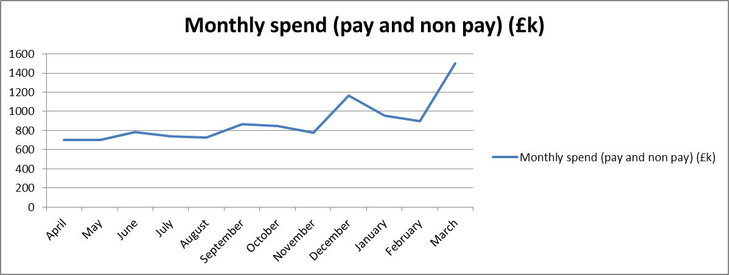

A summary of the overall position is presented overleaf.

|  |  |  |  |  |  |
| --- | --- | --- | --- | --- | --- |
| **Summary of financial outturn 31 March 2015** | |  |  |  |  |
|  |  |  |  |  |  |
|  | **Description** | **Initial Annual Budget** | **Budget for period to** | **Outturn as at** | **Variance** |
|  | **31 March 2015** | **31 March 2015** |
|  |  | **(£'000)** | **(£'000)** | **(£'000)** | **(£'000)** |
| **Income** | |  |  |  |  |
|  | HRA income | 240 | 313 | 327 | 14 |
|  | Grant in aid | 13444 | 13444 | 10343 | -3101 |
|  | **Total** | **13684** | **13757** | **10670** | **-3087** |
| **Expenditure** | |  |  |  |  |
|  | Operations and Approval | 4,527 | 4,625 | 4,429 | -196 |
|  | Chief Exec - Team, Board and Corporate Secretary | 1,650 | 1,724 | 1,768 | 44 |
|  | Corporate Services | 1,986 | 1,951 | 1,984 | 33 |
|  | Finance Estates and Procurement (incl Reserves) | 5,172 | 3,564 | 639 | -2925 |
|  | Systems and Development | 0 | 1,893 | 1,850 | -43 |
|  | Communications | 349 | 0 | 0 | 0 |
|  | **Total** | **13,684** | **13,757** | **10,670** | **-3,087** |
|  |  |  |  |  |  |
| **Surplus/Deficit** | | **0** | **0** | **0** | **0** |

The main points to note in the outturn expenditure position as at 31 March 2015 of £10.67m are:

1. Total pay costs incurred to date are £6.55m (61%) of total expenditure costs. (£6.52m net of income from a secondment recharge of £11k and the annual leave accrual adjustment at end of March of (£14k)).
2. The largest element of underspend relates to **reserves** not deployed and reported within finance at £2.925million under spend. Reserves are retained in two distinct pots, one representing the HRA Approval Programme funding (£2.5million retained as at the end March) and the other for non programme related functions. (£389k retained as at the end of March).
3. Considerable work has been deployed during the year into the recruitment phases supporting the HRA Approval programme. Phase 1, 2 and phase 3 recruitment has completed and the profile of starters is set out in the following table along with high level plans for phases 4 to 6. Reserves are not released for posts until approvals for gradings, recruitment and timing are clear and in place. The understandable time it has taken to recruit to posts following the welcome news at the end of March 2014 on funding has led to a £1.97million underspend on pay costs alone against expected HRA Approval programme funding retained within reserves. The pay related non pay costs and contingencies for liabilities related to recruitment of £300k increase this underspend or non deployment from reserves to £2.5million. (Forecasts of the full year effect costs of successful HRA Approval programme recruitment during 2014/15, point to a tight position on programme related pay into 2015/16 with just a £48k underspend expected.)

|  |  |  |  |  |  |  |  |
| --- | --- | --- | --- | --- | --- | --- | --- |
|  | **Phase 1** | **Phase 2** | **Phase 3** | **Phase 4** | **Phase 4 & 5** | **Phase 6** | Total |
|  | In Post July-Sept | In Post Oct | In post Nov - Dec | In Post by Mar | Early 2015/16 | Mid 2015 |  |
| **Headcount** | 15 | 12 | 12 | 6 | 36 | 15 | 96 |
| **WTE's** | 13 | 6.9 | 9.8 | 2.04 | 36 | 15 | 82.74 |
| **% WTEs inpost** | 15.7% | 8.3% | 11.8% | 2.5% | 43.5% | 18.2% |  |

1. The general reserve had a balance of £389k not deployed at the end of March. This is due to contingencies set aside during the year which were not required. £130k potential VAT clawback liability set aside following the HMRC VAT inspection; £30k planned estates related costs that could not be deployed due to the late but welcome decision on the Manchester office lease extension; £57k costs not deployed to CAG posts planned to support the expected impact of changes to HSCIC related workload following delays to the laying of the regulations; £25k NDPB transition costs not required; £15k set aside for the costs of NHS Mail which proved not to be required.
2. After 12 months, a total of 77.5% of the total expenditure budget has been spent within the year, with staff costs amounting to £6.55m.
3. The overall underspend of £196k within **Operations and Approval** largely relates to underspends within HRA Office Jarrow (£14k including income of £11k), HRA Office Manchester (£106k), HRA Office Bristol (£32k) and the Regional Manager North and South (£62k) and the HRA Office London of (£25k). These underspends are partially offset by an overspend within HRA Office Nottingham of £31k.

During October the Operations establishment was re-organised to reflect the movement of REC’s from the beginning of the year. This has moved the under spend from within the HRA Office London to the offices that took on additional REC’s. The main causes of the underspends are:

* 1. Recurrent savings of high cost area allowance as a result of moving posts from London (this was highlighted on the KPI report for October – circa £23k)
  2. Recurrent savings as a result of the full year effect of reducing the number of RECs by 1. (circa £33k) Both of these savings will help fund pay awards and pension cost increases in 2015/16.
  3. Non recurrent savings as a result of the decision to largely use internal cover rather than agency staff to cover vacant posts. This decision was directly linked to the poor quality of staff offered through the agency staff contract. Performance of the affected centres dipped slightly in year but recovered by the end of the year, and remaining staff are working at full capacity.
  4. Non recurrent saving as a result of carrying a senior vacant post. Due to problems experienced in the past through the use of senior temps the decision was taken to cover internally to mitigate similar risks. The under spend within the Regional Manager North relates to the acting up of a Regional Manager into the NRES Manager posts whose post has not been backfilled currently. The under spend within the Regional Manager South is as a result of the changed configuration of the HRA Office London and cover arrangements. Recruitment plans are now being progressed.

Further explanations are offered below:

* + - The under spend within the HRA Office Jarrow relates mainly to staff recharge income (£7k net) and (£4k) on Stationery and Storage and (£3k) on Chairs allowances.
    - The HRA Office Manchester underspend of £106k is in relation to staff costs £95k – this increase is largely due to the budget transferred from the HRA Office London for the pay for transferred REC’s. The recruitment to HRA Office Manchester continues to be undertaken. There is a plan for additional hours to be worked by some of the current staff in order to continue to meet set deadlines and these will be charged to the staff underspend. There is an underspend within stationery £14k, a £6k underspend in postage and an underspend within Contract photocopiers of £3k and a small underspend within Chairs Allowance of £3k. These underspends are slightly offset by overspends in meeting expenses £4k and £14k service charge costs.
    - The underspend of £32k within the HRA Office Bristol is mostly in relation to staff costs £52k and these have arisen due to the pay budgets transferred to reflect the REC committees transferred to Bristol from London. There is an £12k underspend within the Chairs Allowance. These underspends are offset by an over spend in service charge of £6k relating to a late charge from former host and an £16k overspend within travel costs and an overspend in meeting room expenses of £4k.
    - The underspend with the HRA Office London of £25k is mostly in relation to staff underspends of £36k, which are offset by overspends on removal expenses and a non-recurrent computer software charge.
    - The overspend in the HRA Office Nottingham of £31k is in relation to £4k pay costs and £29k travel expenses.
    - The Chairs under spends in the larger centres have been investigated and are due to the budget being based on Chairs Allowance plus on-costs – at a rate we would be recharged from an external host. The majority of Chairs are now on payroll and the on-costs are significantly lower than budgeted. For 2015/16 we will be budgeting based on actual process for each Chair so the under spend should be eliminated and produce a small saving back to reserves.

1. The **Corporate Services** directorate has over spent by £33k however within that position training for staff and members is underspent (£43k) although a break even had been predicted. The initial contributing factor to this position appear to be linked to the accounting for training related travel costs a significant proportion of which are being charged to line managers rather than training. Treatment will be clarified. The overspends within Corporate Services relate to Business Partnerships (£45k) in relation to additional charges for the Atos contract and an overspend relating to the non recurrent Nottingham Office Project £28k. There is also an overspend within the area of Public Involvement of £11k with regards to Participation Fees and travel costs and budgets for 2015/16 have been increased.
2. Within the **Systems and Development Directorate** there is an under spend of £43k. The underspend relates to Research Information systems requiring less penetration testing than originally budgeted and potentially reduced costs relating to new system platforms (£42k).
3. The overspend showing within the Chief Executive directorate relates to non recurrent, non pay related investment to save costs on the E-Learning Project.
4. Overall expenditure year to date is below that expected at the time the Financial Plan was presented. A comparison of the expected profiled forecast against the actual year to date expenditure can be seen in the graph below. The main reasons are the timing of recruitment to vacancies and the phasing of new HRA Approval starters being later than the original plan. This delay has also impacted on the profile of the pay related non-pay spend that was included in the Financial Plan in areas of Training, Shared service costs (payroll, IT, HR), telephone handsets, travel and mobile phone costs,etc. These areas are all sensitive to the numbers in the establishment.

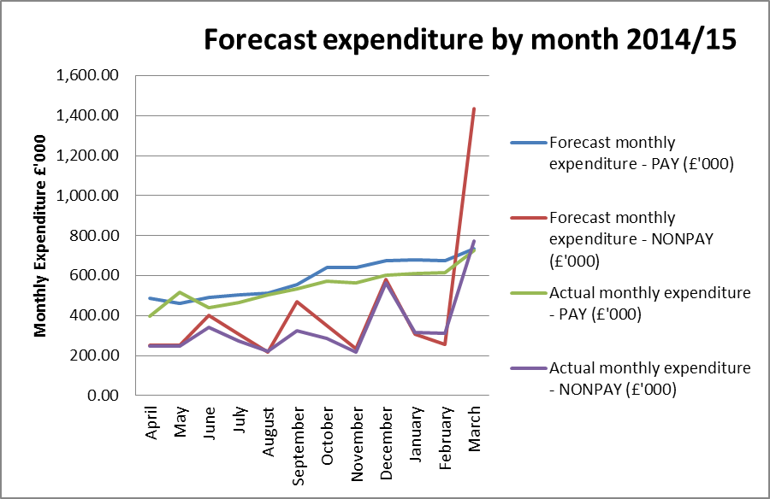

**4. Forecast outturn 2014/15**

Early forecasts were presented in the Financial Plan for 2014/15 and pointed to an underspend at a level of around £1.57million, largely as a result of the welcome but late decision on the HRA Approval business case and the expected time it would take to recruit to posts.

The review of the likely expenditure position in February was pointing to a forecast range of £2.35m to £3.01m and as at the end of March is £3.09m. The forecasts were a result of intelligence provided by HRA budget managers in meetings with their finance lead, and a regular review of reserves in the light of the latest information.

The outturn was at the higher end of the range, as had been indicated to DH Finance from October onwards and was due to clarification on the outcome of negotiations across the Department of Health bodies with HMRC with regards to the claw back of VAT reclaims in previous years for agency workers, contingencies in reserves not being deployed and reprofiled recruitment in relation to the HRA Approval programme business case.

**5. Better payments performance**

Better payment performance has met the duty to pay 95% of invoices in 30 days achieving 98% based on number of invoices, and achieved the target based on value by achieving 97%. HRA has also met the 2014/15 target of paying 50% within 10 days. The performance for the year for payments made within 10 days is 58% (number of invoices), and 62% based on value and additional actions are underway to further improve performance in 2015/16.

**6. Travel costs**

Travel is an area which is being intentionally monitored and managed with a view to a reduction in staff costs per head (given that costs are likely to increase overall as a result of more posts with a requirement for travel). This has been largely successful, no mean feat in light of increased ticket costs. The table below sets out the total travel costs position (staff, members inclusive) at the end of March and reflects an over spend of £61.9k (overspend of £22.3k end February). A further focus on ways of working and resulting impact on travel costs is in hand to try to drive down costs in this area further. The treatment of travel costs associated with training is also being investigated. There is additional travel relating to the Talent and Leadership Programmes implemented within year which will have impacted on overall costs.

|  |  |  |  |
| --- | --- | --- | --- |
| **Travel costs across the HRA** | **Full year spend** | **Full year variance** | **% share of total year to date spend** |
|  | **(£)** | **(£)** | **%** |
| Operations and Approval | 364,067 | 58,664 | 61% |
| Chief Exec inc Team, Board and Corp. Sec. | 76,285 | 22,275 | 13% |
| Corporate Services | 61,252 | -25,093 | 10% |
| Finance | 6,522 | 3,972 | 1% |
| Systems and Development | 86,672 | 2,082 | 15% |
| Communications | 0 | 0 | 0% |
| **Total** | **594,799** | **61,900** |  |

Full year staff travel costs for 2014/15 compared with the average cost in 2013/14 have been analysed and are presented in the graph below.

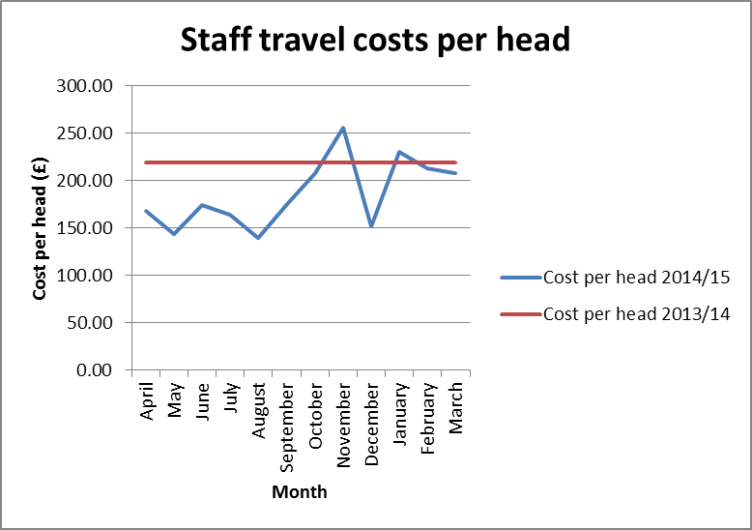

The holiday period and the cancellation of a small number of REC meetings will have contributed to the reduction in monthly costs per head along with the likely low levels of travel associated with new starters. The travel costs associated with the very successful all staff day during November explains the November peak. However the graph does highlight the success and focus on travel costs so far with staff and line managers working hard to ensure costs are minimised wherever possible, for example use of telephone or video conference calls, tickets booked in advance and on timed trains. There has also been helpful feedback at staff inductions.

**7. Staff numbers**

Pay represents 61% of the costs incurred in year, the profile of our staff headcount is presented below for information. The slight increase in numbers represents the commencement of contracts relating to Phase 1 to Phase 3 of the recruitment outlined in the business case. The graph also shows we are still some way off the expected complete headcount of circa 220 (financial plan) and visually helps to partially explain the forecast under spend.

**Chart to show actual staff headcount 2014/15**

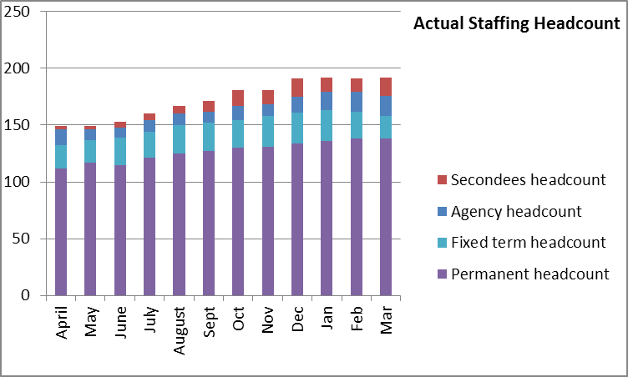

**8. Month end faster close**

The internal finance team objective to complete the management accounts within 7 days for completion of the statutory accounts by the 23rd April was achieved. The team continues to do well against an NHS Average benchmark of 8 days to close month end accounts. Work continues to be undertaken to ensure all agreed deadlines for completion of the returns and reports for EMT and Board are achieved.

**9. Capital**

The final capital expenditure position is presented below. The underspend has increased by £20k against the forecast underspend reported in February. This movement is due to an element of the expenditure being charged to revenue for maintenance work. The underspend on capital is mainly as a result of the work undertaken by the current IS posts being revenue rather than capital as had been initially anticipated. The planned capital expenditure on Estates did not materialise this financial year due to the later than hoped decision on the Manchester lease exemption case.

**Capital expenditure 214/15**

|  |  |  |  |  |
| --- | --- | --- | --- | --- |
| **Plan initiative** |  | **2014/15 plan** | **2014/15 actual** | **2014/15 to go** |
|  | **£ '000** | **£ '000** | **£ '000** |
| New generation of IRAS |  | 351.00 | 221.68 | 129.32 |
| HARP |  | 143.40 | 113.29 | 30.11 |
| TOPS |  | 7.50 | 0.00 | 7.50 |
| Estates requirements related |  | 40.10 | 0.00 | 40.10 |
| Video conferencing |  | 8.00 | 7.80 | 0.20 |
| **TOTAL** |  | **550.00** | **342.77** | **207.23** |

**10. Balance sheet and cash**

A summarised balance sheet can be found in Appendix B comparing the closing balances in March 2014 with the position at the end of March 2015, the previous month of February 2015.

The cash flow forecast can be found in Appendix B. The final cash position at year end was £3.741m. This is a slight increase on the year end forecast position of £3.549m reported in February, and is linked to the final underspend position. A total of £3.6m cash was intentionally not drawn down as reported in previous months. In order to fulfil the duty to avoid holding excess levels of cash, the HRA will continue to monitor the cash position during 2015/16 to ensure that sufficient cash is held for future needs, but will aim to reduce the cash balances held.

**11. Recommendations**

That the Executive Management Team (EMT) approves the final financial position prior to reporting to the HRA Board and to particularly note the following:

* An increased under spend at year end and requirement to institute further actions to ensure that this is minimised in 2015/16. A budget manager checklist was introduced in 2014/15. This will now be further strengthened with a requirement for all budget managers to evidence their break even forecasts with a plan of spend showing timing and amounts where the likelihood of an underspend is being flagged by finance.
* The maintained Better Payments Practice Code position to meet the 95% target based on number of invoices and the value, and the requirement to review invoices in the workflow on a daily basis, put invoices on hold if under dispute or set up a substitute.
* The final cash position of £3.741m.
* The final capital position.

**Debbie Corrigan**

**Director of Finance**

**27 April 2015**

**Health Research Authority – Financial position as at 31 March 2015 Appendix A**

|  |  |
| --- | --- |
| **FINANCIAL RESULTS**  **HEADLINES** | * HRA is reporting an expenditure budget underspend of £3.09m at the end of March (£3.101m against grant in aid) * 77.5% (£10.67million) of the annual budget has been spent. * The largest variance at month 12 (March) is the under spend within the Operations and Approval directorate cost centres. This relates to under spends within HRA Office Jarrow of £14k, HRA Office Manchester of £106k, HRA Office Bristol £32k and an under spend of £62k in Regional Manager North and South and HRA Office London of £25kand an overspend in HRA Office Nottingham of £31k * The under spend within HRA Office Jarrow relates to £7k staff costs net of recharge income, £4k on Stationery and Storage and £3k on Chairs Allowance. Meeting rooms and Chairs Allowance will be budgeted on an actual basis for 2015/16 so should reduce the potential for underspends in these areas in the future. * The under spend within the HRA Office Manchester is in relation to £95k of staff costs. The Office is currently under staffed. Recruitment is currently being undertaken and the new starters should commence in the near future, but it is planned for current staff to work additional hours to ensure delivery of the service remains effective. There are also under spends within the HRA Office Manchester in relation to stationery £14k, postage £6k and contract photocopiers £3k and a small underspend within Chairs Allowance £3kThese are offset by overspends in Meeting expenses of £4k and Service Charge £14k. * The under spend within the Regional Manager North (£47k) relates to the acting up of a Regional Manager into the NRES Manager post (who is currently seconded to C & D) and currently the Regional Manager post has not been back filled. The underspend within the Regional Manager South post (£15k) is as a result of the changed staff configuration in the HRA Office London – and forms part of the plans for the skill mix going forward. * The underspend of £32k within the HRA Office Bristol is mostly in relation to staff costs – within the underspend transferring from the HRA Office London. There is also an underspend within Chairs Allowances (£12k) which is offset by overspends of £6k within Service charge due to a late hosting charge and £16k overspend within Travel and Meeting Room expense of £4k. * The Better Payment Practice Code (BPPC) compliance for April to March maintained the performance level of 2013/14 of 98% for the number of invoices paid, and in March maintaining 97% for value of invoices paid. The HRA is aiming to pay 50% of invoices within 10 days in 2014/15, with this target rising to 60% in 2015/16 – current performance shows 57% on the number of invoices (57% in February) and 62% based on invoice values (61% in February). All approvers are asked to note this and to approve invoices promptly or place on hold if there is a dispute. Performance is published on our website. * Balance sheet highlights – Net Assets and Taxpayers Equity are positive at £3.466million. Cash balance has reduced from year end £3.8 million (with liabilities to pay of £1.5million) to £3.7 million (with liabilities to pay of £1.4 million) due to intentional lack of drawdown of cash so far this year. * Cash flow statement is based on the actual year end position and reflects the reduction of £3.6m in drawdown in March. |

**Health Research Authority – Non Pay Expenditure Year to end March 2015 Appendix B**

|  |  |  |  |  |  |  |  |  |  |  |  |  |  |  |  |  |  |  |  |  |  |  |  |  |  |  |  |  |  |  |  |  |  |  |  |  |  |  |  |  |  |  |  |  |  |  |  |  |  |  |  |  |  |  |  |  |  |  |  |  |  |  |  |  |  |  |  |  |  |  |  |  |  |  |  |  |  |  |  |  |  |  |  |  |  |  |  |  |  |  |  |  |  |  |  |  |  |  |  |  |  |  |  |  |  |  |  |  |  |  |  |  |  |  |  |  |  |  |  |  |
| --- | --- | --- | --- | --- | --- | --- | --- | --- | --- | --- | --- | --- | --- | --- | --- | --- | --- | --- | --- | --- | --- | --- | --- | --- | --- | --- | --- | --- | --- | --- | --- | --- | --- | --- | --- | --- | --- | --- | --- | --- | --- | --- | --- | --- | --- | --- | --- | --- | --- | --- | --- | --- | --- | --- | --- | --- | --- | --- | --- | --- | --- | --- | --- | --- | --- | --- | --- | --- | --- | --- | --- | --- | --- | --- | --- | --- | --- | --- | --- | --- | --- | --- | --- | --- | --- | --- | --- | --- | --- | --- | --- | --- | --- | --- | --- | --- | --- | --- | --- | --- | --- | --- | --- | --- | --- | --- | --- | --- | --- | --- | --- | --- | --- | --- | --- | --- | --- | --- | --- | --- |
| **Areas of Non- Pay Expenditure** | |  |  |  |  |  |  |  | | --- | --- | --- | --- | --- | --- | --- | | **Subjective** | | **Annual** | **Next year** | **Year to date (£)** | | | | **Code** | **Name** | **budget (£)** | **plan (£)** | **Budget** | **Actual** | **Variance** | | **1 Meeting Rooms/Catering** | | 233,895 | 223,445 | 233,895 | 218,310 | (15,584) | | **2 Office equipment/Stationery/Furniture/Consumable** | | 131,166 | 78,382 | 131,166 | 133,478 | 2,312 | | **3 Photocopying/Printing/Postage/Storage/Waste** | | 186,202 | 181,152 | 186,202 | 179,898 | (6,304) | | **4 Premises - inc premise removal costs** | | 811,628 | 795,139 | 811,628 | 834,952 | 23,324 | | **5 Training Expenses - expenses/materials , conferences, workshops** | | 199,497 | 68,956 | 199,497 | 204,163 | 4,666 | | **7 Other Staff costs - Recruitment/adverts/redundancy/PILON** | | 68,182 | 6,000 | 68,182 | 67,166 | (1,016) | | **8 Travel costs - include excess mileage/interview expenses** | | 553,468 | 535,714 | 553,468 | 621,720 | 68,251 | | **9 Chairs/Members/Participation - activity costs** | | 361,028 | 321,028 | 361,028 | 344,312 | (16,716) | | **10 Publications** | | 4,800 | 4,800 | 4,800 | 2,134 | (2,666) | | **11 Mobile Phones/Mobile Data** | | 25,808 | 25,103 | 25,808 | 19,201 | (6,607) | | **12 Statutory Costs - health & Safety/Audit Fees/Depreciation & Amort** | | 264,710 | 258,070 | 264,710 | 261,602 | (3,108) | | **13 Computer Costs - software/licences/system maintenance/purchases** | | 133,500 | 61,707 | 133,500 | 209,094 | 75,594 | | **14 Other External Contracts - SLA's - Premises, SBS,BSA, DH IT** | | 1,138,790 | 851,296 | 1,138,790 | 1,048,987 | (89,803) | | **15 Other - Misc/Reserves** | | 2,884,042 | 2,657,356 | 2,884,042 | (26,830) | (2,910,872) | | **Grand Total** | | 6,996,716 | 6,068,148 | 6,996,716 | 4,118,187 | (2,878,529) | |

**HRA Better Payment Practice Code for the period 1 April to 31 March 2015**

|  |  |  |  |  |
| --- | --- | --- | --- | --- |
|  | Number | % | Value (£) | % |
| 0-5 | 225 | 6% | 1,143,656 | 24% |
| 6-10 Days | 2072 | 52% | 1,821,255 | 38% |
| 11-20 Days | 1586 | 39% | 1,630,815 | 34% |
| 21-30 Days | 64 | 2% | 54,766 | 1% |
| Over 30 Days | 72 | 2% | 127,073 | 3% |
| Total | 4,019 | 100% | 4,777,565 | 100% |
|  |  |  |  |  |
| **BPPC achieved** | 98% | 98% | 97% | 97% |

**Aged Creditors at 31 March 2015**

**Headlines – clock start date is the invoice date (regardless of when the invoice is received in the system) – there are no issues of concern.**

|  |  |  |  |
| --- | --- | --- | --- |
|  | **Aged Creditors – (£) amounts past due date** | | |
|  | **1-30 days** | **31-60 days** | **60 + days** |
| **Non NHS Trade** | 3,455.92 | 1,107.94 | 315.70 |
| **Non NHS Other** | 310.70 | 337.80 | (187.90) |
| **NHS** | 22,260.04 | 0.00 | (1,958.98) |
|  |  |  |  |
| **Total** | 26,026.66 | 1,445.74 | (1,831.18) |

**HRA Revenue position for the period ended 31 March 2015**

|  |  |  |  |  |  |  |  |  |  |  |  |  |  |
| --- | --- | --- | --- | --- | --- | --- | --- | --- | --- | --- | --- | --- | --- |
| **Period (£'000)** | | |  | **Department** |  | **Year to date (£'000)** | | |  | **Full year (£'000)** | | | |
| **Budget** | **Actual** | **Variance** |  | **Income** |  | **Budget** | **Actual** | **Variance** |  | **2013/14 actual** | **Initial budget** | **Latest Budget** | **Forecast** |
| 72 | 72 | 0 |  | HRA income |  | 313 | 327 | 14 |  | -258 | -240 | -313 | -240 |
| 4075 | 1431 | -2644 |  | Grant in Aid |  | 13444 | 10343 | -3101 |  | -8,523 | -13,444 | -13,444 | -13,444 |
| **4,147** | **1,503** | **-2,644** |  | **Total Income** |  | **13,757** | **10,670** | **-3,087** |  | **-8,781** | **-13,684** | **-13,757** | **-13,684** |
|  |  |  |  |  |  |  |  |  |  |  |  |  |  |
| **Budget** | **Actual** | **Variance** |  | **Expenditure** |  | **Budget** | **Actual** | **Variance** |  | **2012/13 actual** | **Initial budget** | **Latest Budget** | **Forecast** |
| 400 | 476 | 76 |  | Operations and Approval |  | 4,625 | 4,429 | -196 |  | 4,337 | 4,527 | 4,625 | 4,418 |
| 180 | 246 | 66 |  | Chief Executive inc. Corp Sec |  | 1,724 | 1,768 | 44 |  | 1,574 | 1,650 | 1,724 | 1,694 |
| 238 | 304 | 66 |  | Corporate Services |  | 1,951 | 1,984 | 33 |  | 1,369 | 1,986 | 1,951 | 1,984 |
| 2,999 | 125 | -2,874 |  | Finance |  | 3,564 | 639 | -2,925 |  | 445 | 5,172 | 3,564 | 639 |
| 330 | 352 | 22 |  | Systems and Development |  | 1,893 | 1,850 | -43 |  | 807 | 0 | 1,893 | 1,848 |
| 0 | 0 | 0 |  | Communications |  | 0 | 0 | 0 |  | 249 | 349 | 0 | 0 |
| **4,147** | **1,503** | **-2,644** |  | **Total Expenditure** |  | **13,757** | **10,670** | **-3,087** |  | **8,781** | **13,684** | **13,757** | **10,583** |
|  |  |  |  |  |  |  |  |  |  |  |  |  |  |
| **0** | **0** | **0** |  | **Surplus (Deficit)** |  | **0** | **0** | **0** |  | **0** | **0** | **0** | **-3,101** |

**HRA Balance Sheet as at 31 March 2015**

|  |  |  |  |  |  |  |
| --- | --- | --- | --- | --- | --- | --- |
|  | **Mar-14** |  | **Feb-15** |  | **Mar-15** |  |
|  | **£k** |  | **£k** |  | **£k** |  |
| **Fixed assets** | 711 |  | 923 |  | 892 |  |
|  |  |  |  |  |  |  |
| **Current assets** |  |  |  |  |  |  |
| Trade and other receivables | 183 |  | 158 |  | 203 |  |
| Cash and cash equivalents | 3,819 |  | 2,568 |  | 3,741 |  |
|  | **4,002** |  | **2,726** |  | **3,944** |  |
| **Less** |  |  |  |  |  |  |
|  |  |  |  |  |  |  |
| **Current Liabilities** |  |  |  |  |  |  |
| Trade and other payables | 1,289 |  | 1,396 |  | 1,370 |  |
| Provisions for liabilities and charges |  |  |  |  |  |  |
| Other liabilities | 8 |  |  |  |  |  |
|  | **1,297** |  | **1,396** |  | **1,370** |  |
|  |  |  |  |  |  |  |
| **Net Current Assets/(Liabilities)** | **2,705** |  | **1,331** |  | **2,574** |  |
|  |  |  |  |  |  |  |
|  | **3,416** |  | **2,254** |  | **3,466** |  |
| **Net Assets/(Liabilities)** |  |  |  |
|  |  |  |  |  |  |  |
| **Represented by:-** |  |  |  |  |  |  |
| **Tax payers Equity** |  |  |  |  |  |  |
| Department of Health Funding General Fund | 3,416 |  | 2,254 |  | 3,466 |  |
|  |  |  |  |  |  |  |
| **Total Taxpayers' Equity** | **3,416** |  | **2,254** |  | **3,466** |  |

**Cash Flow Forecast as at 31 March for 2014/15**

Actuals for April to March 2015



Notes and Assumptions

1. April to March are cash actuals
2. Includes the return of cash of £1m relating to the 2012/13 underspend.
3. Includes the return of cash of £2.6m relating to £1m relating to underspend in 2013/14 and £1.6m relating to underspend in 2014/15
4. Tax/NI and pensions for March 2015 were paid in March 2015