

|  |  |
| --- | --- |
| **Agenda item:** | **12** |
| **Attachment:** | **E** |

**HRA BOARD COVER SHEET**

|  |  |
| --- | --- |
| **Date of Meeting:** | 15 April 2015 |

|  |  |
| --- | --- |
| **Title of Paper:** | Financial report as at 28 February 2015 for financial year 2014/15 |
| **Purpose of Paper:** | To report on the financial position of the Authority for the month ended February 2015 |
| **Reason for Submission:** | To ensure the EMT and the Board are aware of the financial position of the HRA. |
| **Lead Reviewer:** | Tom Smith, Director of Quality, Standards & Information |
| **Details:** | This paper presents the financial position as at the end of February 2015.  In summary, a planned under spend has been forecast from early on in the financial year. The extent of the forecast underspend has grown during the year for the reasons previously reported. There has been a further slight increase in the forecast under spend in February which should be noted as a matter of importance for the Board in terms of the overall position and potential reputational impacts. The Board is asked to approve the report.  Main points to note   * Year to date under spend of £457k (£309k in January – swing of £148k). Main reasons for in month swing are due to release of budget for IT costs for which an overspend had been reported previously. Training budget forecast had been a break even, however a further £13k under spend is reporting, plus materialization of increased under spends in operations and approval across areas previously forecast to break even. * The forecast under spend has increased slightly to that reported in January of £2.17milliont to £2.98 million to £2.35million to £3.01million. * Main reason for forecast under spend swing in month is that the risk (highlighted in January) of a further £130k under spend within Operations & Approval has now been incorporated into the forecast outturn. Additionally, costs related to the Social Care REC will no longer be incurred in this financial year remaining as a recharge direct to the Department of Health until April. * Main reason for the previously reported forecast under spend is the time it has taken and is taking to recruit successful candidates to HRA Approval posts. The expectation now is that 36% (rather than 61%) of the 87.5 WTE will have been fully recruited to by March. This alongside the significant reduction in linked pay and non pay related costs is the main reason forecast under spend, together with changes to plans for desired early transfer of posts to support HRA Approval and systems transition and the non deployment of contingencies. * Continued need for approvers to review their invoice workflow on a daily basis. * Decrease in cash surplus as a result of intentionally not drawing down an additional £2.6 million as reported in previous months. * A forecast underspend on capital expenditure in the range of £160k - £180k following assessment of work being undertaken by current IS posts. |
| **Suitable for wider circulation?** | **After approval.** |
| **Time required for item:** | **15 minutes** |

|  |  |  |  |
| --- | --- | --- | --- |
| **Recommendation / Proposed Actions:** | **To Approve** | | **Yes** |
| **To Note** | |  |
| **For discussion** | |  |
| **Comments** |  | |

|  |  |
| --- | --- |
| **Name:** | Debbie Corrigan |
| **Job Title:** | Director of Finance |
| **Date:** | 10 March 2015 |

**Finance Report - Financial Year 2014/15**

**Health Research Authority as at 28 February 2015**

1. **Introduction**

This report outlines the financial position of the Authority in respect of revenue and capital expenditure for the month ended 28 February 2015 and the expected full year 2014/15.

**2. Revenue Resource Limit**

The HRA indicative grant in aid/ opening revenue resource limit for 2014/15 was agreed at £13.444m. The whole of this sum has been classified as administration funding under HM Treasury definitions and this sum represents HRA annual statutory funding from the Department of Health (DH) for the year. This sum excludes income from other government departments or income from the devolved administrations, the planning assumptions for which amount to a sum of £240k.

The HRA Board approved the Financial Plan for 2014/15 in July 2014. The initial declared under spend of £1.57 million, has grown over the course of the year. In January the forecast remained similar to December with the range was expected to be £2.17million to £2.98million. The range has moved slightly upward at the end of February to £2.35million to £3.01million. The main reason for the forecast under spend is due to re-profiled recruitment in relation to the HRA Approval business case, vacancies that have arisen within the Operations and Approval directorate and resulting time taken to recruit, unlikely but possible claw back of VAT reclaims in previous years for agency workers and the now unlikely utilisation of contingencies. It has also been clarified over the course of the last month that expected costs, associated with the Social Care Research Ethics Committee will no longer be incurred in this financial year.

**3. Revenue Position at 28 February 2015**

The revenue position of the Authority is summarised in the table on the next page with further performance detail in Appendix A.

The Authority has spent £9.17million (£8.27m end January) year to date and under spent against profiled budgets by £457k (£309k end January). The rate of monthly spend and overall trend is shown in the graph below.

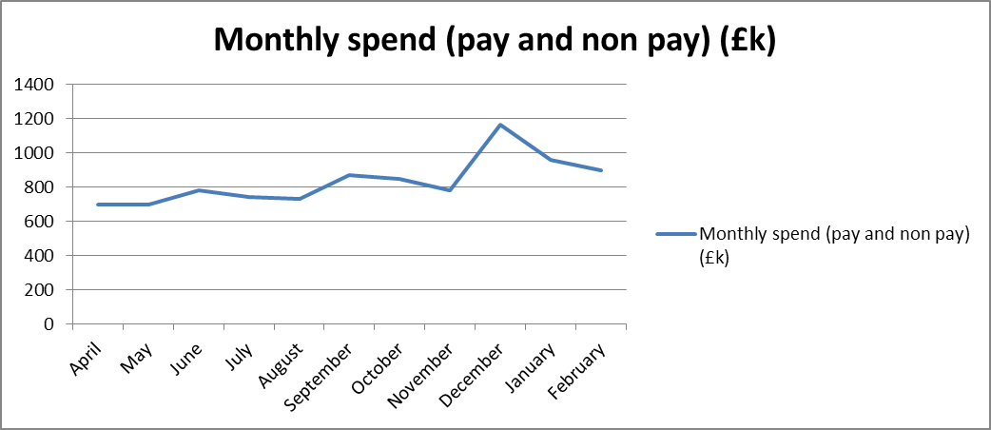

A summary of the position is presented below.

|  |  |  |  |  |  |
| --- | --- | --- | --- | --- | --- |
| **Summary of financial outturn 28 February 2015** | | |  |  |  |
|  |  |  |  |  |  |
|  | **Description** | **Initial Annual Budget** | **Budget for period to** | **Outturn as at** | **Variance** |
|  | **28 February 2015** | **28 February 2015** |
|  |  | **(£'000)** | **(£'000)** | **(£'000)** | **(£'000)** |
| **Income** | |  |  |  |  |
|  | HRA income | 240 | 240 | 254 | 14 |
|  | Grant in aid | 13444 | 9369 | 8912 | -457 |
|  | **Total** | **13684** | **9609** | **9166** | **-443** |
| **Expenditure** | |  |  |  |  |
|  | Operations and Approval | 4,527 | 4,225 | 3,953 | -272 |
|  | Chief Exec - Team, Board and Corporate Secretary | 1,650 | 1,544 | 1,521 | -23 |
|  | Corporate Services | 1,986 | 1,712 | 1,681 | -31 |
|  | Finance Estates and Procurement (incl Reserves) | 5,172 | 565 | 514 | -51 |
|  | Systems and Development | 0 | 1,563 | 1,497 | -66 |
|  | Communications | 349 | 0 | 0 | 0 |
|  | **Total** | **13,684** | **9,609** | **9,166** | **-443** |
|  |  |  |  |  |  |
| **Surplus/Deficit** | | **0** | **0** | **0** | **0** |

The main points to note in the outturn expenditure position as at 28 February 2015 of £9.17m are:

1. 59% of *direct* costs are being deployed towards our stated ambitions and strategic objectives. 43% towards our key purpose of protecting the interests of patients and the public in health research through ethical review. A further 16% of direct costs are being deployed to creating a streamlined and efficient framework for the approval and management of research.
2. Total pay costs incurred to date are £5.82m (£5.79m net of income from a secondment recharge of £11k and the annual leave accrual adjustment at end of December of (£20k)). Considerable work has been deployed in to the recruitment phases supporting HRA Approval. Phase 2 and phase 3 recruitment has completed and the profile of starters is set out below along with high level plans for phases 4 to 6.

|  |  |  |  |  |  |  |  |
| --- | --- | --- | --- | --- | --- | --- | --- |
|  | **Phase 1** | **Phase 2** | **Phase 3** | **Phase 4** | **Phase 4 & 5** | **Phase 6** | Total |
|  | In Post July-Sept | In Post Oct | In post Nov - Dec | In Post by Mar | Early 2015/16 | Mid 2015 |  |
| **Headcount** | 15 | 12 | 12 | 3 | 42 | 20 | 104 |
| **WTE's** | 13 | 6.9 | 9.8 | 1.8 | 36 | 20 | 87.5 |
| **% WTEs inpost** | 15% | 8% | 11% | 2% | 41% | 23% |  |

1. The allocation of budgets linked to the business case requirement continues to be finalised. Phase 1 to Phase 3 posts have been allocated and profiled and appointed posts have been transferred from reserves during September to January. £1.916m has been allocated from the business case reserve with £2.59m of the budget therefore still remaining as expected at the beginning of the financial year. £0.7m of the £2.59m remains earmarked however only a further £200k is expected to be allocated from Reserves in March.
2. The business as usual reserve has a balance of £430k, of which there are earmarked reserves of £409k. There has been a movement of £22k in month due to a £6k allocation for additional approved costs along with a movement between the business as usual reserves and HRA Approval reserves for estates strategy related costs.
3. A disciplined approach continues to be required to focus on business as usual and delivery in the final few weeks of the financial year to avoid an even larger under spend at year end.
4. After 11 months, a total of 67% of the total expenditure budget has been spent within the year so far, with staff costs amounting to £5.82m.
5. The underspends within Operations and Approval largely relate to underspends within HRA Office Jarrow (£29k including income of £11k), HRA Office Manchester (£131k), HRA Office Bristol (£47k) and the Regional Manager North and South (£60k) and the HRA Office London of (£29k).

During October the Operations establishment was re-organised to reflect the movement of REC’s from the beginning of the year. This has moved the under spend from within the HRA Office London to the offices that took on additional REC’s. The main causes of the underspends are:

* 1. Recurrent savings of high cost area allowance as a result of moving posts from London (this was highlighted on the KPI report for October – circa £23k)
  2. Recurrent savings as a result of the full year effect of reducing the number of RECs by 1. (circa £33k) Both of these savings will help fund pay awards and pension cost increases in 2015/16.
  3. Non recurrent savings as a result of the decision to largely use internal cover rather than agency staff to cover vacant posts. This decision was directly linked to the poor quality of staff offered through the agency staff contract. Performance of the affected centres has dipped slightly and remaining staff are working at full capacity.
  4. Non recurrent saving as a result of carrying a senior vacant post. Due to problems experienced in the past through the use of senior temps the decision was taken to cover internally to mitigate similar risks. The under spend within the Regional Manager North relates to the acting up of a Regional Manager into the NRES Manager posts whose post has not been backfilled currently. The under spend within the Regional Manager South is as a result of the changed configuration of the HRA Office London and cover arrangements. Recruitment plans are now being progressed.

Further explanations are offered below:

* + - The under spend within the HRA Office Jarrow relates mainly to staff recharge income (£11k) and (£6k) on meeting expenses, (£4.5k) on Stationery and Storage and (£3k) on Chairs allowances.
    - The HRA Office Manchester underspend of £131k is in relation to staff costs £100k – this increase is largely due to the budget transferred from the HRA Office London for the pay for transferred REC’s. The recruitment to HRA Office Manchester continues to be undertaken. There is a plan for additional hours to be worked by some of the current staff in order to continue to meet set deadlines and these will be charged to the staff underspend. There is an underspend within stationery £14k, a £5k underspend in postage and an underspend within minor works of £4k and a small underspend within Chairs Allowance of £3k and a £4k underspend in meeting expenses.
    - The underspend of £47k within the HRA Office Bristol is mostly in relation to staff costs £49k and these have arisen due to the pay budgets transferred to reflect the REC committees transferred to Bristol from London. There is an £11k underspend within the Chairs Allowance this is recognised in the forecast outturn. These underspends are offset by an over spend in service charge of £6k relating to a late charge from former host and an £8k overspend within travel costs.
    - The underspend with the HRA Office London of £29k is mostly in relation to staff underspends of £35k, which are offset by overspends on removal expenses and a non-recurrent computer software charge.
    - The Chairs under spends in the larger centres have been investigated and are due to the budget being based on Chairs Allowance plus on-costs – at a rate we would be recharged from an external host. The majority of Chairs are now on payroll and the on-costs are significantly lower than budgeted. For 2015/16 we will be budgeting based on actual process for each Chair so the under spend should be eliminated and produce a small saving back to reserves.

1. Within the Corporate Services directorate the budgets for Training for staff and members is underspent (£58k). The budgets for this area have been re-profiled and the current underspend is expected to be allocated in year resulting in a forecast break even position. This position was reconfirmed at the most recent budget management meeting, however finance considers that there is a risk that an under spend will result. The overspends within Corporate Services relate to Head Office Costs (£9k) in relation to staff costs and the non pay overspends relate to the Nottingham Office Project £22k.
2. Within the Systems and Development Directorate there is an under spend of £66k. The underspend relates to Research Information systems requiring less penetration testing than originally budgeted and potentially reduced costs relating to new system platforms (£56k). There is also an under spend in relation to agency staff within the directorate (£10k).
3. Expenditure year to date is below that expected at the time the Financial Plan was presented. A comparison of the expected profiled forecast against the actual year to date expenditure can be seen in the graph below. The main reasons are the timing of recruitment to vacancies and the phasing of new HRA Approval starters being later than the original plan. This delay has also impacted on the profile of the pay related non-pay spend that was included in the Financial Plan in areas of Training, Shared service costs (payroll, IT, HR), telephone handsets, travel and mobile phone costs,etc. These areas are all sensitive to the numbers in the establishment. There is also an underspend against meeting room costs across the organisation of £46k .

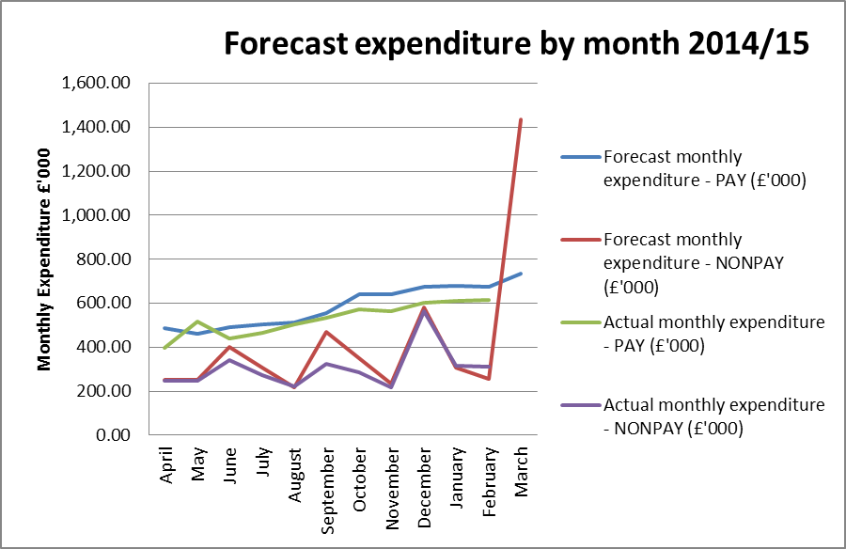

**4. Forecast outturn 2014/15**

The year to date position continues to be reviewed and investigated at regular budget management meetings. Early forecasts were presented in the Financial Plan for 2014/15 and pointed to an underspend at a level of around £1.57million, largely as a result of the welcome but late decision on the HRA Approval business case and the expected time it would take to recruit to posts.

The latest review of the likely position is pointing to a forecast range of £2.35m to £3.01m and this has now been reflected in the cash flow. These forecasts are a result of intelligence provided by HRA budget managers in meetings with their finance lead, and a review of reserves. The main reason for the movement in the forecast under spend is due to the vacancies that have arisen within the Operations and Approval directorate and resulting recruitment, alongside taking longer to recruit to project posts than planned and the expected Social Care REC costs no longer being charged.

The difference in the expected range relates to the likely outcome of negotiations across the Department of Health bodies with HMRC with regards to the claw back of VAT reclaims in previous years for agency workers, alongside the likelihood of contingencies not being deployed and reprofiled recruitment in relation to the business case.

**5. Better payments performance**

Better payment performance has met the duty to pay 95% of invoices in 30 days achieving 98% based on number of invoices, and achieved the target based on value by achieving 97%. HRA has also met the 2014/15 target of paying 50% within 10 days. Currently the performance for payments made within 10 days is 57% (number of invoices), and 61% based on value and additional actions are underway to further improve performance.

**6. Travel costs**

Travel is an area which is being intentionally monitored and managed with a view to a reduction in costs per head (given that costs are likely to increase overall as a result of more posts with a requirement for travel). The table below sets out the total travel costs position (staff, members inclusive) at the end of February and reflects an over spend of £22.3k (overspend of £11.2k end January). A further focus on ways of working and resulting impact on travel costs is in hand to try to drive down costs in this area further.

The Systems and Development directorate is a new area and the budget for travel is to be re-assessed and the budget amended accordingly during budget setting for 2015/16. There is additional travel relating to the Talent and Leadership Programmes implemented within year which will have impacted on overall costs.



Year to date staff travel costs for 2014/15 compared with the average cost in 2013/14 have been analysed and are presented in the graph below.

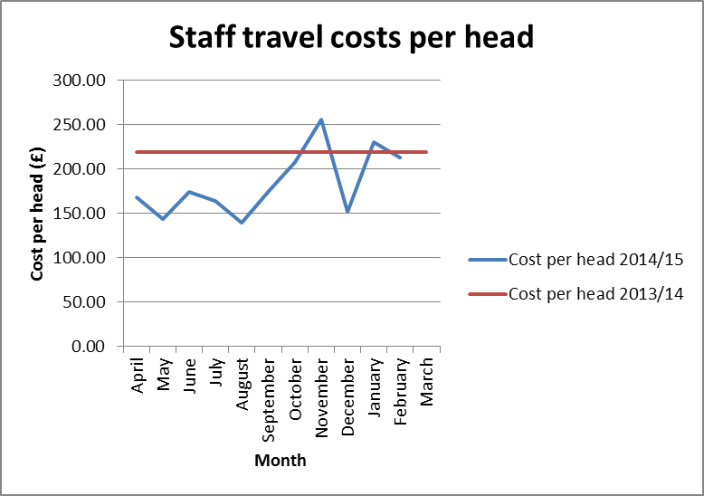

The holiday period and the cancellation of a small number of REC meetings will have contributed to the reduction in monthly costs per head along with the likely low levels of travel associated with new starters. The travel costs associated with the very successful all staff day during November explains the November peak. However the graph does highlight the success and focus on travel costs so far with staff and line managers working hard to ensure costs are minimised wherever possible. There has also been helpful feedback at staff inductions.

**7. Staff numbers**

Pay represents 63% of the costs incurred in year, the profile of our staff headcount is presented below for information. The slight increase in numbers represents the commencement of contracts relating to Phase 1 to Phase 3 of the recruitment outlined in the business case. The graph also shows we are still some way off the expected complete headcount of circa 220 (financial plan) and visually helps to partially explain the forecast under spend.

**Chart to show actual staff headcount 2014/15**

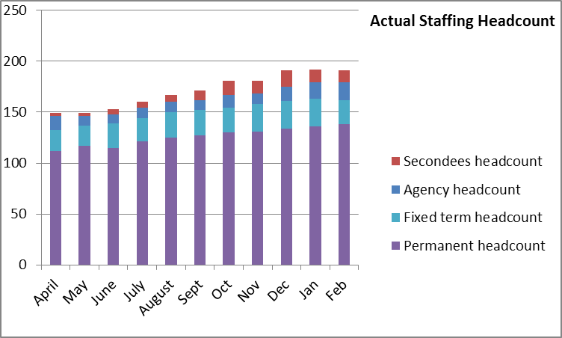

**8. Month end faster close**

The internal finance team objective to complete the month end to a target of 4 days was achieved for February. The team continues to do well against an NHS Average benchmark of 8 days to close month end accounts. Work continues to be undertaken to ensure all agreed deadlines for completion of the returns and reports for EMT and Board are achieved.

**9. Capital**

The current capital expenditure position is presented below. It is now very unlikely that we will break even on capital, and the current forecast is an underspend in the range of £160k to £180k, dependant on the work undertaken on the HARP and IRAS systems in March. It is likely that the under spend will be at the higher end of the range. This underspend is mainly as a result of the work undertaken by the current IS posts being revenue rather than capital as had been initially anticipated. The planned capital expenditure on Estates, is also not expected to materialise this financial year due to the later than hoped decision on the Manchester lease exemption case.

|  |  |  |  |  |
| --- | --- | --- | --- | --- |
| **Plan initiative** |  | **2014/15 plan** | **2014/15 actual** | **2014/15 to go** |
|  | **£ '000** | **£ '000** | **£ '000** |
| New generation of IRAS |  | 351.00 | 208.20 | 142.80 |
| HARP |  | 143.40 | 112.70 | 30.70 |
| TOPS |  | 7.50 | 0.00 | 7.50 |
| Estates requirements related |  | 40.10 | 0.00 | 40.10 |
| Video conferencing |  | 8.00 | 7.80 | 0.20 |
| **TOTAL** |  | **550.00** | **328.70** | **221.30** |

**10. Balance sheet and cash**

A summarised balance sheet can be found in Appendix B comparing the closing balances in March 2014 with the position at the end of February 2015, the previous month of January 2015, and a forecast year end position.

The cash flow forecast can be found in Appendix B. The potential surplus of cash at year end has decreased from £5.3m to £3.5m. This is mainly due to intentionally not drawing down an additional £2.6m of cash in March, in addition to the agreed £1m related to the inherent 12/13 underspend, as reported in previous months. The cash surplus could increase further still, if invoices are not received, approved and paid by the 31st March 2015.

**11. Recommendations**

That the Executive Management Team (EMT) approves the final financial position prior to reporting to the HRA Board and to particularly note the following:

* An increasing under spend year to date and requirement to institute further actions to ensure that this minimised in 2015/16. A budget manager checklist was introduced in 2014/15. This should now be further strengthened with a requirement for all budget managers to evidence their break even forecasts with a plan of spend showing timing and amounts where the likelihood of an underspend is being flagged by finance.
* Slightly increased forecast under spend of £0.03m and the reasons as well as possible range of under spend
* **Importance of remaining focussed on business as usual** to avoid an even larger under spend at year end
* Requirement to ensure that monthly budget manager meetings are undertaken with your finance lead.
* The maintained Better Payments Practice Code position to meet the 95% target based on number of invoices and the value, and the requirement to review invoices in the workflow on a daily basis, put invoices on hold if under dispute or set up a substitute.
* The reduction in the cash drawn down in March of £2.6million in addition to the agreed £1million which related to inherent 12/13 under spend.
* The forecast underspend on capital.

**Debbie Corrigan**

**Director of Finance**

**10 March 2015**

**Health Research Authority – Financial position as at 28 February2015 Appendix A**

|  |  |
| --- | --- |
| **FINANCIAL RESULTS**  **HEADLINES** | * HRA is reporting an underspend of £457k at the end of February. * 67% (£9.17million) of the annual budget has been spent. * The largest variance at month 11 (February) is the underspend within the Operations and Approval directorate cost centres. This relates to under spends within HRA Office Jarrow of £29k, HRA Office Manchester of £131k, HRA Office Bristol £47k and an under spend of £60k in Regional Manager North and South and HRA Office London of £29k. * The under spend within HRA Office Jarrow relates to £11k staff recharge income, £6k underspend on meeting expenses and £4.5k on Stationery and Storage and £3k on Chairs Allowance. Meeting rooms and Chairs Allowance will be budgeted on an actual basis for 2015/16 so should reduce the potential for underspends in these areas in the future. * The under spend within the HRA Office Manchester is in relation to £100k of staff costs. The Office is currently under staffed. Recruitment is currently being undertaken and the new starters should commence in the near future, but it is planned for current staff to work additional hours to ensure delivery of the service remains effective. There are also under spends within the HRA Office Manchester in relation to stationery £14k, postage £5k and minor works £4k and a small underspend within Chairs Allowance £4k and an underspend in Meeting expenses of £4k. * The under spend within the Regional Manager North (£44k) relates to the acting up of a Regional Manager into the NRES Manager post (who is currently seconded to C & D) and currently the Regional Manager post has not been back filled. The underspend within the Regional Manager South post (£16k) is as a result of the changed staff configuration in the HRA Office London – and forms part of the plans for the skill mix going forward. * The underspend of £47k within the HRA Office Bristol is mostly in relation to staff costs – within the underspend transferring from the HRA Office London. There is also an underspend within Chairs Allowances (£11k) which is offset by overspends of £6k within Service charge due to a late hosting charge and £8k overspend within Travel. * HRA is reporting a forecast underspend on capital in the range of £160k to £180k. * The Better Payment Practice Code (BPPC) compliance for April to February maintained the performance level of 2013/14 of 98% for the number of invoices paid, and in February maintaining 97% for value of invoices paid. The HRA is aiming to pay 50% of invoices within 10 days in 2014/15, with this target rising to 60% in 2015/16 – current performance shows 57% on the number of invoices (57% in January) and 61% based on invoice values (63% in January). All approvers are asked to note this and to approve invoices promptly or place on hold if there is a dispute. Performance is published on our website. * Balance sheet highlights – Net Assets and Taxpayers Equity are positive at £2.254million. Cash balance has reduced from year end £3.8 million (with liabilities to pay of £1.5million) to £2.6 million (with liabilities to pay of £1.4 million) due to intentional lack of drawdown of cash so far this year. * Cash flow statement has been refined to reflect a further reduction of £2.6m in draw down for March. The cashflow statement assumes spend in March based on trends through the year, and the surplus could increase further if invoices are not received, approved and paid by the 31st March 2015. |

**Health Research Authority – Non Pay Expenditure Year to end February 2015 Appendix B**

|  |  |  |  |  |  |  |  |  |  |  |  |  |  |  |  |  |  |  |  |  |  |  |  |  |  |  |  |  |  |  |  |  |  |  |  |  |  |  |  |  |  |  |  |  |  |  |  |  |  |  |  |  |  |  |  |  |  |  |  |  |  |  |  |  |  |  |  |  |  |  |  |  |  |  |  |  |  |  |  |  |  |  |  |  |  |  |  |  |  |  |  |  |  |  |  |  |  |  |  |  |  |  |  |  |  |  |  |  |  |  |  |  |  |  |  |  |  |  |  |  |  |  |  |  |  |  |  |  |  |  |  |  |  |  |  |  |  |  |  |  |  |  |  |  |  |  |  |  |  |  |  |  |  |  |
| --- | --- | --- | --- | --- | --- | --- | --- | --- | --- | --- | --- | --- | --- | --- | --- | --- | --- | --- | --- | --- | --- | --- | --- | --- | --- | --- | --- | --- | --- | --- | --- | --- | --- | --- | --- | --- | --- | --- | --- | --- | --- | --- | --- | --- | --- | --- | --- | --- | --- | --- | --- | --- | --- | --- | --- | --- | --- | --- | --- | --- | --- | --- | --- | --- | --- | --- | --- | --- | --- | --- | --- | --- | --- | --- | --- | --- | --- | --- | --- | --- | --- | --- | --- | --- | --- | --- | --- | --- | --- | --- | --- | --- | --- | --- | --- | --- | --- | --- | --- | --- | --- | --- | --- | --- | --- | --- | --- | --- | --- | --- | --- | --- | --- | --- | --- | --- | --- | --- | --- | --- | --- | --- | --- | --- | --- | --- | --- | --- | --- | --- | --- | --- | --- | --- | --- | --- | --- | --- | --- | --- | --- | --- | --- | --- | --- | --- | --- | --- | --- | --- | --- | --- | --- | --- |
| **Areas of Non- Pay Expenditure** | |  |  |  |  |  |  |  |  |  | | --- | --- | --- | --- | --- | --- | --- | --- | --- | | **Subjective** | | **Annual** | **In month (£)** | | | **Year to date (£)** | | | | **Code** | **Name** | **budget (£)** | **Budget** | **Actual** | **Variance** | **Budget** | **Actual** | **Variance** | | **1 Meeting Rooms/Catering** | | 233,895 | 33,516 | 30,579 | (2,938) | 210,347 | 164,259 | (46,088) | | **2 Office equipment/Stationery/Furniture/Consumable** | | 131,166 | 11,756 | 9,225 | (2,531) | 124,360 | 117,327 | (7,033) | | **3 Photocopying/Printing/Postage/Storage/Waste** | | 186,202 | 16,579 | 13,444 | (3,135) | 168,681 | 163,455 | (5,226) | | **4 Premises - inc premise removal costs** | | 825,028 | 14,303 | 21,067 | 6,764 | 713,142 | 774,044 | 60,902 | | **5 Training Expenses - expenses/materials , conferences, workshops** | | 199,497 | 9,362 | 2,839 | (6,523) | 173,625 | 147,045 | (26,580) | | **7 Other Staff costs - Recruitment/adverts/redundancy/PILON** | | 68,182 | 0 | 504 | 504 | 62,182 | 67,167 | 4,985 | | **8 Travel costs - include excess mileage/interview expenses** | | 540,008 | 58,058 | 69,552 | 11,495 | 493,785 | 518,052 | 24,268 | | **9 Chairs/Members/Participation - activity costs** | | 307,628 | 26,832 | 22,144 | (4,688) | 280,762 | 241,065 | (39,697) | | **10 Publications** | | 4,800 | 399 | 222 | (177) | 4,390 | 2,134 | (2,256) | | **11 Mobile Phones/Mobile Data** | | 25,796 | 2,122 | 365 | (1,757) | 23,553 | 17,939 | (5,614) | | **12 Statutory Costs - health & Safety/Audit Fees/Depreciation & Amort** | | 264,710 | 38,809 | 43,683 | 4,874 | 207,274 | 199,748 | (7,526) | | **13 Computer Costs - software/licences/system maintenance/purchases** | | 128,500 | 3,629 | 7,577 | 3,948 | 117,040 | 130,772 | 13,732 | | **14 Other External Contracts - SLA's - Premises, SBS,BSA, DH IT** | | 1,058,790 | 157,600 | 88,607 | (68,994) | 937,097 | 826,211 | (110,886) | | **15 Other - Misc/Reserves** | | 3,029,918 | 0 | 2,000 | 2,000 | 0 | (26,818) | (26,818) | | **GRAND TOTAL** | | **7,004,120** | **372,965** | **311,808** | **(61,158)** | **3,516,238** | **3,342,400** | **(173,837)** | |

**HRA Better Payment Practice Code for the period 1 April to 28 February 2015**

|  |  |  |  |  |
| --- | --- | --- | --- | --- |
|  | Number | % | Value (£) | % |
| 0-5 | 193 | 5% | 812,337 | 21% |
| 6-10 Days | 1833 | 52% | 1,591,611 | 40% |
| 11-20 Days | 1395 | 39% | 1,368,261 | 35% |
| 21-30 Days | 60 | 2% | 36,138 | 1% |
| Over 30 Days | 68 | 2% | 126,568 | 3% |
| Total | 3,549 | 100% | 3,934,915 | 100% |
|  |  |  |  |  |
| **BPPC achieved** | 98% | 98% | 97% | 97% |

**Aged Creditors at 28 February 2015**

**Headlines – clock start date is the invoice date (regardless of when the invoice is received in the system) – there are no issues of concern.**

|  |  |  |  |
| --- | --- | --- | --- |
|  | **Aged Creditors – (£) amounts past due date** | | |
|  | **1-30 days** | **31-60 days** | **60 + days** |
| **Non NHS Trade** | 1,528.40 | 686.76 | 15.84 |
| **Non NHS Other** | 145.35 | 0.00 | (67.51) |
| **NHS** | 0.00 | (1,928.38) | (30.60) |
|  |  |  |  |
| **Total** | 1,673.75 | (1,241.62) | (82.27) |

**HRA Revenue position for the period ended 28 February 2015**

|  |  |  |  |  |  |  |  |  |  |  |  |  |  |
| --- | --- | --- | --- | --- | --- | --- | --- | --- | --- | --- | --- | --- | --- |
| **Period (£'000)** | | |  | **Department** |  | **Year to date (£'000)** | | |  | **Full year (£'000)** | | | |
| **Budget** | **Actual** | **Variance** |  | **Income** |  | **Budget** | **Actual** | **Variance** |  | **2013/14 actual** | **Initial budget** | **Latest Budget** | **Forecast** |
| 60 | 60 | 0 |  | HRA income |  | 240 | 254 | 14 |  | -258 | -240 | -240 | -240 |
| 983 | 866 | -117 |  | Grant in Aid |  | 9369 | 8912 | -457 |  | -8,523 | -13,444 | -13,444 | -13,444 |
| **1,043** | **926** | **-117** |  | **Total Income** |  | **9,609** | **9,166** | **-443** |  | **-8,781** | **-13,684** | **-13,684** | **-13,684** |
|  |  |  |  |  |  |  |  |  |  |  |  |  |  |
| **Budget** | **Actual** | **Variance** |  | **Expenditure** |  | **Budget** | **Actual** | **Variance** |  | **2012/13 actual** | **Initial budget** | **Latest Budget** | **Forecast** |
| 362 | 337 | -25 |  | Operations and Approval |  | 4,225 | 3,953 | -272 |  | 4,337 | 4,527 | 4,622 | 4,278 |
| 145 | 144 | -1 |  | Chief Executive inc. Corp Sec |  | 1,544 | 1,521 | -23 |  | 1,574 | 1,650 | 1,647 | 1,623 |
| 214 | 172 | -42 |  | Corporate Services |  | 1,712 | 1,681 | -31 |  | 1,369 | 1,986 | 1,955 | 1,961 |
| 96 | 87 | -9 |  | Finance |  | 565 | 514 | -51 |  | 445 | 5,172 | 3,665 | 1,730 |
| 226 | 186 | -40 |  | Systems and Development |  | 1,563 | 1,497 | -66 |  | 807 | 0 | 1,795 | 1,738 |
| 0 | 0 | 0 |  | Communications |  | 0 | 0 | 0 |  | 249 | 349 | 0 | 0 |
| **1,043** | **926** | **-117** |  | **Total Expenditure** |  | **9,609** | **9,166** | **-443** |  | **8,781** | **13,684** | **13,684** | **11,331** |
|  |  |  |  |  |  |  |  |  |  |  |  |  |  |
| **0** | **0** | **0** |  | **Surplus (Deficit)** |  | **0** | **0** | **0** |  | **0** | **0** | **0** | **-2,353** |

**HRA Balance Sheet as at 28 February 2015**

|  |  |  |  |  |  |  |  |
| --- | --- | --- | --- | --- | --- | --- | --- |
|  | **Mar-14** |  | **Jan-15** |  | **Feb-15** |  | **Forecast** |
|  | **£k** |  | **£k** |  | **£k** |  | **£k** |
| **Fixed assets** | 711 |  | 879 |  | 923 |  | 928 |
|  |  |  |  |  |  |  |  |
| **Current assets** |  |  |  |  |  |  |  |
| Trade and other receivables | 183 |  | 115 |  | 158 |  | 80 |
| Cash and cash equivalents | 3,819 |  | 2,219 |  | 2,568 |  | 3,540 |
|  | **4,002** |  | **2,335** |  | **2,726** |  | **3,620** |
| **Less** |  |  |  |  |  |  |  |
|  |  |  |  |  |  |  |  |
| **Current Liabilities** |  |  |  |  |  |  |  |
| Trade and other payables | 1,289 |  | 1,344 |  | 1,396 |  | 2,070 |
| Provisions for liabilities and charges |  |  |  |  |  |  |  |
| Other liabilities | 8 |  |  |  |  |  |  |
|  | **1,297** |  | **1,344** |  | **1,396** |  | **2,070** |
|  |  |  |  |  |  |  |  |
| **Net Current Assets/(Liabilities)** | **2,705** |  | **990** |  | **1,331** |  | **1,551** |
|  |  |  |  |  |  |  |  |
|  | **3,416** |  | **1,869** |  | **2,254** |  | **2,478** |
| **Net Assets/(Liabilities)** |  |  |  |
|  |  |  |  |  |  |  |  |
| **Represented by:-** |  |  |  |  |  |  |  |
| **Tax payers Equity** |  |  |  |  |  |  |  |
| Department of Health Funding General Fund | 3,416 |  | 1,869 |  | 2,254 |  | 2,478 |
|  |  |  |  |  |  |  |  |
| **Total Taxpayers' Equity** | **3,416** |  | **1,869** |  | **2,254** |  | **2,478** |

**Cash Flow Forecast as at 28 February for 2014/15**

Actuals for April to February 2015



Notes and Assumptions

1. April to February are cash actuals
2. Assumes return of cash of £1m relating to the 2012/13 underspend.
3. Assumes return of cash of £2.6m relating to £1m relating to underspend in 2013/14 and £1.6m relating to underspend in 2014/15
4. Assumed that non pay budget for April and May were spent in June and July
5. Assumes that Tax/NI and pensions for March 2015 are paid in March 2015
6. Assume that level of creditors at year end will be approximately £2m
7. Assumes £1.1m of creditors paid in April and May (ie all cash payments are for year end creditors) with a remaining £150k to be paid included within the month 12 payments.
8. Debtors figures relate to Devolved Administrations income