

|  |  |
| --- | --- |
| **Agenda item:** | **10** |
| **Attachment:** | **F** |

**HRA BOARD COVER SHEET**

|  |  |
| --- | --- |
| **Date of Meeting:** | 20 January 2016 Board meeting |

|  |  |
| --- | --- |
| **Title of Paper:** | Financial report - October 2015 |
| **Purpose of Paper:** | To report on the financial position of the Authority for the year to date as at 31st October 2015 |
| **Reason for Submission:** | To ensure the EMT and the Board, are aware of the financial position of the HRA as at the end of October2015 with an early indication of the end of year financial position. |
| **Lead Reviewer:** | Tom Smith, Director of Quality, Guidance and Learning |
| **Details:** | This paper presents the financial position as at the end of October 2015.  Main points to note:   * The HRA is living well within its means. * 50% of the financial plan has been spent after 58% of the financial year has passed. * There is a £256k under spend as at the end of October 2015 (£253k September 2015), largely within the Operations Directorate and mostly due to the number of vacancies that have arisen either because of successful applications for roles linked to HRA Approval or due to the move of Research Ethics Comittees (RECs) between HRA Offices in order to spread the support more equitably. * The under spend is being actively tracked and managed to ensure that business requirements are being met. Recruitment plans have been brought forward and an initial review of requirements relating to Research Information Systems (RIS) posts has been completed and a case to extend contractors made, agreed and actioned. Further work to review longer term requirements in this area is required, and will form part of the RIS strategy discussions. * Early forecasting work points to an underspend position of circa £500k. |
| **Suitable for wider circulation?** | **Yes, following Board** |
| **Time required for item:** | **15 minutes** |

|  |  |  |  |
| --- | --- | --- | --- |
| **Recommendation / Proposed Actions:** | **To Approve** | | **Yes** |
| **To Note** | |  |
| **For discussion** | |  |
| **Comments** |  | |

|  |  |
| --- | --- |
| **Name:** | Debbie Corrigan |
| **Job Title:** | Director of Finance, Procurement and Estates |
| **Date:** | 12 November 2015 |

**Finance Report - Financial Year 2015/16**

**Health Research Authority as at 31 October 2015**

1. **Introduction**

This report outlines the financial position of the Authority in respect of revenue and capital expenditure for the month ended 31 October 2015 and the expected full year 2015/16.

**2. Revenue Resource Limit**

The HRA initial grant in aid/ opening revenue resource limit for 2015/16 has been confirmed as expected at £13,346k. Confirmation on additional funding for CAG2 (second committee for review of applications) of £65k has now been confirmed and an adjustment to grant in aid has been made. The HRA revenue resource limit now stands at £13,410 The whole of this sum is classified as administration funding under HM Treasury definitions and this sum represents HRA annual statutory funding from the Department of Health (DH) for the year. It excludes income from other government departments or income from the Devolved Administrations, the planning assumptions for which amount to a sum of £196k.

**3. Revenue expenditure position at 31 October 2015**

The revenue position of the Authority is summarised in the table on the next page with further performance detail in Appendix A.

The Authority has spent £6.89 million (£5.88m Sept 15) year to date. This represents a £256k under spend against expenditure budgets.

A summary of the overall position by Directorate is presented in table 1 below.

|  |  |  |  |  |  |
| --- | --- | --- | --- | --- | --- |
| **Summary of financial outturn 31 October 2015** | |  |  |  |  |
|  |  |  |  |  |  |
|  | **Description** | **Initial Annual Budget** | **Budget for period to** | **Outturn as at** | **Variance** |
|  | **31 October 2015** | **31 October 2015** |
|  |  | **(£'000)** | **(£'000)** | **(£'000)** | **(£'000)** |
| **Income** | |  |  |  |  |
|  | HRA income | 196 | 98 | 98 | 0 |
|  | Grant in aid (confirmed) | 13,346 | 6,944 | 6,688 | (256) |
|  | Grant in aid (CAG2 to be confirmed) | 139 | 0 | 0 | 0 |
|  | Non cash revenue resource limit | 270 | 104 | 104 | 0 |
|  | **Total** | **13,951** | **7,146** | **6,890** | **(256)** |
| **Expenditure** | |  |  |  |  |
|  | Operations -Research Ethics Service England incl CAG | 4,794 | 2,691 | 2,505 | (186) |
|  | Chief Exec - Team, Board and Corporate Secretary | 1,560 | 1,042 | 1,033 | (9) |
|  | Corporate Services incl Communications, staff training, public involvement, programme office, HR services, IT contract | 1,731 | 991 | 970 | (21) |
|  | Finance, Procurement and Estates and Reserves | 3,153 | 523 | 545 | 22 |
|  | Research Systems,Standards and HRA Approval Programme activity, Quality Assurance, Guidance advice and learning | 2,713 | 1,899 | 1,837 | (62) |
|  | **Total** | **13,951** | **7,146** | **6,890** | **(256)** |
|  |  |  |  |  |  |
| **Surplus/(Deficit)** | | **0** | **0** | **0** | **0** |

The main points to note in the outturn expenditure position as at 31 October 2015 of £6.89m are:

1. Total pay costs incurred to date are £4.52m (66% of total expenditure costs).
2. Of this, £450k (10%) relates to agency costs. These costs include key research information systems staff who are progressing critical work which in October alone represented 61% of the monthly agency costs. The Research Information Systems Strategy is under development which includes consideration of the mix of permanent and contractor roles moving forward.
3. £6.7k of the October pay costs relates to overtime that staff have worked to help cover vacancies for which we are extremely grateful. Year to date, overtime costs amount to £48k.
4. The largest element of the under spend year to date relates to the Operations directorate with a further under spend relating to Research Systems, Standards and HRA Approval Programme. Directorate.
5. Considerable work continues to be deployed into the recruitment phases supporting the HRA Approval programme. The final stages are underway. The profile of starters is set out in the Table 2 below, along with high level plans for phases 4 to 6. Revision to the phase 4 plan relates to extending the current RIS contractor roles and removal of previously identified potential RIS roles. There has also been some re-phasing of the planned posts from phase 4 to phase 5. Reserves are not released for posts until approvals for grading’s, recruitment and timing are clear and in place. The related slippage against earmarked reserves for these posts is tracked as part of under spend management. New recruits have largely been appointed at the bottom of the scale, however the budgets for these posts had been based on mid point and this is one of the main factors behind the latest forecast.

**Table 2: HRA Recruitment phases**

|  |  |  |  |
| --- | --- | --- | --- |
|  | **Phase 4** | **Phase 5** | **Phase 6** |
|  | Apr-15 | Jul-15 | Oct-15 |
| Original Planned headcount | 24 | 16 | 15 |
| Original Planned WTE | 23.75 | 15.1 | 15 |
| Revised Planned headcount | 20 | 20 | 17 |
| Revised Planned WTE | 20 | 15.1 | 17 |
| **Actual Headcount** | 20 | 18 | 3 |
| **Actual WTE's** | 20 | 13.5 | 3 |

1. After just 7 months or 58% of the financial year, a total of 50% of the total expenditure budget has been spent within the year. However 96% of the profiled budget year to date has been spent.
2. The overall under spend of £186k within **Operations** directorate has increased from the previous month (£164k September). The Operations directorate underspend is largely broken down as follows. HRA Office Jarrow (£33k), HRA Office Manchester (£46k), HRA Office Bristol (£25k), Regional Manager North and South (£29k), HRA Office London of (£25k) and HRA Office Nottingham (£15k). There is also an underspend within Confidentiality Advisory Group and Team – which is mostly due to staff vacancies which have arisen – recruitment to these posts has been ongoing.
3. £170k of the £186k under spend within Operations, is pay related and due to vacancies that have arisen since the budgets were set and which are in the process of recruitment following the movement of some RECs between centres and the success of Operations staff obtaining posts supporting the HRA Approval programme. New staff are expected to join from September onwards. An early contributing factor is thought to be related to the level of service being received from our out sourced HR recruitment service via NHS Business Services Authority (BSA) which has led to delays in the actual recruitment of staff. Urgent action has been taken to try to mitigate this and an experienced and named HR lead allocated by BSA has led to some improvements..
4. Meeting expenses and catering costs within the Operations directorate account for an under spend of £32k. Further work continues to finesse the periodic payments register that finance is setting up to ensure that required accruals are actioned each month, along with realignment of RECs to HRA Centres which will also incur savings due to reduced associated travel costs. Travel is overspent by £21k and stationery underspent by £7k.
5. A final review of all Operations budgets has taken place and budgets adjusted for agreed efficiencies.
6. Within the **Research Systems, Standards and HRA Approval Programme. Directorate** there is an under spend of £62k. External facing and member training is now managed from within the Research Systems, Standards and HRA Approval Programme Directorate. £26k of the under spend relates to this service and again the contributing factor is thought to be the accounting treatment for training related travel which will be corrected following a change in expense claim processes. The remainder of the under spend relates to vacancies that have either been recruited to or will be very shortly. These non recurrent under spends will be captured for deployment in areas of pressure.
7. Overall expenditure year to date is below that expected at the time the Financial Plan was presented. A comparison of the expected profiled plan against the actual year to date expenditure can be seen in the graph overleaf. The main reasons for the variance highlighted in the graph for non pay are due to
   1. Quarterly non pay property costs – mainly due to the successful lease exemption case agreed in Manchester and the negotiated rent free period from June only being profiled after agreement – the profile has now been corrected. This will require further adjustment in November following a review of accounting treatments whereby the rent free period should be spread across the length of the lease.
   2. Original quarterly profiling of non pay areas of earmarked reserves in the plan which we now have a clearer picture of such as estates strategy related spend.
   3. Incorrect profiling of external training – members - £50k planned in quarter one originally which has now been re-profiled following discussion and agreement with the budget manager.
   4. There are no meetings of RECs in August and this is thought to be one of the reasons for the dip in expenditure alongside the fact that leave impacts on activity. Profiling of budgets continue to be reviewed.
   5. Table 3 and 4 below set out separate graphical presentations of pay and non pay including the updated and revised profiled plan to the original profile of the plan in light of new information. These illustrate that the monthly spend is much closer to this revised plan.
8. Corrective action is being taken by the Executive Management Team to re-profile HR recruitment plans and to also strengthen capacity across the organisation. Prudent investments will be made to support key areas of the business to mitigate the risks to maintaining our delivery of key performance indicators. Recruitment will be brought forward.

**Table 3: Profile of planned and actual Pay costs 2015/16**

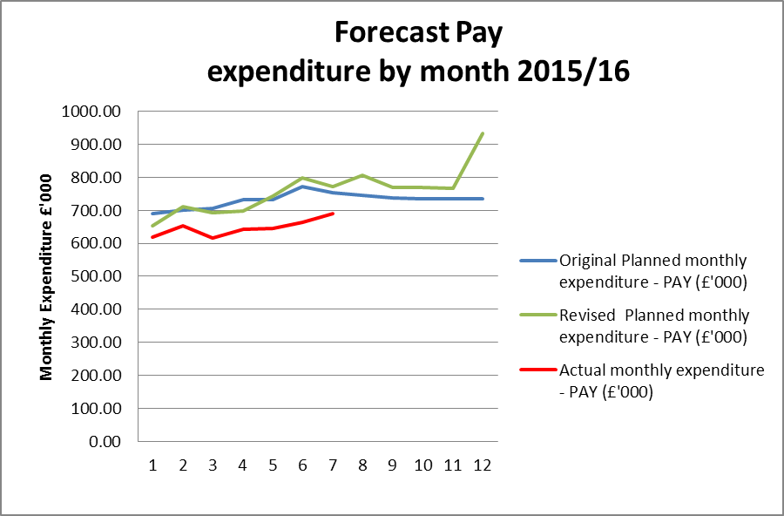

**Table 4: Profile of planned and actual Non Pay costs 2015/16**

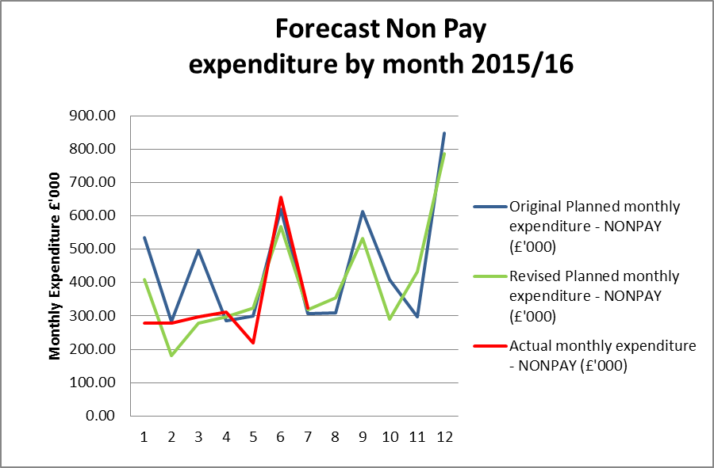

**4. Forecast outturn 2015/16**

Early forecasts point to a growth in the underspend position from £300k to £500k. The position is being actively tracked to ensure that any underspend is managed and communicated but this estimation could increase. Work is being undertaken to further clarify spending plans with budget managers and exploration of invest to save initiatives which may impact on spend in this financial year. Risks to the position relate to any further unexpected delays to expected recruitment plans alongside the actual pay point that additional new recruits are appointed on, which are the two main factors behind the early forecast position.

**5. Better payments performance**

Better payment performance has met the duty to pay 95% of invoices in 30 days achieving 98% based on number of invoices, and achieved the target based on value by achieving 99%. HRA are committed to paying suppliers promptly and have increased the target of paying suppliers within 10 days to 60% for 2015/16. The performance at the end of October 2015 for payments made within 10 days is 59% (number of invoices), which is broadly in line with the stretched 60% target, and 58% based on value. The escalation days for invoices awaiting approval have been reduced from 7 days to 4 days (after which invoices are escalated to line managers) and further reminders on vacation rules and the importance of checking the workflow daily, have been issued to staff. An additional payment run has also been actioned with effect from the 19th October to further improve performance in 2015/16.

**6. Travel costs**

Over £500k has been allocated for planned travel costs in 2015/16. Travel continues to be an area which is being intentionally monitored and managed with a view to a reduction in staff costs per head (given that costs are likely to increase overall as a result of more posts with a requirement for travel). The graph below shows that we are achieving this aim compared to a benchmark of 2013/14.

Table 5 below sets out the total travel costs position (staff, members inclusive) at the end of October and reflects a marked rise in the monthly expenditure in travel and an over spend of £48.3k (£27.7k over spend September). It should be noted that one explanation for the over spend is due to the number of update meetings being held to discuss HRA Approval with every Research Ethics Committee. Another is due to face to face meetings being held to discuss and clarify new processes and build new teams now that recruitment to posts is well underway. The treatment of travel costs associated with training is being investigated and could be one explanation for the over spends within Directorates as there have been staff related training (Arbinger development day across the organisation, training for new staff relating to HRA Approval and workshops for the first cohort, plus interviews ). Additionally, the arrangements for staff training are being reviewed to see if any savings can be realised from the choice of venue and methods of training provision. The estates strategy work is also encouraging greater use of video conferencing or “Lync” meetings, however this aspect is strongly dependent on the reliability and capacity of the IT service.

A contributing factor to the position within Operations may be the minimal member related training events in the first 2 months of the year.

There are a number of new starters within Systems and Development and travel budgets have not yet been released from reserves for the travel element to these posts. The associated budget requirement for these new staff continue to be assessed and will be released from reserves once the travel requirements are agreed.

**Table 5: Travel costs and budget across the HRA by Directorate**



Year to date staff travel costs for 2015/16 are presented in Table 6 below allowing comparison with the average cost per head in 2014/15 and 2013/14. This clearly demonstrates the reductions in costs per head being achieved year to date, however the peak in October will be investigated.

The lower travel costs in April and May is likely to be linked to fewer training events being held in these months. The peak in 2014/15 November is due to the All Staff Training day. Efforts continue with staff and line managers working hard to ensure costs are minimised wherever possible, for example use of telephone or video conference calls, tickets booked in advance and on timed trains.

**Table 6: Staff travel costs per head**

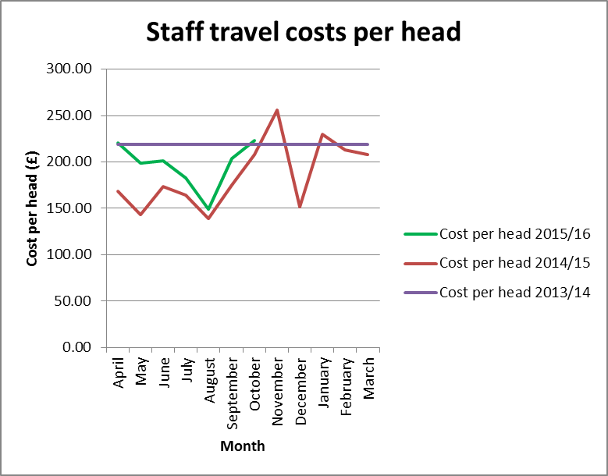

**7. Staff numbers**

Pay represents 66% of the costs incurred so far in year. The profile of our staff headcount is presented in Table 7 below for information and despite the vacancies continues to show a slowly increasing trajectory.

**Table 7: Chart to show actual staff headcount so far in 2015**

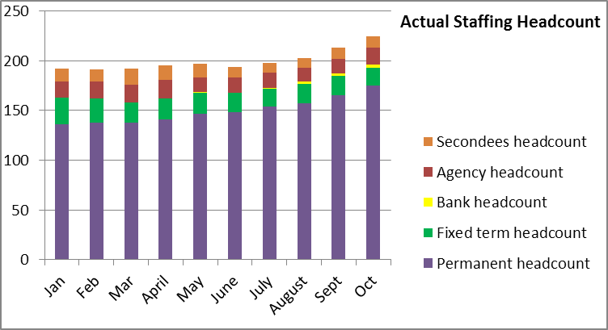

**8. Month end faster close**

The Finance team have over the last few months moved to working flexibly with most Finance team members working a proportion of their time from home. The achievement of key deadlines continues to be maintained. Unfortunately due to HRA system wide IT problems the finance system was inaccessible for the majority of day 1 of the October month end. This necessitated extending the month end closure by 1 day. The internal finance team objective to complete the management accounts within 4 days (with system availability) was achieved in October. All agreed deadlines for completion of required returns and reports for EMT and Board were achieved.

**9. Capital**

The capital expenditure position is presented below for October 2015. The capital plan includes budget for those Information Systems posts which include an element of development or capital work within their roles. A review of these posts is required over the next month to ensure that the assumptions remain the same, now that staff have been working in the roles for a number of months.

A total of 58% of the capital budget has been spent at the end of October 2015 (58% of the year).

The HRA received confirmation of the capital funding of £1.060m from the Department of Health on the 25th June 2015. The required investment in digital telephony has led to a review of cost treatments which will impact on the capital plan, at present £117k of costs relating to the purchase of new laptops has been capitalised. The HRA is working with the auditors to determine whether there are any further costs, associated with the implementations of VOIP at Skipton House, that require capitalisation in this year. HRA is working with colleagues in the Sponsor and DH Finance departments to notify requirements in advance.

A report on the monthly spend against budget for each of the capital programmes has been developed and is shared with the Deputy Director – Research Information Systems. This enables us to highlight any potential forecast under spend or over spend at an early stage. Work is ongoing to forecast the capital position for the year end, and will be completed once the capitalised salaries and laptop issues have been finalised.

**Capital expenditure 2015/16**

|  |  |  |  |  |
| --- | --- | --- | --- | --- |
| **Plan initiative** |  | **2015/16 plan** | **2015/16 actual** | **2015/16 to go** |
|  | **£ '000** | **£ '000** | **£ '000** |
| HARP Developments |  | 275.00 | 152.4 | 122.6 |
| IRAS Developments |  | 542.00 | 254.8 | 287.2 |
| IS Team – capitalised salaries |  | 243.00 | 87.8 | 155.2 |
| IT Equipment (digital telephony) |  | 0.00 | 116.8 | (116.8) |
| **TOTAL** |  | **1,060.00** | **611.8** | **448.2** |

**10. Statement of Financial Position and cash**

To align with the quarterly accountability meetings with the Department of Health, during 2015/16 a quarterly Statement of Financial Position (formerly balance sheet) and cash flow forecast will be produced and reported to EMT. These will next be reported in the finance report as at 31st December 2016.

At the end of the reporting period, the cash balance was £2.411m, which is broadly in line with the balance held at the end of September 2015 of £2.483m, and a reduction against the balance of £3.741m held at the end of the 2014/15 financial year. At the end of October, 40% of the total cash limit had been drawn down. In order to fulfil the duty to avoid holding excess levels of cash, the HRA will continue to monitor the cash position during 2015/16 to ensure that sufficient cash is held for future needs, but will aim to reduce the cash balances held.

**11. Recommendations**

That EMT and the Board notes the final financial position and to particularly note the following:

* The under spend year to date and the ongoing work required by finance to present the under spends relating to vacancies year to date, non recurrent expenditure plans to offset and the likely forecast for the year.
* The amended presentation of the profiled planned expenditure as requested by the Board and the closer match between actual monthly spend and this revised profile
* The maintained Better Payments Practice Code position to meet the 95% target based on number of invoices and the value, and the continued requirement to review invoices in the workflow on a daily basis, put invoices on hold if under dispute or set up a substitute.
* The cash position of £2.411m at the end of the period.
* The capital position and further work required to forecast the year end position.

**Debbie Corrigan**

**Director of Finance, Procurement and Estates**

**12 November 2015**

**Health Research Authority – Financial position as at 31 October 2015 Appendix A**

|  |  |
| --- | --- |
| **FINANCIAL RESULTS**  **HEADLINES** | * HRA is reporting an expenditure budget under spend of £256k at the end of October (£253k end of September) * 50% (£6.89million) of the annual budget has been spent after 58% of the year has passed. * Work is ongoing to finesse some areas of budget and to start to prepare forecasts for the year end. * The largest variance at month 7 (October) is the under spend within the Operations and Approval directorate cost centres. * The under spend within Operations largely relates to pay costs. The efficiencies made as a result of reducing the number of RECs has been identified and a budget adjustment undertaken in September. * Work has begun during September to commence a process to correctly capture the training related travel costs and will provide opportunity for subsequent analysis to transfer them to the training cost centres which are currently underspent along with a revised process for administering these travel costs. * The Better Payment Practice Code (BPPC) compliance for April to October was 98% for the number of invoices paid, which is in line with the overall performance for 2014/15, and is reporting 99% for value of invoices paid, which is a slight improvement against the previous year 2014/15. Having achieved the 50% target of paying invoices within 10 days during 2014/15, the HRA is aiming to pay 60% of invoices within 10 days – current performance shows 59% on the number of invoices and 58% based on invoice values. All approvers are asked to note this and to approve invoices promptly or place on hold if there is a dispute. Performance is published on our website. * Cash balance has reduced from year end £3.7 million (with liabilities to pay of £1.37million) to £2.411 million (with liabilities to pay of £1.41 million). * The cash balance at the end of October 2015 was £2.411m, which is broadly in line with the balance held at the end of September of £2.483m. * The HRA has drawn down £5.750m in cash for the period April to October. This represents 40% of the total cash drawdown for the year and reflects management of cash drawdowns to match expected need. |

**Health Research Authority – Non Pay Expenditure Year to end October 2015 Appendix B**

|  |  |  |  |  |  |  |  |  |  |  |  |  |  |  |  |  |  |  |  |  |  |  |  |  |  |  |  |  |  |  |  |  |  |  |  |  |  |  |  |  |  |  |  |  |  |  |  |  |  |  |  |  |  |  |  |  |  |  |  |  |  |  |  |  |  |  |  |  |  |  |  |  |  |  |  |  |  |  |  |  |  |  |  |  |  |  |  |  |  |  |  |  |  |  |  |  |  |  |  |  |  |  |  |  |  |  |  |  |  |  |  |  |  |  |  |  |  |  |  |  |  |  |  |  |  |  |  |  |  |  |  |  |  |  |  |  |  |  |  |  |  |  |  |  |  |  |  |  |  |  |  |  |  |  |  |  |  |  |  |  |  |  |  |  |  |  |  |  |  |  |  |  |  |  |  |  |  |  |  |  |  |  |  |  |  |  |  |  |  |  |  |  |  |  |  |  |  |  |  |  |  |  |  |  |  |  |  |  |  |
| --- | --- | --- | --- | --- | --- | --- | --- | --- | --- | --- | --- | --- | --- | --- | --- | --- | --- | --- | --- | --- | --- | --- | --- | --- | --- | --- | --- | --- | --- | --- | --- | --- | --- | --- | --- | --- | --- | --- | --- | --- | --- | --- | --- | --- | --- | --- | --- | --- | --- | --- | --- | --- | --- | --- | --- | --- | --- | --- | --- | --- | --- | --- | --- | --- | --- | --- | --- | --- | --- | --- | --- | --- | --- | --- | --- | --- | --- | --- | --- | --- | --- | --- | --- | --- | --- | --- | --- | --- | --- | --- | --- | --- | --- | --- | --- | --- | --- | --- | --- | --- | --- | --- | --- | --- | --- | --- | --- | --- | --- | --- | --- | --- | --- | --- | --- | --- | --- | --- | --- | --- | --- | --- | --- | --- | --- | --- | --- | --- | --- | --- | --- | --- | --- | --- | --- | --- | --- | --- | --- | --- | --- | --- | --- | --- | --- | --- | --- | --- | --- | --- | --- | --- | --- | --- | --- | --- | --- | --- | --- | --- | --- | --- | --- | --- | --- | --- | --- | --- | --- | --- | --- | --- | --- | --- | --- | --- | --- | --- | --- | --- | --- | --- | --- | --- | --- | --- | --- | --- | --- | --- | --- | --- | --- | --- | --- | --- | --- | --- | --- | --- | --- | --- | --- | --- | --- | --- | --- | --- | --- |
| **Areas of Non- Pay Expenditure** | |  |  |  |  |  |  |  |  |  | | --- | --- | --- | --- | --- | --- | --- | --- | --- | | **Subjective** | **Annual** | **Next year** | **In month (£)** | | | **Year to date (£)** | | | | **Name** | **budget (£)** | **plan (£)** | **Budget** | **Actual** | **Variance** | **Budget** | **Actual** | **Variance** | | **1 Meeting Rooms/Catering** | 243,797 | 213,776 | 20,536 | 25,623 | 5,087 | 118,776 | 80,052 | (38,724) | | **2 Office equipment/Stationery/Furniture/Consumable** | 61,314 | 59,114 | 5,290 | 116,995 | 111,705 | 35,218 | 166,069 | 130,851 | | **3 Photocopying/Printing/Postage/Storage/Waste** | 160,591 | 161,730 | 12,823 | 9,834 | (2,989) | 91,404 | 105,978 | 14,574 | | **4 Premises - inc premise removal costs** | 794,882 | 781,772 | 31,440 | 36,210 | 4,770 | 407,674 | 426,103 | 18,429 | | **5 Training Expenses - expenses/materials , conferences, workshops** | 174,795 | 86,600 | 11,641 | 3,085 | (8,556) | 54,107 | 50,724 | (3,383) | | **7 Other Staff costs - Recruitment/adverts/redundancy/PILON** | 12,000 | 12,000 | 0 | 0 | 0 | 6,000 | 5,646 | (354) | | **8 Travel costs - include excess mileage/interview expenses** | 569,043 | 513,414 | 48,770 | 69,214 | 20,443 | 316,163 | 365,904 | 49,741 | | **9 Chairs/Members/Participation - activity costs** | 290,081 | 281,854 | 25,208 | 16,653 | (8,555) | 163,136 | 147,530 | (15,606) | | **10 Publications** | 8,000 | 1,500 | 125 | 1,990 | 1,865 | 5,375 | 6,490 | 1,115 | | **11 Mobile Phones/Mobile Data** | 22,954 | 21,925 | 1,894 | 1,203 | (691) | 13,393 | 10,603 | (2,790) | | **12 Statutory Costs - Health & Safety/Legal/Audit Fees/Dep. & Amort.** | 529,222 | 368,722 | 51,482 | 62,957 | 11,475 | 295,746 | 293,234 | (2,512) | | **13 Computer Costs - Software/licences/system maint./purchases** | 331,470 | 313,597 | 17,979 | 59,374 | 41,395 | 193,066 | 220,725 | 27,659 | | **14 Other External Contracts - SLA's - Premises, SBS,BSA, DH IT** | 1,131,303 | 845,500 | 67,796 | (78,201) | (145,997) | 656,576 | 489,311 | (167,265) | | **15 Other - Misc/Reserves** | 1,176,178 | 0 | 0 | (1,796) | (1,796) | 0 | (2,548) | (2,548) | | **Grand Total** | 5,505,630 | 3,661,504 | 294,984 | 323,141 | 28,156 | 2,356,634 | 2,365,821 | 9,187 | |  | | | | | | | | | |  |  |  |  |  |  |  |  |  | |  |  |  |  |  |  |  |  |  | | **Notes:** |  |  |  |  |  |  |  |  | |  |  |  |  |  |  |  |  |  | | 1. The overspend in Office equipment is a budget coding issue - the underspend in Other external contracts is the offset budget for this spend. Budget to be recoded November. | | | | | | | | |  | |

**HRA Better Payment Practice Code for the period 1 April to 31 October 2015 Appendix C**



**Aged Creditors at 31 October 2015**

Headlines – clock start date is the invoice date (regardless of when the invoice is received in the system) – there are no issues of concern.

|  |  |  |  |
| --- | --- | --- | --- |
|  | **Aged Creditors – (£) amounts past due date** | | |
|  | **1-30 days** | **31-60 days** | **60 + days** |
| **Non NHS Trade** | 72,944.04 | 0.00 | (31.59) |
| **Non NHS Other** | 4,620.15 | 7,050.00 | 65.00 |
| **NHS** | 19,292.32 | (78.78) | 466.23 |
|  |  |  |  |
| **Total** | 96,856.51 | 6,971.22 | 499.64 |

**HRA Revenue position for the period ended 31 October 2015 Appendix D**

|  |  |  |  |  |  |  |  |  |  |  |  |  |  |
| --- | --- | --- | --- | --- | --- | --- | --- | --- | --- | --- | --- | --- | --- |
| **Period (£'000)** | | |  | **Department** |  | **Year to date (£'000)** | | |  | **Full year (£'000)** | | | |
|  |  |  |  |  |  |  |  |  |  |  | **2015/16** | | |
| **Budget** | **Actual** | **Variance** |  | **Income** |  | **Budget** | **Actual** | **Variance** |  | **2014/15 actual** | **Initial budget** | **Latest Budget** | **Forecast** |
| 0 | 0 | 0 |  | HRA income |  | 98 | 98 | 0 |  | 327 | 196 | 196 | 196 |
| 961 | 959 | -2 |  | Grant in Aid confirmed |  | 6,944 | 6,688 | -256 |  | 10,343 | 13,346 | 13,346 | 13,346 |
| 0 | 0 | 0 |  | Grant in aid - to be confirmed CAG2 |  | 0 | 0 | 0 |  | 0 | 139 | 65 | 65 |
| 54 | 54 | 0 |  | Non cash revenue resource limit |  | 104 | 104 | 0 |  | 0 | 270 | 270 | 270 |
| **1,015** | **1,013** | **-2** |  | **Total Income** |  | **7,146** | **6,890** | **-256** |  | **10,670** | **13,951** | **13,877** | **13,877** |
|  |  |  |  |  |  |  |  |  |  |  |  |  |  |
| **Budget** | **Actual** | **Variance** |  | **Expenditure** |  | **Budget** | **Actual** | **Variance** |  | **2014/15 actual** | **Initial budget** | **Latest Budget** | **Forecast** |
| 380 | 357 | -23 |  | Operations |  | 2,691 | 2,505 | -186 |  | 4,429 | 4,794 | 4,696 | 4,696 |
| 170 | 184 | 14 |  | Chief Executive inc. Corp Sec |  | 1,042 | 1,033 | -9 |  | 1,768 | 1,560 | 1,793 | 1,793 |
| 128 | 129 | 1 |  | Corporate Services |  | 991 | 970 | -21 |  | 1,984 | 1,731 | 1,819 | 1,819 |
| 34 | 40 | 6 |  | Finance, Procurement and Estates |  | 523 | 545 | 22 |  | 639 | 3,153 | 2,112 | 1,612 |
| 303 | 303 | 0 |  | Research Systems, Standards and HRA Approval Prog |  | 1,899 | 1,837 | -62 |  | 1,850 | 2,713 | 3,457 | 3,457 |
| **1,015** | **1,013** | **-2** |  | **Total Expenditure** |  | **7,146** | **6,890** | **-256** |  | **10,670** | **13,951** | **13,877** | **13,377** |
|  |  |  |  |  |  |  |  |  |  |  |  |  |  |
| **0** | **0** | **0** |  | **Surplus /Deficit** |  | **0** | **0** | **0** |  | **0** | **0** | **0** | **-500** |

**Reconciliation of grant in aid to 2015/16 financial plan Appendix E**

