Agenda item: | 12
Attachment: | D

HRA BOARD COVER SHEET

Date of Meeting: | 25th January 2017 – report to Board

Title of Paper: | Financial report - October 2016
Purpose of Paper: | To seek approval of the financial position of the Authority as at the 31st October 2016
Reason for Submission: | To ensure the Board, are aware of the financial position of the HRA as at the end of October 2016.
Lead Reviewer: | Tom Smith, Director of Guidance and Learning - 31 October 2016
Details: | This paper presents the financial position as at the end of October 2016.  Main points to note:  - The HRA moved to an overspend position of £29k as at the end of October 2016 (position at end of September over spend of £4k).  - An underspend on pay of £36.5k was offset by an overspend on non pay of £65k.  - The position includes the previously reported unbudgeted charge for the disposal of the Video conferencing equipment (£18.5k) and includes costs associated with the archiving project (£70k) which unexpectedly over ran into 2016/17.  - The reduction from initial budget with regards to HRA income  - The HRA has continued to meet the duty to pay 95% of invoices in 30 days achieving 97% based on number of invoices, and achieved the target based on value by achieving 100%.  - The capital position is reporting a slight underspend of £21k (position at end of September £18k underspent). Initial forecasting indicates a year end underspend of £141k, as a result of the reduced contract price with the systems developers.  - There has been a reduction in the level of cash held from the year end of £3.485m to £2.889m  - The Department of Health has confirmed the budget for 2016/17 in line with the financial plan as expected.
Suitable for wider circulation? | Yes, following Board
Time required for item: | 10 minutes

Recommendation / Proposed Actions: | To Approve |  | Yes
 | To Note
 | For discussion
 | Comments

Name: | Sylvia Hazard
Job Title: | Acting Director of Finance and Procurement
Date: | 24 October 2016

Executive Summary – Headlines

- HRA is reporting an expenditure budget overspend of £29k at the end of October (£4k overspend in September). Revenue forecast outturn remains at break-even.

- Pay budgets are under spent by £36.5k. This is including a £87.4k year to date vacancy factor having been applied.

- Non pay budgets are over spent by £65k largely due the over run of the archiving project and the disposal of the video conferencing assets.

- Reduction in income budget as calculated charges for Devolved Administrations lower than initial budget estimate.

- Capital budgets are underspent by £21k at the end of October.

- The Better Payment Practice Code (BPPC) compliance for April to October (year to date) was 97% for the number of invoices paid, which is in line with the overall performance for 2015/16, and is reporting 100% for value of invoices paid. The HRA has maintained the stretched target of paying 60% of suppliers in 10 days target for 2016/17. All approvers are asked to note this and to approve invoices promptly or place on hold if there is a dispute. Performance is published on our website.

- Cash balance has reduced from year end £3.485 million (with liabilities to pay of £1.296million) to £2.889 million (with liabilities to pay of £1.104million).

- The cash balance at the end of October 2016 was £2.889m, which is a reduction against the balance held at the end of September 16 (£2.727m) and less than the balance held at the end of March 16 of £3.485m.

Finance Report - Financial Year 2016/17
Health Research Authority as at 31 October 2016

Resource Limit Revenue and Capital
The HRA grant in aid and revenue resource limit for the year was presented in the 2016/17 financial plan and this report continues to be based on the same figures of £13,080k. The Capital Resource Limit agreed for 2016/17 by the Department of Health is £910k.

Position Against Revenue and Capital Resource Limit

The Authority has spent £7.1 million year to date – shown in table 1
The main points to note in the reported outturn expenditure position as at 31 October 2016 of £7.1m are:

- Total pay costs incurred are £4.98m (69% of total expenditure costs).
- Pay budgets are under spent by £36.5k. This is net of the £87.4k year to date vacancy factor, the overall pay underspend would have therefore been £124k.
- Non-pay budgets are over spent by £65k. As previously advised £70k relates to the archiving projects running into the new year and £18.5k relates to the asset disposal. These are both non recurrent impacts. A continuing cost pressure on non-pay is the overspend on Skipton House rent which will remain as a recurrent pressure.

Table 1: HRA Revenue position for the period ended 31 October 2016
Period (£'000) |  |  |  | Department |  | Year to date (£'000) |  |  |  | Full year (£'000)
 |  |  |  |  |  |  |  |  |  |  | 2016/17
Budget | Actual | Variance |  | Income |  | Budget | Actual | Variance |  | 2015/16 actual | Initial budget | Latest Budget | Forecast
0 | 0 | 0 |  | HRA income |  | 88 | 88 | 0 |  | 198 | 200 | 176 | 176
991 | 1,016 | 25 |  | Grant in Aid confirmed |  | 6,870 | 6,899 | 29 |  | 12,509 | 12,630 | 12,630 | 12,630
0 | 0 | 0 |  | Non cash revenue resource limit |  | 186 | 186 | 0 |  | 253 | 450 | 450 | 450
991 | 1,016 | 25 |  | Total Income |  | 7,144 | 7,173 | 29 |  | 12,960 | 13,280 | 13,256 | 13,256
Budget | Actual | Variance |  | Expenditure |  | Budget | Actual | Variance |  | 2015/16 actual | Initial budget | Latest Budget | Forecast
334 | 342 | 8 |  | Operations |  | 2,343 | 2,351 | 8 |  | 4,573 | 4,021 | 4,021 | 4,090
119 | 123 | 4 |  | Chief Executive inc. Corp Sec |  | 1,043 | 1,065 | 22 |  | 1,821 | 1,986 | 1,977 | 1,971
274 | 270 | -4 |  | Corporate Services |  | 1,572 | 1,592 | 20 |  | 1,828 | 1,812 | 2,809 | 2,801
56 | 52 | -4 |  | Finance, Procurement and Estates |  | 398 | 391 | -7 |  | 1,256 | 1,315 | 1,253 | 1,201
208 | 229 | 21 |  | Research Systems, Standards and HRA Approval Prog |  | 1,788 | 1,774 | -14 |  | 3,482 | 4,146 | 3,196 | 3,193
991 | 1,016 | 25 |  | Total Expenditure |  | 7,144 | 7,173 | 29 |  | 12,960 | 13,280 | 13,256 | 13,256
0 | 0 | 0 |  | Surplus /Deficit |  | 0 | 0 | 0 |  | 0 | 0 | 0 | 0

The Authority has spent £419k on capital year to date – shown in table 1a.
The main points to note in the reported capital outturn expenditure position as at 31 October 2016 of £419k are:

- Underspend on the capitalised salaries of £31k. This is due to contractors leaving earlier than originally budgeted for and a delay in recruitment of one post.
- Overspend on the BGO contract of £10k. This is a slight in month movement, due to less days being used in October than budgeted for. This follows discussions held with BGO over the use of the more senior roles in prior months.
Table 1a
Plan initiative | 2016/17 plan | 2016/17 budget to date | 2016/17 actual | 2016/17 variance | 2016/17Year end Forecast
 | £ '000 | £ '000 | £ '000 | £ '000 | £ '000
HARP Developments | 215 | 126 | 122 | -4 | 212
IRAS Developments | 362 | 211 | 225 | 14 | 376
IS Team – capitalised salaries | 155 | 103 | 72 | -31 | 126
Capital reserve | 178 | 0 | 0 | 0 | 55
TOTAL AGREED FOLLOWING SPENDING REVIEW | 910 | 440 | 419 | -21 | 769

Forecast outturn 2016/17

Revenue
The finance team have received monthly forecast from budget managers since June. These forecasts have been refined over the three months, and although some further refinements are still required the forecast position against expenditure remains at broadly break even.
The reserves have being reviewed and the updated position is £435k of earmarked reserves and £105k unearmarked reserves. Some of the projects within earmarked reserves are in collaboration with other organisations and this creates an element of uncertainty with regards to the projects timescales. Following further review a range may be introduced.

Capital

Refinement on the forecasting for the year end, taking into account the slight in month movement on the BGO contract, indicates a surplus of £141k, which is mainly as a result of the contract for the development of the HARP and IRAS system being negotiated at a lower cost than anticipated when setting the capital budget. DH have been informed of a potential surplus on the capital budget, but the HRA have not agreed for this to be returned for use in the wider system until the final position is known regarding planned investment linked to the EU portal, which may impact on the final year end position.
Statement of Financial Position and cash
No Statement of Financial Position or cashflow have been produced for October 16. These will be produced for each quarter end.

At the end of the reporting period, the cash balance was £2.889m. The forecast cash balance at the end of March 2017 is £3.195m. In order to fulfil the duty to avoid holding excess levels of cash, the HRA will continue to monitor the cash position during 2016/17 to ensure that sufficient cash is held for future needs, but will aim to reduce the cash balances held.

Better payments performance

The HRA has continued to meet the duty to pay 95% of invoices in 30 days, also maintaining the internal stretched target of paying 60% of suppliers in 10 days.

 | Number | % | Value (£) | %
0-5 | 238 | 10% | 496,637 | 16%
6-10 Days | 1491 | 62% | 1,384,093 | 46%
11-20 Days | 556 | 23% | 994,766 | 33%
21-30 Days | 37 | 2% | 148,671 | 5%
Over 30 Days | 66 | 3% | 2,377 | 0%
Total | 2,388 | 100% | 3,026,544 | 100%
BPPC achieved | 97% | 97% | 100% | 100%
2015/16 Performance | 98% | 98% | 97% | 97%
2015/16 0-5 day performance | 306 | 7% | 1,395,005 | 21%

Travel costs
Table 2 below sets out the total travel costs position (staff, members inclusive) at the end of September 2016. £321k has been spent year to date with a £1.2k over spend against the plan (£1.6k underspend in September).
Table 2: Travel costs and budget across the HRA by Directorate
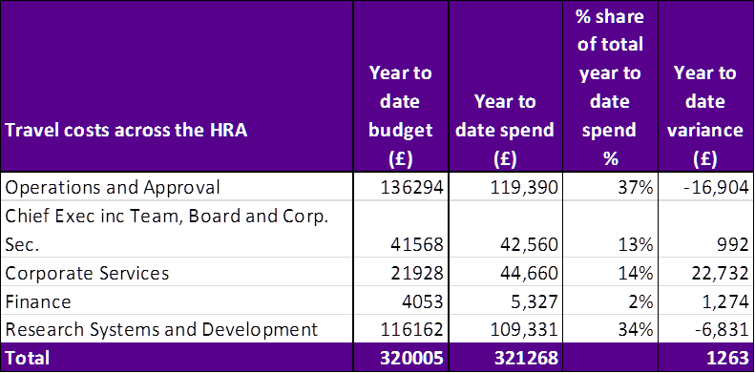

Recommendations

The Board is asked to note the financial position and the following points of note:

- The current overspend position, with the broadly breakeven revenue forecast outturn
- The under spend on pay offset by an over spend on non pay and the reasons.
- The excellent performance on the Better Payments Practice Code position to meet the 95% target based on number of invoices and the value and the 60% achievement of payments within 10 days.
- The actual performance on travel costs which show that delivery of savings is achievable provided travel decisions and timings are carefully considered.
- The capital position at the end of the period and likely underspend forecast outturn.

Sylvia Hazard
Acting Director of Finance and Procurement
24 October 2016

Supplementary Information

The following tables and comments are included to provide additional information:

Cash releasing Savings

The following areas will form the basis of ensuring that the HRA continues to remain within its financial envelope over the term of the spending review:

- Vacancy factor.
- Continued savings in estates costs through improved use of footprint.
- Savings in per head staff travel costs to justify the investment made in digital telephony. Given the expenditure on travel in 2015/16, this area poses a risk and a challenge and will require concerted management action.
- Savings in introduction of Managed Print Service and roll out of this service as leases expire on current photocopier agreements.
- Savings through the use of the Member Portal.
- Savings on HRA’s largest information systems contract.

Health Research Authority – Non Pay Expenditure Breakdown Year to end October 2016
Areas of Non- Pay Expenditure | Annual Next year In month (£) Year to date (£)  Subjective budget (£) plan (£) Budget Actual Variance Budget Actual Variance  Meeting Rooms/Catering 217,281 219,040 12,754 16,498 3,744 120,021 110,537 (9,484)  Office equipment/Stationery/Furniture/Consumable 67,769 101,794 5,311 7,332 2,021 26,686 25,542 (1,144)  Photocopying/Printing/Postage/Storage/Waste 159,169 155,410 14,872 15,904 1,032 92,698 97,851 5,153  Premises - inc premise removal costs 717,327 717,327 59,969 79,525 19,556 416,085 431,734 15,649  Training Expenses - expenses/materials , conferences, workshops 82,390 75,390 5,036 2,168 (2,868) 46,616 48,983 2,367  Other Staff costs - Recruitment/adverts/redundancy/PILON 27,000 40,000 0 3,935 3,935 23,000 27,759 4,759  Travel costs - include excess mileage/interview expenses 561,208 537,403 45,308 49,007 3,699 325,026 330,540 5,514  Chairs/Members/Participation - activity costs 290,710 286,410 19,403 16,126 (3,277) 158,856 150,200 (8,656)  Publications 2,250 2,250 2,020 2,124 104 2,150 2,346 196  Mobile Phones/Mobile Data 18,661 18,661 1,553 315 (1,238) 10,711 10,609 (102)  Statutory Costs - Health & Safety/Legal/Audit Fees/Dep. & Amort. 549,365 549,365 5,455 6,150 695 223,013 243,199 20,186  Computer Costs - Software/licences/system maintenance/purchases 342,672 346,722 18,558 23,420 4,862 196,033 203,067 7,034  Other External Contracts - SLA's - Premises, SBS,BSA, DH IT 909,729 792,403 70,693 49,697 (20,996) 483,136 509,591 26,455  Other - Misc/Reserves 539,038 0 0 (3) (3) 0 (1,932) (1,932)  Grand Total 4,484,569 3,842,175 260,932 272,197 11,265 2,124,031 2,190,026 65,995  Note: The overspend on other external contracts largely relates to the over run on the archiving project, offset by underspend within Research Information systems and IT contract. The overspend within the statutory costs relates to the Asset disposal. The overspend in permises costs relates to Skipton house costs.

Directorate Pay – budget, actual, variance and vacancy factor 2016/17

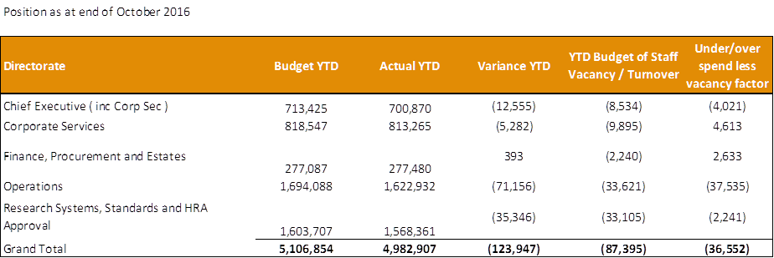

Chart to show actual staffing headcount so far in 2016

