Agenda item: | - 9
Attachment: | - A & B

HRA Board paper

18 May 2022
Title of paper: | Strategic performance report: April 2021 – Mar 2022
Submitted by: | Karen Williams, Deputy Chief Executive and Director of Finance
Summary of paper: | To provide the HRA Board with a review of strategic performance
Reason for submission: | For approval
Further information: | The paper presents the performance of the HRA in delivering the strategy. It focuses on four key areas:  - Our people  - Our customers and stakeholders  - Our services  - Finance  It also provides an overview of activity since the last report, commentary on the external environment, key strategic risks and issues and the outlook for the next period. The report includes the most recent data available. For this meeting, we report on performance from April 2021 to March 2022.  This report provides a high-level strategic dashboard as well as a more detailed performance report to the Board.  Paper 7B provides the draft financial outturn position for 2021-22.
Budget / cost implication: | N/A
Dissemination: | Published on HRA website with Board papers
Time required: | 15 minutes

Strategic performance report 2022: Apr-Mar
High level dashboard
Staff capacity  Apr/May: 74%  Jun/Jul: 78%  Aug/Sep 82%  Oct/Nov:86%  Dec/Jan: 86%  Feb/Mar: 87%  Maximum target: 94.5%.  Target is based on number of staff funded minus 4% sick leave KPI and vacancy rate. It is calculated on figures for staff working against figures for staff funded. Steady improvement evidenced and continues to be a key focus for executive committee. | 
Customer satisfaction  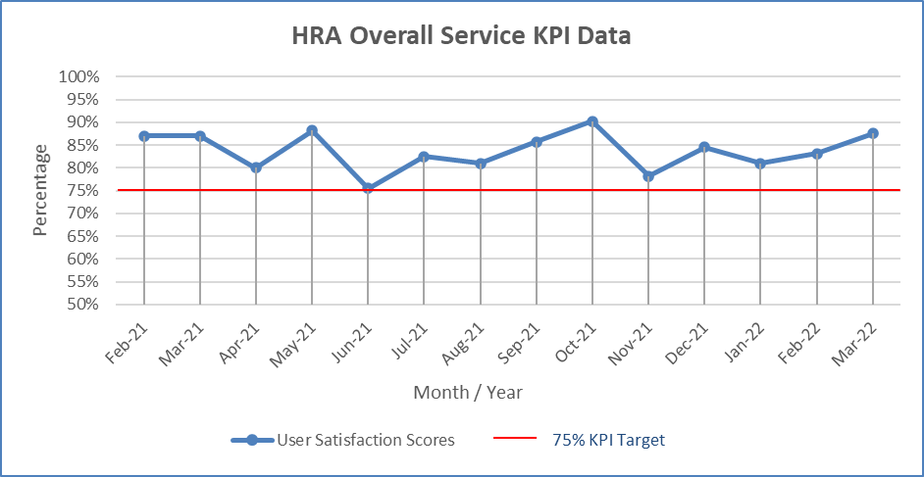  Customer satisfaction outperforms our target, the UK Customer Satisfaction Index for public sector organisations (77%)  Feedback received:  “Friendly yet professional. Always helpful”  “The meeting and organisation around it was excellent” | 
Ethical review of CTIMPs (both the combined and non-combined processes)  Median time to complete full review 33 days  Proportion of full reviews completed in 60 days 99%  97% of standard process CTIMPs were reviewed within 60 days (37 out of 38 studies). 100% (80 out of 80) Combined Review CTIMPs were reviewed within 60 days. | 
Expenditure within 4% of funding (to Mar 2022)  Overall Research systems programme  £1.9M underspend on core activities confirmed to DHSC mostly due to vacancy rate and move to virtual working. Research systems programme £2.3M costs deferred with strategic refresh reprofiling delivery to achieve objectives within term of business case. | 

Commentary
Our combined review service is now embedded within our core service offering delivering significant improvements to timelines for clinical trials research approval. In this period we have also:
- Launched our new campaign, #StepForward, to test new ways to recruit more Research Ethics Committee members, inviting doctors to become Research Ethics Committee members and play a key role in making sure health and social care research is ethical and fair for patients.
- Marked the start of British Science Week we came together with other influential health and social care leaders to sign up to a bold new shared commitment to improve public involvement in research. This supports delivery of the UK government’s vision for clinical research to be open to everyone and to make participation in research as easy as possible.
- Continued to celebrate our ten-year anniversary holding a joint workshop with the Academy of Medical Sciences (AMS), whose 2011 report led to our creation, and a workshop with the Nuffield Council on Bioethics, the independent body that informs policy and public debate about the ethical questions raised by biological and medical research. A formal report of the AMS workshop will be published shortly.
- Responded to feedback on the automatic registration process by making changes so if applicants tell us that their trial is or will be registered on ClinicalTrials.gov (link is external), it will not now need to be automatically registered with ISRCTN.
- Completed our annual staff survey with 71% response rate and 82% employee engagement score (-4% on 2021; +15% on benchmark)

External environment
UK Research and Innovation (UKRI) published their strategy 2022 – 2027: transforming tomorrow together (bit.ly/3OFwNYK). It is set within the overarching policy of the Governments of the Research and Development (R&D) Roadmap (bit.ly/3rZGJ5z) pledge to reach R&D spend of 2.4% of GDP by 2027.
DHSC have confirmed our funding settlement for 2022/23, this includes supporting our recovery, resilience and growth activities as well as our research systems programme. DHSC have confirmed some support for inflationary pressures including agenda for change cost of living and national insurance increases however this is balanced by a 5% reduction on revenue grant in aid and 20% reduction on capital.

Outlook for the next period
We will finalise our refreshed strategy for 2022 – 2022, working with public contributors to ensure it is accessible and easily understood. At the same time, we will agree our business plan for 2022/23.
We will complete our strategic review of the research systems programme and make recommendations to the HRA Board for the next phase of this transformation activity.

Strategic risk update
The Strategic risk register was reviewed at the 4 May 2022 Executive Committee. A new risk relating to cyber security was added.
Risk ref | Risk description | Residual risk score | Tolerance threshold | Trend | Latest update
HRA1 | Research Systems - The HRA is unable to deliver transformed research systems as it does not have the capacity to deliver a complex programme with multiple connections and dependencies across a number of organisations and is unable to understand or meet the requirements of the health research community. | 16 | 8 | ↔ | Recommendations for RSP reset drafted and to be considered at May HRA Board
HRA2 | Resources - The HRA is unable to deliver its business plan objectives due to limits in its ability to secure and deploy resources and capabilities in full and must prioritise certain programmes or core business delivery. | 12 | 9 | ↔ | Once GIAA audit management action plan has been completed the risk score may be decrease.
HRA3 | Reputational - The HRA has very low representation from individuals with protected characteristics at Board and senior management level and is not representative of society and therefore risks making decisions that do not take account of a diverse range of views and undermines its effectiveness in meeting its public sector equality duty. | 9 | 6 | ↔ | Community insight group to feed into HRA Board via paper and attendance at each meeting. Expertise in inclusive approach to recruitment practices a key requirement of senior posts.
HRA4 | Reputational - The reputation of the HRA is adversely affected with fewer participants choosing to take part in research because an adverse event resulting from the decision of a Research Ethics Committee, the conduct of a research study or from lack of public involvement / influence within the HRA occurs. | 8 | 8 | ↔ | Additional resources identified and posts to be recruited to support and strengthen assurance and third-party complaint handling.
HRA5 | Reputational - There is a perception that the HRA is not prioritising the most important areas of improvement to the research landscape or is not communicating appropriately the success of programmes to external stakeholders. | 8 | 8 | ↔ | Business plan to support focus on being led by data to help prioritise and lead our overall approach to delivery, capturing learning to aid decision making.
HRA6 | Information - Risk to the operational delivery of the HRA due to a successful and destructive cyber-attack causing loss of systems, loss of data, damage to reputation. | 9 | 3 | New | Although good controls are in place risk escalated to Board due to growing international cyber activity.

Our people
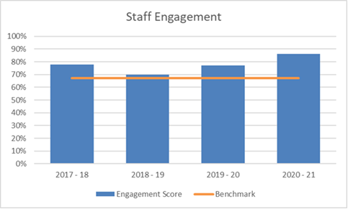  Staff engagement  Staff engagement based on answers to the annual staff survey:  HRA staff 86% (target: 78%)  Industry benchmark: 67%  March 2021  HRA continues to significantly out-perform the industry benchmark and our own internal target. | 
Staff capacity  Apr/May: 74%  Jun/Jul: 78%  Aug/Sep 82%  Oct/Nov:86%  Dec/Jan: 86%  Feb/Mar: 87%  Target: 94.5%  Maximum target: 94.5%. Target is based on number of staff funded minus 4% sick leave KPI and vacancy rate. It is calculated on figures for staff working against figures for staff funded. Steady improvement evidenced and continues to be a key focus for executive committee. | 
Research Ethics Committee membership (England only)  Number of members: April (835), May (845), Jun (839), Jul (843), Aug (841), Sep (836), Oct (838), Nov (839), Dec (839), Jan (833), Feb (823), Mar (804)  Number of vacancies: April (125), May (115), Jun (121), Jul (117), Aug (119), Sep (124), Oct (122), Nov (121), Dec (121), Jan (127), Feb (137), Mar (156)  Percentage vacancies: April (13%), May (12%), Jun (13%), Jul (12%), Aug (125), Sep (13%), Oct (13%), Nov (14%), Dec (13%), Jan (15%), Feb (14%), Mar (16%)  121 new members appointed this year. 17 new members have been interviewed and are awaiting appointment. These successful candidates are at various stages of the recruitment process, e.g. waiting for two suitable references, negotiating which Committees to join, etc. Looking forward, a balanced scorecard approach to monitoring member vacancies is being developed. This will include understanding recruitment pressures, for example in expert members. | 

Our customers and stakeholders
Customer satisfaction  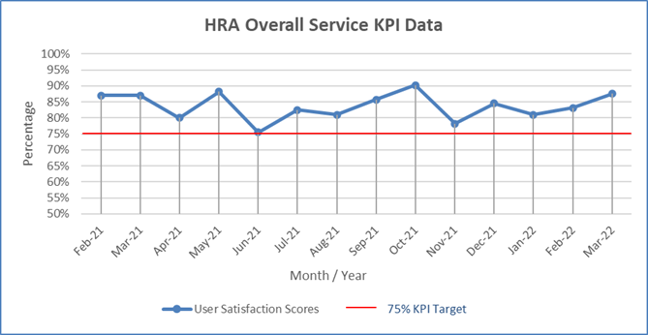  Customer satisfaction outperforms our target, the UK Customer Satisfaction Index for public sector organisations (77%)  Feedback received:  “Friendly yet professional. Always helpful”  “The meeting and organisation around it was excellent” | 

Finance
Expenditure within 4% of funding  Overall Research systems  £1.9M underspend on core activities confirmed to DHSC mostly due to vacancy rate and move to virtual working. Research systems programme £2.3M costs deferred with strategic refresh reprofiling delivery to achieve objectives within term of business case. | 

Approvals service
Number of applications for HRA Approval
April - Mar 2020: | 4742
April - Mar 2021: | 4003
April - Mar 2022: | 4148

This shows a 13% reduction in applications compared to the same period in 2019/20 and a small increase on last year. This is broadly in line with the long-term trend in reducing applications (approximately 6% a year) balanced by a slight rebound this year and increased complexity of some studies reviewed including complex innovative designs for COVID-19 studies.

Number of applications for REC review only
April- Jan 2020: | 1007
April- Jan 2021: | 930
April- Jan 2022: | 868

This shows a 14% reduction in applications compared to the same period in 2019/20. Phase 1 application numbers have now returned to the volume received pre-pandemic. This reduction in numbers is primarily a reduction in student application numbers.

Ethics review of clinical trials of investigational medicinal products (CTIMPs)
Our target is for 100% of applicable CTIMPs to be reviewed by the REC within 60 days. Where the CTIMP is for gene therapy or somatic cell therapy or the product contains a genetically modified organism, our target is for 100% to be reviewed within 90 days, by the Gene Therapy Advisory Committee.

Ethics review of standard process CTIMPs
REC review of standard review CTIMPS (England only) | Oct-21 | Nov-21 | Dec-21 | Jan-22 | Feb-22 | Mar-22
Median time to complete full review | 25 | 26 | 30 | 30 | 30 | 28
Full reviews completed in 60 days | 100% | 100% | 100% | 97% | 100% | 93%
Full reviews completed within 60 days | 44 | 38 | 33 | 34 | 23 | 14
Total completed | 44 | 38 | 33 | 35 | 23 | 15
Ethics review of combined review CTIMPs
REC review of combined review CTIMPS (England only) | Oct-21 | Nov-21 | Dec-21 | Jan-22 | Feb-22 | Mar-22
Median time to complete full review | 43 | 39 | 36 | 24 | 38 | 30
Full reviews completed in 60 days | 88% | 100% | 100% | 100% | 100% | 100%
Full reviews completed within 60 days | 22 | 27 | 27 | 35 | 32 | 48
Total completed | 22 | 27 | 27 | 35 | 32 | 48

Combined review.
For statutory timelines applicable to the HRA, 99% of applications are processed within 60 days in the two-month reporting period. One non-combined review CTIMP took over 60 days to be given an opinion in March – this application was initially reviewed in mid-December and the committee needed advice from an external referee. All CTIMP committees are now only accepting Combined Review CTIMPs. We saw a dip in performance whilst committees prepared for this service development and staff were trained on the enhanced system. However, performance has now returned to 100% being reviewed within the statutory timeframe since November 2021. A dedicated Approvals Manager continues to focus on service delivery to improve statutory compliance for Combined Review as well as researcher experience in general.

Fast-track REC (standard review)

(Non-COVID-19 studies)
Fast Track REC | Oct-21 | Nov-21 | Dec-21 | Jan-22 | Feb-22 | Mar-22
Median time to complete full review | 14.5 | 13 | 11 | 12.5 | n/a | 13
Full reviews completed in 60 days | 100% | 100% | 100% | 100% | n/a | 100%
Total completed | 16 | 11 | 3 | 4 | 0 | 1
Total completed within 60 days | 16 | 11 | 3 | 4 | 0 | 1
Studies Submitted for Review | 13 | 3 | 4 | 1 | 1 | 0

Fast-track REC (combined review)

(Non-COVID-19 studies)
Fast Track REC | Oct-21 | Nov-21 | Dec-21 | Jan-22 | Feb-22 | Mar-22
Median time to complete full review* | 24.5 | 15 | 15 | 15 | 10.5 | 11.5
Full reviews completed in 60 days | 100% | 100% | 100% | 100% | 100% | 100%
Total completed | 6 | 1 | 4 | 5 | 6 | 12
Total completed within 60 days | 6 | 1 | 4 | 5 | 6 | 12
Studies Submitted for Review | 2 | 4 | 5 | 9 | 13 | 18

Combined review studies considered through fast-track REC have comparable timelines to non-combined review studies when just the REC review aspect is considered. For Phase I trials MHRA have a shorter timeline for review that aligns with our fast-track timeline. For other trials we are working with applicants to explore the added value of fast-track service as part of combined review.

HRA Approval
For HRA and HCRW Approval in England and Wales, the graph below shows the median and mean elapsed timeline for applications from submission to approval (no clock stops). Applications withdrawn or invalid have been omitted from the data set. Combined review median normally maps closely to mean showing a more predictable process, but divergence over the summer months shows that a small number of outliers (caused by IT issues and staff familiarising themselves with the new process) affected predictability. Steps have been taken to address these anomalies in the process and the median is once again mapping closely to the mean, showing a more consistent process.

Median approval timeline for CAG research studies
Month | Days from application to completion | Number of applications
April | 30 days | 10
May | 30 days | 9
June | 31 days | 9
July | 26 days | 6
August | 26 days | 11
September | 23 days | 14
October | 27 days | 13
November | 28 days | 7
December | 28 days | 12
January | 17 days | 7
February | 27 days | 14
March | 29 days | 15

Applications in progress that have exceeded target times: None

RAG Status criteria
Staff engagement | green >76%, amber 68%-75%, red <68%
Staff Capacity | green over 90%, amber 80%-90%, red <80%
REC membership vacancies | green <5%, amber 6%-14%, red >14%
Customer satisfaction | green >76%, amber 68%-75%, red <68%
Ethical review of CTIMPs (both the combined and non-combined processes) | green > 94%, amber 90%-94%, red <90%
Finance | Green +/- 4%, amber +/- 10%, red +/- 15%

