Equality, Diversity & Inclusion Strategy

Background/Context
The HRA vision is for high-quality health and social care research that improves people’s health and wellbeing.
Our mission is to protect and promote the interests of patients and the public in health and social care research, working with partners across the UK. . We do this by supporting and promoting a robust and efficient regulatory and governance framework in the UK. We provide the Research Ethics Service (RES) in England, Confidentiality Advice function, assessments and assurances on behalf of the NHS, and learning, guidance and advice for the research community.
Our purpose is to ensure that research involving NHS patients and members of the public is approved through a proportionate and robust system, that they are provided with the information they need to help them decide whether they wish to take part and that their opportunity to do so is maximised by simplifying the processes by which high quality research is assessed. We have already delivered significant improvements by centralising and simplifying the approval of research in the NHS in England and are undertaking a range of significant programmes to deliver further improvements.
Our strategic aims are to:
- Enable high-quality research which is in the interests of participants and carried out with patient and public involvement and high standards of transparency
- Provide a user-friendly and efficient service which facilitates a strong research environment
- Be a knowledgeable, well-run organisation that’s true to its values
The values which drive the HRA are:
- Inspiring leadership: enabling people and teams to develop and deliver dynamic, innovative and transformative services and systems.
- Integrity: being fair, ethical and honest in everything we do
- Trusted: being respected for delivering to consistently high standards.
- Transparent: being accountable and open about all aspects of our work.
- Collaborative: listening to and working with others to identify and make improvements to the health research environment.
- Empowering: supporting independent thinking and decision-making.
As a public sector body our Equality and Diversity strategy is underpinned by the overall legislative Framework under the Equality Act 2010, as well as the by the public sector equality duty https://www.gov.uk/government/publications/public-sector-equality-duty. The HRA has a responsibility as a public body to meet its equality duty to:
- Eliminate unlawful discrimination, harassment and victimisation and other conduct prohibited by the Act.
- Advance equality of opportunity between people who share a protected characteristic and those who do not.
- Foster good relations between people who share a protected characteristic and those who do not.
The scope and focus of this strategy is internal - on our organisation and staff although we recognise that the benefits have a wider impact for those we serve. This is the first time the HRA has addressed the inclusion agenda for staff with a proactive strategy. It is designed to deliver cultural change and address the issues that staff with protected characteristics have identified as a priority from their lived experience within the HRA. Developing an ED&I strategy also aligns to the wider NHS People Plan.

Our Vision
We want the HRA to be an inclusive and diverse organisation. Having a diverse workforce and inclusive culture will help us in our mission to protect and promote the interests of patients and the public in health and social care research.

Our method in developing the strategy
In spring 2019 the HRA began more proactive discussions with staff about the Equality, Diversity and Inclusion agenda led by our then Chief Executive, Teresa Allen. Our staff partnership forum and Unison representative had also identified this agenda as an important priority area. In the lead up to these conversations we had been developing our knowledge on best practice and approaches taken by other organisations in our sector to learn from what others had discovered worked well.
During the summer of 2019 we invited the Diversity & Inclusion lead from NHS Blood and Transplant to join a webinar with staff to discuss their work to help our staff understand what was possible and to share with them an example of another organisations approach and the way they worked with a staff network and groups. The webinar was well attended, provoked a lot of interest and with the support of our staff forum and Unison Equality and Diversity representative we invited interested staff to volunteer to work with us on this agenda and established some staff-led interest groups.
Staff came forward to set up the following staff-led interest groups:
- Black, Asian and minority ethnic (BAME)
- Religious and other beliefs
- LGBTQ+
- Disability
- Gender
Since establishing the initial groups a further three staff-led interest groups have been established:
- Mental health
- Age
- Working parents/ carers

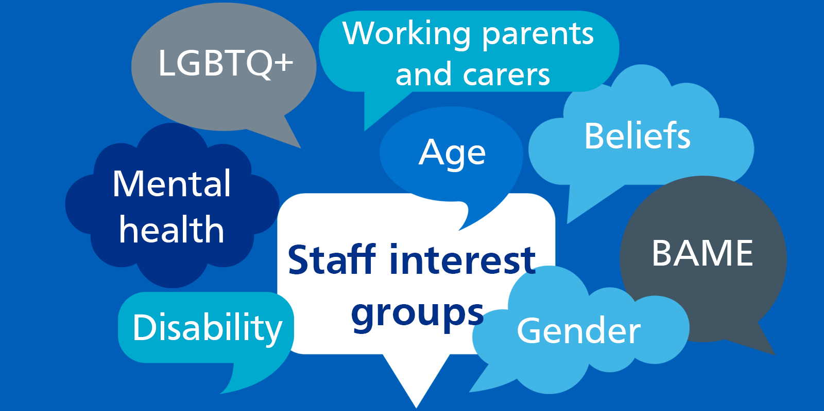
We established a steering group led by our Deputy Director of Transformation and Corporate Services (tasked with the E,D & I brief) with membership of the lead staff member for each of our groups alongside our Head of HR and Head of Learning & Development. In addition, we benefit from the active membership and involvement of the Unison E&D representative.
In developing the strategy there have been significant discussions within staff-led interest groups reviewing HRA workforce data, staff survey responses and the experiences of staff whilst at the HRA. Discussions within the staff-led interest groups have provided the input which forms the basis of this strategy.
The membership of each staff-led interest groups is confidential to the members of that group. This decision was taken at the outset to create the right environment for sensitive discussions to take place in a mutually supportive space whilst removing barriers such as fear of identification, speaking out or retribution. Membership of the group is voluntary and the only criteria to join is interest – nobody is required to declare any protected characteristic.
Staff-led interest groups can be set up to cover any area of interest, including ones which aren’t protected characteristics although we recognise that the issues they discuss may be relevant to the E,D& I agenda.
The staff lead for each of the groups attends the steering group where they share the themes, nature of the discussions and ideas from the groups to inform the proposals and decisions of the steering group with additional professional expertise from HR, Learning & Development and the Unison E&D rep.
Our intention is to ensure lived experience of staff in our organisation informs our strategy. This lived experience is vital in enabling the organisation to progress meaningful actions and initiatives that have a felt difference for our staff. It also presents the opportunity to better uncover systemic barriers that would otherwise remain unseen.
By working with our staff-led interest groups it is also our intention is to continue to co-develop and co-produce the programme of work that supports this strategy. The benefit of this is the ability to prioritise and move the organisation towards being a more inclusive employer in ways that are identified by those with protected characteristics as being the most effective in making a difference. This partnership approach will also allow the organisation to learn, evolve and build on its progress as we continue to take this work forwards. This shared ownership of this agenda is vital to achieving long-term, lasting results that bring about sustainable felt change for our staff. The journey and learning by staff across the whole organisation is a vital part of this process.
We are also members of the Arms Length Body (ALB) Diversity and Inclusion network where we share best practice and learning across ALBs which has also informed this work.
Equality & Diversity principles
We have agreed a set of principles to guide our work and help us in developing our strategy for the HRA:
- Our equality, diversity and inclusion agenda is owned by the whole organisation (individual and collective action and work)
- We will:
  - use our workforce and staff survey results to benchmark where we are and help us identify areas to prioritise or improve
  - listen to and value the lived experiences of our staff with protected characteristics under the equalities act to help us understand the work that we need to do and prioritise those things that will make a felt difference
  - be a learning and listening organisation, open to feedback and making changes as we go on our journey to creating a more diverse and inclusive organisation
  - share and celebrate improvements and changes we make
  - strive for continuous improvement and change
  - try to create a safe space for open conversations recognising we may need to work in partnership with others to achieve this as a small organisation
  - seek to value, support and celebrate all our staff who are vital to the successes of our organisation
- We recognise that (a) protected characteristic(s) are part of who we are and not our whole identity

Where we are now - our data
The data that informed this was taken in June 2019. This was shared with the staff-led groups for consideration and discussion. The data provided us with a baseline of the diversity of our workforce looking at the different protected characteristics as well as some insight for areas that needed work or further exploration with our staff-led group for that characteristic to determine what work the organisation needed to take forward to become more inclusive.
Our data shows that we employ more women (77%) than men (23%), as a result there are more women than men at each level of the organisation across the pay bands. However, when you look at the data more closely by showing how many women are at each pay band as a percentage of the women in our workforce and how many men are at each pay band as a percentage of the workforce we get a different picture. In this view, women are over-represented at band 6 (men are under-represented) and then under-represented in bands 7 – 8c (men are over represented). At the most senior tier of our organisation women are over represented as a percentage of the workforce.

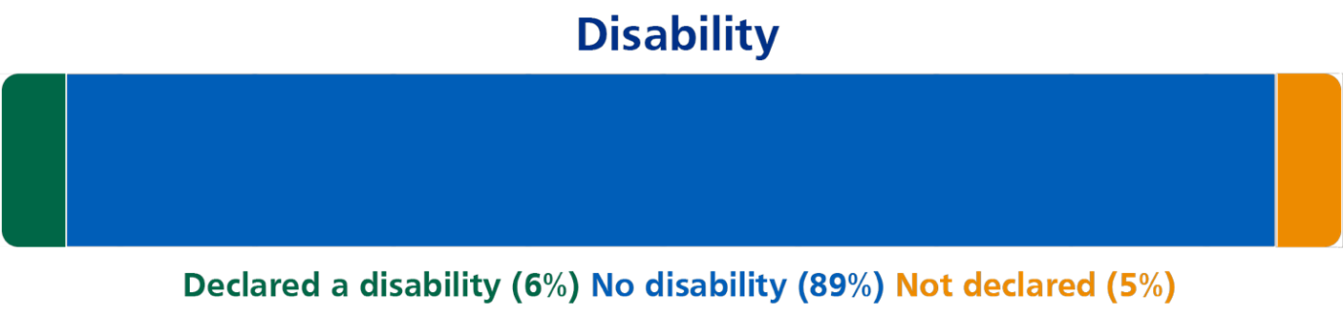
Our data shows that 6% of staff declare a disability, 89% do not have a disability and 5% are not declaring. Typically disability is an area where there can be under-reporting as staff with disabilities under the definition in the Equality Act 2010 do not always define themselves in this way.
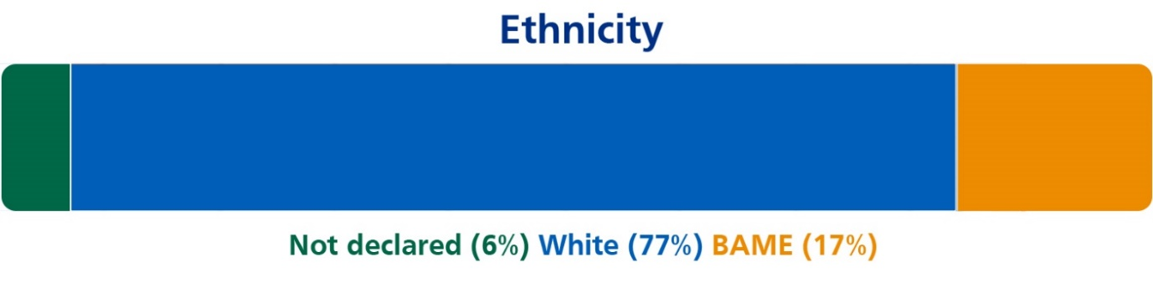
Our data shows that 6% of our people have not declared their ethnicity. Overall 17% of our people are from a BAME background and 77% are from a white background. This compares with national statistics of from the 2011 Census where 80.5% of people in England and Wales said they were White British and 19.5% were from ethnic minorities. https://www.ethnicity-facts-figures.service.gov.uk/
Looking at our data on ethnicity across our structure as a percentage of each group within our workforce we can see that our people from BAME backgrounds are under-represented in bands 7 and above. Undeclared ethnicity is also affecting the accuracy of our statistics across the bandings.

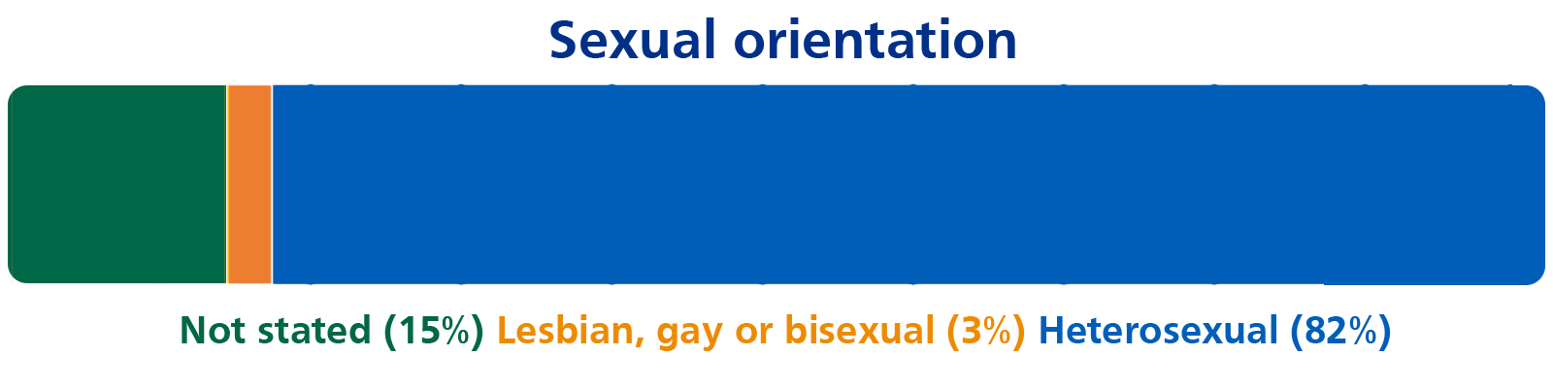
Our data shows that this is the biggest area where we have under-reporting from our staff with 15% of our people not choosing to share this information. There are small numbers reported – 3% sharing they identify as lesbian, gay or bisexual. This compares to national statistics where 2% of the population identify as lesbian, gay or bisexual. This level of under- reporting suggests the organisation has work to do for our staff to be comfortable to share this sensitive information. This may also be an area where the categories available for staff to select do not provide ways for staff to declare how they identify.
https://www.ons.gov.uk/peoplepopulationandcommunity/culturalidentity/sexuality/bulletins/sexualidentityuk/2017
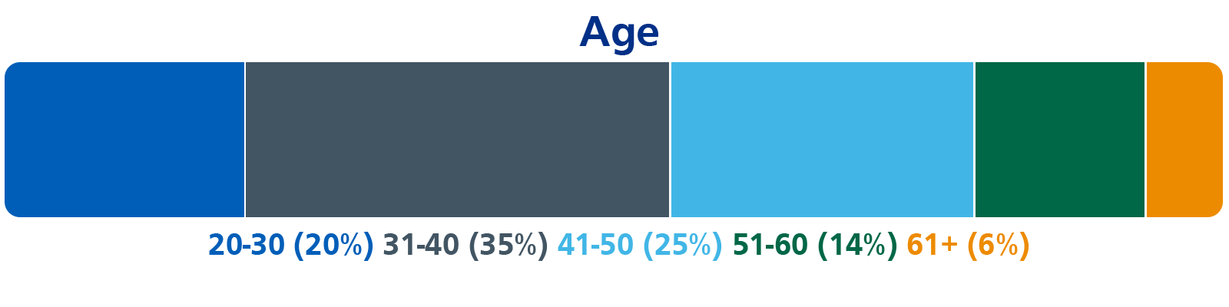
The data shows there is an age range spread across the organisation – the highest percentage of 35% is in the 31-40 age bracket. Percentages are lower in the age ranges above 51.
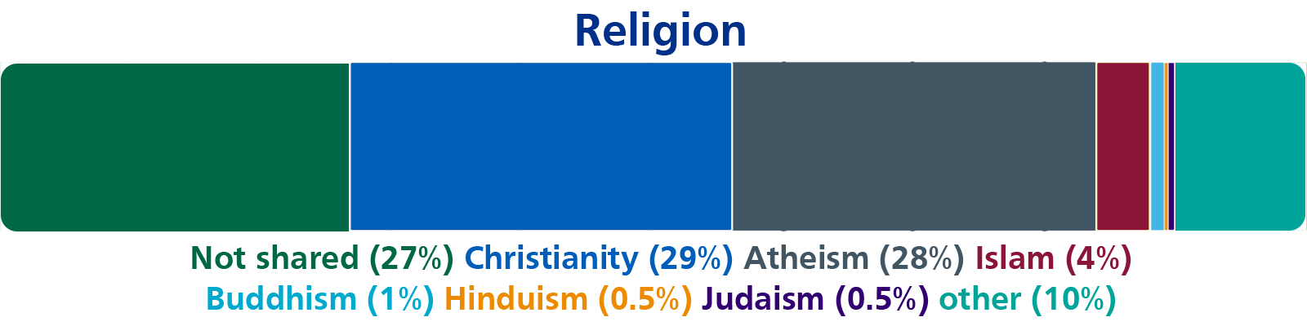
A large proportion of staff (27%) have chosen not to share their religion. The largest percentages are Christianity (29%) and Atheism (28%). Smaller percentages are Islam (4%), Buddhism (1%), Hinduism (0.5%) and Judaism (0.5%). 10% of staff have also selected other suggesting the categories do not cover enough religious groups.

Bullying and Harassment
There were no formally reported cases of bullying and harassment – 3 informal complaints to HR were discussed and resolved informally.

Staff Survey data 2018-19
71% of staff agree the HRA is an inclusive place to work 9% disagree.
67% feel the HRA offers opportunities to staff regardless of their background 9% disagree. 38% of staff from a BAME background disagree.
45% agree the makeup of the HRA staff reflects the local community, 25 % disagree.
The overall staff engagement score is 70%, for staff from a BAME background this is 65%.
13% of staff said they had experienced harassment, bullying or abuse from staff, REC members or the public in the last 12 months. 38% of staff with a disability reported they had experienced this.

The result of discussions within the staff-led groups around the data were a series of themes that were common across the groups for areas where they felt actions and activity should be developed as the basis of the strategy:
- Learning & Development
- Recruitment (including retention and promotion)
- Respect
- Awareness raising
- Social inclusion at work

Activity in support of Equality, Diversity and Inclusion during 19/20
Whilst the discussions in the groups and across the organisation have been taking place to inform the strategy there have been a number of initiatives and actions underway to move the agenda forward and in particular builds on work that has been taking place around policy development:
- Disability leave policy published
- Disability awareness & leave policy training
- Awareness raising activities from the staff-led groups such as blogs, articles, and updates at staff meetings.
- Updates to the whole organisation via the all staff VC.
The staff survey results in 19-20 have also been considered by the staff-led groups, the improved findings could be linked to the work undertaken since June 2019.

Staff survey data 2019-20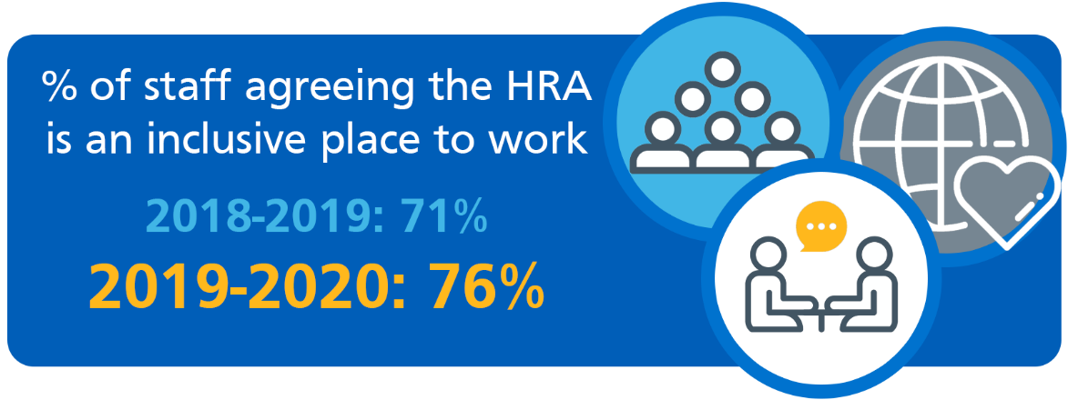
76% of staff agree the HRA is an inclusive place to work (increase of 5 % compared to previous year) and 7 % disagree (decrease 2%).
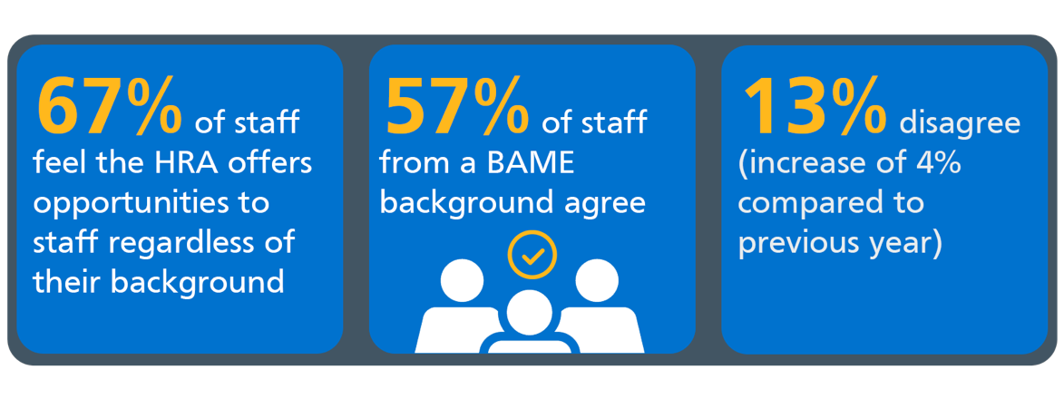
67% of staff feel the HRA offers opportunities to staff regardless of their background (same as previous year although only 57% of staff from a BAME background agree) 13% disagree (increase of 4% compared to previous year). 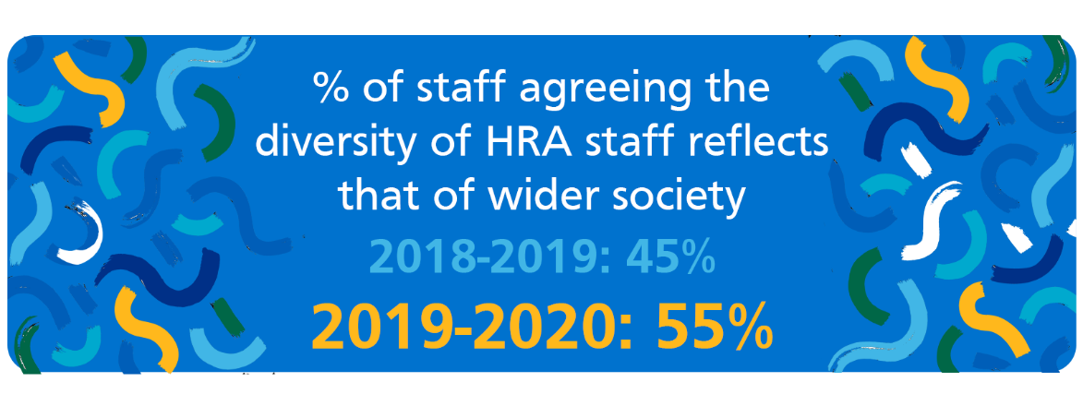
55% agree the diversity of HRA staff reflects that of wider society (increase of 10 % compared to last year) 21 % disagree (decrease of 3% compared to previous year).
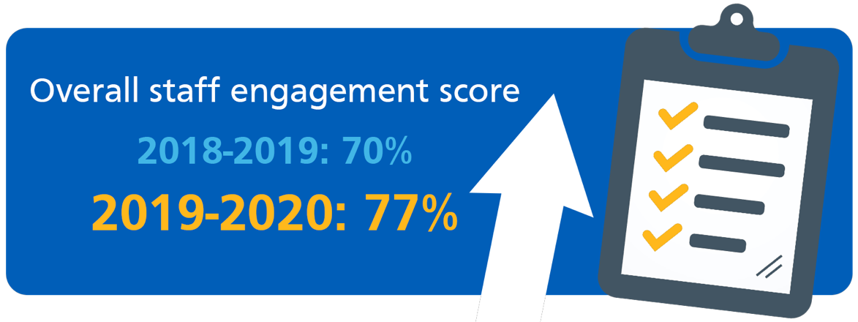
The overall staff engagement score is 77% (an increase of 7% on the previous year), for staff from a BAME background this is 96% (an increase of 31% however the proportion of staff not sharing demographic data may mean this figure is over-inflated so it should be treated with caution).
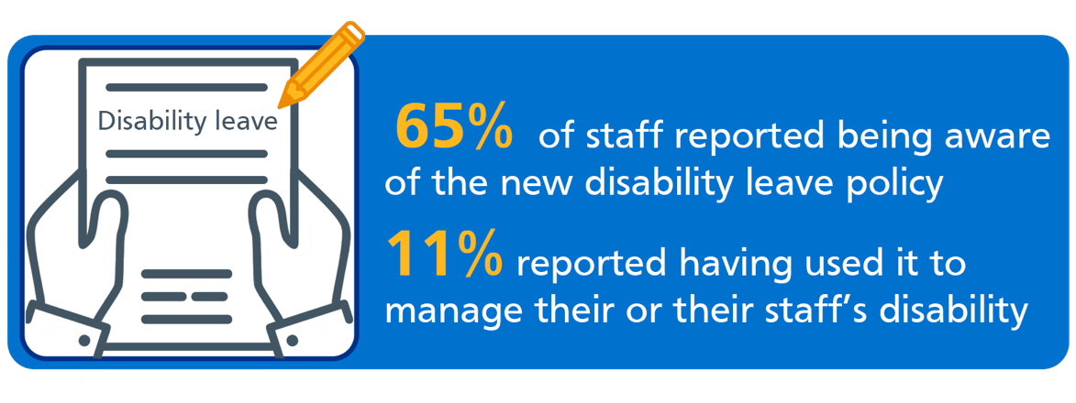
65% of staff reported being aware of the new disability leave policy and 11% reported having used it to manage their or their staff’s disability.
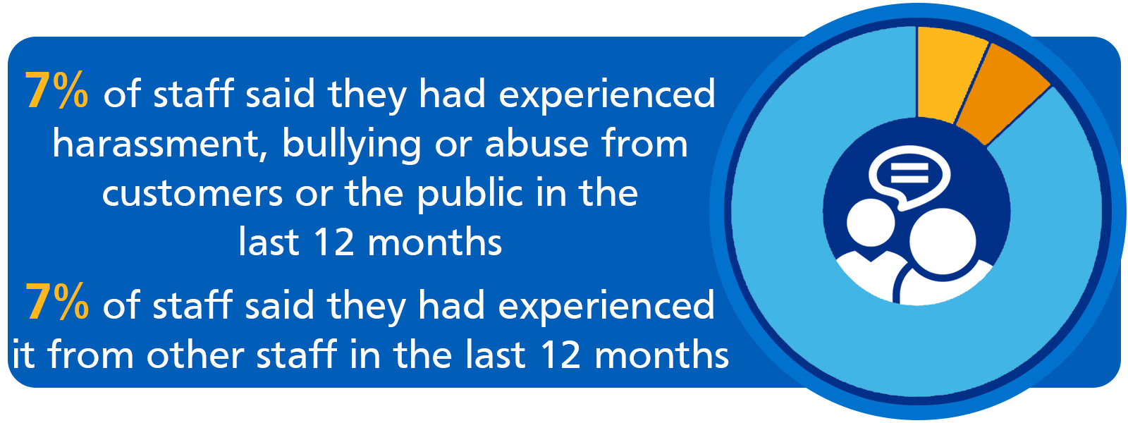
7% of staff said they had experienced harassment, bullying or abuse from customers or the public in the last 12 months and 7% of staff said they had experienced it from other staff in the last 12 months. This question was asked differently to the previous year so the data is not comparable.
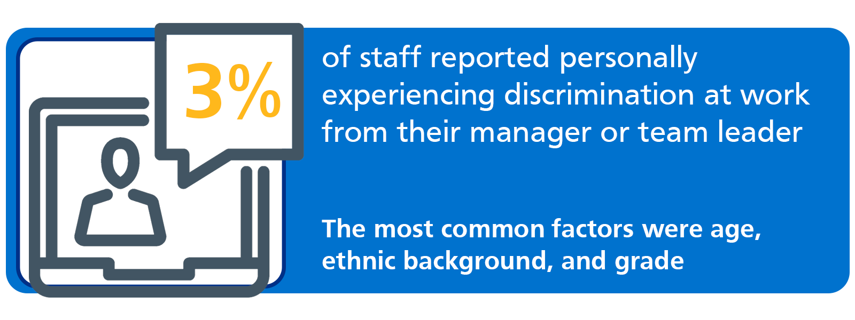
3% of staff reported personally experiencing discrimination at work from their manager or team leader with 7% preferring not to say and 5% reported experiencing discrimination from other colleagues with 7% preferring not to say. Staff were asked on what grounds they believed they had experienced discrimination in the workplace in the last 12 months, the most common factors were age, ethnic background, grade. Other factors included religion or belief, working patterns, caring responsibilities, disability, language, sexual orientation and working location.
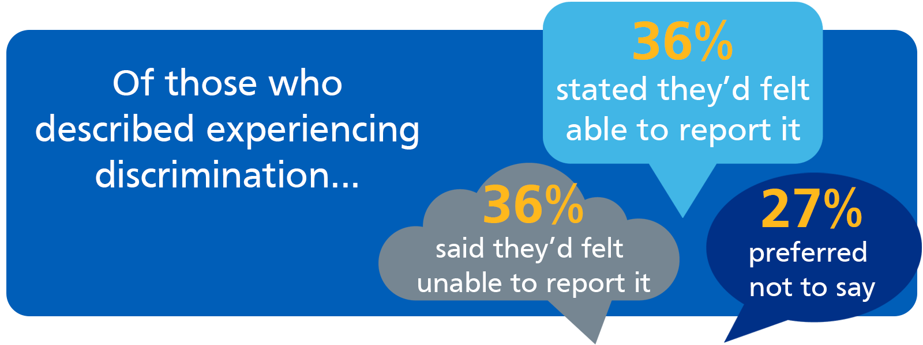
As a percentage of those who described experiencing discrimination 36% said they’d felt able to report it, 36% stated not and 27% preferred not to say.

Equality, Diversity & Inclusion Strategic Objectives 2020 - 2023
It is widely recognised that diverse and inclusive organisations are better placed to meet the needs of the communities they were set up to serve. Our overarching objective is to become a more diverse and inclusive organisation which we will set out to achieve by:
- Developing an inclusive culture
- Promoting and supporting inclusive leadership at the Board. Senior Leadership Team and across the organisation at all levels
- Increasing diversity across all pay bands in particular band 7 and above
- Measuring our progress utilising standards and benchmarking

Planned activity to support strategic objectives
To enable us to make progress with our ambitions we will establish a new permanent specialised role for ED&I to bring expertise and capacity needed to support this area of organisational priority and will recruit to this role during 2020/21.
Many of our activities will support more than one of these objectives, for ease of reference we have placed them under one of the headings. However, it is widely recognised in ED&I work that it is the combination of activities together which leads to improvements and change.

Developing an inclusive culture

A core part of an inclusive culture is respect, where we cultivate positive recognition of difference and create an environment where all our staff feel able to belong and be their true selves at work. This is a whole organisation activity where, as staff members, we are all encouraged to recognise our responsibility to contribute positively to an inclusive culture through our actions and behaviours. We each have a responsibility to value and be curious about different perspectives and lived experiences and recognise how our own privilege and unconscious bias can shape our views.
Our activity to support this objective includes:
- Awareness raising of our ED&I ambitions and agenda; protected characteristics and the associated issues, individual and organisational responsibilities to support change and improvements
- Celebrating key calendar dates including religious festivals, PRIDE, Black History Month, World Mental Health day, etc as identified by our staff-led interest groups
- Developing materials and a Respect campaign
- Developing resources and awareness raising on micro-aggressions and their impact
- Signing up to and participating in the Stonewall LGBTQ diversity champion programme
- Developing information and resources on the staff intranet on protected characteristics, terminology and language in partnership with the staff-led groups
- Implementing the NHS rainbow lanyards and badges initiative
- Introducing awareness of pronouns and implementing their use (i.e. they/them/theirs; he/him/his; she;her;hers)
- Promoting social inclusion at work
- Supporting our staff network of staff-led interest groups
- Supporting our staff to learn and integrating ED&I into existing learning opportunities
- Creating opportunities for wider participation in conversations around ED&I topics and issues e.g curious conversations, workshops, discussion boards, signposting and curating content such as TED talks or podcasts
- Integrating further consideration of ED&I topics and issues into existing policies, guidance and support and creating new policies e.g transitioning at work policy, menopause policy. Ensuring equality impact assessment are conducted when policies are reviewed or first created.

Promoting and supporting inclusive leadership from the Board, Senior Leadership Team and across the organisation at all levels

- HRA Board Chair-led work with public appointments committee and DHSC sponsor to increase likelihood of diverse Board Non-executive director appointments and senior appointments as vacancies arise
- Board ED&I development (e.g. unconscious bias training)
- Strategic Leadership Team (SLT) ED&I self-development and regular discussion of ED&I topics and issues at SLT meetings.
- SLT conscious modelling of inclusive leadership behaviours (see Appendix A) and proactive discussion of inclusive leadership and ED&I within their directorate leadership teams and meetings.
- SLT modelling curiosity and self-directed learning sharing useful existing external learning resources e.g. podcasts, videos, books, articles, documentaries
- Integrating ED&I into learning opportunities for managers.
- Sharing good practice ( e.g. case studies of reasonable adjustments including disability leave)
- Review of line manager guidance & toolkits to support inclusive management

Increasing diversity across all pay bands in particular band 7 and above

There are two elements to addressing this, the first is focussed on externally recruiting to HRA roles with a particular focus on bands 7 and above. The second is focussing internally to develop existing staff to be able to secure more senior roles.
- Review the recruitment lifecycle starting with data analysis to benchmark where the organisation is and identify areas for attention to improve in this area. Develop a plan to address areas including adverts, reach to pool of applicants, language in JDs and adverts, diversity of interview panels, etc
- Unconscious bias training and best practice refreshers for recruiters
- Review the approach to developing talent
- Positive action development and learning opportunities for staff with a disability, LGBTQ+, from BAME, or women under-represented at band 7 and above as part of a wider emerging leaders learning & development programme.
- Accessing positive action programmes such as the NHS Leadership academy programmes for BAME staff when we are able to do so.

Measuring our progress utilising standards and benchmarking

Standards and benchmarking are vital for measuring progress and identifying areas where further improvements can be made. To enable the organisation to learn, change and progress they are a useful tool to assess where more work is needed or where the activity the organisation is undertaking is making a difference. However, they have their limitations which is why the feedback from the staff-led interest groups is vital in understanding if our work is making a difference to the experiences of those with protected characteristics within our organisation. The following are the standards/indexes we intend to use, some of which we have begun to participate in already:
- NHS Workforce Race Equality Standard
- NHS Workforce Disability Equality Standard
- Stonewall LGBTQ UK Workplace Equality index
- Disability Confident Employer
- Gender pay gap reporting

Underpinning all of this activity with be the commitment to the principle of learning, accepting that as an organisation we will not always get it right with our work in this area. We are committed to adjusting and changing what we do and how we do it to make progress.

Delivery
The detailed plan will be developed by the ED&I Manager once they are in post (May 2021). During the development of this strategy the Steering Group, HR, Learning and Development and staff-led interest groups have already been taking activity forwards to make progress with our work and have developed an outline plan. Much of the work will be carried out in partnership with the members of the staff-led interest groups through the leads for each group.
The pace of work will be dictated by the availability and capacity of staff to engage with the activities where we are working in partnership noting that for this work is done voluntarily within work for the benefit of themselves, colleagues and the organisation and as such is greatly appreciated. This also means we need to mindful of the burden and to carefully balance their input with the work that the organisation can undertake with their input.
Work led by the organisation will be planned by the relevant heads of function (e.g HR, communications, learning and development).
This work will continue at the pace we can currently achieve with the expectation that once in post the ED&I Manager will be able to increase our ability to deliver against our ambitions.

Outcomes
As a result of our E,D & I work we would expect to achieve:
- An increase in declaration rates of protected characteristics by our staff providing us with better quality data on which to base our analysis and inform our work
- An increase in the diversity of our workforce both in overall numbers and showing an improvement in the diversity of band 7 and above particularly relating to the characteristics of race, gender (women), disability and sexual orientation.
- Improvements in staff survey data relating to equality and diversity
- Improvements in awareness and experiences of staff

Governance
The full plan will be regularly reviewed by the E,D &I steering group who will ensure its updated to reflect the capacity and availability of staff to deliver the work. Members can share the plan with their staff-led interest groups so that there is a shared understanding of how and when we plan to carry out the activities within it. The plan will also have oversight within the overall Supporting our People programme so that any challenges or issues with delivery can be escalated for support to resolve by the Supporting our People programme board or where further escalation is needed the Workforce Board.
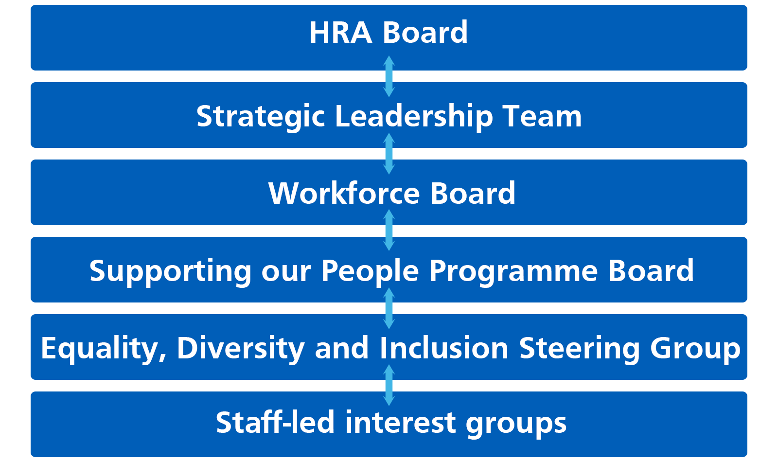

Costs
The funding for the ED&I role has been identified to enable this to be a permanent appointment as part of the HRA establishment.
A business case will be submitted via the HRA’s internal processes for funding for participation in the Stonewall Diversity champion programme and equality index, Board development, and supporting resources and material as part of the business planning process for 2021/22– approx. £10k.
Funding within existing Learning and Development, Comms and HR budgets should be able to support other integrated activities.

Evaluation & Reporting
Progress against the outcomes will be monitored annually and reported to the workforce board. The ED&I Steering group will consider the progress against the outcomes and will adjust the plans and activity in response to what we are learning as an organisation in our delivery.

Appendix A
Six Traits of Inclusive Leaders
- Visible commitment: They articulate authentic commitment to diversity, challenge the status quo, hold others accountable, and make diversity and inclusion a personal priority.
- Humility: They are modest about capabilities, admit mistakes, and create the space for others to contribute.
- Awareness of bias: They show awareness of personal blind spots, as well as flaws in the system, and work hard to ensure a meritocracy.
- Curiosity about others: They demonstrate an open mindset and deep curiosity about others, listen without judgment, and seek with empathy to understand those around them.
- Cultural intelligence: They are attentive to others’ cultures and adapt as required.
- Effective collaboration: They empower others, pay attention to diversity of thinking and psychological safety, and focus on team cohesion.

Juliet Bourke and Andrea Titus, Harvard Business Review March 2019

