

|  |  |
| --- | --- |
| **Agenda item:** | **14** |
| **Attachment:** | **G** |

**HRA BOARD COVER SHEET**

|  |  |
| --- | --- |
| **Date of Meeting:** | 15th May 2019 |

|  |  |
| --- | --- |
| **Title of Paper:** | Finance report - for the 12 months ended 31 March 2019 |
| **Purpose of Paper:** | To enable an informed understanding of our financial performance for the 12 months to 31 March 2019.  To improve decision making by increasing financial literacy particularly in relation to our 2018/19 financial plan and future financial strategy. |
| **Reason for Submission:** | The Board, Accounting Officer and Leadership Team have a key governance role in the financial stewardship of the HRA.  This report supports this aspect of the governance framework, providing the Board, Accounting Officer and senior management with essential financial information to inform strategy, inform decision making and ensure robust financial management. |
| **Lead Reviewer:** |  |
| **Details:** | Main points to note:   * **Year to date financial performance** is an **underspend** of **£204k (1.4%)** (2017/18: £4k (0.03%) on revenue expenditure and **£2k (0.1%)** (2017/18 £4k (0.5%) underspend on capital expenditure. * **Including within overall figures:**    + **An underspend on ring-fenced transition funding, £179k.** Staff redeployment and natural turnover have reduced requirements saving money for the public purse.   + **An underspend on ring-fenced funding** for depreciation, **£25k.** This is due to phasing of expenditure. * **Financial plan for 2019/20 has been approved** by the HRA Board. Balanced budget has been presented but relies on a further £400k unallocated savings to fund NHS Pension and Agenda for Change budget pressures. * The HRA continues to meet its **regulatory requirements** in paying invoices quickly. |
| **Suitable for wider circulation?** | **Yes** |
| **Time required for item:** | **10 minutes** |

|  |  |  |  |
| --- | --- | --- | --- |
| **Recommendation / Proposed Actions:** | **To Approve** | | **Yes** |
| **To Note** | |  |
| **For discussion** | |  |
| **Comments** |  | |

|  |  |
| --- | --- |
| **Name:** | Karen Williams & Sylvia Hazard |
| **Job Title:** | Director of Finance, Procurement and Estates, Deputy Director of Finance |
| **Date:** | 08 May 2019 |

**Finance Report - Financial Year 2018/19**

**Health Research Authority as at 31 March 2019**

**Executive Summary – Headlines**

* The HRA 2018/19 outturn for the 12 months of the year was **£14,577k** (2017/18: £13,396k) and **£1,934k** (2017/18 £796k) capital. On revenue expenditure this represented an underspend of **£204k, 1.4%** (2017/18 £4k, 0.03%) and on capital expenditure a **£2k , 0.1%** underspend (2017/18 £4k, 0.5%). Increased expenditure compared to 2017/18 relates to investment in the research systems transformation programme off set by £397k organisation efficiencies made in year
* **Capital expenditure** is in line with expectations. Capital and revenue classification has been revised to reflect new approach to systems development. A further revenue to capital transfer has been undertaken in March to reflect this application. DHSC have been informed and our proposed accounting treatment will be subject to audit as part of the statutory annual report and accounts process.

**Revenue financial performance for the 12 mths-ended 31 March 2019**

|  |  |  |  |  |
| --- | --- | --- | --- | --- |
|  | **Year ended 31 March 2019**  **£000** | | | |
|  |  |  |  |  |
| **Income** | **Budget** | **Actual** | **Variance** | **Variance%** |
| Grant in Aid confirmed inc AfC increase | 12,423 | 12,423 | 0 | 0.0% |
| Research systems Prog (revenue) | 673 | 673 | 0 | 0.0% |
| Transition Funding | 500 | 321 | -179 | 0.0% |
| HRA income | 186 | 186 | 0 | 0.0% |
| Non cash revenue resource limit | 1,000 | 975 | -25 | 0.0% |
| **Total Income** | **14,782** | **14,578** | **-204** | **-1.4%** |
| **Expenditure** | **Budget** | **Actual** | **Variance** | **Variance** |
| Approvals - Operational | 5,444 | 5,403 | -41 | -0.8% |
| Approvals - Programme and Guidance | 780 | 774 | -6 | -0.8% |
| Approvals - Member Support | 552 | 557 | 5 | 0.9% |
| Research systems | 1,179 | 1,183 | 3 | 0.3% |
| Confidentiality Advisory Service | 211 | 201 | -10 | -4.8% |
| Total Services Expenditure | 8,168 | 8,118 | -50 | -0.6% |
| Chief Exec and Board | 347 | 345 | -3 | -0.7% |
| Policy | 509 | 496 | -13 | -2.6% |
| Governance ( inc. Quality) | 331 | 333 | 3 | 0.9% |
| Training | 495 | 488 | -7 | -1.4% |
| Corporate Services ( inc IT Services) | 1,378 | 1,452 | 74 | 5.3% |
| Transformation | 835 | 857 | 23 | 2.7% |
| Premises | 836 | 818 | -19 | -2.2% |
| Finance, Procurement & Estates | 695 | 708 | 13 | 1.9% |
| Reserves | 189 | -11 | -200 | 0.0% |
| Depreciation | 1,000 | 975 | -25 | 0.0% |
| **Total Expenditure** | **14,782** | **14,578** | **-204** | **-1.4%** |
| **Surplus /Deficit** | **-0** | **-0** | **0** |  |

**Highlight report:**

**Overall**

As previously reported, there are **no significant financial variances** on business as usual activities although budget pressure remains. Finanical management has benefited from tight control of costs and budgets, with budget managers supported by finance colleagues managing the resources delegated to them carefully, in line with our statutory and strategic objectives. With a significant proportion of costs recurrent and committed, organisational change processes throughout the HRA in 2017 – 2019 have helped reduce fixed costs to meet spending review requirements. Looking forward to 2019/20, £700k (6%) annual economies have been achieved through these initiatives with an overall reduction in FTE of 20 (approx. 10%).

Despite these steps, **long-term impact of tight fiscal environment** remains a concern with no ‘head-room’ in Grant In Aid funding to invest. Further streamlining and automating of processes are key if we are to achieve our target operating model along with continued cost reduction and developing new sources of revenue to achieve a sustainable model for the future.

**Transformation costs** include research systems replacement programme £2,002k (£673k revenue; £1,329k capital), future services programme (FSP) (to replace our ICT infrastructure support contract and invest in Windows 10) £192k and service improvement programme activity £63k. Expenditure continues to be managed within budget.

Budget pressure in research system replacement programme remains and has been partially mitigated through the approval of 2019/20 funding for phase 2 of the programme. HRA are redesigning the programme roadmap to reflect stakeholder requirements and the funding envelope set. This inturn will be used to inform the commercial strategy for this programme and subsequent procurement exercise, supported by DHSC commercial team. A strategic governance review of the programme has also been commissioned with Government Internal Audit. FSP and Windows 10 costs are predicted to be lower than planned this year (approx. £50k) due to delay in getting the FSP programme up and running. Funding for this programme for next year has been confirmed and is greater than originally planned due more of the programming shifting into 2019/20.

**Savings achieved***–* £397k recurrent savings have been achieved through activities initiated in 2017/18. Further savings of £330k have been ring-fenced through 2018/19 activities relating to organisational change. HRA are also reviewing our existing contractual arrangements to gain efficiencies and economes from commercial arrangements where contract terms permit.

**Key variances:**

**Approvals – Operational:** £41k, -0.8%. Underspend primarily due to non-pay travel costs, and vacant support staff posts. This was a forecast underspend and supported planned overspend in other areas. In relation to travel the underspend is expected to be non-recurrent due to increased team meetings/new process days in delivering the new integrated structure from 1 April 2019.

**Corporate Services (inc IT Services):** £74k, 5.3%. The overspend within this area relates to the Win10 project and was supported by planned underspends in other areas (Future Services Programme)and from unallocated reserves.

**Transformation:** £23k, 2.7%. Overspend due to project extension impacting on travel, project support and Implementation partner budgets. These pressures have been managed from underspends on operational activities.

**2018/19: financial risks:**

1. **Complexity of research systems, interoperability and Brexit** present financial risk to the HRA. Costs associated with the current architecture may increase due to significant delivery risk, creation of technical debt and additional costs of parallel running. Business case submitted to mitigate this risk has been approved with a proportion of the funding requested released. HRA are working up detailed planning for second phase of the programme to ensure this risk is managed.
2. **Organisational and technological system changes have identified £700k (approx. 6%) economies** to meet spending review requirements in 2019/20. Despite these savings, cost increases arising from external environment (Agenda for Change 2018 terms and conditions; NHS Pensions Employers Contribution proposed increase and FSP) place further challenge on limited funds. Further £300k economies required to remain within budget envelope. Savings plan is being developed to manage this budget pressure.
3. **Increasing pressure to deliver on transparency** **remit** could place additional demands on already limited resources. Requirements are being reviewed with initial response to select committee report by the end of the calendar year.
4. **Estates strategy:** HRA is committed to working with government intiatives and with the health family to secure value to the exchequer and enable our estates strategy. Set up costs associated with the London strategy agenda are currently subject to a DHSC business case. If this business case is not successful there is a risk that the associated costs of securing a new London location (Skipton House end of lease – 2021) will not be affordable.

**Staff costs (Year-ended 31 March 2019)**



**Approvals:** -£31k (0.5%) underspend was expected and profiled to the end of year, and mostly related to vacant (unbackfilled) admin support roles within the directorate. The capacity remained in place to meet service levels and deliver on organisational change to achieve an integrated team. Organisational change process has delivered agreed economies in line with our target operating model and will provide be implemented 1 April 2019.

**Corporate Services**: £22k, (1.2%) over budget. Cost increase relates to reclassification of Apprentice Levy costs from Non-Pay into Pay.

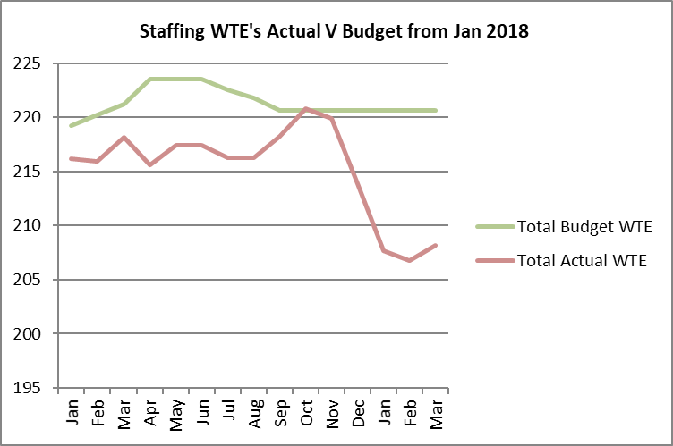

Agency staff in Oct/Nov utilised to provide sufficient capacity to delivery operational services pushing establishment numbers slightly over plan. This additional resourcing was funded from in year underspends. Reduction in December reflects natural turnover with staff leaving to take up opportunities in the health research sector combined with lower agency numbers over the seasonal period.

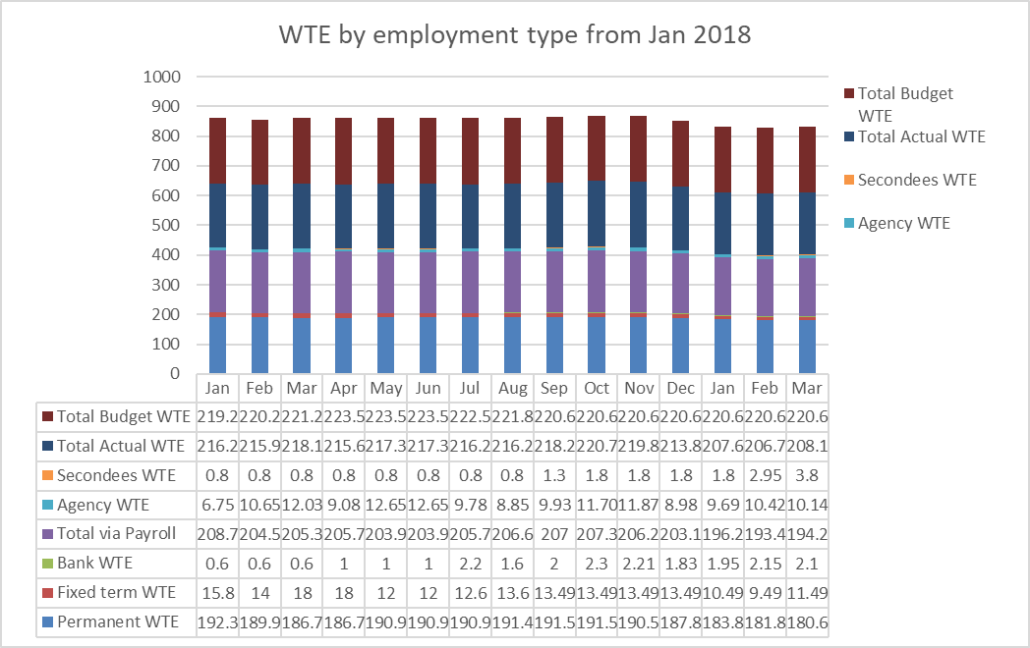

**Non-staff costs**

**No significant variances** to report at this stage of the year.

**Estates related costs** – lease re-gear and sub-lease wiith HS2 in our Manchester office is now complete (April) and HS2 are due to move into Manchester at the end of April. This will provide approximately £20k cost sharing for 2019/20 together with accommodation certainty to 2023. Skipton House costs are forecast to be £10k greater than budget due to a small revision in shared space allocation.

**Reserves**

Our **GIA funded reserves** programme was revised to **£432k.** This is in addition, to our fully funded **RS transformation programme, £2,002k** (funded by DHSC Research funding and Brexit funding).

|  |  |
| --- | --- |
| **Programme** | **£000** |
| Future services programme including Windows 10/ VC Amendment and Office 365 upgrade | 298.5 |
| Service improvement programme (including 2nd phase of ESR roll out) | 53.5 |
| PIER additional capacity | 23 |
| Website development | 8 |
| EU clinical trials and CWOW | 5 |
| Chief Executive recruitment | 40 |
| Organisational change – learning and development | 4 |
| **Totals** | **432** |
| **Released to ledger** | **-432** |
| **Reserves funding required** | **0** |

**Capital expenditure**

Capital expenditure is in line with expectations with a small variance reported at the end of March. There is a small variance in relation to capitalised salaries. This is due to a vacancy in the Research Systems team treated as partly capital.

Investment in existing IRAS and HARP developments are in line with the budget, reflecting activity supporting the 28th June IRAS release and required development in HARP (operational and technical). The accounting treatment of the costs of developing new IRAS has been established and are reflected in the March accounts. Capital allocation for Future Services Programme (£27k) and CRM (£30k) has been redirected to support the development of new IRAS application, in particular integration functionality.

As part of our IT infrastructure upgrade, an additional 70 laptops have been procured to support our move to Windows 10 and Office 365. This purchase is supplemented by a further 40 second hand laptops from DHSC (£112.50/unit; £4,500). This has been funded from the allocation for our rolling replacement programme for laptops.

|  |  |  |  |  |  |
| --- | --- | --- | --- | --- | --- |
| **Plan initiative** |  | **2018/19 plan full year** | **2018/19 budget ytd** | **2018/19 actual ytd** | **2018/19 variance ytd** |
|  | **£000** | **£000** | **£000** | **£000** |
| HARP Developments |  | 215 | 215 | 214 | -1 |
| IRAS Developments |  | 1,458 | 1,458 | 1,568 | 110 |
| **BGO Contract** |  | **1,673** | **1,673** | **1,782** | **109** |
| IS Team – capitalised salaries |  | 106 | 106 | 85 | -21 |
| **BGO Contract and Capitalised salaries position** |  | **1,779** | **1,779** | **1,867** | **88** |
| Future Services Programme |  | 27 | 27 | 0 | -27 |
| ICT infrastructure |  | 100 | 100 | 66 | -34 |
| CRM |  | 30 | 30 | 0 | -30 |
| **Total Capital** |  | **1,936** | **1,936** | **1,934** | **-2** |

**Better payments performance**

The HRA has continued to meet the duty to pay 95% of invoices in 30 days, also maintaining the internal stretched target of paying 60% of suppliers in 10 days.

|  |  |  |
| --- | --- | --- |
|  | **Number** | **Value (£)** |
| **Benchmark** | **95%** | **95%** |
| **2018/19** | **99%** | **100%** |
| **2017/18** | **98%** | **98%** |
| **2016/17** | **98%** | **98%** |

**Recommendations**

The Board are asked to review and approve the finance report for the year-ended 31 March 2019

**Sylvia Hazard and Karen Williams**

**Deputy Director of Finance and Director of Finance, Procurement and Estates**

**08 May 2019**