HRA 2019 Staff Survey

- Introduction

  - This paper represents the management response to the findings of the 2019 staff survey and offers the opportunity for the Board and Staff Forum to discuss those areas where responses either represented the lowest level of satisfaction or most negative differences to the BMG benchmark (an average score calculated across many other organisations) and to comment on the approach suggested by the Senior Leadership Team.

  - It is worth noting that the survey was undertaken before people had moved into new roles – where a significant number had promotion. It is suggested that the generally lower responses are not a surprise in the context of the level of significant change – not just in Approvals – and that whilst recognising that this is difficult for staff, the scores are actually overall indicative of a change process that in general has been managed as best as possible

  - Analysis of the main findings of the survey will be presented directly back by BMG at the meeting

- Overall Survey Headlines

  - The following offers a high-level summary of the key findings derived from the 2019 survey undertaken during February/March 2019. A total of 157 responses were received, giving a response rate of 72%. This is a decrease on the rate recorded in 2017 (78%).

- The HRA achieved 28 out of 50 results above the BMG benchmark and out of the 89 comparable year on year questions 5 improved 38 had stayed the same and 46 had deteriorated since the 2017 survey
- Least positive scores were the from Research Ethics Service - which has been a trend in each of the previous surveys – however generally strong scores from other functions within Approvals Directorate and other Directorates
- Overall ‘new starters’ and those at more senior levels were more positive in their responses
- Still many who did not want to state their directorate or office base
- Responses were significantly more negative than in 2017 particularly around morale, ‘speaking up’ and general job satisfaction
- Respondents still felt they were able to offer an excellent service to their customers (up 5%)
- 8 out of 10 indicators around the management of change had decreased although understanding the need for change had increased and how well change is managed was still 15% better than the BMG benchmark
- Career development and pay were the characteristics that people were most concerned about improving
- New questions around Equality and Diversity were introduced this year and whilst the vast majority (71%) felt the HRA was an inclusive place to work 24% felt that they weren’t respected in their role
- Workload remains a significant concern for many
- Within and across directorates and locations there were a number of significant variations

- Progress against areas for improvement identified from 2017 Survey

  - This meeting also presents an opportunity to reflect on progress made against 2017 priorities.

Area | Change | Comment
HRA makes good use of my skills and ability | down 9% | Primarily concern was expressed from those within the ‘REC Service’ however the new structure has tried to take account of this with more roles requiring greater skills and expertise
Senior Leaders (Executive Team) are approachable | up 19% | Indicates generally positive experience when colleagues interact with the Senior Leadership Team
View on effectiveness of Staff Forum | up 2% | Though slight decline in knowing who reps were
Opportunities for Career development |  | Same score as 2017 (35%) remains the characteristic people would most like to improve in their job. Awareness of this feedback from previous years had been taken into account in new structures with more line management opportunities and more career structure
Managing poor performance | up 13% | Difficult to ascertain what the specific causes are for this improvement though more support has been offered to line managers in the last 12 months
Having a manageable workload | down 7% | Though ability to have a good work life balance has remained at 2017 levels
Reliability of IT | up 4% | Significant investment in developing a better service has resulted in some improvement
Looking for a job in next 12 months | up 10% | Probably a strong link with the changes that have taken place and the uncertainty that brings although it is hoped that when the new structure beds in there will be less inclination for people to look to leave
Learning and Development to do my job effectively | down 6% | Lowest score was within Corporate Services (includes Finance and Policy) 48% compared to 58% for the whole organisation which represents a ‘buck’ in trend compared to the rest of the survey

- Further detailed analysis – Lowest scoring areas and those scoring lowest against the BMG benchmark

  - The focus for the remainder of the report is to consider response to the lowest scoring areas and those with scored lowest against the BMG benchmarks.

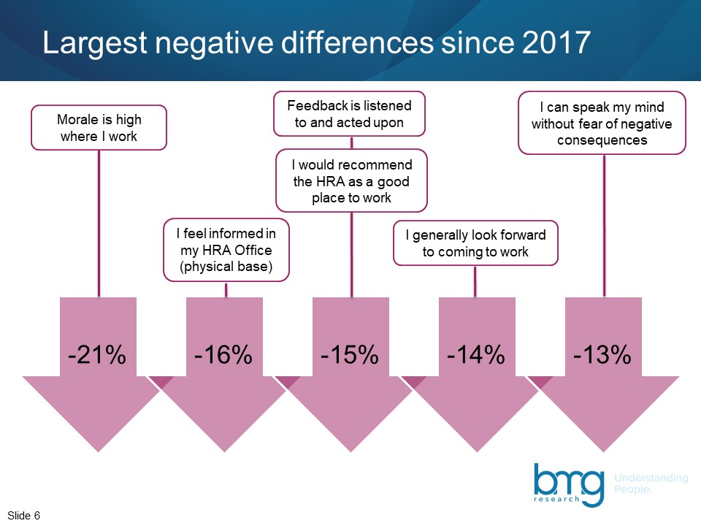

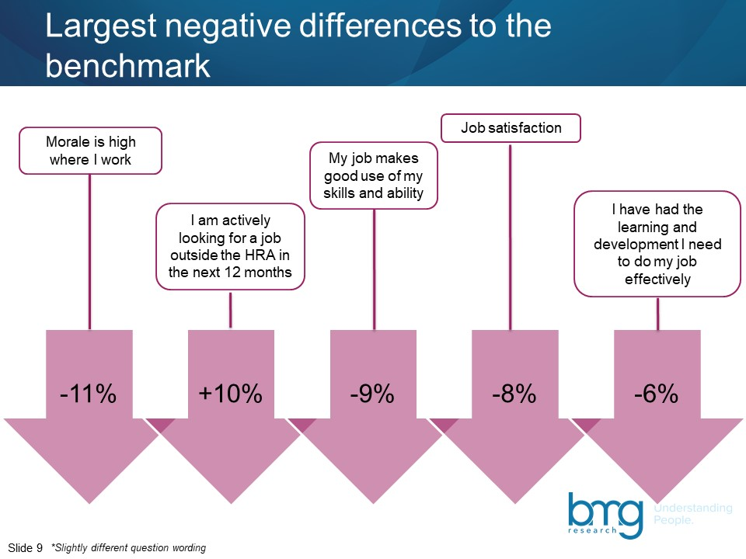

  - In considering how best the organisation responds to these results it may be worth presenting them in the form of cause and effect model (see below)
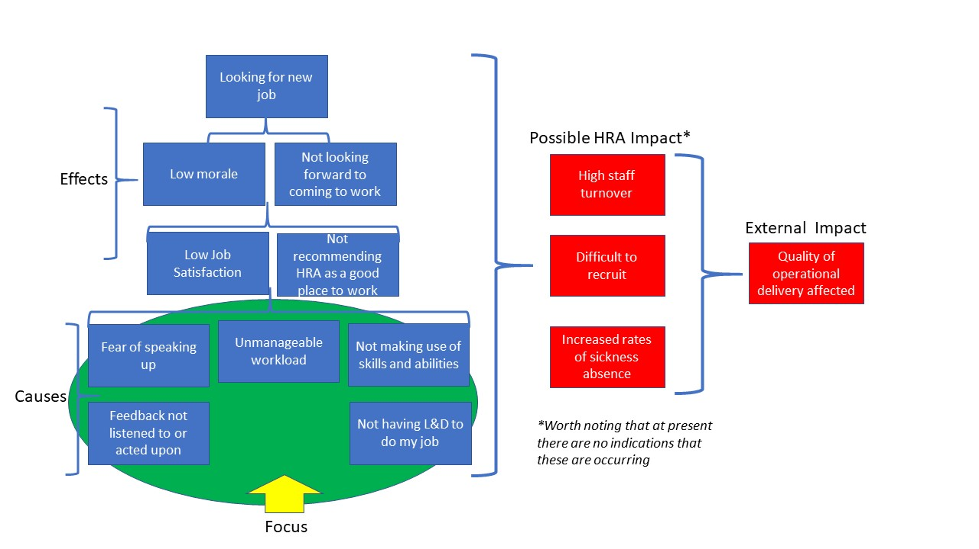
  - If we use this model as a way to frame our thinking around how best to respond, logic suggests that we focus on the main causes which if successfully addressed should impact on the poor outcomes being experienced by sections of the organisation i.e. low job satisfaction, poor morale etc.

  - In terms of creating a plan that responds to these key ‘causes’ there would appear to be a number of logical steps that need to be followed

- Trying to understand more around the underlying factors that have influenced responses

- Considering and agreeing mitigating actions (short, medium and longer term) that will address these factors

- Putting in place monitoring activity to gauge impact of changes

- Steps that have already been taken

Fear of speaking up/feedback not being listened to or acted upon
Understanding underlying factors | The HRA has always striven to ensure that staff feel that they can actively engage in discussion and if necessary be challenging/questioning around areas of change that they or their colleagues are affected by. In terms of feedback we are exploring the concept that the issue may be more around it not being acted upon rather than not listened to – which may be for good reason or that it has been, but the impact hasn’t been felt yet
Actions | Changes to the structure in the Approvals Directorate are intended to enable a more open and supportive system and across the HRA we are looking to improve how we respond to feedback to ensure there is a better understanding on what actions have been taken as a result it.

Workload
Understanding underlying factors | Workload remains an issue, particularly in the Approvals Directorate and is probably of most concern out of all the survey findings. The programme of change remains significant and touches all. Furthermore, HRA was required to achieve significant savings from the change, whilst achieving no compulsory redundancies and minimising voluntary redundancies. Stretched budgets and prioritisation of other areas of work meant that some developments that could have reduced workloads could not be implemented in advance of the implementation of the new structures in the Approvals Directorate.
Actions | The SLT are actively engaged in looking at ways of taking out some of the stress as new structures and working practices bed in and the senior team within the Approvals directorate are working closely with staff on the concerns that have been expressed and are already implementing appropriate responses. We are also looking at how we can more effectively support the physical and mental health and well-being of colleagues as well as developing a supportive L&D programme that helps individuals build their own personal resilience and coping strategies.

Not making use of skills and abilities
Understanding underlying factors | The response appears to be primarily from junior staff in the RES who have historically had no career structure and development opportunities.
Actions | The new Approvals structure will provide more career opportunities and greater exposure to research system to gain skills and expertise.

Not having necessary L&D to do my job
Understanding underlying factors | This appears to be less of an issue for Approvals in relation to actual job as lots of training is, and will be, given in house. However within Corporate Services there is a need to understand further what contributed towards the reduction in response compared to last year. There is also perhaps a perception that the HRA need to offer more L&D for career development even if not directly relevant to their job
Actions | An internal reference group has already been set up, which includes strong staff representation, which will act as a valuable source of feedback from staff. The HRA are also in the process of agreeing a number of days flexible study leave for all staff as well as interest free loans for more expensive forms of study. It is also worth noting that significant work has been invested into the L&D pages on the intranet (the Learning Zone) where staff have access to a raft of useful information and links to L&D information and it’s the most visited set of pages (apart from the home page).

  - Monitoring – The impact of projects/policies/activities developed as a result of the survey will be monitored through regular reporting to the Leadership Team. It is also intended to carry out a series of ‘temperature’ checks i.e. short high-level surveys via the intranet to review the ongoing experience/perception of staff in relation to these key issues. The Staff Forum and the Joint Negotiating Committee will also remain critical sources of information in gathering feedback.

- Conclusion

  - The results of the 2019 survey are less positive than in previous years, however the timing and circumstances of when the survey was carried out undoubtedly had an impact on the outcome. Therefore, the results were not surprising, and it was still pleasing to see that they held up well in a number of areas and across a broad range of questions. Notwithstanding this there is still much to consider in relation to the main root causes of the concerns expressed by staff and the senior leadership team is committed to working with colleagues across the HRA to ensure that the necessary and appropriate steps are taken to improve results in the next survey

Ian Cook
Director of Transformation and Corporate Services
8 May 2019

