Agenda item: | 11
Attachment: | E

HRA BOARD COVER SHEET

Date of Meeting: | Leadership team: 8th May 2018  Board: 16th May 2018

Title of Paper: | Finance report - for the 12 months ended 31 March 2018
Purpose of Paper: | To enable an informed understanding of the HRA’s financial performance for the year-ended 31 March 2018.
Reason for Submission: | The Board, Accounting Officer and Leadership Team have a key governance role in the financial stewardship of the HRA.  This report supports this aspect of the governance framework, providing the Board, Accounting Officer and senior management with essential financial information to inform strategy, inform decision making and ensure robust financial management.
Lead Reviewer: | Steve Tebbutt
Details: | Main points to note:  - The full year’s financial performance is £13,396k expenditure compared to a revenue allocation of £13,400k. This resulted in a small underspend position of £4k (0.03%).  - On capital expenditure, our year-end position was £796k compared to a capital allocation of £800k, giving a small underspend of £4k (0.5%).  - Close monitoring of our forecast and nimble investment decisions to best meet our strategic objectives have ensured we have fully utilized our available resources this year. This also reflects the tightening fiscal environment and the need to secure structural savings to meet future spending review requirements.  - 66% of our costs are staff costs, consistent with our budgeted level (66%). Underspends achieved early in the year have been reinvested in additional staffing resource towards the tail-end of the year to help bolster capacity.  - We have reduced our cash position in year to better reflect our annual requirements. Our cash position at the end of the year was £965k compared to £3,485k 31 March 2017.  - Key investment decisions in qtr4 include: £51k in training module IP; £68k RS infrastructure; £18k penetration testing; £49k IRAS question architecture; £20k ESR roll out; £10k project support and £73k investment in our rolling laptop programme.  - Key criteria informing these decisions include supporting the transformation programme (RS development and capacity building) and projects that provide a return on investment to meet spending review targets.  - The HRA continues to meet its regulatory requirements in paying invoices quickly and meeting key finance deadlines.
Suitable for wider circulation? | Yes
Time required for item: | 10 minutes

Recommendation / Proposed Actions: | To Approve |  | Yes
 | To Note
 | For discussion
 | Comments

Name: | Sylvia Hazard and Karen Williams
Job Title: | Deputy Director of Finance and Director of Finance
Date: | 4th May 2018

Finance Report - Financial Year 2017/18
Health Research Authority as at 31 March 2018

Executive Summary – Headlines

- The HRA 2017/18 outturn for the year was £13,396k (2016/17: £12,932k) and £796k (2016/17 £770k) capital. On revenue expenditure this represented a £4k, 0.03% underspend (2016/17 £323k, 2.4% underspend) and on capital expenditure a £4k, 0.5% underspend (2016/17 £140k, 15.4%). Our final year end position is within our financial KPIs and has ensured that we have fully utilised the resources made available to us to meet the requirements of our strategic and operational objectives.
- The HRA continued to meet its regulatory requirements in paying invoices quickly and key finance deadlines.
Revenue financial performance for the year ended 31 March 2018

 |  | 12 Months ended 31 March 2018 (£'000)
 | 2017/18
Income | Latest Budget | Original Budget |  | Actual | Variance |  |  |  |  | Variance%
Grant in Aid confirmed | 12,730 | 12,525 |  | 12,483 |  | -42 |  |  |  | -0.3%
HRA income | 205 | 205 |  | 243 |  | 38 |  |  |  | 18.5%
Non cash revenue resource limit | 670 | 670 |  | 670 |  | 0 |  |  |  | 0.00%
Total Income | 13,605 | 13,400 |  | 13,396 |  | -4 |  |  |  | -0.03%
Expenditure | Latest Budget | Original Budget |  | Actual |  | Variance |  |  |  | Variance
HRA Approval | 2,823 | 2,823 |  | 2,831 |  |  | 7 |  | 0.3%
Research ethics service | 3,796 | 3,796 |  | 3,804 |  |  | 8 |  | 0.2%
Research systems | 1,490 | 1,490 |  | 1,482 |  |  | -7 |  | -0.5%
Confidentiality Advisory Service | 280 | 280 |  | 244 |  |  | -36 |  | -12.9%
Total Services Expenditure | 8,389 | 8,389 |  | 8,361 |  |  | -28 |  | -0.3%
Chief Exec inc. Governance. | 842 | 842 |  | 823 |  |  | -19 |  | -2.28%
Policy | 295 | 295 |  | 296 |  |  | 1 |  | 0.27%
Training | 419 | 419 |  | 421 |  |  | 2 |  | 0.42%
Corporate Services | 1,323 | 1,323 |  | 1,318 |  |  | -6 |  | -0.43%
Finance, Procurement & Estates | 1,666 | 1,461 |  | 1,507 |  |  | 46 |  | 3.18%
Depreciation | 670 | 670 |  | 670 |  |  | 0 |  | 0.00%
Total Expenditure | 13,605 | 13,400 |  | 13,396 |  |  | -4 |  | -0.03%
Surplus /Deficit | -0 | -0 |  | 0 |  |  | -0

Highlight report:
Annual performance remains well within 1% of budget.

Significant variances
Confidentiality Advisory Group: (£36k lower than budget, 13%)
As previously reported, team member retention and lower application numbers have resulted in actual costs being significantly below original expectations. Additional support secured in the year (by an external provider) helped increase capacity in the team temporarily but has not addressed retention challenge. Recruitment exercise is now in progress which will provide greater resilience for the team.

Chief Executive including Governance: (£19k lower than budget, 2%)
Costs lower than expected due to Chief Executive recruitment falling into 2018/19 rather than 2017/18. These costs will now need to be accommodated in 2018/19 financial plan.
Finance, Procurement and Estates (46k greater than budget 3%)
Skipton House rent greater than planned due to renegotiation of the lease by DHSC and associated VAT costs £32k. Cost sharing revenue from NHS BSA off-sets this additional cost (shown in revenue). Organisational change costs less lower than expected legal costs provide the balance.
Pay costs
Our people resource is our greatest asset and represents 66% of HRA’s cost base. For 2017/18 we tracked slightly behind the original budget set, net of vacancy factor for the year. The Board and Senior Leadership agreed that we needed to build additional capacity to support our transformation programme – both service improvement programme and also our research systems programme. This has resulted in January costs being more in line with expectations and February expenditure slightly exceeding original budget. March costs were significantly higher than budget reflecting an increase in annual leave accrual in this year’s accounts as well as costs related to the organisational change process.
Tight control over recruitment and any changes to the establishment remains in place with the recruitment panel overseeing all approvals. Weekly meetings ensure that we are able to balance financial control with the business requirements to act quickly to meet service delivery need.
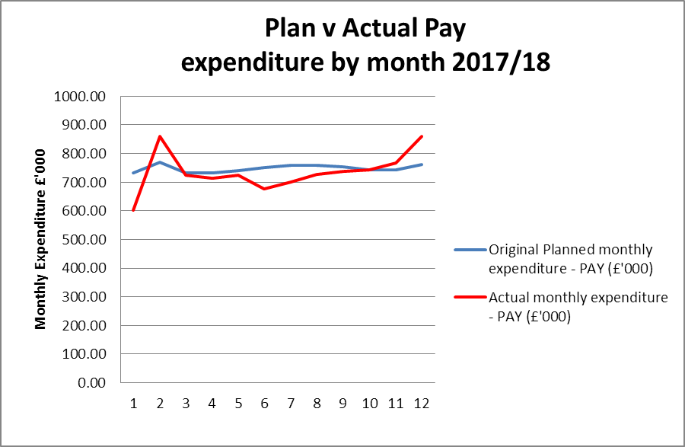
Cost of living increase paid in May (including backdated April payment)
As previously reported, the recently announced NHS pay award (currently in consultation with the unions) will have an impact on future pay (estimated £390k, 4% based on our provisional model). We have informed DHSC of the potential impact who have indicated that this will be fully funded by HMT. More details will follow once they are known. Further work is planned to cost the pay award over the three years based on the proposed model. Final confirmation of the deal and payment are not expected until June / July.
Our work on the target operating model (TOM) remains a key focus to create a structure and establishment that best meets our strategic objectives within our tight financial constraints. Following the executive restructure in 2017, two organisational change processes were completed in March 2018 within finance and corporate secretariat teams. It is estimated that annual savings from this restructure will be in excess of £100k/annum and associated costs of the restructure have been included in 2017/18 figures above. The implementation of these changes is being phased with finance meeting with regional managers and those involved in managing estates to ensure the new systems and ways of working release capacity in the service teams and efficiencies and economies from a consolidated approach to estates contract and budget management.
Travel costs
Travel costs are £13k (2.2%) higher than budget, largely due to training related travel costs.
Travel costs across the HRA | Year to date budget | Year to date spend | % share of total spend | Year to date variance
 | (£) | (£) | % | (£)
Research ethics service | 206 | 222 | 37% | 16
HRA Approval | 113 | 115 | 19% | 2
Confidentiality Advisory Service | 40 | 28 | 5% | -11
Research systems | 27 | 25 | 4% | -3
Total services | 385 | 390 | 65% | 5
Chief Executive ( inc Governance ) | 44 | 34 | 6% | -10
Policy | 28 | 26 | 4% | -2
Corporate Services | 59 | 60 | 10% | 1
Finance, Procurement and Estates | 11 | 13 | 2% | 2
Training Service | 61 | 78 | 13% | 16
Total | 587 | 600 | 100% | 13

Reserves
Reserves have been closely monitored by the senior leadership team on a fortnightly basis. Any changes to our forecast position releasing funds have been reinvested in strategically targeted activities to support our transformation programme and / or provide a return on investment to support our spending review requirements in 2018/19 and beyond.
Strategic aims key:
1. Championing health and social care research
2. Leading improvements that make it easier to conduct high quality research in the UK
3. Develop a pro-active, strategically focussed organisation
4. Capitalising upon technological and data development
5. Ensuring the HRA is managed and governed effectively and provides value for money for the tax payer

 |  | Strategic aims
Reserves projects |  | 1 | 2 | 3 | 4 | 5
Service improvement programme | 110,000
Website development | 85,000
ICT service manager and associated projects | 85,000
Organisational change process | 75,000
IT infrastructure programme | 68,000
Business analyst and tester | 50,000
IRAS questions architecture | 48,000
North East office relocation | 30,000
Health Tissue Authority - direct dialogue project | 25,000
Apprenticeship levy | 21,000
ESR and workforce development | 20,000
Cyber – penetration testing | 18,000
Tissue Bank research | 12,000
Total | 647,000

Financial risks:
- We need to adapt our business and operating model in order to sustain future real-terms funding reductions and create sufficient head room for strategic investment. This work is underway and plans are in place to develop a target operating model this year. Organisational change processes (executive restructure; finance team; corporate secretariat management team) have been performed to meet future requirements and secure economies where possible. Further work is planned to restructure Approvals directorate in 2018/19.

- 2018/19 financial plan requires £400k of economies which may not be achieved. This includes financial benefits from the executive restructure in 2017 (£75k) and organisational change processes within our Finance and Corporate Secretariat teams (£75k) as well as restricting our reserves funding with some projects delayed until funding is available (£100k). A cost saving plan will be put in place by October informed by business as usual requirements as well as transformation programme to meet this year’s and 2019/20 spending review targets.

- The funding available to support the RS systems change programme is time and resource limited. The market testing exercise currently nearing completion, will provide firmer costings to enable HRA to plan available resources. All potential avenues are being explored including DHSC Brexit funding and re-evaluating the current IRAS / HARP budget allocation. We are also working with DHSC on our capital / revenue funding split to see whether improved flexibility could provide a more dynamic funding envelope.

- Opportunities to maximise the use of technology to improve use experience and reduce our fixed cost base may not be gained. The research systems programme needs to meet the requirements of the changing legislative environment as well as providing a more efficient and streamlined research approval process. This process needs to be more effective for the research community as well as achieving economies within the HRA. Our work on the TOM will inform our requirements for the new system and ensure that the new system supports our strategic and financial objectives.

Capital expenditure
Plan initiative |  | 2017/18 plan full year | 2017/18 budget ytd | 2017/18 actual ytd | 2017/18 variance ytd
 |  | £0 | £0 | £0 | £0
HARP Developments |  | 215 | 215 | 212 | -3
IRAS Developments |  | 362 | 362 | 358 | -4
BGO Contract |  | 577 | 577 | 570 | -7
IS Team – capitalised salaries |  | 114 | 114 | 102 | -12
BGO Contract and Capitalised salaries position as at 31 March 2018 |  | 691 | 691 | 672 | -19
Software licences for IP |  | 0 | 0 | 51 | 51
ICT infrastructure |  | 24 | 24 | 73 | 49
Estates |  | 85 | 85 | 0 | -85
Total Capital |  | 800 | 800 | 796 | -4

100% of the capital budget has been committed and spent. The BGO contract delivering HARP and IRAS developments as well as the internal team working on improvements to these current systems make up 86% of this amount. The remainder has been committed to PC rolling replacement (£73k) as well as investment in the IP related to our e-learning modules (£51k). BGO strategically targeted work to support the development of a replacement of IRAS is not considered to be capital in nature and has been expensed in the income and expenditure account.
Better payments performance
The HRA has continued to meet the duty to pay 95% of invoices in 30 days. .

 | Number | Value (£)
Benchmark | 95% | 95%
2017/18 | 98% | 99%
2016/17 | 98% | 98%
2015/16 | 98% | 97%

Recommendations

Leadership team is asked to review and approve the finance report for the full year to 31 March 2018.

Karen Williams and Sylvia Hazard
Director of Finance and Deputy Director of Finance
4 May 2018
Detailed non-pay expenditure analysis

Subjective | Annual | Year to date (£)
Name | budget (£) | Budget | Actual | Variance | Explanation/Comments
Meeting Rooms/Catering | 254,313 | 254,313 | 234,616 | (19,697) | Tight control of costs across operations
Office equipment/Stationery/Furniture/Consumable | 60,737 | 60,737 | 51,363 | (9,374) | E-review project reducing stationery costs
Photocopying/Printing/Postage/Storage/Waste | 129,021 | 129,021 | 117,722 | (11,299)
Premises - inc premise removal costs | 809,398 | 809,398 | 846,109 | 36,711 | SKH costs greater than originally planned – irrecoverable VAT
Training Expenses - expenses/materials , conferences, workshops | 105,000 | 105,000 | 73,150 | (31,850) | Apprentice Levy moved to pay costs
Other Staff costs - Recruitment/adverts/redundancy/PILON | 262,687 | 262,687 | 249,785 | (12,902) | Recruitment procurement finalised 18/19
Travel costs - include excess mileage/interview expenses | 587,155 | 587,155 | 624,964 | 37,809 | Training related costs – agile; all staff day
Chairs/Members/Participation - activity costs | 281,877 | 281,877 | 270,950 | (10,927)
Publications | 2,124 | 2,124 | 2,214 | 90
Mobile Phones/Mobile Data | 9,935 | 9,935 | 14,245 | 4,310
Statutory Costs - Health & Safety/Legal/Audit Fees/Dep. & Amort. | 765,000 | 765,000 | 756,447 | (8,553) | Underspend in relation to Legal costs
Computer Costs - Software/licences/system maintenance/purchases | 378,149 | 378,149 | 391,292 | 13,143
Other External Contracts - SLA's - Premises, SBS,BSA, DH IT | 1,145,677 | 1,145,677 | 1,172,893 | 27,216 | Budgeted as costs within pay, but non-pay charge received
Other - Misc/Reserves | 0 | 0 | (11) | (11)
Grand Total | 4,791,073 | 4,791,073 | 4,805,739 | 14,666

