Agenda item: | 10
Attachment: | E

HRA BOARD & LT COVER SHEET

Date of Meeting: | Leadership team: 14th March 2018  Board: 21st March 2018

Title of Paper: | Finance report - for the 10 months ended 31 January 2018
Purpose of Paper: | To enable an informed understanding of the HRA’s financial performance for the 10 months to 31 January 2018, forecast position for the year-ended 31 March 2018, and proposed financial plan for 2018/19.  To share the steps being taken to ensure our resources are being utilized to best effect to achieve our strategic goals.  To improve decision making by increasing financial literacy particularly in relation to our 2017/18 financial performance, 2018/19 financial plan and future target operating model (TOM).
Reason for Submission: | The Board, Accounting Officer and Leadership Team have a key governance role in the financial stewardship of the HRA.  This report supports this aspect of the governance framework, providing the Board, Accounting Officer and senior management with essential financial information to inform strategy, inform decision making and ensure robust financial management.
Lead Reviewer: | Steve Tebbutt
Details: | Main points to note:  - Year to date financial performance reports an underspend position of £61k (0.6%) on revenue expenditure and £110k (16.0%) underspend on capital expenditure.  - Our forecast for the year remains a breakeven position although there is increased risk, due to the delay in gaining approval for the RS business case, of up to 1% underspend (up to £130k)  - 2018/19 financial plan is presented for approval by leadership team. Financial plan includes £150k savings target. It is believed this is achievable based on past performance and with tight controls in place over expenditure, however it does mean that there is more ‘overspend’ risk in the financial plan than in previous years.  - The HRA continues to meet its regulatory requirements in paying invoices quickly and meeting key finance deadlines.
Suitable for wider circulation? | Yes
Time required for item: | 10 minutes

Recommendation / Proposed Actions: | To Approve |  | Yes
 | To Note
 | For discussion
 | Comments

Name: | Sylvia Hazard and Karen Williams
Job Title: | Deputy Director of Finance and Director of Finance
Date: | 26th February 2018

Finance Report - Financial Year 2017/18
Health Research Authority as at 31 January 2018

Executive Summary – Headlines

- The HRA 2017/18 outturn for the first 10 months of the year was £10,366k (2016/17: £10,236k) and £575k (2016/17 £596k) capital. On revenue expenditure this represented a £61k, 0.6% underspend (2016/17 £109k, 1.1% underspend) and on capital expenditure a £110k, 16.0% underspend (2016/17 £35k, 5.5%). Our forecast position remains on track to achieve budget within 1% variance.
- All the necessary approvals (Ministerial, GDS, DH Digital, DH Procurement, FAP and Finance) to proceed with our RS transformation programme have been obtained together with confirmation of DH funding for this year (£261k). DH have agreed to move £261k additional funds to HRA as part of the Qtr4 consolidation return in support of this development.
- Following a robust procurement process, PWC have been chosen as our RS procurement partner including performing a market appraisal and supporting us in the selection of a supplier to provide the new systems. Contract sum for this element, £145k plus VAT and contract procurement has been reviewed by ARC in accordance with our SFI. .
- The HRA continued to meet its regulatory requirements in paying invoices quickly and key finance deadlines.
Revenue financial performance for the 10 months-ended 31 January 2018

 | Full year | ytd | ytd
Income | Budget  £000 | Budget  £000 | Actual  £000 | Variance  £000 | Variance  %
Grant in Aid confirmed | 12,469 | 9,915 | 9,827 | -88 | -0.9%
HRA income | 205 | 113 | 140 | 27 | -44.3%
Non cash revenue resource limit | 570 | 400 | 400 | 0 | 0.0%
Total Income | 13,244 | 10,428 | 10,367 | -61 | -0.6%
Expenditure
HRA Approval | 2,823 | 2,320 | 2,327 | 7 | 0.2%
Research ethics service | 3,722 | 3,129 | 3,117 | -12 | -0.4%
Research systems | 1,365 | 1,106 | 1,098 | -9 | -0.8%
Confidentiality Advisory Service | 280 | 222 | 195 | -28 | -12.4%
Total Services Expenditure | 8,191 | 6,778 | 6,736 | -42 | -0.6%
Chief Exec inc. Governance. | 842 | 685 | 672 | -12 | -1.8%
Policy | 295 | 231 | 230 | -1 | -0.3%
Training | 419 | 324 | 322 | -2 | -0.5%
Corporate Services | 1,062 | 866 | 875 | 8 | 1.0%
Finance, Procurement & Estates | 1,636 | 1,144 | 1,132 | -13 | -1.1%
Reserves | 228 | 0 | 0 | 0 | 0.0%
Depreciation | 570 | 400 | 400 | 0 | 0.0%
Total Expenditure | 13,244 | 10,428 | 10,367 | -61 | -0.6%
Surplus /Deficit | 0 | -0 | -0 | -0

Highlight report:
Year to date figures remain within 1% of budget. Forecast figures continue to track closely behind budget. No significant changes to note on previous reports with individual directorates remaining within financial KPI of 3%.
Significant variances:
Confidentiality Advisory Group: Retention of team members and also application numbers have meant that actual costs are below original expectations – particularly staff costs; meeting costs; travel and subsistence. Additional support has been secured by an external provider to increase capacity in the team to meet service requirements although will not reverse this trend at this stage of the year. Forecast underspend for the year £34k.
Chief executive – including Governance: Underspend relates to travel and meeting expenses both expected to continue to year-end.
Finance, Procurement and Estates: Better than budget due to cost sharing arrangements at Skipton House and lower legal costs than usual. Likely to yield a net improvement on forecast at the end of the year of approximately £15k.
Pay costs
Pay costs represent 70% of HRA’s cost base and for 2017/18 and have tracked slightly behind the original budget set, net of vacancy factor for the year. Additional capacity sourced to provide extra support for RS transformation programme has meant that in January costs are more in line with expectations and this is likely to continue for the remainder of the year. Recruitment panel have also approved extension of interim administration support team to June 2018 (and potentially further if funding is available) to continue to provide additional capacity to bolster services teams. The extension also enables further exploration of what other roles / activities could be taken on by this team to help provide capacity to support our core and transformation programmes.
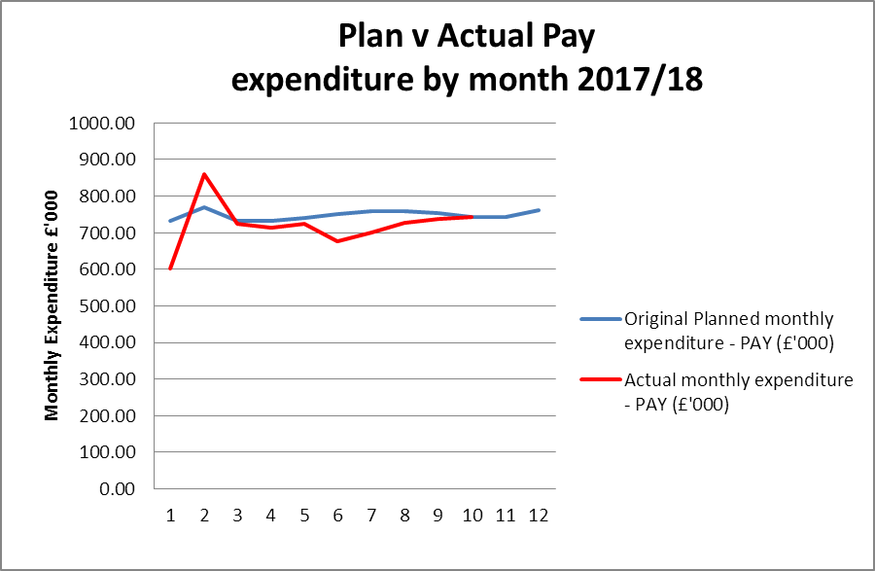
Cost of living increase paid in May (including backdated April payment)
This slight negative variance throughout the year is due predominantly to the impact of vacant posts in service delivery with roles remaining unfilled for longer than anticipated (particularly in London & Bristol) as well as the impact of internal development opportunities within teams. This is keenly experienced in the teams supporting the ethics service where many staff have been successful in securing internal secondment opportunities. Whilst this is a positive for the organisation and our people it also provides a challenge as vacant posts ‘domino’ throughout the HRA. Previous reports have detailed steps being taken to address this including utilising agency staff to provide capacity, offering overtime, providing administrative support between Bristol and London, all with some success. However more still needs to be done if we are to provide a resilient structure to support the transformation programme in 2018/19. Work on the target operating model (TOM) will address future requirements. Recruitment panel is therefore focusing on current and medium term resourcing needs to enable sufficient capacity to deliver on our programme of work in 2018/19. This is also complemented by the resource management project (part of corporate SIP) looking at how we best resource both business as usual activities as well as our strategic programme.
Travel costs
Travel costs are £24k (5%) lower than budget and are forecast to come in £24k under budget.
Travel costs across the HRA | Year to date budget | Year to date spend | % share of total year to date spend | Year to date variance | Forecast Outturn
 | (£) | (£) | % | (£) | (£)
Research ethics service | 172 | 164 | 36% | -8 | -4
HRA Approval | 93 | 88 | 19% | -5 | -6
Confidentiality Advisory Service | 32 | 22 | 5% | -10 | -12
Research systems | 22 | 20 | 4% | -2 | 4
Total services | 320 | 295 | 64% | -25 | -17
Chief Executive ( inc Governance ) | 35 | 28 | 6% | -8 | -12
Policy | 24 | 23 | 5% | -1 | -1
Corporate Services | 44 | 49 | 11% | 4 | 6
Finance, Procurement and Estates | 9 | 7 | 2% | -2 | 0
Training Service | 55 | 60 | 13% | 5 | 0
Total | 487 | 461 | 100% | -26 | -25

Reserves
Reserves continue to be closely monitored by the senior leadership team on a fortnightly basis. Any changes to our forecast position are considered and funds (if available) reallocated to strategic priority projects where appropriate. Further strategic investment has been targeted at supporting the transformation programme and reducing our cost base in future years.
Strategic aims key:
1. Championing health and social care research
2. Leading improvements that make it easier to conduct high quality research in the UK
3. Develop a pro-active, strategically focussed organisation
4. Capitalising upon technological and data development
5. Ensuring the HRA is managed and governed effectively and provides value for money for the tax payer

 |  | Strategic aims
Reserves projects |  | 1 | 2 | 3 | 4 | 5
Service improvement programme | 100,000
Website development | 85,000
ICT service manager and associated projects | 85,000
IT infrastructure programme | 50,000
Business analyst and tester | 50,000
North East office relocation | 30,000
Health Tissue Authority - direct dialogue project | 25,000
Apprenticeship levy | 21,000
ESR and workforce development | 20,000
Cyber – penetration testing | 18,000
Tissue Bank research | 12,000
Social Care | 4,000
Total | 500,000

Financial risks:
- We need to adapt our business and operating model in order to sustain future real-terms funding reductions and create sufficient head room for strategic developments. This work is now underway and plans are in place to develop a target operating model by June 2018. This will be discussed with the Board in March and is the main focus of the Workforce Board.

- The financial plan for 2018/19 requires economies and savings of £400k to achieve a balanced budget. Steps have been identified to ensure a balanced budget although not without strategic and operational risk. Reserves funding has been reanalysed with some projects delayed until funding is available (£100k). Other organisational change programmes have been initiated to help contribute to this plan (£100k). Further cost savings have been identified £50k with £150k additional vacancy factor saving target agreed by Leadership Team and the Board. These saving are achievable however place additional pressures on our staff group and ability to deliver across the various transformation programmes in place. Our workforce board and recruitment panel are both providing strategic and operational oversight of this to mitigate this risk.

- The funding available to support the RS systems change programme is time-limited and must be spent by 31/03/2019. As a consequence a key objective of the programme is to create a more automated and efficient system, reducing both the direct and indirect costs of support and development. The system will not only release capacity in the research community by providing a more streamlined and simple process, it will also provide economies and efficiencies within the HRA to support our strategic objectives, the TOM and spending review requirements. The risk of project over-run is included in the RS transformation risk register and is being managed by a variety of methods including securing expertise to support the HRA in the market appraisal and delivery of the system as well as securing sufficient back fill resource within the HRA to support the delivery of our transformation programme and core service delivery.

Capital expenditure
Plan initiative |  | 2017/18 plan full year  £000 | 2017/18 budget ytd | 2017/18 actual ytd | 2017/18 variance ytd
 |  |  | £000 | £000 | £000
HARP Developments |  | 215 | 179 | 176 | (3)
IRAS Developments |  | 362 | 302 | 298 | (4)
BGO Contract |  | 577 | 481 | 474 | (7)
IS Team – capitalised salaries |  | 114 | 95 | 101 | 6
BGO Contract and Capitalised salaries position as at 30 September 2017 |  | 691 | 576 | 575 | (1)
ICT infrastructure |  | 24 | 24 | 0 | (24)
Estates |  | 85 | 85 | 0 | (85)
Total Capital |  | 800 | 685 | 575 | (110)

100% of the capital budget is now committed. The BGO contract delivering HARP and IRAS developments as well as the internal team working on improvements to these current systems make up 86% of this amount, with the remainder committed to a strategically critical research systems piece of work (approved by the research Systems Board) key to enable the IRAS transformation programme in 2018/19. This work will be performed before the end of the year and will inform the new system development following the market appraisal exercise. Investment in the IP related to our e-learning modules (£40k) makes up the balance.
Better payments performance
The HRA has continued to meet the duty to pay 95% of invoices in 30 days. .

 | Number | Value (£)
Benchmark | 95% | 95%
2017/18 | 98% | 99%
2016/17 | 98% | 98%
2015/16 | 98% | 97%

Recommendations

Leadership team and HRA Board are asked to review and approve the finance report for the 10 months to 31 January 2018.

Karen Williams and Sylvia Hazard
Director of Finance and Deputy Director of Finance
26th February 2018
Detailed non-pay expenditure analysis

Subjective | Annual | Year to date (£) |  |  | Forecast (£) |  | Explanation
Name | budget (£) | Budget | Actual | Variance | Outturn | Variance
Meeting Rooms/Catering | 248,543 | 174,822 | 173,530 | (1,292) | 203,499.00 | (45,044) | Careful management of space and forward planning
Office equipment/Stationery/Furniture/Consumable | 35,737 | 27,160 | 16,751 | (10,409) | 22,981.00 | (12,756) | E-review project reducing stationery costs
Photocopying/Printing/Postage/Storage/Waste | 129,021 | 90,731 | 75,718 | (15,013) | 142,513.00 | 13,492 | Print contractual arrangements incorrectly reflected in budget
Premises - inc premise removal costs | 811,023 | 641,639 | 653,112 | 11,473 | 833,385.00 | 22,362 | SKH costs greater than originally planned – irrecoverable VAT
Training Expenses - expenses/materials , conferences, workshops | 90,770 | 53,283 | 41,110 | (12,173) | 147,154.00 | 56,384 | Phasing and additional investment in capacity building
Other Staff costs - Recruitment/adverts/redundancy/PILON | 188,687 | 169,889 | 173,325 | 3,436 | 190,669.00 | 1,982
Travel costs - include excess mileage/interview expenses | 573,465 | 432,137 | 393,752 | (38,385) | 566,231.00 | (7,234) | Better use of technology
Chairs/Members/Participation - activity costs | 281,877 | 197,497 | 194,549 | (2,948) | 267,197.00 | (14,680) | Related to activity levels
Publications | 2,124 | 2,124 | 2,214 | 90 | 2,214.00 | 90
Mobile Phones/Mobile Data | 9,935 | 7,705 | 9,714 | 2,009 | 11,959.00 | 2,024
Statutory Costs - Health & Safety/Legal/Audit Fees/Dep. & Amort. | 665,000 | 432,976 | 429,209 | (3,767) | 641,105.00 | (23,895) | Capital spend phased end of year – reduced in year depreciation
Computer Costs - Software/licences/system maintenance/purchases | 329,949 | 249,960 | 255,405 | 5,445 | 333,736.00 | 3,787
Other External Contracts - SLA's - Premises, SBS,BSA, DH IT | 780,456 | 541,406 | 546,093 | 4,687 | 748,715.00 | (31,741) | Better management of DH IT contract, reduced number of users
Other - Misc/Reserves | 311,369 | 0 | (9) | (9) | 311,369.00 | 0
 | 4,457,956 | 3,021,329 | 2,964,472 | (56,856) | 4,422,727 | (35,229)

