

|  |  |
| --- | --- |
| **Agenda item:** | **10** |
| **Attachment:** | **F** |

**HRA BOARD COVER SHEET**

|  |  |
| --- | --- |
| **Date of Meeting:** | 15 August 2016 – email report to SEMT (verbal update given at 8th August).  30 August 2016 - written report to SEMT  7 September 2016- written report to EMT  21 September 2016 – written report to Board |

|  |  |
| --- | --- |
| **Title of Paper:** | Financial report - July 2016 |
| **Purpose of Paper:** | To report on the financial position of the Authority as at the 31st July 2016 |
| **Reason for Submission:** | To ensure the SEMT, EMT and the Board, are aware of the financial position of the HRA as at the end of July 2016. |
| **Lead Reviewer:** | Tom Smith, Director of Guidance and Learning - 16 August 2016 |
| **Details:** | This paper presents the financial position as at the end of July 2016.  Main points to note:   * The HRA moved to an underspend position of £35k as at the end of July 2016 ( position at end of June broadly break even). * An under spend on pay of £86k was offset by an over spend on non pay of £51k. * The position includes an unbudgeted charge for the disposal of the Video conferencing equipment (£18.5k) and includes the costs of the archiving project (£70k) which unexpectedly over ran into 2016/17. * The HRA has continued to meet the duty to pay 95% of invoices in 30 days achieving 97% based on number of invoices, and achieved the target based on value by achieving 99%. * The capital position is reporting a slight underspend of £9k (position at end of June £8k underspent), but further work is required to finalise the year end forecast position and identify any potential surplus, as a result of the reduced contract costs, which could be released for the wider system. * There has been a reduction in the level of cash held from the year end of £3.485m to £2.694m * The Department of Health has confirmed the budget for 2016/17 in line with the financial plan as expected. |
| **Suitable for wider circulation?** | **Yes, following Board** |
| **Time required for item:** | **10 minutes** |

|  |  |  |  |
| --- | --- | --- | --- |
| **Recommendation / Proposed Actions:** | **To Approve** | | **Yes** |
| **To Note** | |  |
| **For discussion** | |  |
| **Comments** |  | |

|  |  |
| --- | --- |
| **Name:** | Debbie Corrigan |
| **Job Title:** | Director of Finance, Procurement and Estates |
| **Date:** | 12 August 2016 |

**Finance Report - Financial Year 2016/17**

**Health Research Authority as at 31 July 2016**

1. **Introduction**

This report outlines the financial position of the Authority in respect of revenue and capital expenditure for the month ended 31 July 2016.

**2. Revenue Resource Limit**

The Department of Health (DH) HRA has confirmed the budget for the year which matches expectations discussed during the 2016/17 business planning round. The HRA grant in aid and revenue resource limit for the year was presented in the 2016/17 financial plan and this report continues to be based on the same figures of £13,080k. The whole of this sum is classified as administration funding under HM Treasury definitions and this sum represents HRA annual statutory funding from the Department of Health (DH) for the year. It excludes income from other government departments or income from the Devolved Administrations.

**3. Revenue expenditure position at 31 July 2016**

The revenue position of the Authority is summarised in the table below with further performance detail in Appendix A. The Authority has spent £4.12 million year to date. This represents a £35k under spend against profiled expenditure budgets. A summary of the overall position by Directorate is presented in table 1 below.

|  |  |  |  |  |  |  |
| --- | --- | --- | --- | --- | --- | --- |
| **Summary of financial outturn 31st July 2016** | | |  |  |  |  |
|  |  |  |  |  |  |  |
|  | **Description** | **Initial Annual Budget** |  | **Budget for period to** | **Outturn as at** | **Variance** |
|  | **Latest Annual Budget** | **31st July 2016** | **31st July 2016** |
|  |  | **(£'000)** | **(£'000)** | **(£'000)** | **(£'000)** | **(£'000)** |
| **Income** | |  |  |  |  |  |
|  | HRA income | 200 | 200 | 0 | 0 | 0 |
|  | Grant in aid (confirmed) | 12,630 | 12,630 | 4,070 | 4,035 | (35) |
|  | Non cash revenue resource limit | 450 | 450 | 88 | 88 | 0 |
|  | **Total** | **13,280** | **13,280** | **4,158** | **4,123** | **(35)** |
| **Expenditure** | |  |  |  |  |  |
|  | Operations -Research Ethics Service England | 4,021 | 4,021 | 1,341 | 1,351 | 10 |
|  | Chief Exec - team, board, corporate secretary, quality assurance and policy | 1,986 | 1,998 | 571 | 579 | 8 |
|  | Corporate Services incl communications, staff training, public involvement, programme office, HR services, IT contract | 1,812 | 1,812 | 602 | 606 | 4 |
|  | Finance, Procurement and Estates and Reserves | 1,315 | 1,275 | 240 | 232 | (8) |
|  | Research Systems,Standards and HRA Approval Programme activity, Guidance advice and learning and CAG | 4,146 | 4,174 | 1,404 | 1,355 | (49) |
|  | **Total** | **13,280** | **13,280** | **4,158** | **4,123** | **(35)** |
|  |  |  |  |  |  |  |
| **Surplus/(Deficit)** | | **0** | **0** | **0** | **0** | **0** |

The main points to note in the reported outturn expenditure position as at 31 July 2016 of £4.12m are:

1. Total pay costs incurred are £2.8m (68% of total expenditure costs).
2. Of this, £177k (6.3%) relates to agency costs. These costs include key research information systems staff who are progressing critical work. Work to recruit staff onto the payroll is nearing completion. This is in line with the developing Research Information Systems Strategy.
3. Within the underspend position year to date, there are two key areas to highlight. There is an under spend year to date relating to the Research Systems, Standards and HRA Approval Programme directorate (£49k), of which (£40k) relates to pay ( less the current vacancy factor (net)). There are vacancies within performance management, collaboration & development and assessment. This underspend reflects planned timing with regards to meeting the full directorate annual vacancy factor target in the early part of the year. Staff recruitment has now been undertaken with regards to these vacancies. In light of emerging workloads there is a planned increase in establishment within this area which will be supported from internal underspends and reserves.
4. There is an offsetting overspend of £10k within Operations which relates to an underspend of £20k in pay (net of vacancy factor) and a £30k overspend within non-pay. This overspend is resulting from the archiving project running into the new year £70k, mitigated by underspends within Operations in meeting costs (£8k), travel (£10k), Chairs Allowance (£9k) and Stationery and Postage (£13k).
5. There is a further offsetting overspend of £8k within Chief Executive (including Corporate secretary) which relates to unexpected costs linked to the asset disposal of the replaced video conferencing equipment £18.5k. This charge has been highlighted as part of the Quarter one finance return submission and will be flagged in discussions with the sponsor. This is offset by an underspend within Pay (£13k) related to a vacancy which is currently under review.
6. Within Corporate services there is currently an overspend of £4k. This arises from an underspend within the IT contracts (Open Service, MPS and backup lines) of £33k. This underspend will be further investigated to determine potential outturn and required budget with the likelihood of transferring surplus budget to reserves for reassignment to corporate objectives. This underspend is currently offset within Corporate Services by an overspend within Staff Training of £31k. The £31k overspend relates to £8k on travel which needs to be investigated but may be an early adoption of the coding of training related travel costs direct to training and which may link to underspends in travel in other areas. There is also an overspend within the pay budget of £11k this area is awaiting a virement to be actioned that should mitigate this position. There is an overspend of £11k in Training expenses which will need to investigated further with the budget manager.
7. Pay budgets are under spent by £86k. This is net of the £49.9k year to date vacancy factor; the overall pay underspend would have therefore been £136k. Within the Research Systems, Standards and HRA Approval Programme directorate the pay underspend is £40k. This underspend is in line with original timing of plans regarding achievement of the vacancy factor within the directorate. Work is also underway to identify plans to support the service being provided due to emerging workloads. The remainder of the pay underspend is £20k within Operations, £11k within Corporate Services and £13k within Chief Executive (inc Corp Sec).
8. Non-pay budgets are over spent by £51k. As explained above £70k relates to the archiving projects running into the new year and £18.5k relates to the asset disposal. These are both non recurrent impacts. There is a £3.5k overspend within travel, an overspend on Skipton House rent of £27k, an overspend in training expenses of £13k. These overspends are offset by underspends within meeting costs £13k, contract other external (Atos as explained above) £33k, minor works of £8k in relation to the Estates Strategy, and a service charge underspend of £4k in HRA Office Manchester. There are also underspends within Chairs Allowance (£10k) and Stationery and Postage (£8k).
9. All staff planned within the HRA Approval programme are now in post. There may be some further refinements required in response to emerging workload pressures.
10. Staff Vacancy Factor

A staff vacancy factor was introduced for 2016/17. The achievement by Directorate is shown in Table 3 below. The position will be reviewed and refined following discussion with Directorates. This table highlights that without the introduction of a vacancy factor, the under spend on pay would have been much higher. (£136k compared to £86k after the vacancy factor netted off.)

**Table 3: Directorate Pay – budget, actual, variance and vacancy factor 2016/17**

|  |  |  |  |  |  |
| --- | --- | --- | --- | --- | --- |
| Position as at end of July 2016 |  |  |  |  |  |
|  |  |  |  |  |  |
| **Directorate** | **Budget YTD (£)** | **Actual YTD (£)** | **Variance YTD (£)** | **YTD Budget of Staff Vacancy / Turnover** | **Under/over spend less vacancy factor** |
| Chief Executive ( inc Corp Sec ) | 436,352 | 418,020 | (18,332) | (4,877) | (13,455) |
| Corporate Services | 285,744 | 271,952 | (13,792) | (2,844) | (10,948) |
| Finance, Procurement and Estates | 124,098 | 122,422 | (1,676) | (1,280) | (396) |
| Operations | 968,052 | 928,159 | (39,893) | (19,212) | (20,681) |
| Research Systems, Standards and HRA Approval | 1,129,643 | 1,067,453 | (62,190) | (21,727) | (40,463) |
| Grand Total | **2,943,889** | **2,808,006** | **(135,883)** | **(49,940)** | **(85,943)** |

1. Tables 4 and 5 below present the run rate of expenditure by type, pay and non pay. The stepped increase in the trend lines between April and May is due to full accruals accounting being actioned in May which were not adjusted for in April, whilst the finance team concentrated on the financial year end for 2015/16.

**Table 4: Profile of planned and actual Pay costs 2016/17**

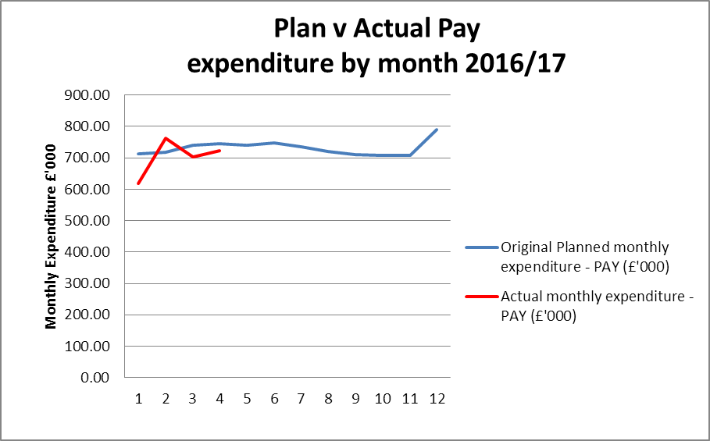

**Table 5: Profile of planned and actual Non Pay costs 2016/17**

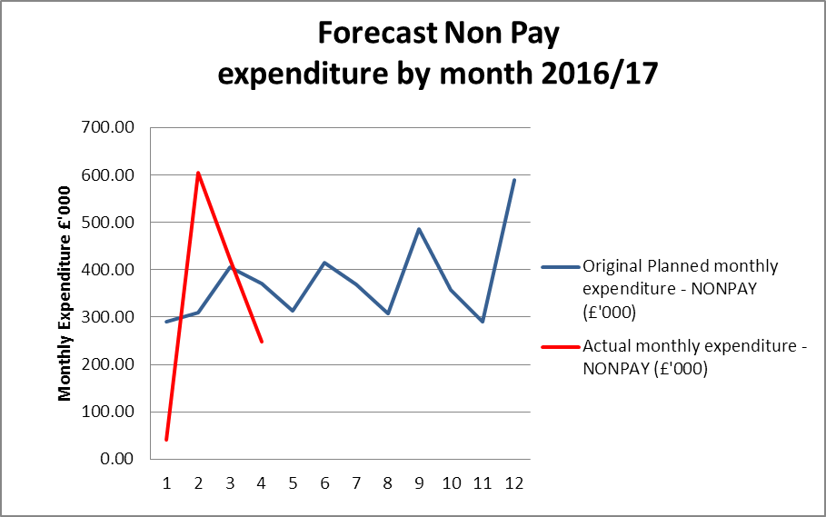

**4. Forecast outturn 2016/17**

Early forecasts point to a break even. The finance team will be working hard with budget managers to refine the forecasting process this year. Returns have been issued for budget manager completion with the expectation that the July position is discussed during August in light of the returns received. The aim is to provide an accurate forecast in September which will then form the basis of a month on month comparison to try to minimise any significant changes.

The table below highlights the current accumulated underspend. Future monthly reports will present the position by month as the year progresses.

**Table 5: Overall (£) variance position by month**

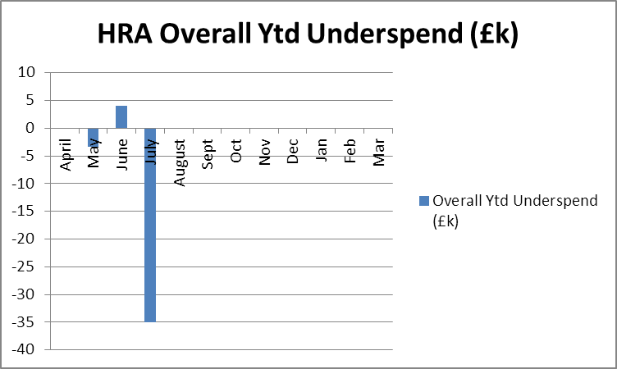

**5. Better payments performance**

Better payment performance provides an indicator to the board and stakeholders of the financial service being provided. These services are influenced by strong management of the finance and accounting service contract with NHS Shared Business Services, the additional support service offered by the finance team and the performance of budget managers in approving invoices in a timely manner.

The HRA has continued to meet the duty to pay 95% of invoices in 30 days achieving 97% based on number of invoices, and achieved the target based on value by achieving 99%. HRA are committed to paying suppliers promptly and have maintained a target of paying suppliers within 10 days to 60% for 2016/17. The performance at the end of July 2016 for payments made within 10 days is 71% (number of invoices) and 66% (value of invoices), both achieving the stretched 60% target. The escalation days for invoices awaiting approval continues to be 4 days (after which invoices are escalated to line managers) and further reminders on vacation rules and the importance of checking the workflow daily have recently been issued. The HRA continues to have 3 payment runs each week to maintain the performance.

**6. Travel costs**

£535k has been initially allocated for planned travel costs in 2016/17. This budget covers staff travel costs as well as volunteer REC member travel. £586k was allocated in 2015/16 and it continues to be an area which is being intentionally monitored and managed with a view to reducing staff travel expenditure given the significant investments made to facilitate flexible working.

The graph below shows the staff costs per head incurred to date compared to a benchmark of 2013/14. The increase in staff travel costs per head is due to the timing of the all staff day in May.

**Table 6: Staff travel costs per head**

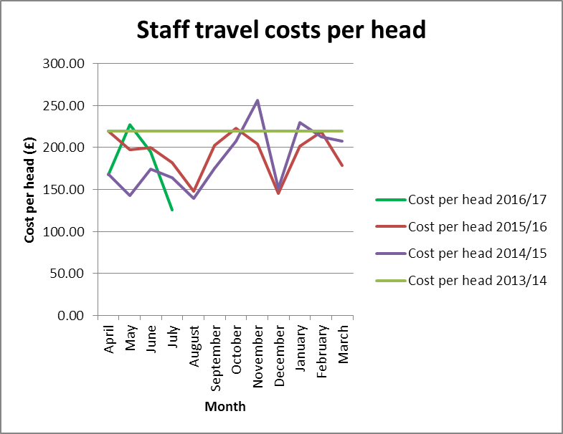

Table 7 below sets out the total travel costs position (staff, members inclusive) at the end of June 2016. £191k has been spent year to date with a £3.5k over spend against the plan (£10k overspend in June). It should be noted that one explanation for the over spend is due to the all staff day in May alongside the replacement Video Conference (VC) service, which resulted in the VC not being available for a period of time.

**Table 7: Travel costs and budget across the HRA by Directorate**



Table 8 highlights the fact that although overall year to date travel costs are slightly higher than at this time in 2015/16 due to the all staff day in May 2016 (£185k compared to £191k), they are showing a steeper reduction in the monthly run rate, implying that savings are being made. Provided all travel decisions are carefully considered, the savings in this area can be delivered.

The treatment of travel costs associated with training continues to be investigated and a solution is expected to be implemented during September. The arrangements for staff training continue to be reviewed to see if any savings can be realised from the choice of venue and methods of training provision. The estates strategy work is also encouraging greater use of video conferencing or “Lync” meetings, however this aspect is strongly dependent on the reliability and capacity of the IT service.

**Table 8: Year on year travel costs**

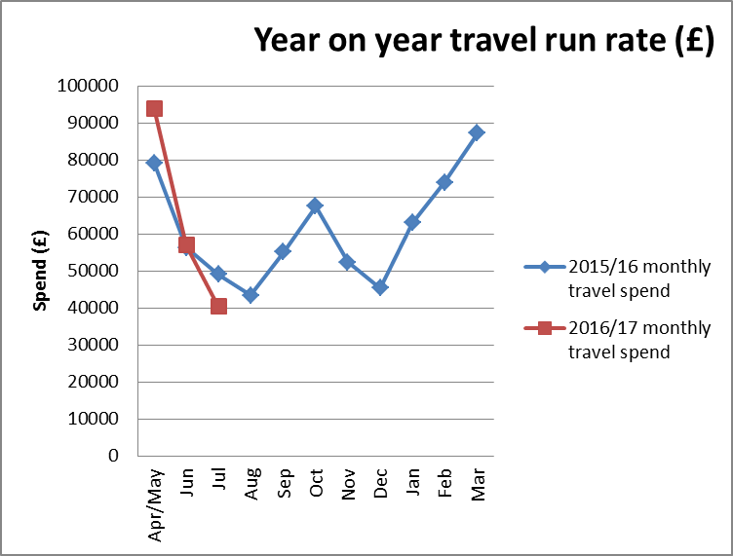

**7. Staff numbers**

Pay represents 68% of the costs incurred in year. The profile of our staff headcount is presented in Table 8 below for information.

**Table 8: Chart to show actual staffing headcount so far in 2016**

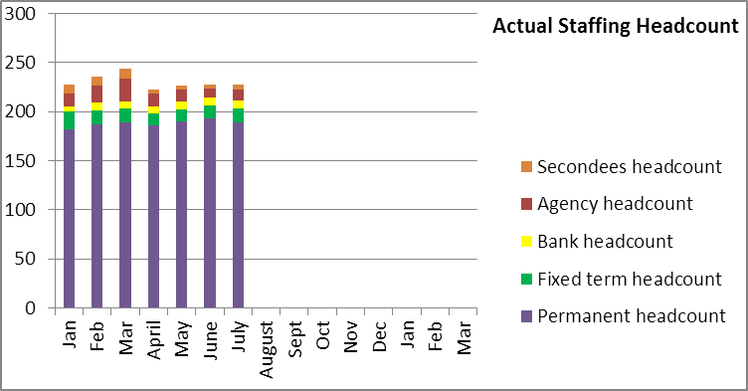

The overall headcount has reduced as expected. Whilst permanent, fixed term headcount has remained broadly steady, secondments have reduced as project posts came to the end of their expected terms.

**8. Month end faster close**

The achievement of key deadlines continues to be maintained. Finance aim to complete the month end within 4 working days of the end of the month in question. In July month end close took 4 working days. All agreed deadlines for completion of required reports for EMT and Board were achieved.

**9. Capital**

The capital expenditure position is presented below for July 2016 and is running at a slight underspend of £9k. This is mainly due to an underspend on the capitalised salaries (17k), as a result of contractors leaving earlier than originally budgeted for and a delay in one post being recruited to. The underspend in the capitalised salaries is offsetting a slight overspend on the BGO contract (£8k), which is due to more senior posts being used during June and July on the developments to the IRAS system.

The HRA received confirmation of the capital funding of £910k from the Department of Health in line with the amount included within the Spending Review.

The capital plan includes budget for the development of the HARP and IRAS systems and for those Information Systems posts which include an element of development or capital work within their roles. An additional budget was initially identified for laptop refreshment, but following the advice from the auditors that these could be charged to revenue, and the subsequent recent completion of the statutory audit, where this was discussed and concluded that the treatment was correct, this budget will no longer be required. As work is completed on forecasting for the year end position, any surplus on the allocated budget will be identified and notified to DH through the quarterly returns for use by the wider system.

A report on the monthly spend against budget for each of the capital programmes is shared with the Deputy Director – Research Information Systems and monthly meetings are taking place to monitor the capital position, which enable us to highlight any potential forecast under spend or over spend at an early stage.

**Capital expenditure 2016/17**



**10. Statement of Financial Position and cash**

To align with the quarterly accountability meetings with the Department of Health, during 2016/17 a quarterly Statement of Financial Position and cashflow forecast will be produced and reported to EMT. The next Statement of Financial Position and cash flow therefore will be produced for the end of September 2016.

At the end of the reporting period, the cash balance was £2.694m, which is a reduction against the balance of £3.485m held at the end of the 2015/16 financial year. In order to fulfil the duty to avoid holding excess levels of cash, the HRA will continue to monitor the cash position during 2016/17, to ensure that sufficient cash is held for future needs, but will aim to reduce the cash balances held.

**11. Cash releasing Savings**

The following areas will form the basis of ensuring that the HRA continues to remain within its financial envelope over the term of the spending review:

* Vacancy factor.
* Continued savings in estates costs through improved use of footprint.
* Savings in per head staff travel costs to justify the investment made in digital telephony. Given the expenditure on travel in 2015/16, this area poses a risk and a challenge and will require concerted management action.
* Savings in introduction of Managed Print Service and roll out of this service as leases expire on current photocopier agreements.
* Savings through the use of the Member Portal.
* Savings on HRA’s largest information systems contract.

**12. Recommendations**

That EMT and the Board note the financial position and to particularly note the following:

* The current underspend position, with forecast outturn to be included from September.
* The under spend on pay offset by an over spend on non pay and the reasons.
* The excellent performance on the Better Payments Practice Code position to meet the 95% target based on number of invoices and the value and the 60% achievement of payments within 10 days.
* The actual performance on travel costs which show that delivery of savings is achievable provided travel decisions and timings are carefully considered.
* The capital position at the end of the period and likely forecast.

**Debbie Corrigan**

**Director of Finance, Procurement and Estates**

**12 August 2016**

**Health Research Authority – Financial position as at 31 July 2016 Appendix A**

|  |  |
| --- | --- |
| **FINANCIAL RESULTS**  **HEADLINES** | * HRA is reporting an expenditure budget underspend of £35k at the end of July ( £4k overspend in June). * Pay budgets are under spent by £86k. This is including a £49.9k year to date vacancy factor having been applied. * Non pay budgets are over spend by £51k largely due the over run of the archiving project and the disposal of the video conferencing assets. * The largest directorate under spend is within Research systems, Standards and HRA Approval directorate (£49k), of which £40k relates to pay within performance management, collaboration & development and assessment areas. This was a planned underspend to achieve the vacancy factor in the early part of the financial year. These plans are currently being reviewed/re- developed to meet the needs of the service and emerging workload pressures. * Work has almost completed to introduce a process to correctly capture training related travel costs and is anticipated go live in September. * The Better Payment Practice Code (BPPC) compliance for April to July was 97% for the number of invoices paid, which is in line with the overall performance for 2015/16, and is reporting 99% for value of invoices paid. Having achieved the 60% target of paying invoices within 10 days during 2015/16, the HRA has maintained this target for 2016/17 and at the end of July, this target has been achieved. All approvers are asked to note this and to approve invoices promptly or place on hold if there is a dispute. Performance is published on our website. * Cash balance has reduced from year end £3.485 million (with liabilities to pay of £1.296million) to £2.694 million (with liabilities to pay of £1.125million). * The cash balance at the end of July 2016 was £2.694m, which is a reduction against the balance held at the end of June 16 (£2.999m) and less than the balance held at the end of March 16 of £3.485m. |

**Health Research Authority – Non Pay Expenditure Year to end July 2016 Appendix B**

|  |  |  |  |  |  |  |  |  |  |  |  |  |  |  |  |  |  |  |  |  |  |  |  |  |  |  |  |  |  |  |  |  |  |  |  |  |  |  |  |  |  |  |  |  |  |  |  |  |  |  |  |  |  |  |  |  |  |  |  |  |  |  |  |  |  |  |  |  |  |  |  |  |  |  |  |  |  |  |  |  |  |  |  |  |  |  |  |  |  |  |  |  |  |  |  |  |  |  |  |  |  |  |  |  |  |  |  |  |  |  |  |  |  |  |  |  |  |  |  |  |  |  |  |  |  |  |  |  |  |  |  |  |  |  |  |  |  |  |  |  |  |  |  |  |  |  |  |  |  |  |  |  |  |  |
| --- | --- | --- | --- | --- | --- | --- | --- | --- | --- | --- | --- | --- | --- | --- | --- | --- | --- | --- | --- | --- | --- | --- | --- | --- | --- | --- | --- | --- | --- | --- | --- | --- | --- | --- | --- | --- | --- | --- | --- | --- | --- | --- | --- | --- | --- | --- | --- | --- | --- | --- | --- | --- | --- | --- | --- | --- | --- | --- | --- | --- | --- | --- | --- | --- | --- | --- | --- | --- | --- | --- | --- | --- | --- | --- | --- | --- | --- | --- | --- | --- | --- | --- | --- | --- | --- | --- | --- | --- | --- | --- | --- | --- | --- | --- | --- | --- | --- | --- | --- | --- | --- | --- | --- | --- | --- | --- | --- | --- | --- | --- | --- | --- | --- | --- | --- | --- | --- | --- | --- | --- | --- | --- | --- | --- | --- | --- | --- | --- | --- | --- | --- | --- | --- | --- | --- | --- | --- | --- | --- | --- | --- | --- | --- | --- | --- | --- | --- | --- | --- | --- | --- | --- | --- | --- |
| **Areas of Non- Pay Expenditure** | |  |  |  |  |  |  |  |  |  | | --- | --- | --- | --- | --- | --- | --- | --- | --- | | **Subjective** | **Annual** | **Next year** | **In month (£)** | | | **Year to date (£)** | | | | **Name** | **budget (£)** | **plan (£)** | **Budget** | **Actual** | **Variance** | **Budget** | **Actual** | **Variance** | | **Meeting Rooms/Catering** | 217,281 | 219,040 | 13,521 | 12,335 | (1,186) | 73,027 | 60,071 | (12,956) | | **Office equipment/Stationery/Furniture/Consumable** | 67,769 | 101,794 | (28,714) | 2,588 | 31,302 | 21,253 | 14,011 | (7,242) | | **Photocopying/Printing/Postage/Storage/Waste** | 159,169 | 155,410 | 11,873 | 12,715 | 842 | 51,945 | 51,285 | (660) | | **Premises - inc premise removal costs** | 717,327 | 717,327 | 57,249 | 73,859 | 16,610 | 237,428 | 254,153 | 16,725 | | **Training Expenses - expenses/materials , conferences, workshops** | 82,390 | 75,390 | 12,436 | 8,381 | (4,055) | 29,876 | 42,610 | 12,734 | | **Other Staff costs - Recruitment/adverts/redundancy/PILON** | 40,000 | 40,000 | 0 | 0 | 0 | 3,700 | 2,649 | (1,051) | | **Travel costs - include excess mileage/interview expenses** | 556,208 | 531,403 | 49,111 | 41,140 | (7,971) | 192,789 | 198,254 | 5,465 | | **Chairs/Members/Participation - activity costs** | 286,410 | 286,410 | 22,115 | 20,803 | (1,312) | 91,785 | 81,436 | (10,349) | | **Publications** | 2,250 | 2,250 | 20 | (767) | (787) | 90 | 222 | 132 | | **Mobile Phones/Mobile Data** | 18,661 | 18,661 | 1,543 | 295 | (1,248) | 6,172 | 4,939 | (1,233) | | **Statutory Costs - Health & Safety/Legal/Audit Fees/Dep. & Amort.** | 549,365 | 549,365 | 5,080 | 2,717 | (2,364) | 108,461 | 127,002 | 18,541 | | **Computer Costs - Software/licences/system maintenance/purchases** | 352,422 | 346,722 | 36,383 | 21,668 | (14,715) | 119,429 | 117,968 | (1,461) | | **Other External Contracts - SLA's - Premises, SBS,BSA, DH IT** | 993,674 | 879,231 | 81,827 | 51,533 | (30,294) | 328,364 | 360,823 | 32,459 | | **Other - Misc/Reserves** | 565,389 | (21,226) | 0 | 0 | 0 | 0 | (6) | (6) | | **Grand Total** | 4,608,315 | 3,901,777 | 262,444 | 247,267 | (15,177) | 1,264,319 | 1,315,415 | 51,096 |   Note: The overspend on other external contracts largely relates to the over run on the archiving project, with the offset of the underspend on the IT contract. The overspend within the statutory costs relates to the Asset disposal. The overspend within Premises mostly relates to Skipton House costs and is offset by underspend within Estates Strategy and a service ahrge underspend in HRA Office Manchester. |

**HRA Better Payment Practice Code for the period 1 April to 31 July 2016 Appendix C**

|  |  |  |  |  |
| --- | --- | --- | --- | --- |
|  | Number | % | Value (£) | % |
| 0-5 | 159 | 11% | 261,804 | 14% |
| 6-10 Days | 902 | 60% | 1,011,109 | 53% |
| 11-20 Days | 376 | 25% | 576,137 | 30% |
| 21-30 Days | 16 | 1% | 48,962 | 3% |
| Over 30 Days | 44 | 3% | 27,859 | 1% |
| Total | 1,497 | 100% | 1,925,871 | 100% |
|  |  |  |  |  |
| **BPPC achieved** | 97% | 97% | 99% | 99% |
|  |  |  |  |  |
| **2015/16 Performance** | 98% | 98% | 97% | 97% |
| **2015/16 0-5 day performance** | 306 | 7% | 1,395,005 | 21% |

**Aged Creditors at 31 July 2016**

Headlines – clock start date is the invoice date (regardless of when the invoice is received in the system) – £101k of the £216k overdue in 1-30 days has been paid at the start of August, the balance relates mainly to one invoice with the Department of Health (£99k) which we is currently on hold due to a query on the amount.

|  |  |  |  |
| --- | --- | --- | --- |
|  | **Aged Creditors – (£) amounts past due date** | | |
|  | **1-30 days** | **31-60 days** | **60 + days** |
| **Non NHS Trade** | 109,729.48 | 726.93 | 680.98 |
| **Non NHS Other** | 6,069.99 | 0.00 | 254.10 |
| **NHS** | 100,645.38 | 0.00 | 0.00 |
|  |  |  |  |
| **Total** | 216,444.85 | 726.93 | 935.08 |

**HRA Revenue position for the period ended 31 July 2016 Appendix D**

|  |  |  |  |  |  |  |  |  |  |  |  |  |  |
| --- | --- | --- | --- | --- | --- | --- | --- | --- | --- | --- | --- | --- | --- |
| **Period (£'000)** | | |  | **Department** |  | **Year to date (£'000)** | | |  | **Full year (£'000)** | | | |
|  |  |  |  |  |  |  |  |  |  |  | **2016/17** | | |
| **Budget** | **Actual** | **Variance** |  | **Income** |  | **Budget** | **Actual** | **Variance** |  | **2015/16 actual** | **Initial budget** | **Latest Budget** | **Forecast** |
| 0 | 0 | 0 |  | HRA income |  | 0 | 0 | 0 |  | 198 | 200 | 200 | 200 |
| 1,009 | 970 | -39 |  | Grant in Aid confirmed |  | 4,070 | 4,035 | -35 |  | 12,509 | 12,630 | 12,630 | 12,630 |
| 0 | 0 | 0 |  | Non cash revenue resource limit |  | 88 | 88 | 0 |  | 253 | 450 | 450 | 450 |
| **1,009** | **970** | **-39** |  | **Total Income** |  | **4,158** | **4,123** | **-35** |  | **12,960** | **13,280** | **13,280** | **13,280** |
|  |  |  |  |  |  |  |  |  |  |  |  |  |  |
| **Budget** | **Actual** | **Variance** |  | **Expenditure** |  | **Budget** | **Actual** | **Variance** |  | **2015/16 actual** | **Initial budget** | **Latest Budget** | **Forecast** |
| 334 | 317 | -17 |  | Operations |  | 1,341 | 1,351 | 10 |  | 4,573 | 4,021 | 4,021 | 4,021 |
| 129 | 122 | -7 |  | Chief Executive inc. Corp Sec |  | 571 | 579 | 8 |  | 1,821 | 1,986 | 1,998 | 1,998 |
| 149 | 159 | 10 |  | Corporate Services |  | 602 | 606 | 4 |  | 1,828 | 1,812 | 1,812 | 1,812 |
| 51 | 43 | -8 |  | Finance, Procurement and Estates |  | 240 | 232 | -8 |  | 1,256 | 1,315 | 1,275 | 1,275 |
| 346 | 329 | -17 |  | Research Systems, Standards and HRA Approval Prog |  | 1,404 | 1,355 | -49 |  | 3,482 | 4,146 | 4,174 | 4,174 |
| **1,009** | **970** | **-39** |  | **Total Expenditure** |  | **4,158** | **4,123** | **-35** |  | **12,960** | **13,280** | **13,280** | **13,280** |
|  |  |  |  |  |  |  |  |  |  |  |  |  |  |
| **0** | **0** | **0** |  | **Surplus /Deficit** |  | **0** | **0** | **0** |  | **0** | **0** | **0** | **0** |

|  |
| --- |
|  |