Agenda item: | 8
Attachment: | B

HRA BOARD COVER SHEET

Date of Meeting: | 22nd November 2017

Title of Paper: | HRA Approval Update
Purpose of Paper: | To provide the HRA Board with a general update on the activities of the HRA Approval team and performance of HRA Approval.
Reason for Submission: | The Board has requested a general update on HRA Approval.
Details: | This report details the current position of HRA Approval in terms of current performance, demonstrating how changes have been made in response to feedback and how further change through the Service Improvement Programme is supporting the original ambitions of HRA Approval.
Time required for item: | 10 minutes

Recommendation / Proposed Actions: | To approve
 | For information / to note
 | For discussion |  | X
 | Comments

Name: | Chris Cannaby
Job Title: | Head of Assessment & Assurance
Date: | 15/11/17

HRA Approval Update for Leadership Team and HRA Board
October 2017
This report details the current position of HRA Approval in terms of current performance, feedback and lessons learnt, focussing on where aspects of change have been managed to improve our processes and systems.
The report summarises relevant information from the Service Improvement Programme, but does not replicate information from the SIP board which would supply more comprehensive information about the SIP.
- Establishing HRA Approval and dealing with change
1.1 The Assessment and Assurance team are now an established team within the Health Research Authority and have moved from the initial period of recruitment and induction into an established and integral part of the organisation. HRA Approval is now ‘business as usual’ and plays a central role in facilitating study approvals.
1.2 Since recruitment to the team first started in 2015 there has been a concentration on developing the team in a collegiate way to ensure that the team members are confident with working in a fast paced environment and reacting positively to the regularly changing internal processes and systems as we continue to develop for efficiency and effectiveness. The training methods that have been used over the past year have been gradually refined to provide a level of consistency of service in spite of the geographical remoteness of the teams, and to develop team members in an appropriate way to allow them to provide an excellent service.
1.3 The leadership team working for Assessment and Assurance are committed to providing a framework within which these teams can flourish, and, in concentrating on establishing an environment in which excellent service can be provided, rather than overtly concentrating on achieving ‘one size fits all’ metrics, are now seeing the benefits of this approach in the way the team are performing. Leadership has been devolved wherever possible throughout the team (and training offered to new and aspiring leaders) to move towards a ‘leaderful’ team. The close management of a Senior Assessor to only 2 or 3 Assessors has allowed the line manager to work closer with each of their team members to ensure development and support is personalised and appropriate.
Service Improvement Programme: the A&A team are actively engaged in supporting the SIP work from an operational perspective and have representation on each of the work packages for the Integrated Process
1.4 In particular, positive staff survey results; a low sickness/absence record; few leavers; high engagement with system development; and the beginnings of personnel progression through the hierarchy (we have had our first Application Administrator be appointed to an Assessor role) has justified the principles of personalised leadership that have been used. Though we will of course have turnover within the team there is a robustness of experience and learning that we believe will survive such challenges, though the lean numbers within the team remain a challenge.
1.5 The Assessment and Assurance Team work very closely with their colleagues in the REC service. Joint leadership meetings, cross-representation on governance meetings and shared ownership of projects (including SIP) have contributed to more cohesive working practices. We are though still hearing some feedback from our external stakeholders that the 2 teams are still seen as separate entities and that the communication and content of reviews are not as united as might be expected from one organisation.
Service Improvement Programme: the work to integrate the HRA Assessment process and the REC service is on-going. Led by the Head of each service and expertly supported by the Programme Team the proposed outcome is an integrated, simple process for gaining HRA Approval

- Process and System change
2.1 The Assessment & Assurance team have a close and collaborative working relationship with the Programme Team – who work to develop the processes and systems through which HRA Approval can be issued in a quick and robust manner. Regular meetings between the teams, including feedback sessions on particularly interesting or difficult studies allows processes to be refined, and the understanding developed of how to deal on an operational level with complex scenarios.
Service Improvement Programme: the programme team are integral in refining the concepts and principles underlining the direction of the SIP work and will support the development and implementation of the future operational state
2.2 The Programme Team are dedicated to creating an environment within the UK research approval system which is easy to understand, and quick to navigate. Along with supporting the Assessment & Assurance team with their operational practices (including SOPs, work instructions, training support) they also work on specific projects to enhance the environment within which researchers work:
- The contracts with which sponsors and sites set out their roles and responsibilities are being refined to be fit for practice

- Complex study submission or assessment queries are answered directly with the applicant

- Work with the NHS is on-going to continue the changes that are needed to support the principles of HRA Approval

- Work to develop the use of the Schedule of Events alongside funders to support study cost attribution at grant application

- Attending and supporting external groups and committees, such as R&D Forum Working Groups

- Work with the Devolved Administrations to continue the endeavour to dovetail our systems of submission and assessment to provide a simplified UK wide system of approval across the UK.

- UK wide working
3.1 The Four Nations NHS/HSC Compatibility Programme has been working since January 2017 to increase consistency across the UK in terms of the process to get approval to set up projects across the UK. This includes work in IRAS. There are four main products expected from this programme of work.
- Use of a single IRAS Form across UK country. This has been achieved, with positive feedback from the community.
- E-submission of the IRAS Form for studies led from Scotland, Wales and Northern Ireland for study wide review simultaneously with ethics submission. This is an on-going project.
- Local Information Pack in IRAS to replace the Statement of Activities in England and SSI Form in Scotland, Wales and Northern Ireland – this ongoing project is expected to be completed first half of 2018.
- E-submission of amendments. This is a project which will begin once resources across the UK can be identified.
3.2 To achieve these goals, the HRA Approval Programme Team and the HRA Assessment Team manager are working extremely closely with colleagues in the Devolved Administrations and with the HRA Research Systems Team. Leadership for the programme is provided by the HRA Approval Programme Implementation Manager which ensures that learning from the implementation of HRA Approval is used to best effect in evolving processes for use across the UK and supporting change across the NHS to align with changed processes
Service Improvement Programme:
Information about the SIP Integrated Process work is being shared with the DAs so that they can engage with the changes and look to link into the programme where appropriate. Though having HRA Assessment team and the REC service in the same organisation in England is a solid foundation on which to build further integration, that structure is not mirrored in some DAs, so there is the possibility of challenges ahead when dovetailing process across the UK.
3.3 Since the establishment of this leadership role, supported by all 4 nations, there has been excellent progress on the gradual integration of joint systems and processes for both the submission of studies across the UK and the way in which the studies are then assessed and approved. There is now a stable day to day operational relationship between the HRA Assessment team and their counterparts in Scotland, Wales and Northern Ireland, without duplication of review, and allowing any ad hoc issues or challenges to be resolved quickly without the need for further escalation.
3.4 The past 9 months have seen many future changes agreed that will increase consistency of process across the whole of the UK, for example:
A common Local Information Pack format will be introduced
CVs of local teams will not be needed as part of the Local Information Pack
All sites will be selected from the IRAS drop down list using standardised names

Discussion is ongoing about how the Industry Costing Template is validated
Discussion is ongoing around the level of study wide review completed before sharing the study
For simple studies, a Local Information Template will be used in place of a study agreement

- Current performance
4.1 The development of the performance of HRA Approval is perhaps best demonstrated by the open case load that the Assessment Team are responsible for managing. Though the number of applications ‘open’ at the end of each month rose over the course of the summer of 2016 we have seen a steady decrease in these applications to the point that in October 2017 we have touched on the outer limits of our expected, business as usual, plateau. The high percentage of invalid applications is currently hampering further efforts to reduce the open case load, although we have seen some recent improvement in the proportion of submissions from commercial sponsors that are valid for assessment, following a focus on this in training to companies.
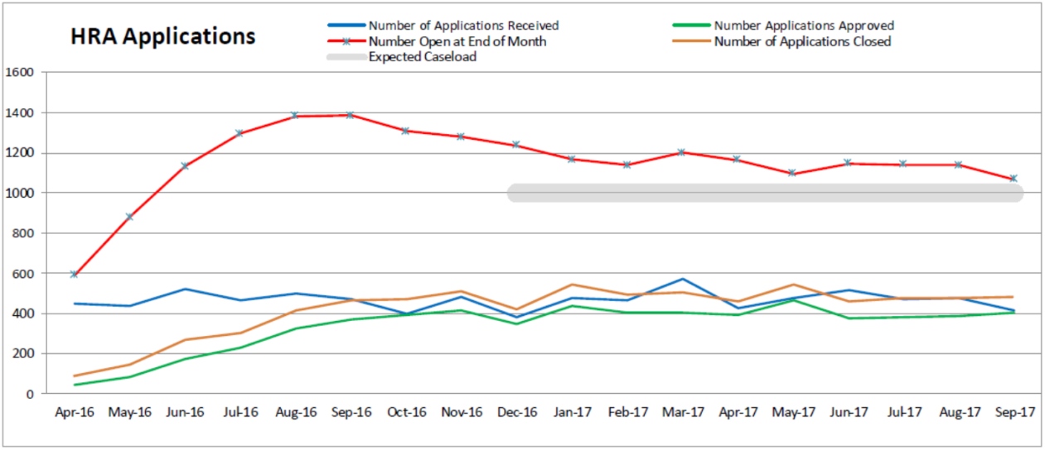
Service Improvement Programme: Helping applicants ‘get it right first time’ will reduce the number of studies that are submitted with missing documentation, allowing more resource to be used on study assessment. Updating the internet, refining our guidance and implementing validation tools within IRAS which will not allow a submission without the correct actions having been taken will all support this endeavour

4.2 We can now interrogate the ‘open’ caseload far more intelligently due to the introduction of Assessor workbooks (which detail where in the assessment process a study might be) and so we can show that the majority of studies are either waiting for a regulatory opinion and so cannot be approved, or are back with the applicants for them to respond to queries. Those studies that have been with us for a long period of time are regularly reviewed by the Assessment team and the applicant contacted to attempt to clear them through the system.
4.3 The change in the way in which amendments were categorised, coupled with the introduction of the triage system removing a high proportion of the amendments from the assessment system, alongside process changes and removing the challenge of the pre-HRA studies has meant that the team have reduced their personal caseloads from what was in some areas over a hundred each to a far more manageable 25-30.
4.4 Training for and engagement with commercial sponsors on the HRA Approval process, and focussing on what they can do to ensure a swift assessment has received positive feedback. The collaborative work between the HRA and sponsors which we now have the capacity with the Assessment team to offer has proved vital in developing those relationships at all levels. The rapport building we encourage the Assessment Team to engage in when speaking to applicants will continue to offer benefit to both sides. The collaborative work between the applicants and our Assessors is proving fruitful, particularly in the commercial sector where the numbers of valid applications is beginning to rise.
Service Improvement Programme: to remove the current 2 step validation process and to attempt to increase the number of times information to REC is provided in time for committee review, a pilot project has been undertaken with 8 RECs and dedicated Assessment Team support to trial a new way of validating a study on submission.
4.5 The time for the Assessment Team to issue a HRA Approval letter after the last regulatory approval is in place has dropped dramatically over the last 6 months and, for studies that need REC review, is now under 10 days – with a small but increasing number being issued in a combined single email. The initial target set for non-commercial studies when HRA Approval was first opened was 25 days, with commercial studies set at 10 days. Both the reducing case load for Assessors and more joined up working between Assessors and REC Managers (so that both understand when a favourable opinion is possible) have contributed to this reduction. However, there are still challenges in ensuring that the Information to REC is received and reviewed by the committee in time to support its decision. Though the Assessment team have a more manageable caseload, there is still an element of over-leanness to the team which militates against achieving any but the most prioritised milestone – issuing HRA Approval. This, coupled with approximately 30% of the studies not being valid for assessment to begin due to missing documents (even when valid for REC) has historically led to only a small proportion of Information to RECs getting through to the committee. The number of these is however increasing over the last few months with the team attempting to prioritise now that the overall caseload has lessened. From 49 Information to RECs in June of this year the team have issued almost 100 in October.
4.6 The team’s performance on assessing studies has been supported by the increasing proportionality that has gradually been introduced. The training that the team receive has always included an element of when to take a more pragmatic step to assist the applicant’s journey with us. With the increasing experience the team now have and the support from the Programme Team in understanding where they can implement such learning, the team have managed to demonstrate a fluid approach to the process of Assessing and issuing Approvals. More formally the team have looked into piloting a proportionate approach to certain types of staff research, and single centre studies at sponsor site.

- Amendments
5.1 Though the early days of managing the amendment submissions to the HRA proved challenging, that experience did allow the Team to review all the processes and look where there might be opportunity to change the way we do things. Changes to the process of handling amendments, along with clearer guidance for applicants has led to achieving satisfactory timelines for amendments to be categorised and assessed. The open caseload of around 500 amendments reflects the time taken for amendments to complete regulatory approvals where applicable.
Not all amendments are equal, and some are simple enough not to require further assessment after an initial triage at the same time as validation and categorisation. This has led to approx. 50% of the amendments submitted to the HRA not needing further assessment.
The task of categorising substantial amendments, which initially was undertaken by 4 people was shared across the REC managers and assistants as well. This increase in resource has led to amendments being validated and categorised within 5 days – allowing applicants to liaise with their sites much quicker
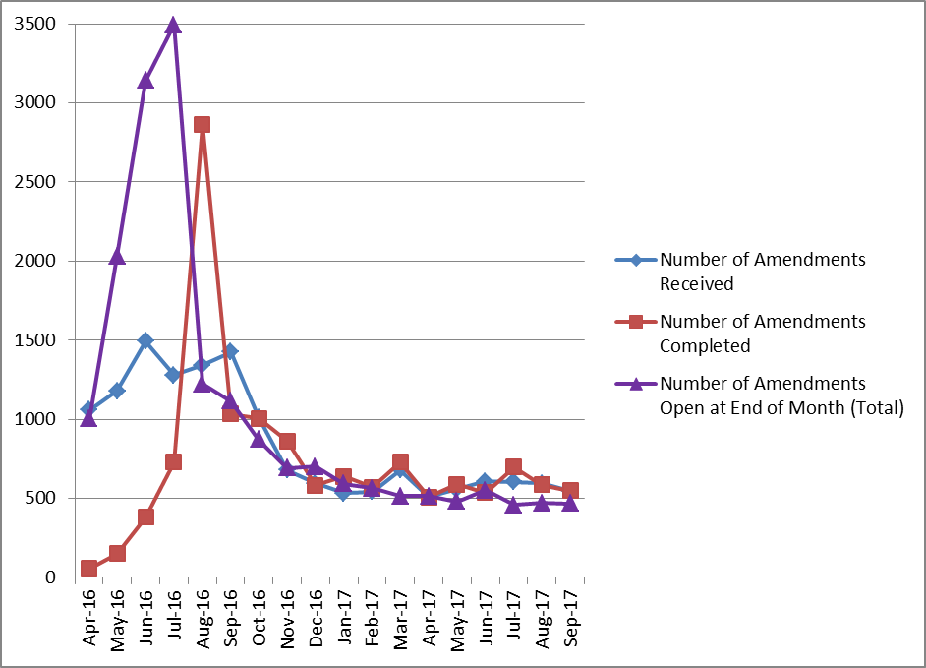
5.2 Applicants and sponsors are reporting some interesting and inconsistent site behaviour when amendments are dealt with locally. The system operates by assuming that the amendment is acceptable to a site 35 days after the site is informed of the amendment unless they have raised an objection with the sponsor. This was a UK wide process introduced ahead of HRA Approval but remains poorly understood by sponsors and sites.
5.3 Though the HRA Approval Programme team and UK wide colleagues are not currently able to start a full project to address the amendment complexity due to resources being allocated to both business as usual and the Service Improvement Programme they are attempting to simplify some areas of the process where there are quick wins:
- Seeking agreement with the DAs to remove unnecessary changes from needing to be submitted as amendments at all

- Improving guidance on when it is appropriate to group amendments together when submitting them to the HRA

- Working with sites to understand where the gaps in understanding are around the amendment process and supporting changes in local practice

- Technical Assurance
6.1 The Technical Assurance team have been working on defining and refining the processes through which the HRA can offer a centralised service for collating pharmacy technical information for Clinical Trials of Investigational Medicinal Products and for supporting Medical Physics Experts and Clinical Radiation Experts with their respective inputs to the IRAS form and Patient Information Sheets for ionising radiation. During the development of the process the team have been liaising with colleagues from the Devolved Administrations and the resulting system will now be one across all 4 home nations.
6.2 Online training modules are currently being developed to support the training of new reviewers (for both pharmacy and radiation aspects) before the team launch a recruitment drive to increase the numbers of potential reviewers they have. Technical Assurance will then be gradually phased into the environment by progressively increasing the numbers of studies applicable to use the service. Currently, process awareness training is linked into the updates the team provide to the commercial and non-commercial sponsors on HRA Approval, and more detailed communication will be published through the HRA website at each project milestone.
