

|  |  |
| --- | --- |
| **Agenda item:** | **7** |
| **Attachment:** | **B** |

**HRA BOARD COVER SHEET**

|  |  |
| --- | --- |
| **Date of Meeting:** | 20 June 2016 – verbal report to EMT  6 July 2016 – written report to EMT  11 July 2016 – written report and update to SEMT  20 July 2016 – written report to Board |

|  |  |
| --- | --- |
| **Title of Paper:** | Financial report - May 2016 |
| **Purpose of Paper:** | To report on the financial position of the Authority as at the 31st May 2016 |
| **Reason for Submission:** | To ensure the EMT, SEMT and the Board, are aware of the financial position of the HRA as at the end of May 2016. |
| **Lead Reviewer:** | Tom Smith, Director of Quality, Guidance and Learning - 23 June 2016 |
| **Details:** | This paper presents the financial position as at the end of May 2016.  Main points to note:   * The HRA achieved a broad break even financial position for the period April to May 2016. * An under spend on pay of £50k was offset by an over spend on non pay of £46k. * The HRA has continued to meet the duty to pay 95% of invoices in 30 days achieving 97% based on number of invoices, and achieved the target based on value by achieving 99%. * The capital position is reporting a slight underspend of £10k, but further work is required to finalise the year end forecast position and identify any potential surplus, as a result of the reduced contract costs, which could be released for the wider system. * There has been a reduction in the level of cash held from the year end of £3.485m to £3.362m * An indicative budget for 2016/17 in line with expectations has been received from the Department of Health. This is unlikely to change. |
| **Suitable for wider circulation?** | **Yes, following Board** |
| **Time required for item:** | **10 minutes** |

|  |  |  |  |
| --- | --- | --- | --- |
| **Recommendation / Proposed Actions:** | **To Approve** | | **Yes** |
| **To Note** | |  |
| **For discussion** | |  |
| **Comments** |  | |

|  |  |
| --- | --- |
| **Name:** | Debbie Corrigan |
| **Job Title:** | Director of Finance, Procurement and Estates |
| **Date:** | 22 June 2016 |

**Finance Report - Financial Year 2015/16**

**Health Research Authority as at 31 May 2016**

1. **Introduction**

This report outlines the financial position of the Authority in respect of revenue and capital expenditure for the month ended 31 May 2016.

**2. Revenue Resource Limit**

To date, the HRA has received an indicative budget which matches expectations discussed during the 2016/17 business planning round. Meetings have been held with the Department of Health (DH) Sponsor and DH finance colleagues and this budget is unlikely to change. The expected HRA grant in aid and revenue resource limit for the year was presented in the 2016/17 financial plan and this report continues to be based on the same figures of £13,080k. The whole of this sum is classified as administration funding under HM Treasury definitions and this sum represents HRA annual statutory funding from the Department of Health (DH) for the year. It excludes income from other government departments or income from the Devolved Administrations.

**3. Revenue expenditure position at 31 May 2016**

The revenue position of the Authority is summarised in the table below with further performance detail in Appendix A.

The Authority has spent £2.03 million year to date. This represents a £3k under spend against profiled expenditure budgets. A summary of the overall position by Directorate is presented in table 1 below.



The main points to note in the first reported outturn expenditure position for 2016/17, as at 31 May 2016 of £2.03m are:

1. Total pay costs incurred are £1.4m (68% of total expenditure costs).
2. Of this, £88k (6.4%) relates to agency costs. These costs include key research information systems staff who are progressing critical work. Work to recruit staff onto the payroll is nearing completion. This is in line with the developing Research Information Systems Strategy.
3. Within the broad break even position year to date, there are two key areas to highlight. There is an under spend year to date relating to the Research Systems, Standards and HRA Approval Programme directorate (£34k), of which £27k relates to vacancies within performance management, collaboration & development and assessment). There is an offsetting overspend of £21k within corporate services all of which relates to staff training and is due the miscoding of expenditure related to the all staff day, which should have been charged to the communications budget the profile of which also requires correction.
4. Pay budgets are under spend by almost £50k. This is net of a £25k year to date vacancy factor, the overall pay underspend would have therefore been £75k. Half of the £50k is within the Research Systems, Standards and HRA Approval Programme directorate. Further work is required to identify the reasons and plans to re-cycle this money into supporting the service being provided. The remainder of the pay underspend is shared almost equally across all Directorates.
5. Non-pay budgets are over spent by £46k. £28k is within Corporate Services and is due to the all staff day accounting treatment which will be corrected. Recruitment costs are another area of pressure which will need to be funded from reserves. An £11k overall over spend within the operations directorate is due to the archiving project running into the new year £30k year to date impact (this is expected to rise to circa £70k), offset by under spends in meeting expenses (£7k), travel costs (£7k) and chairs Allowance (£5k) which require further investigation and resolution.
6. The expectation is that all staff will be in post within the HRA Approval programme by June with some further refinements being made in response to emerging workload pressures. The final profile of actual starters is set out in the Table 2 below and shows that there are still 4 new starters yet to join the payroll during June 2016.

**Table 2: HRA Recruitment phases**



1. Tables 3 and 4 below present the run rate of expenditure by type, pay and non pay. This is the first full month end for the 2016/17 year and the stepped increase in the trend lines between April and May is due to full accruals accounting being actioned in May which were not adjusted for in April, whilst the finance team concentrated on the financial year end for 2015/16.

**Table 3: Profile of planned and actual Pay costs 2016/17**

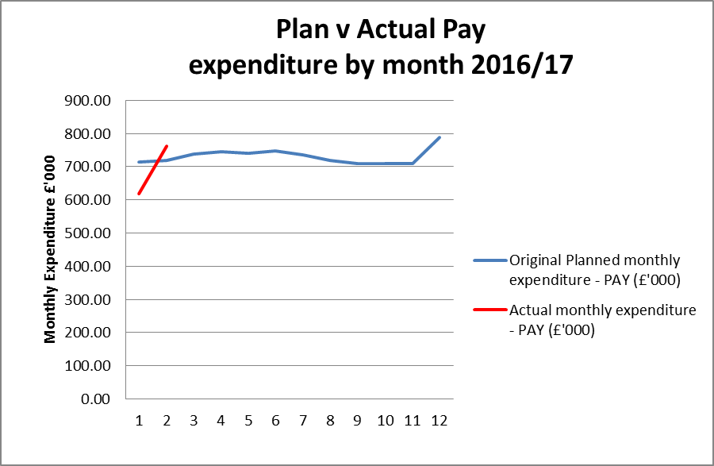

**Table 4: Profile of planned and actual Non Pay costs 2016/17**

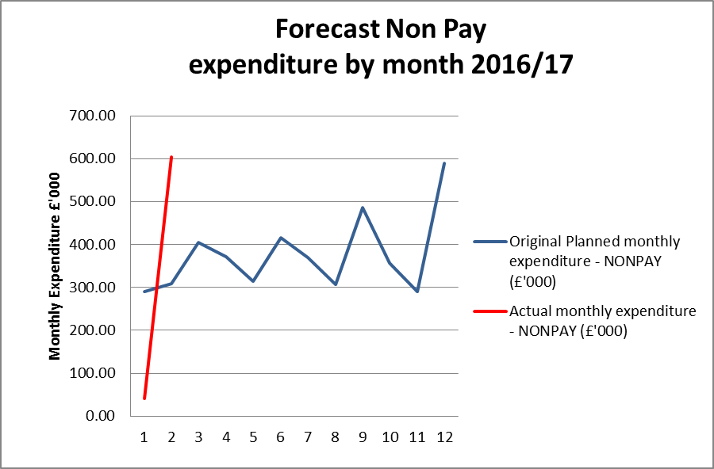

**4. Forecast outturn 2016/17**

Early forecasts point to a break even. The finance team will be working hard with budget managers to refine the forecasting process this year. Returns have been issued for budget manager completion and the aim is to provide an accurate forecast in September which will then form the basis of a month on month comparison to try to minimise any significant changes.

The table below highlights the current accumulated underspend. As this is the first full financial report for 2016/17 there is only one table presented here. Future monthly reports will present the position by month as the year progresses.

**Table 5: Overall (£) variance position by month**

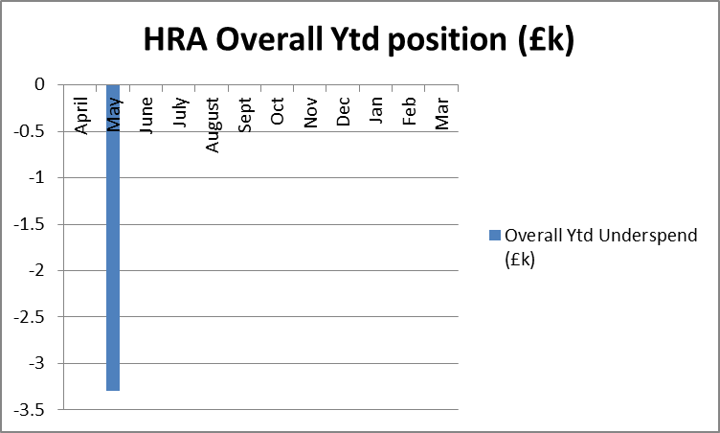

**5. Better payments performance**

Better payment performance provides an indicator to the board and stakeholders of the financial service being provided. These services are influenced by strong management of the finance and accounting service contract with NHS Shared Business Services, the additional support service offered by the finance team and the performance of budget managers in approving invoices in a timely manner.

The HRA has continued to meet the duty to pay 95% of invoices in 30 days achieving 97% based on number of invoices, and achieved the target based on value by achieving 99%. HRA are committed to paying suppliers promptly and have maintained a target of paying suppliers within 10 days to 60% for 2016/17. The performance at the end of May 2016 for payments made within 10 days is 71% (number of invoices) and 77% (value of invoices), both achieving the stretched 60% target. The escalation days for invoices awaiting approval continues to be 4 days (after which invoices are escalated to line managers) and further reminders on vacation rules and the importance of checking the workflow daily will be issued to staff in June. The HRA continues to have 3 payment runs each week to maintain the performance.

**6. Travel costs**

£535k has been allocated for planned travel costs in 2016/17. This budget covers staff travel costs as well as volunteer REC member travel. £586k was allocated in 2015/16 and it continues to be an area which is being intentionally monitored and managed with a view to a reducing staff travel expenditure given the significant investments made to facilitate flexible working.

The graph below shows the staff costs per head incurred to date compared to a benchmark of 2013/14. The increase in staff travel costs per head is due to the timing of the all staff day in May.

**Table 6: Staff travel costs per head**

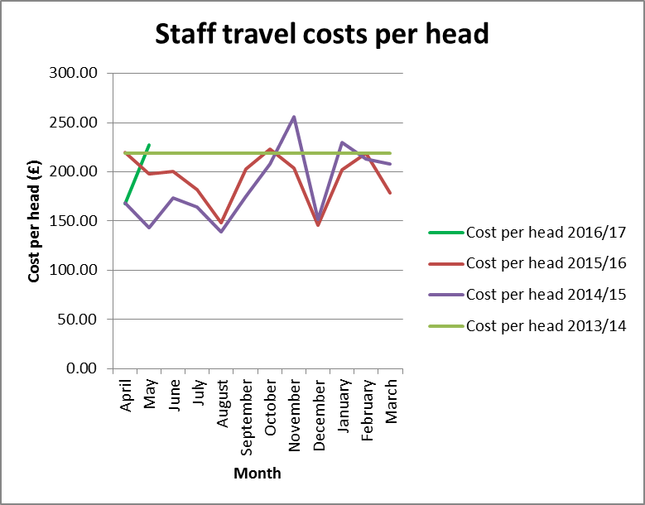

Table 7 below sets out the total travel costs position (staff, members inclusive) at the end of May 2016. £94k has been spent year to date with a £3k over spend against the plan. It should be noted that one explanation for the over spend is due to the all staff day in May. The treatment of travel costs associated with training continues to be investigated and a solution is nearing completion. The arrangements for staff training continue to be reviewed to see if any savings can be realised from the choice of venue and methods of training provision. The estates strategy work is also encouraging greater use of video conferencing or “Lync” meetings, however this aspect is strongly dependent on the reliability and capacity of the IT service.

**Table 7: Travel costs and budget across the HRA by Directorate**



**7. Staff numbers**

Pay represents 68% of the costs incurred in year. The profile of our staff headcount is presented in Table 8 below for information.

**Table 8: Chart to show actual staffing headcount so far in 2016**

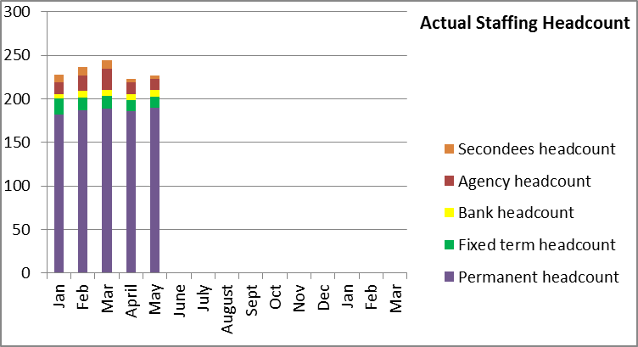

The overall headcount has reduced as expected. Whilst permanent, fixed term headcount has remained broadly steady, secondments have reduced as project posts came to the end of their expected terms.

**8. Month end faster close**

The achievement of key deadlines continues to be maintained. Finance aim to complete the month end within 4 working days of the end of the month in question. In May, month end close took 5 working days following an extension by 1 day as a result of IT problems affecting a member of the team. All agreed deadlines for completion of required reports for EMT and Board were achieved.

**9. Capital**

The capital expenditure position is presented below for May 2016 and is running at a slight under spend. The HRA received confirmation of the capital funding of £910k from the Department of Health in line with the amount included within the Spending Review.

The capital plan includes budget for the development of the HARP and IRAS systems and for those Information Systems posts which include an element of development or capital work within their roles. An additional budget was initially identified for laptop refreshment, but following the advice from the auditors that these could be charged to revenue, and the subsequent recent completion of the statutory audit, where this was discussed and concluded that the treatment was correct, this budget will no longer be required. As work is completed on forecasting for the year end position, any surplus on the allocated budget will be identified and notified to DH through the quarterly returns for use by the wider system.

A report on the monthly spend against budget for each of the capital programmes is shared with the Deputy Director – Research Information Systems. This enables us to highlight any potential forecast under spend or over spend at an early stage.

**Capital expenditure 2016/17**



**10. Statement of Financial Position and cash**

The Statement of Financial Position and cash flow will be presented on a quarterly basis, at the end of June, September, December and March 2017.

At the end of the reporting period, the cash balance was £3.362m, which is a reduction against the balance of £3.485m held at the end of the 2015/16 financial year. . In order to fulfil the duty to avoid holding excess levels of cash, the HRA will continue to monitor the cash position during 2016/17 to ensure that sufficient cash is held for future needs, but will aim to reduce the cash balances held.

**11. Cash releasing Savings**

The following areas will form the basis of ensuring that the HRA continues to remain within its financial envelope over the term of the spending review:

* Vacancy factor.
* Continued savings in estates costs through improved use of footprint.
* Savings in per head staff travel costs to justify the investment made in digital telephony. Given the expenditure on travel in 2015/16, this area poses a risk and a challenge and will require concerted management action.
* Savings in introduction of Managed Print Service and roll out of this service as leases expire on current photocopier agreements.
* Savings through the use of the Member Portal.
* Savings on HRA’s largest information systems contract.

**12. Recommendations**

That EMT and the Board note the financial position and to particularly note the following:

* The broad overall breakeven position.
* The under spend on pay offset by an over spend on non pay.
* The excellent performance on the Better Payments Practice Code position to meet the 95% target based on number of invoices and the value and the 60% achievement of payments within 10 days.
* The capital position at the end of the period and likely forecast.

**Debbie Corrigan**

**Director of Finance, Procurement and Estates**

**22 June 2016**

**Health Research Authority – Financial position as at 31 May 2016 Appendix A**

|  |  |
| --- | --- |
| **FINANCIAL RESULTS**  **HEADLINES** | * HRA is reporting an expenditure budget under spend of £3k at the end of May. * Pay budgets are under spent by almost £50k. This is including a £25k year to date vacancy factor having been applied. * Non pay budgets are over spend by £46k largely due to accounting treatment for the all staff day and the over run of the archiving project. * The largest directorate under spend is within Research systems, Standards and HRA Approval directorate (£34k), of which £27k relates to vacancies within performance management, collaboration & development and assessment areas. Plans are being developed to recycle these budgets to meet the needs of the service. * Work has almost completed to introduce a process to correctly capture training related travel costs. * The Better Payment Practice Code (BPPC) compliance for April to May was 97% for the number of invoices paid, which is in line with the overall performance for 2015/16, and is reporting 99% for value of invoices paid. Having achieved the 60% target of paying invoices within 10 days during 2015/16, the HRA has maintained this target for 2016/17 and at the end of May, this target has been achieved. All approvers are asked to note this and to approve invoices promptly or place on hold if there is a dispute. Performance is published on our website. * Cash balance has reduced from year end £3.485 million (with liabilities to pay of £1.296million) to £3.362 million (with liabilities to pay of £1.181million). * The cash balance at the end of May2016 was £3.362m, which is slightly less than the balance held at the end of March of £3.485m. |

**Health Research Authority – Non Pay Expenditure Year to end May 2016 Appendix B**

|  |  |  |  |  |  |  |  |  |  |  |  |  |  |  |  |  |  |  |  |  |  |  |  |  |  |  |  |  |  |  |  |  |  |  |  |  |  |  |  |  |  |  |  |  |  |  |  |  |  |  |  |  |  |  |  |  |  |  |  |  |  |  |  |  |  |  |  |  |  |  |  |  |  |  |  |  |  |  |  |  |  |  |  |  |  |  |  |  |  |  |  |  |  |  |  |  |  |  |  |  |  |  |  |  |  |  |  |  |  |  |  |  |  |  |  |  |  |  |  |  |  |  |  |  |  |  |  |  |  |  |  |  |  |  |  |  |  |  |  |  |  |  |  |  |  |  |  |  |  |  |  |  |  |  |
| --- | --- | --- | --- | --- | --- | --- | --- | --- | --- | --- | --- | --- | --- | --- | --- | --- | --- | --- | --- | --- | --- | --- | --- | --- | --- | --- | --- | --- | --- | --- | --- | --- | --- | --- | --- | --- | --- | --- | --- | --- | --- | --- | --- | --- | --- | --- | --- | --- | --- | --- | --- | --- | --- | --- | --- | --- | --- | --- | --- | --- | --- | --- | --- | --- | --- | --- | --- | --- | --- | --- | --- | --- | --- | --- | --- | --- | --- | --- | --- | --- | --- | --- | --- | --- | --- | --- | --- | --- | --- | --- | --- | --- | --- | --- | --- | --- | --- | --- | --- | --- | --- | --- | --- | --- | --- | --- | --- | --- | --- | --- | --- | --- | --- | --- | --- | --- | --- | --- | --- | --- | --- | --- | --- | --- | --- | --- | --- | --- | --- | --- | --- | --- | --- | --- | --- | --- | --- | --- | --- | --- | --- | --- | --- | --- | --- | --- | --- | --- | --- | --- | --- | --- | --- | --- |
| **Areas of Non- Pay Expenditure** | |  |  |  |  |  |  |  |  |  | | --- | --- | --- | --- | --- | --- | --- | --- | --- | | **Subjective** | **Annual** | **Next year** | **In month (£)** | | | **Year to date (£)** | | | | **Name** | **budget (£)** | **plan (£)** | **Budget** | **Actual** | **Variance** | **Budget** | **Actual** | **Variance** | | **Meeting Rooms/Catering** | 180,793 | 178,793 | 20,850 | 31,405 | 10,555 | 35,743 | 30,675 | -5,068 | | **Office equipment/Stationery/Furniture/Consumable** | 101,794 | 101,794 | 35,627 | 3,395 | -32,232 | 44,106 | 8,024 | -36,082 | | **Photocopying/Printing/Postage/Storage/Waste** | 155,410 | 155,410 | 12,910 | 17,564 | 4,654 | 25,852 | 28,982 | 3,130 | | **Premises - inc premise removal costs** | 717,327 | 717,327 | 61,599 | -21,645 | -83,244 | 121,364 | 113,614 | -7,750 | | **Training Expenses - expenses/materials , conferences, workshops** | 73,990 | 73,990 | 3,911 | 16,420 | 12,509 | 10,072 | 41,947 | 31,875 | | **Other Staff costs - Recruitment/adverts/redundancy/PILON** | 40,000 | 40,000 | -500 | 3,717 | 4,217 | 0 | 2,649 | 2,649 | | **Travel costs - include excess mileage/interview expenses** | 540,429 | 522,624 | 46,920 | 99,705 | 52,785 | 93,323 | 97,263 | 3,940 | | **Chairs/Members/Participation - activity costs** | 268,685 | 268,685 | 21,845 | 81,682 | 59,837 | 44,230 | 39,823 | -4,407 | | **Publications** | 2,250 | 2,250 | -136 | 0 | 136 | 50 | 222 | 172 | | **Mobile Phones/Mobile Data** | 18,661 | 18,661 | 1,543 | 1,497 | -46 | 3,086 | 2,993 | -93 | | **Statutory Costs - Health & Safety/Legal/Audit Fees/Dep. & Amort.** | 549,365 | 549,365 | 1,261 | 45,671 | 44,410 | 9,520 | 10,872 | 1,352 | | **Computer Costs - Software/licences/system maintenance/purchases** | 310,873 | 310,873 | 24,510 | 77,589 | 53,079 | 50,413 | 59,370 | 8,957 | | **Other External Contracts - SLA's - Premises, SBS,BSA, DH IT** | 1,070,349 | 983,231 | 78,909 | 247,594 | 168,685 | 162,485 | 209,676 | 47,191 | | **Other - Misc/Reserves** | 604,489 | 0 | 0 | -3 | -3 | 0 | -6 | -6 | | **GRAND TOTAL** | **8,059,852** | **7,846,006** | **618,498** | **1,209,185** | **590,687** | **1,200,488** | **1,292,212** | **91,724** |   Note: The under spend on office equipment/furniture relate to Estates Strategy budgets. The profile of the budget requires correction. The overspend on other external contracts largely relates to the over run on the archiving project along with an incorrect treatment relating to an end of year 15/16 accrual double counted. This will be corrected. |

**HRA Better Payment Practice Code for the period 1 April to 31 May 2016 Appendix C**



**Aged Creditors at 31 May 2016**

Headlines – clock start date is the invoice date (regardless of when the invoice is received in the system) – there are no issues of concern..

|  |  |  |  |
| --- | --- | --- | --- |
|  | **Aged Creditors – (£) amounts past due date** | | |
|  | **1-30 days** | **31-60 days** | **60 + days** |
| **Non NHS Trade** | 4,077.38 | 576.00 | (420.29) |
| **Non NHS Other** | 415.91 | 159.70 | (17.10) |
| **NHS** | 31,508.49 | 26,806.16 | 75.48 |
|  |  |  |  |
| **Total** | 36,001.78 | 27,541.86 | (361.91) |

**HRA Revenue position for the period ended 31 May 2016 Appendix D**

