

|  |  |
| --- | --- |
| **Agenda item:** | **9** |
| **Attachment:** | **D** |

**HRA BOARD COVER SHEET**

|  |  |
| --- | --- |
| **Date of Meeting:** | 4 May 2016 – written report to EMT  20 May 2016 – written report to Board |

|  |  |
| --- | --- |
| **Title of Paper:** | Financial report - March 2016 |
| **Purpose of Paper:** | To report on the financial position of the Authority for the 12 months to 31st March 2016 |
| **Reason for Submission:** | To ensure the EMT and the Board, are aware of the financial position of the HRA as at the end of March 2016 with an update on changes to the yearend financial position. |
| **Lead Reviewer:** | Tom Smith, Director of Quality, Guidance and Learning - 3 May 2016 |
| **Details:** | This paper presents the financial position as at the end of March 2016.  Main points to note:   * The HRA continues to live well within its means. * 93.3% of the financial plan has been spent up to the end of the financial year. 63% of this is pay related. * There has been an in-month increase in the under spend of £443k, largely due to reserves not being required in line with expectations. * There continue to be 5 posts yet to join the Systems, Standards & HRA Approval program, all with start dates in May and June 2016. * The final under spend position, standing at £931k (£489k February 2016), largely increased due to the predicted release of reserves in month 12 (£557k). The underspend of £122k within the Operations Directorate and mostly due to the unique number of vacancies that have arisen either because of successful applications for roles linked to HRA Approval or due to the move of Research Ethics Committees (RECs) between HRA Offices in order to spread the support more equitably. These vacancies have taken longer than expected to fill due to the knock on vacancies that have resulted from successful internal candidates. * There has been unprecedented recruitment within the organization over the last 12 months with 167 VCFs raised compared with 92 last year. 46% of these relate to the Operations Directorate. Whilst the volume was expected within the Research Systems Directorate, the extent of the knock on recruitment in Operations was not. * The final underspend position of £931k was slightly less than the predicted £1.0m probable underspend forecast. * The final capital underspend position was £190k, which is in line with the upper range underspend of the forecast. * The forecast year end cash position has intentionally not drawn down £1.2m of the full cash limit. This is to aid the overall system manage its cash but also to meet our requirement to only draw down to match need. * An indicative budget for 2016/17 has been received. |
| **Suitable for wider circulation?** | **Yes, following Board** |
| **Time required for item:** | **10 minutes** |

|  |  |  |  |
| --- | --- | --- | --- |
| **Recommendation / Proposed Actions:** | **To Approve** | | **Yes** |
| **To Note** | |  |
| **For discussion** | |  |
| **Comments** |  | |

|  |  |
| --- | --- |
| **Name:** | Debbie Corrigan |
| **Job Title:** | Director of Finance, Procurement and Estates |
| **Date:** | 22 April 2016 |

**Finance Report - Financial Year 2015/16**

**Health Research Authority as at 31 March 2016**

1. **Introduction**

This report outlines the financial position of the Authority in respect of revenue and capital expenditure for the month ended 31 March 2016 and the full year 2015/16.

**2. Revenue Resource Limit**

The final HRA grant in aid and revenue resource limit for the year was £13,410k. Appendix E sets out the details. The whole of this sum is classified as administration funding under HM Treasury definitions and this sum represents HRA annual statutory funding from the Department of Health (DH) for the year. It excludes income from other government departments or income from the Devolved Administrations.

**3. Revenue expenditure position at 31 March 2016**

The revenue position of the Authority is summarised in the table below with further performance detail in Appendix A.

The Authority has spent £12.96 million (£11.24m Feb 2016) year to date. This represents a £931k under spend (£929k under against expenditure budget, and an additional £2k unbudgeted income) against profiled expenditure budgets, which is in line with the significant change to the anticipated position previously highlighted. A summary of the overall position by Directorate is presented in table 1 below.

|  |  |  |  |  |  |  |
| --- | --- | --- | --- | --- | --- | --- |
| **Summary of financial outturn 31 March 2016** | | |  |  |  |  |
|  |  |  |  |  |  |  |
|  | **Description** | **Initial Annual Budget** |  | **Budget for period to** | **Outturn as at** | **Variance** |
|  | **Latest Annual Budget** | **31 March 2016** | **31 March 2016** |
|  |  | **(£'000)** | **(£'000)** | **(£'000)** | **(£'000)** | **(£'000)** |
| **Income** | |  |  |  |  |  |
|  | HRA income | 196 | 196 | 196 | 198 | 2 |
|  | Grant in aid (confirmed) | 13,346 | 13,345 | 13,410 | 12,509 | (901) |
|  | Grant in aid (CAG2 to be confirmed) | 139 | 65 | 0 | 0 | 0 |
|  | Non cash revenue resource limit | 270 | 283 | 283 | 253 | (30) |
|  | **Total** | **13,951** | **13,889** | **13,889** | **12,960** | **(929)** |
| **Expenditure** | |  |  |  |  |  |
|  | Operations -Research Ethics Service England incl CAG | 4,794 | 4,695 | 4,695 | 4,573 | (122) |
|  | Chief Exec - Team, Board and Corporate Secretary | 1,560 | 1,888 | 1,888 | 1,821 | (67) |
|  | Corporate Services incl Communications, staff training, public involvement, programme office, HR services, IT contract | 1,731 | 1,857 | 1,857 | 1,828 | (29) |
|  | Finance, Procurement and Estates and Reserves | 3,153 | 1,837 | 1,837 | 1,256 | (581) |
|  | Research Systems,Standards and HRA Approval Programme activity, Quality Assurance, Guidance advice and learning | 2,713 | 3,612 | 3,612 | 3,482 | (130) |
|  | **Total** | **13,951** | **13,889** | **13,889** | **12,960** | **(929)** |
|  |  |  |  |  |  |  |
| **Surplus/(Deficit)** | | **0** | **0** | **0** | **0** | **0** |

The main points to note in the outturn expenditure position as at 31 March 2016 of £12.96m are:

1. Total pay costs incurred are £8.19m (63.2% of total expenditure costs).
2. Of this, £774k (9.45%) relates to agency costs. These costs include key research information systems staff who are progressing critical work which to March represented 62% of the agency costs. The Research Information Systems Strategy is under development which includes consideration of the mix of permanent and contractor roles moving forward, however plans are being progressed to bring key roles onto the payroll.
3. £11k of the March pay costs relates to overtime that staff have worked to help cover vacancies for which we are extremely grateful. Year to date, overtime costs via the payroll amount to £83.6k.
4. The largest element of the under spend year to date relates to the Research Systems, Standards and HRA Approval Programme directorate (£130k, of which £21k relates to non staff training) with a further under spend £122k relating to the Operations directorate.
5. Considerable work has been deployed into the recruitment phases supporting the HRA Approval programme. Reporting from senior managers indicates that recruitment is mostly complete now, pending confirmation of profile of actual start dates. The profile of actual starters is set out in the Table 2 below and shows that there are still 5 new starters yet to join the payroll during May/June 2016. An additional staff member is starting on the 1st April 2016. (Revision to the phase 4 plan relates to extending the current RIS contractor roles and removal of previously identified potential RIS roles. There has also been some re-phasing of the planned posts from phase 4 to phase 5 with one post in phase 5 not being progressed) Reserves are not released for posts until approvals for grading’s, recruitment and timing are clear and in place. The related slippage against earmarked reserves for these posts has been tracked as part of under spend management. New recruits have largely been appointed at the bottom of the scale, however the budgets for these posts had been based on mid point.

**Table 2: HRA Recruitment phases**

|  |  |  |  |
| --- | --- | --- | --- |
|  | **Phase 4** | **Phase 5** | **Phase 6** |
|  | Apr-15 | Jul-15 | Oct-15 |
| Original Planned headcount | 24 | 16 | 15 |
| Original Planned WTE | 23.75 | 15.1 | 15 |
| Revised Planned headcount | 20 | 20 | 17 |
| Revised Planned WTE | 20 | 15.1 | 17 |
| **Actual Headcount** | 20 | 19 | 11 |
| **Actual WTE's** | 20 | 14.1 | 11 |

1. After 12 months or 100% of the financial year, a total of 93.3% of the total expenditure budget has been spent within the year.
2. The overall under spend of £122k within **Operations** directorate has seen a large decrease from the previous month (£261k February). The Operations directorate underspend is largely broken down as follows. HRA Office Jarrow (£13k), HRA Office Manchester (£93.5k), HRA Office Bristol (£8k), Regional Manager North and South (£5.6k), HRA Office London of (£22.5k) and HRA Office Nottingham has an overspend of £56k (£20k pay due to agency, overtime and over establishment; £36k non pay (£21k travel – 50% of travel spend in this centre relates to members); £5k stationery; £6k confidential waste payment for several years). There is also an under spend within Confidentiality Advisory Group and Team 1 and 2 (£86k) – which is mostly due to staff vacancies which have arisen – and to the delayed training and appointments to the CAG2 team. Planned expenditure on training and events in relation to the CAG2 committee have been delayed which has impacted the underspend position. There is an overspend within the Head of Research Ethics Service of £21k and an overspend within the Director of operations of £26k – this formed part of the planned activities taken to mitigate the underspend within the directorate. One project anticipated to be delivered in 2015/16 has seen some delays and some of the planned expenditure will now be captured into 2016/17 and will require management.
3. £192k of the £122k under spend within Operations, is pay related and due to vacancies that have arisen since the budgets were set and which are in the process of recruitment following the movement of some RECs between centres and the success of Operations staff obtaining posts supporting the HRA Approval programme. The previous forecast plans assumed a move to a full establishment towards the end of October but this was not achieved and this has increased levels of underspend and remained an issue into March. It is worth noting that some of the vacancies have been temporarily supported by HRA Approval staff who had capacity ahead of cohort 3 go-live, a good use of tax payers money. There is an over spend within non-pay of £70k.
4. Meeting expenses and catering costs within the Operations directorate account for an under spend of £34k. Travel is overspent by £60k, a £10k overspend in postage, a £5k overspend in packing and storage and stationery underspent by £5k and an £8k overspend in photocopier costs.
5. Within the **Research Systems, Standards and HRA Approval Programme. Directorate** there is an under spend of £130k (£156k February). External facing and member training is now managed from within the Research Systems, Standards and HRA Approval Programme Directorate. £21k of the under spend relates to this service which continues to deliver the required programmes to members, but the anticipated costs are lower than original estimates. A contributing factor is thought to be the accounting treatment for training related travel which will be corrected following a change in expense claim processes (held up despite huge efforts, by the limitations of the NHS SBS payroll process). The remainder of the under spend within the directorate relates to vacancies that have either been recruited to or will be very shortly. Some vacancies are arising as current Research Systems, Standards and HRA Approval staff secure new roles within the planned phased recruitment within the directorate and create additional vacancies. Travel is overspent by £23k within the directorate.
6. Within the Research Systems team an underspend developed last month and increased in March (£32k) with regard to contractor costs. With reduced working days during December and March, and a contractor leaving a post this underspend has not corrected.
7. Overall expenditure year to date is below that expected at the time the Financial Plan was presented. A comparison of the expected profiled plan against actual year to date expenditure can be seen in the tables 3 and 4 overleaf. The reasons for the pay variances have already been presented. The main reasons for the variances in non pay are due to:
   1. Quarterly non pay property costs – the profiled plan against the actual year to date expenditure can be seen in the graph overleaf. The main reasons for the variance highlighted in the graph are due to a rent free period from June only being profiled after agreement following the successful lease exemption case agreed in Manchester. A further adjustment was actioned in November following a review of accounting treatments whereby the rent free period should be spread across the length of the lease. An adjustment for the Bristol lease was actioned in January to account for the rent free period arising from the successful lease exemption case for Bristol.
   2. Impact on non-pay spend such as travel with the slippage of recruitment to HRA Approval posts.
   3. Original quarterly profiling of non pay areas of earmarked reserves in the plan which we now have a clearer picture of such as estates strategy related spend.
   4. Incorrect profiling of external training – members - £50k planned in quarter one originally which has now been re-profiled following discussion and agreement with the budget manager.
   5. There are very few meetings of RECs in August and this is thought to be one of the reasons for the dip in expenditure alongside the fact that leave impacts on activity. Profiling of budgets continue to be reviewed.
   6. Table 3 and 4 below set out separate graphical presentations of pay and non pay including the updated and revised profiled plan to the original profile of the plan in light of new information. These illustrate that the monthly spend is much closer to this revised plan, however a consistent gap continues between the planned pay expenditure and the actual due to the number of vacancies.

**Table 3: Profile of planned and actual Pay costs 2015/16**

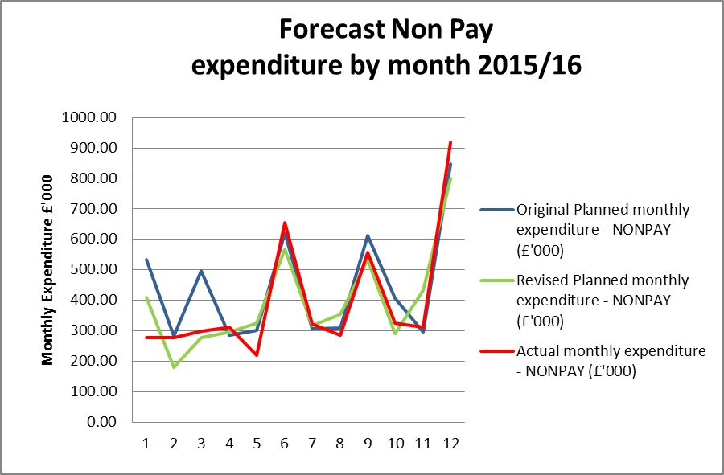

**Table 4: Profile of planned and actual Non Pay costs 2015/16**

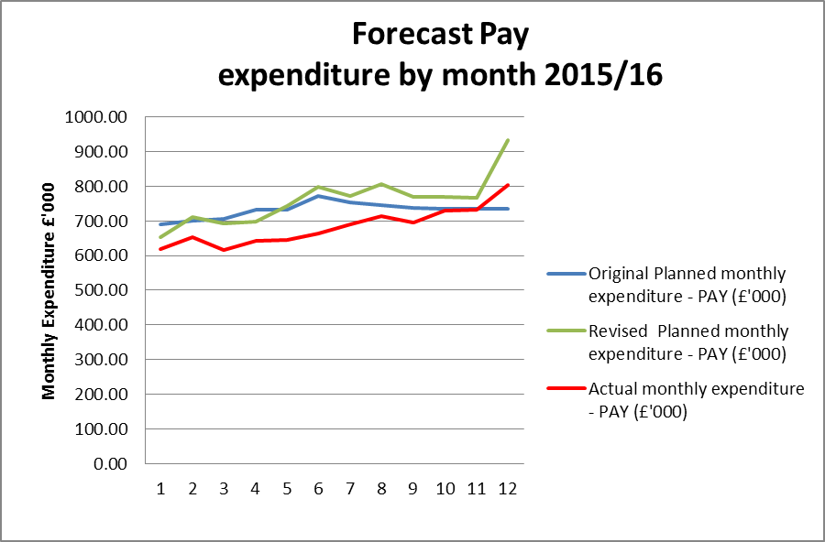

**4. Forecast outturn 2015/16**

Early forecasts pointed to an underspend position of £500k and this was predicated on:

* plans to mitigate and reduce the year to date income and expenditure under spend expected to be around £250k through additional project spend and over recruitment within Operations to mitigate against any further vacancies arising through successful applications to HRA Approval position. Thus a breakeven on the income and expenditure (less reserves).
* Management and visibility of reserves position and a linked and expected £500k under spend largely due to holding back in reserves with a profiled March impact the following:
  + Continued time taken to recruit to posts for HRA Approval and expectations of future time line
  + Appointments on bottom of scale to HRA A posts rather than midpoint
  + Delays in regulations supporting handling of patient information in research with knock on effect of delayed recruitment of staff and members for CAG 2 and vacancies.

However, the significant shift in the Income and Expenditure position which began in November and continued into December, and continued delayed recruitment to posts on reserves led to a significant change in the forecast to a range of £ 1.0m probable and £1.3m possible, and a resulting confirmed £931k underspend.

The active tracking of the underspend suggested we would be moving to a fully established position by the end of October and that the Income and Expenditure underspend would cease to grow and the additional managed planned activities would reduce the current underspend position. However, indications now are that a number of vacancies have remained and we have not reached full establishment which has led to an unanticipated growth in the underspend position. These relate to posts mostly within the Operations and the Research Systems and Standards directorate. Delays to planned expenditure have also resulted from rejection or delayed approval of Professional Service business cases currently being considered by the DH Finance Approvals Panel (FAP).

Additional changes in anticipated spend have also arisen with regards to non-pay. These are in relation to external training, late confirmation from DH with regards to reductions resulting from the move to the managed print service (£25k), alongside clarification regarding previous year charges (£22k) and the decision to reschedule the All Staff Day to May 2016 (£18k).

The tables below highlight the accumulated underspend by month and highlights the significant unexpected change in the positions for November and December. The March in -month position was always expected.

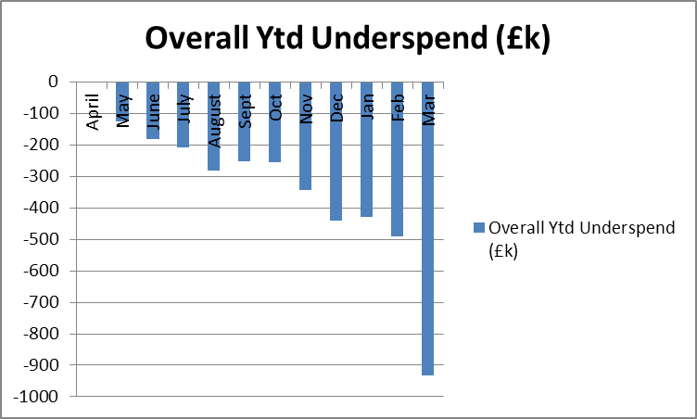

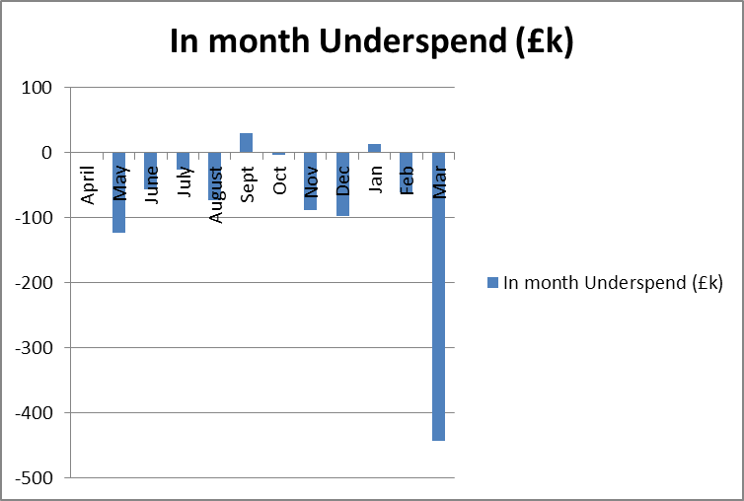

**5. Better payments performance**

Better payment performance has continued to meet the duty to pay 95% of invoices in 30 days achieving 98% based on number of invoices, and achieved the target based on value by achieving 97%. HRA are committed to paying suppliers promptly and have increased the target of paying suppliers within 10 days to 60% for 2015/16. The performance at the end of March 2016 for payments made within 10 days is 63% (number of invoices and value of invoices), both achieving the stretched 60% target. The escalation days for invoices awaiting approval have been reduced from 7 days to 4 days (after which invoices are escalated to line managers) and further reminders on vacation rules and the importance of checking the workflow daily have been issued to staff. An additional payment run has also been actioned as reported in previous months to further improve performance in 2015/16 and onwards.

**6. Travel costs**

£586k has been allocated for planned travel costs in 2015/16. Travel continues to be an area which is being intentionally monitored and managed with a view to a reduction in staff costs per head (given that costs are likely to increase overall as a result of more posts with a requirement for travel). The graph below shows that we are broadly achieving this aim compared to a benchmark of 2013/14.

Table 5 below sets out the total travel costs position (staff, members inclusive) at the end of March and reflects an over spend of £87.2k (£46.4k over spend February). It should be noted that one explanation for the over spend is due to the number of update meetings held to discuss HRA Approval with every Research Ethics Committee. Another is due to face to face meetings being held to discuss and clarify new processes and build new teams now that recruitment to posts is well underway. The treatment of travel costs associated with training continues to be investigated and a solution planned, and could be one explanation for the over spends within Directorates as there have been staff related training (Arbinger development day across the organisation, training for new staff relating to HRA Approval and workshops for the first cohort, plus interviews and an Operations away day in February). Additionally, the arrangements for staff training are being reviewed to see if any savings can be realised from the choice of venue and methods of training provision. The estates strategy work is also encouraging greater use of video conferencing or “Lync” meetings, however this aspect is strongly dependent on the reliability and capacity of the IT service.

**Table 5: Travel costs and budget across the HRA by Directorate**



Year to date staff travel costs for 2015/16 are presented in Table 6 below allowing comparison with the average cost per head in 2014/15 and 2013/14. This clearly demonstrates the reductions in costs per head being achieved year to date. The peak in October results mostly from activity within the Research Systems and HRA Approval directorate.

The lower travel costs in April and May is likely to be linked to fewer training events being held in these months. The peak in 2014/15 November is due to the All Staff Training day. Efforts continue with staff and line managers working hard to ensure costs are minimised wherever possible, for example use of telephone or video conference calls, tickets booked in advance and on timed trains.

**Table 6: Staff travel costs per head**

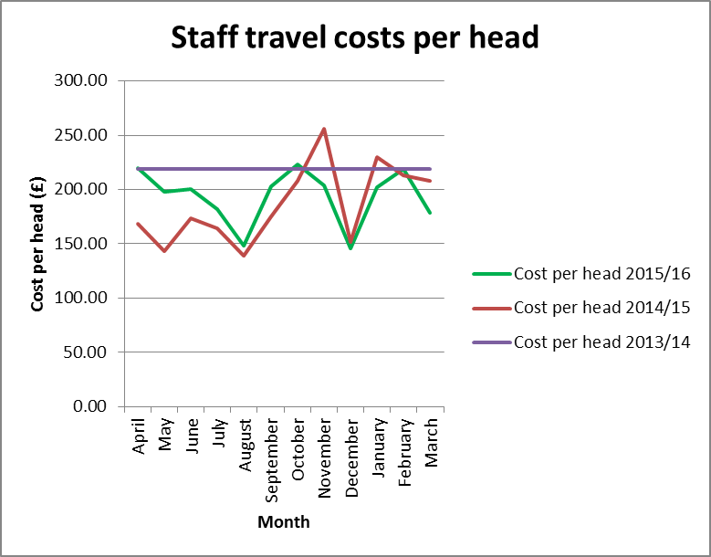

**7. Staff numbers**

Pay represents 63% of the costs incurred so far in year. The profile of our staff headcount is presented in Table 7 below for information. The expected overall upward trend has continued.

Permanent and fixed term headcount continues to increase slightly as does bank headcount.

**Table 7: Chart to show actual staff headcount so far in 2015/16**

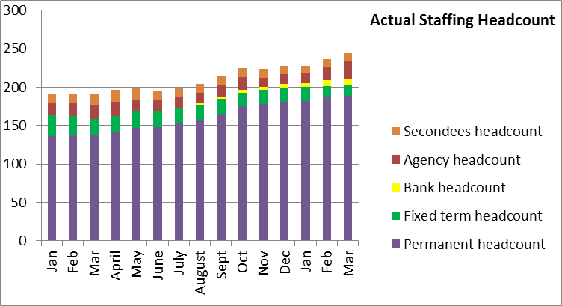

**8. Month end faster close**

The Finance team have over the last few months moved to working flexibly with most Finance team members working a proportion of their time from home. The achievement of key deadlines continues to be maintained. Finance achieved the timetabled close for year end in March. All agreed deadlines for completion of required reports for EMT and Board were achieved.

**9. Capital**

The capital expenditure position is presented below for March 2016. The capital plan includes budget for those Information Systems posts which include an element of development or capital work within their roles. A review of these posts has been undertaken and the original assumptions remain the same.

A total of 82% of the capital budget was spent at the end of March 2016.

The HRA received confirmation of the capital funding of £1.060m from the Department of Health on the 25th June 2015. The required investment in digital telephony led to a review of cost treatments of new laptops which the HRA had capitalised in previous months whilst discussions took place with the auditors to determine whether any further costs required capitalisation. Following guidance from the auditors, the £117k of costs relating to the laptops has been removed from capital and charged to revenue, due to the immaterial value of the laptops.

A report on the monthly spend against budget for each of the capital programmes has been developed and is shared with the Deputy Director – Research Information Systems. This enables us to highlight any potential forecast under spend or over spend at an early stage. The year end capital underspend is in line with the upper range of the forecast underspend reported in prior months. This underspend is partly due to the transfer of the costs for the laptops from capital to revenue.

**Capital expenditure 2015/16**

|  |  |  |  |  |
| --- | --- | --- | --- | --- |
| **Plan initiative** |  | **2015/16 plan** | **2015/16 actual** | **2015/16 to go** |
|  | **£ '000** | **£ '000** | **£ '000** |
| HARP Developments |  | 275.00 | 259.74 | 15.26 |
| IRAS Developments |  | 542.00 | 453.92 | 88.08 |
| IS Team – capitalised salaries |  | 243.00 | 156.35 | 86.65 |
| IT Equipment (digital telephony) |  | 0.00 | 0.00 | 0.00 |
| **TOTAL** |  | **1,060.00** | **870.01** | **189.99** |

**10. Statement of Financial Position and cash**

The Statement of Financial Position as at the end of March 2016 is reported in Appendix F, comparing against the Statement of Financial Position as at the 31st March 2015.

A cash flow is included in Appendix G. The cash figures for the whole year are actuals. At the end of the reporting period, the cash balance was £3.485m, which is slightly higher than the balance held at the end of February 2016 of £3.423m, and a reduction against the balance of £3.741m held at the end of the 2014/15 financial year. In order to fulfil the duty to avoid holding excess levels of cash, the HRA has intentionally not drawn down the full remaining cash balance in March. The amount not drawn down is £1.206m, which was mid point of the original forecast underspend range reported in February. Whilst the actual underspend at the end of March was less than the amount not drawn down, the HRA has used it as an opportunity to give cash back to the overall system.

**11. Cash releasing Savings**

Work on the Spending Review has completed and an indicative budget for 2016/17 received which indicates a 6% reduction in Grant in Aid, in line with expectations.

The following areas will form the basis of ensuring that the HRA continues to remain within its financial envelope over the term of the spending review and further details will be provided as part of financial and business planning for 2016/17:

* Vacancy factor
* Saving on rental budget through closure of an office (already achieved in Jan 2016).
* Continued savings in estates costs through improved use of footprint. £900 saving per head on estates costs in 2015/16 (compared to 2014/15).
* Savings in per head travel costs to justify the investment made in digital telephony. Given the expenditure on travel in 2015/16, this area poses a risk and a challenge and will require concerted management action.
* Savings in introduction of Managed Print Service and roll out of this service as leases expire on current photocopier agreements.
* Savings through the use of the Member Portal
* Savings on external learning budgets
* Savings on HRA’s largest information systems contract.

**12. Recommendations**

That EMT and the Board notes the final financial position and to particularly note the following:

* The under spend outturn at the end of the year of £931k.
* The under spends relating to vacancies.
* The amended presentation of the profiled planned expenditure as requested by the Board and the closer match between actual monthly spend and this revised profile
* The excellent performance on the Better Payments Practice Code position to meet the 95% target based on number of invoices and the value and the 60% achievement of payments within 10 days.
* The cash position of £3.485m at the end of the period and to note the decision not to draw down the full cash limit for the year to assist with the overall system wide position and to meet our duty to draw down in line with need.
* The capital position at the end of the year.

**Debbie Corrigan**

**Director of Finance, Procurement and Estates**

**22 April 2016**

**Health Research Authority – Financial position as at 31 March 2016 Appendix A**

|  |  |
| --- | --- |
| **FINANCIAL RESULTS**  **HEADLINES** | * HRA is reporting an expenditure budget under spend of £931k at the end of March (£489k end of January) against a forecast probable £1.0million. * 93.3% (£12.96 million) of the annual budget has been spent during the financial year * A shift within the profile of underspend which has resulted in a changed forecast position. * The largest variance at month 12 (March) is the under spend within the Research systems, Standards and HRA Approval directorate cost centres and a further large variance within the Operations directorate. * The under spend within Research systems, Standards and HRA Approval directorate largely relates to pay costs, and an underspend within the external facing training budget. * Work has begun during September and continues to introduce a process to correctly capture the training related travel costs and will provide opportunity for subsequent analysis to transfer them to the training cost centres which are currently underspent along with a revised process for administering these travel costs. * The Better Payment Practice Code (BPPC) compliance for April to March was 98% for the number of invoices paid, which is in line with the overall performance for 2014/15, and is reporting 97% for value of invoices paid. Having achieved the 50% target of paying invoices within 10 days during 2014/15, the HRA is aiming to pay 60% of invoices within 10 days – this has been achieved. All approvers are asked to note this and to approve invoices promptly or place on hold if there is a dispute. Performance is published on our website. * Cash balance has reduced from year end £3.7 million (with liabilities to pay of £1.37million) to £3.485 million (with liabilities to pay of £1.296million). * The cash balance at the end of March 2016 was £3.485m, which is slightly higher than the balance held at the end of February of £3.423m. |

**Health Research Authority – Non Pay Expenditure Year to end March 2016 Appendix B**

|  |  |  |  |  |  |  |  |  |  |  |  |  |  |  |  |  |  |  |  |  |  |  |  |  |  |  |  |  |  |  |  |  |  |  |  |  |  |  |  |  |  |  |  |  |  |  |  |  |  |  |  |  |  |  |  |  |  |  |  |  |  |  |  |  |  |  |  |  |  |  |  |  |  |  |  |  |  |  |  |  |  |  |  |  |  |  |  |  |  |  |  |  |  |  |  |  |  |  |  |  |  |  |  |  |  |  |  |  |  |  |  |  |  |  |  |  |  |  |  |  |  |  |  |  |  |  |  |  |  |  |  |  |  |  |  |  |  |  |  |  |  |  |  |  |  |  |  |  |  |  |  |  |  |  |
| --- | --- | --- | --- | --- | --- | --- | --- | --- | --- | --- | --- | --- | --- | --- | --- | --- | --- | --- | --- | --- | --- | --- | --- | --- | --- | --- | --- | --- | --- | --- | --- | --- | --- | --- | --- | --- | --- | --- | --- | --- | --- | --- | --- | --- | --- | --- | --- | --- | --- | --- | --- | --- | --- | --- | --- | --- | --- | --- | --- | --- | --- | --- | --- | --- | --- | --- | --- | --- | --- | --- | --- | --- | --- | --- | --- | --- | --- | --- | --- | --- | --- | --- | --- | --- | --- | --- | --- | --- | --- | --- | --- | --- | --- | --- | --- | --- | --- | --- | --- | --- | --- | --- | --- | --- | --- | --- | --- | --- | --- | --- | --- | --- | --- | --- | --- | --- | --- | --- | --- | --- | --- | --- | --- | --- | --- | --- | --- | --- | --- | --- | --- | --- | --- | --- | --- | --- | --- | --- | --- | --- | --- | --- | --- | --- | --- | --- | --- | --- | --- | --- | --- | --- | --- | --- |
| **Areas of Non- Pay Expenditure** | |  |  |  |  |  |  |  |  |  | | --- | --- | --- | --- | --- | --- | --- | --- | --- | | **Subjective** | **Annual** | **Next year** | **In month (£)** | | | **Year to date (£)** | | | | **Name** | **budget (£)** | **plan (£)** | **Budget** | **Actual** | **Variance** | **Budget** | **Actual** | **Variance** | | **Meeting Rooms/Catering** | 247,797 | 213,776 | 22,680 | 40,019 | 17,339 | 247,797 | 205,348 | (42,449) | | **Office equipment/Stationery/Furniture/Consumable** | 291,314 | 59,114 | 55,186 | 70,130 | 14,944 | 291,314 | 286,865 | (4,449) | | **Photocopying/Printing/Postage/Storage/Waste** | 160,850 | 161,730 | 16,098 | 20,683 | 4,585 | 160,850 | 193,943 | 33,093 | | **Premises - inc premise removal costs** | 930,627 | 781,772 | 237,909 | 168,119 | (69,790) | 930,627 | 838,986 | (91,641) | | **Training Expenses - expenses/materials , conferences, workshops** | 168,295 | 86,600 | 34,543 | 28,360 | (6,183) | 168,295 | 134,100 | (34,195) | | **Other Staff costs - Recruitment/adverts/redundancy/PILON** | 12,000 | 12,000 | 0 | 761 | 761 | 12,000 | 17,547 | 5,547 | | **Travel costs - include excess mileage/interview expenses** | 608,507 | 520,014 | 48,346 | 89,271 | 40,925 | 608,507 | 698,536 | 90,029 | | **Chairs/Members/Participation - activity costs** | 290,081 | 281,854 | 28,747 | 28,422 | (325) | 290,081 | 267,439 | (22,642) | | **Publications** | 8,000 | 1,500 | 125 | 144 | 19 | 8,000 | 7,142 | (858) | | **Mobile Phones/Mobile Data** | 23,232 | 22,303 | 2,058 | 1,511 | (547) | 23,232 | 18,007 | (5,225) | | **Statutory Costs - Health & Safety/Legal/Audit Fees/Dep. & Amort.** | 529,222 | 368,722 | 139,871 | 124,966 | (14,905) | 529,222 | 497,218 | (32,004) | | **Computer Costs - Software/licences/system maint/purchases** | 490,020 | 313,597 | 178,538 | 131,044 | (47,494) | 490,020 | 632,629 | 142,609 | | **Other External Contracts - SLA's - Premises, SBS,BSA, DH IT** | 1,026,703 | 864,610 | 51,892 | 216,720 | 164,828 | 1,026,703 | 967,635 | (59,068) | | **Other - Misc/Reserves** | 555,951 | 0 | 555,951 | (652) | (556,603) | 555,951 | (668) | (556,618) | | **Grand Total** | **5,342,599** | **3,687,592** | **1,371,944** | **919,498** | **(452,446)** | **5,342,599** | **4,764,727** | **(577,871)** |   Note: The over spend on Computer costs and under spend on Premises relate to Estates Strategy. The underspend within Premises mostly relates to confirmed rent for Nottingham Standard Court – confirmed late and below estimated cost. Computer costs are further offset by underspends within budget lines within external learning (other external contracts). The underspend within Training expenses represents budget that offset travel costs and the budget allocation within these codes will be reviewed and amended for next financial year. |

**HRA Better Payment Practice Code for the period 1 April to 31 March 2016 Appendix C**

|  |  |  |  |  |
| --- | --- | --- | --- | --- |
|  | Number | % | Value (£) | % |
| 0-5 | 304 | 7% | 1,395,005 | 21% |
| 6-10 Days | 2471 | 56% | 2,785,422 | 42% |
| 11-20 Days | 1503 | 34% | 2,017,225 | 30% |
| 21-30 Days | 72 | 2% | 323,541 | 5% |
| Over 30 Days | 87 | 2% | 175,108 | 3% |
| Total | 4,437 | 100% | 6,696,302 | 100% |
|  |  |  |  |  |
| **BPPC achieved** | 98% | 98% | 97% | 97% |
|  |  |  |  |  |
| **2014/15 Performance** | 98% | 98% | 97% | 97% |
| **2014/15 0-5 day performance** | 225 | 6% | 1,143,656 | 24% |

**Aged Creditors at 31 March 2016**

Headlines – clock start date is the invoice date (regardless of when the invoice is received in the system) – there are no issues of concern, the Non NHS Trade invoice over 60 days old was paid at the start of March.

|  |  |  |  |
| --- | --- | --- | --- |
|  | **Aged Creditors – (£) amounts past due date** | | |
|  | **1-30 days** | **31-60 days** | **60 + days** |
| **Non NHS Trade** | 8,404.62 | 2,162.44 | (1,069.05) |
| **Non NHS Other** | 31.65 | 0.00 | 253.85 |
| **NHS** | 12,467.40 | 2,909.80 | (2,003.86) |
|  |  |  |  |
| **Total** | 20,903.67 | 5,072.24 | (2,819.06) |

**HRA Revenue position for the period ended 31 March 2016 Appendix D**

|  |  |  |  |  |  |  |  |  |  |  |  |  |  |
| --- | --- | --- | --- | --- | --- | --- | --- | --- | --- | --- | --- | --- | --- |
| **Period (£'000)** | | |  | **Department** |  | **Year to date (£'000)** | | |  | **Full year (£'000)** | | | |
|  |  |  |  |  |  |  |  |  |  |  | **2015/16** | | |
| **Budget** | **Actual** | **Variance** |  | **Income** |  | **Budget** | **Actual** | **Variance** |  | **2014/15 actual** | **Initial budget** | **Latest Budget** | **Forecast** |
| 0 | 0 | 0 |  | HRA income |  | 196 | 198 | 2 |  | 327 | 196 | 196 | 198 |
| 2,050 | 1,638 | -412 |  | Grant in Aid confirmed |  | 13,410 | 12,509 | -901 |  | 10,343 | 13,346 | 13,345 | 13,345 |
| 0 | 0 | 0 |  | Grant in aid - to be confirmed CAG2 |  | 0 | 0 | 0 |  | 0 | 139 | 65 | 65 |
| 111 | 80 | -31 |  | Non cash revenue resource limit |  | 283 | 253 | -30 |  | 0 | 270 | 283 | 283 |
| **2,161** | **1,718** | **-443** |  | **Total Income** |  | **13,889** | **12,960** | **-929** |  | **10,670** | **13,951** | **13,889** | **13,891** |
|  |  |  |  |  |  |  |  |  |  |  |  |  |  |
| **Budget** | **Actual** | **Variance** |  | **Expenditure** |  | **Budget** | **Actual** | **Variance** |  | **2014/15 actual** | **Initial budget** | **Latest Budget** | **Forecast** |
| 372 | 511 | 139 |  | Operations |  | 4,695 | 4,573 | -122 |  | 4,429 | 4,794 | 4,695 | 4,573 |
| 292 | 263 | -29 |  | Chief Executive inc. Corp Sec |  | 1,888 | 1,821 | -67 |  | 1,768 | 1,560 | 1,888 | 1,821 |
| 228 | 257 | 29 |  | Corporate Services |  | 1,857 | 1,828 | -29 |  | 1,984 | 1,731 | 1,857 | 1,828 |
| 906 | 298 | -608 |  | Finance, Procurement and Estates |  | 1,837 | 1,256 | -581 |  | 639 | 3,153 | 1,837 | 1,256 |
| 363 | 389 | 26 |  | Research Systems, Standards and HRA Approval Prog |  | 3,612 | 3,482 | -130 |  | 1,850 | 2,713 | 3,612 | 3,482 |
| **2,161** | **1,718** | **-443** |  | **Total Expenditure** |  | **13,889** | **12,960** | **-929** |  | **10,670** | **13,951** | **13,889** | **12,960** |
|  |  |  |  |  |  |  |  |  |  |  |  |  |  |
| **0** | **0** | **0** |  | **Surplus /Deficit** |  | **0** | **0** | **0** |  | **0** | **0** | **0** | **-931** |

**Reconciliation of grant in aid to 2015/16 financial plan Appendix E**



CAG3 2016/17 – latest assessment is that this will not be required, however the position will be kept under review.`

**Statement of Financial Position as at 31 March 2016 Appendix F**

|  |  |  |  |
| --- | --- | --- | --- |
|  | **Mar-15** |  | **Mar-16** |
|  | **£k** |  | **£k** |
| **Fixed assets** | 892 |  | 1,510 |
|  |  |  |  |
| **Current assets** |  |  |  |
| Trade and other receivables | 203 |  | 270 |
| Cash and cash equivalents | 3,741 |  | 3,485 |
|  | **3,944** |  | **3,755** |
| **Less** |  |  |  |
|  |  |  |  |
| **Current Liabilities** |  |  |  |
| Trade and other payables | 1,362 |  | 1,296 |
| Provisions for liabilities and charges |  |  |  |
| Other liabilities | 8 |  | 0 |
|  | **1,370** |  | **1,296** |
|  |  |  |  |
| **Net Current Assets/(Liabilities)** | **2,574** |  | **2,459** |
|  |  |  |  |
|  | **3,466** |  | **3,969** |
| **Net Assets/(Liabilities)** |  |
|  |  |  |  |
| **Represented by:-** |  |  |  |
| **Tax payers Equity** |  |  |  |
| Department of Health Funding General Fund | 3,466 |  | 3,969 |
|  |  |  |  |
| **Total Taxpayers' Equity** | **3,466** |  | **3,969** |

**Cashflow for period to 31 March 2016 Appendix G**



Notes and assumptions:

1. Tax, National Insurance and Pensions relating to March 2016 pay, have been paid in March 2016
2. Capital payments reflect full invoice amounts paid relating to the development of the HARP and IRAS systems, no adjustment has been made for the element charged to revenue.