

|  |  |
| --- | --- |
| **Agenda item:** | **11** |
| **Attachment:** | **F** |

**HRA BOARD COVER SHEET**

|  |  |
| --- | --- |
| **Date of Meeting:** | 15 February 2016 – verbal update to EMT ; 02 March 2016 – written report to EMT  17 February 2016 – verbal report to Board; March 2016 – written report to Board |

|  |  |
| --- | --- |
| **Title of Paper:** | Financial report - January 2016 |
| **Purpose of Paper:** | To report on the financial position of the Authority for the year to date as at 31st January 2016 |
| **Reason for Submission:** | To ensure the EMT and the Board, are aware of the financial position of the HRA as at the end of January 2016 with an update on changes to the yearend financial position. |
| **Lead Reviewer:** | Tom Smith, Director of Quality, Guidance and Learning - 29 Feb 2016 |
| **Details:** | This paper presents the financial position as at the end of January 2016.  Main points to note:   * The HRA continues to live well within its means. * 73% of the financial plan has been spent after 83% of the financial year has passed. * There has been an in month reduction of the underspend of £13k. * There is a decreased under spend position, standing at £428k under spend as at the end of January 2016 (£441k December 2015), largely within the Operations Directorate and mostly due to the unique number of vacancies that have arisen either because of successful applications for roles linked to HRA Approval or due to the move of Research Ethics Committees (RECs) between HRA Offices in order to spread the support more equitably. These vacancies have taken longer than expected to fill due to the knock on vacancies that have resulted from successful internal candidates. * There has been unprecedented recruitment within the Operations Directorate in 2015/16, with a 259% increase in volume (70 VCFs so far in 2015/16 compared with 27 last year). Whilst this was expected within the Research Systems Directorate, the extent of the knock on recruitment in Operations was not. * The under spend is being vigorously tracked and reviewed to ensure that business requirements are being met. * Latest forecasting work points to a significant shift in the underspend position to a range of £1.0m probable to possible £1.3m. * Forecasting work also indicates an under spend on capital in the range of £165k to £180k. * The forecast year end cash position has subsequently increased in light of the change in the forecast financial position, assuming that there is a 100% drawdown of cash. Subsequent to the production of the cash flow forecast, the decision has been taken not to draw down the forecast underspend. This is to aid the overall system manage its cash but also to meet our requirement to only draw down to match need. * An indicative budget for 2016/17 and the Spending Review period has been received. |
| **Suitable for wider circulation?** | **Yes, following Board** |
| **Time required for item:** | **10 minutes** |

|  |  |  |  |
| --- | --- | --- | --- |
| **Recommendation / Proposed Actions:** | **To Approve** | | **Yes** |
| **To Note** | |  |
| **For discussion** | |  |
| **Comments** |  | |

|  |  |
| --- | --- |
| **Name:** | Debbie Corrigan |
| **Job Title:** | Director of Finance, Procurement and Estates |
| **Date:** | 19 February 2016 |

**Finance Report - Financial Year 2015/16**

**Health Research Authority as at 31 January 2016**

1. **Introduction**

This report outlines the financial position of the Authority in respect of revenue and capital expenditure for the month ended 31 January 2016 and the expected full year 2015/16.

**2. Revenue Resource Limit**

The HRA initial grant in aid/ opening revenue resource limit for 2015/16 has been confirmed as expected at £13,346k. Confirmation on additional funding for CAG2 (second committee for review of applications) of £65k has now been confirmed and an adjustment to grant in aid has been made. The HRA revenue resource limit now stands at £13,410.The whole of this sum is classified as administration funding under HM Treasury definitions and this sum represents HRA annual statutory funding from the Department of Health (DH) for the year. It excludes income from other government departments or income from the Devolved Administrations, the planning assumptions for which amount to a sum of £196k.

**3. Revenue expenditure position at 31 January 2016**

The revenue position of the Authority is summarised in the table on the next page with further performance detail in Appendix A.

The Authority has spent £10.19 million (£9.14m Dec 15) year to date. This represents a £428k under spend against profiled expenditure budgets, which is in line with the significant change to the anticipated position highlighted last month. A summary of the overall position by Directorate is presented in table 1 below.

|  |  |  |  |  |  |  |
| --- | --- | --- | --- | --- | --- | --- |
| **Summary of financial outturn 31 January 2016** | |  |  |  |  |  |
|  |  |  |  |  |  |  |
|  | **Description** | **Initial Annual Budget** |  | **Budget for period to** | **Outturn as at** | **Variance** |
|  | **Latest Annual Budget** | **31 January 2016** | **31 January 2016** |
|  |  | **(£'000)** | **(£'000)** | **(£'000)** | **(£'000)** | **(£'000)** |
| **Income** | |  |  |  |  |  |
|  | HRA income | 196 | 196 | 98 | 101 | 3 |
|  | Grant in aid (confirmed) | 13,346 | 13,346 | 10,351 | 9,918 | (433) |
|  | Grant in aid (CAG2) | 139 | 65 | 0 | 0 | 0 |
|  | Non cash revenue resource limit | 270 | 270 | 171 | 173 | 2 |
|  | **Total** | **13,951** | **13,877** | **10,620** | **10,192** | **(428)** |
| **Expenditure** | |  |  |  |  |  |
|  | Operations -Research Ethics Service England incl CAG | 4,794 | 4,718 | 3,943 | 3,675 | (268) |
|  | Chief Exec - Team, Board and Corporate Secretary | 1,560 | 1,853 | 1,473 | 1,427 | (46) |
|  | Corporate Services incl Communications, staff training, public involvement, programme office, HR services, IT contract | 1,731 | 1,858 | 1,486 | 1,443 | (43) |
|  | Finance, Procurement and Estates and Reserves | 3,153 | 1,870 | 806 | 870 | 64 |
|  | Research Systems,Standards and HRA Approval Programme activity, Quality Assurance, Guidance advice and learning | 2,713 | 3,578 | 2,912 | 2,777 | (135) |
|  | **Total** | **13,951** | **13,877** | **10,620** | **10,192** | **(428)** |
|  |  |  |  |  |  |  |
| **Surplus/(Deficit)** | | **0** | **0** | **0** | **0** | **0** |

The main points to note in the outturn expenditure position as at 31 January 2016 of £10.19m are:

1. Total pay costs incurred to date are £6.66m (65% of total expenditure costs).
2. Of this, £609k (9.1%) relates to agency costs. These costs include key research information systems staff who are progressing critical work which to January represented 64% of the agency costs. The Research Information Systems Strategy is under development which includes consideration of the mix of permanent and contractor roles moving forward, however plans are being progressed to bring key roles onto the payroll.
3. £5k of the January pay costs relates to overtime that staff have worked to help cover vacancies for which we are extremely grateful. Year to date, overtime costs amount to £64k.
4. The largest element of the under spend year to date relates to the Operations directorate with a further under spend relating to Research Systems, Standards and HRA Approval Programme Directorate.
5. Considerable work continues to be deployed into the recruitment phases supporting the HRA Approval programme. Reporting from senior managers in January indicates that recruitment is mostly complete now, pending confirmation of profile of actual start dates. The profile of actual starters is set out in the Table 2 below and shows that there are still a significant number of new starters yet to join the payroll. (Revision to the phase 4 plan relates to extending the current RIS contractor roles and removal of previously identified potential RIS roles. There has also been some re-phasing of the planned posts from phase 4 to phase 5.) Reserves are not released for posts until approvals for grading’s, recruitment and timing are clear and in place. The related slippage against earmarked reserves for these posts is tracked as part of under spend management, and this has seen an increase in the period to end of January. New recruits have largely been appointed at the bottom of the scale, however the budgets for these posts had been based on mid point.

**Table 2: HRA Recruitment phases**

|  |  |  |  |
| --- | --- | --- | --- |
|  | **Phase 4** | **Phase 5** | **Phase 6** |
|  | Apr-15 | Jul-15 | Oct-15 |
| Original Planned headcount | 24 | 16 | 15 |
| Orignal Planned WTE | 23.75 | 15.1 | 15 |
| Revised Planned headcount | 20 | 20 | 17 |
| Revised Planned WTE | 20 | 15.1 | 17 |
| **Actual Headcount** | 20 | 19 | 7 |
| **Actual WTE's** | 20 | 14.1 | 7 |
|  |  |  |  |
| Phase 5 - new vacancy due to internal Systems transfer | | |  |
| Phase 6 - number of staff recruited but delayed starts as currently in project roles within Systems | | | |

1. After just 10 months or 83% of the financial year, a total of 73% of the total expenditure budget has been spent within the year. However 96% of the profiled budget year to date has been spent.
2. The overall under spend of £268k within **Operations** directorate has increased slightly from the previous month (£265k December). The Operations directorate underspend is largely broken down as follows. HRA Office Jarrow (£29k), HRA Office Manchester (£87.5k), HRA Office Bristol (£31k), Regional Manager North and South (£34k), HRA Office London of (£36.5k) and HRA Office Nottingham has an overspend of £16.5k. There is also an underspend within Confidentiality Advisory Group and Team 1 and 2 (£83k) – which is mostly due to staff vacancies which have arisen – and to the delayed training and appointments to the CAG2 team. Planned expenditure on training and events in relation to the CAG2 committee have been delayed which has impacted the underspend position.
3. £224k of the £268k under spend within Operations, is pay related and due to vacancies that have arisen since the budgets were set and which are in the process of recruitment following the movement of some RECs between centres and the success of Operations staff obtaining posts supporting the HRA Approval programme. The previous forecast plans assumed a move to a full establishment towards the end of October but this has not yet been achieved and this has increased current levels of underspend and current indications suggest this could remain an issue into February and March. It is worth noting that some of the vacancies have been temporarily supported by HRA Approval staff who had capacity ahead of cohort 3 go-live, a good use of tax payers money.
4. Meeting expenses and catering costs within the Operations directorate account for an under spend of £37k. Further work continues to finesse the periodic payments register that finance is setting up to ensure that required accruals are actioned each month, along with realignment of RECs to HRA Centres which will also incur savings due to reduced associated travel costs. Travel is overspent by £20k and stationery underspent by £5k.
5. A final review of all Operations budgets has taken place and budgets adjusted for agreed efficiencies.
6. Within the **Research Systems, Standards and HRA Approval Programme. Directorate** there is an under spend of £134k (£123k December). External facing and member training is now managed from within the Research Systems, Standards and HRA Approval Programme Directorate. £41k of the under spend relates to this service which continues to deliver the required programmes to members, but the anticipated costs are lower than original estimates and it is now unlikely that this underspend will be utilised in year. A contributing factor is thought to be the accounting treatment for training related travel which will be corrected following a change in expense claim processes (held up despite huge efforts, by the limitations of the NHS SBS payroll process). The remainder of the under spend within the directorate (£93k) relates to vacancies that have either been recruited to or will be very shortly. Some vacancies are arising as current Research Systems, Standards and HRA Approval staff secure new roles within the planned phased recruitment within the directorate and create additional vacancies. These non-recurrent under spends have now been included into the forecast outturn position.
7. Within the Research Systems team an underspend developed last month (£24k) with regard to contractor costs. With reduced working days during December this underspend has not corrected. Further work will be undertaken with the budget manager but it is anticipated this underspend will remain and is included in the forecast outturn.
8. Overall expenditure year to date is below that expected at the time the Financial Plan was presented. A comparison of the expected profiled plan against actual year to date expenditure can be seen in the tables 3 and 4 overleaf. The reasons for the pay variances have already been presented. The main reasons for the variances in non pay are due to:
   1. Quarterly non pay property costs – mainly profiled plan against the actual year to date expenditure can be seen in the graph overleaf. The main reasons for the variance highlighted in the graph are due to a rent free period from June only being profiled after agreement following the successful lease exemption case agreed in Manchester. A further adjustment was actioned in November following a review of accounting treatments whereby the rent free period should be spread across the length of the lease. An adjustment for the Bristol lease was actioned in January to account for the rent free period arising from the successful lease exemption case for Bristol.
   2. Impact on non-pay spend such as travel with the slippage of recruitment to HRA Approval posts.
   3. Original quarterly profiling of non pay areas of earmarked reserves in the plan which we now have a clearer picture of such as estates strategy related spend. Estates strategy related costs dipped in November but are expected to pick up further momentum in the December to March period as the Bristol proof of concept project (home working) completes, and re-ordering of offices in Nottingham, Jarrow and Bristol complete.
   4. Incorrect profiling of external training – members - £50k planned in quarter one originally which has now been re-profiled following discussion and agreement with the budget manager. This area has been reviewed and an agreed underspend position is now included within the forecasts.
   5. There are very few meetings of RECs in August and this is thought to be one of the reasons for the dip in expenditure alongside the fact that leave impacts on activity. Profiling of budgets continue to be reviewed.
   6. Table 3 and 4 below set out separate graphical presentations of pay and non pay including the updated and revised profiled plan to the original profile of the plan in light of new information. These illustrate that the monthly spend is much closer to this revised plan, however a consistent gap continues between the planned pay expenditure and the actual due to the number of vacancies.
9. In light of the position which emerged in December, urgent and further corrective action has been taken by the Executive Management Team to push ahead on recruitment and staff related costs to ensure support is in place to key areas of the business to mitigate the risks to maintaining our delivery of key performance indicators in light of the number of vacancies.

**Table 3: Profile of planned and actual Pay costs 2015/16**

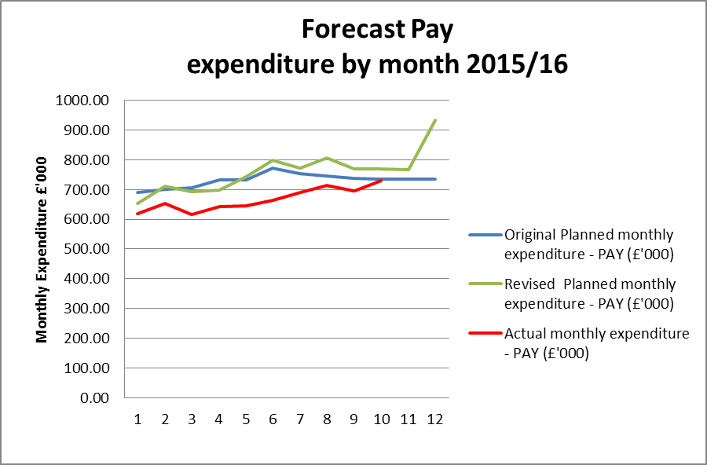

**Table 4: Profile of planned and actual Non Pay costs 2015/16**

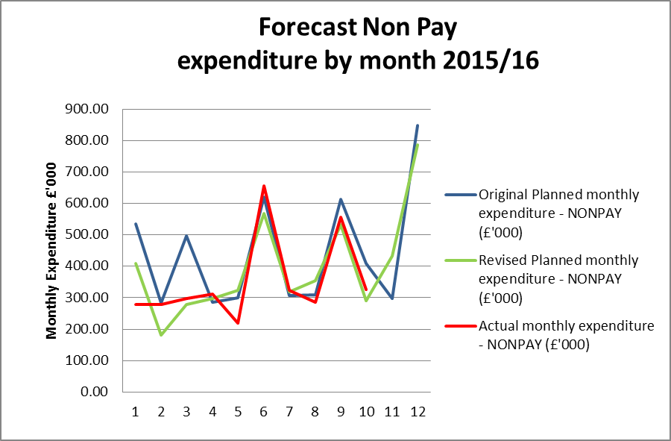

**4. Forecast outturn 2015/16**

Early forecasts pointed to an underspend position of £500k and this was predicated on:

* plans to mitigate and reduce the year to date income and expenditure under spend expected to be around £250k through additional project spend and over recruitment within Operations to mitigate against any further vacancies arising through successful applications to HRA Approval position. Thus a breakeven on the income and expenditure (less reserves).
* Management and visibility of reserves position and a linked and expected £500k under spend largely due to holding back in reserves with a profiled March impact the following:
  + Continued time taken to recruit to posts for HRA Approval and expectations of future time line
  + Appointments on bottom of scale to HRA A posts rather than midpoint
  + Delays in regulations supporting handling of patient information in research with knock on effect of delayed recruitment of staff and members for CAG 2 and vacancies.

However, the significant shift in the Income and Expenditure position which began in November and continued into December, and continued delayed recruitment to posts on reserves has led to a significant change in the forecast to a range of £ 1.0m probable underspend to £1.3m possible underspend.

There is still some risk related to a few key earmarked reserves which are dependent on the timing of decisions by others such as the conclusion of the review of new models of consent by Dame Fiona Caldicott, completion dates of projects and agreement of business cases via DH.

The active tracking of the underspend suggested we would be moving to a fully established position by the end of October and that the Income and Expenditure underspend would cease to grow and the additional managed planned activities would reduce the current underspend position. However, indications now are that a number of vacancies have remained and we have not reached full establishment which has led to an unanticipated growth in the underspend position. These relate to posts mostly within the Operations and the Research Systems and Standards directorate. Delays to planned expenditure have also resulted from rejection or delayed approval of Professional Service business cases currently being considered by the DH Finance Approvals Panel (FAP).

Additional changes in anticipated spend have also arisen with regards to non-pay. These are in relation to external training, late confirmation from DH with regards to reductions resulting from the move to the managed print service (£25k), alongside clarification regarding previous year charges (£22k) and the decision to reschedule the All Staff Day to May 2016 (£18k).

Work is being undertaken to further clarify spending plans with budget managers and exploration of invest to save initiatives which may impact on spend in this financial year. Further risks to the position relate to any further unexpected delays to expected recruitment plans alongside the actual pay point that additional new recruits are appointed on, which are the two main factors behind the early forecast position.

The tables below highlight the accumulated underspend by month and highlights the significant unexpected change in the positions for November and December.

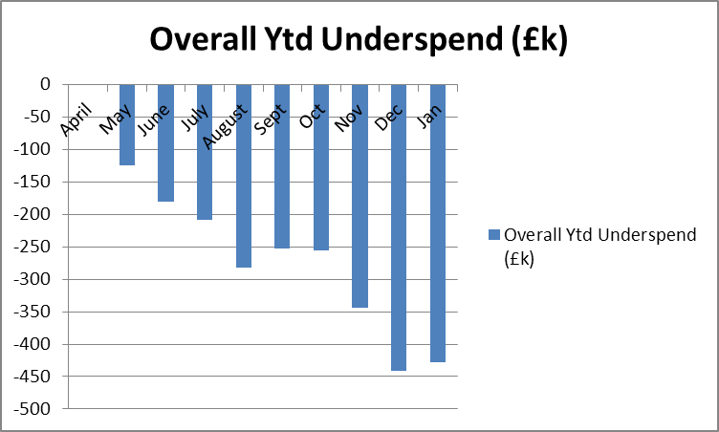

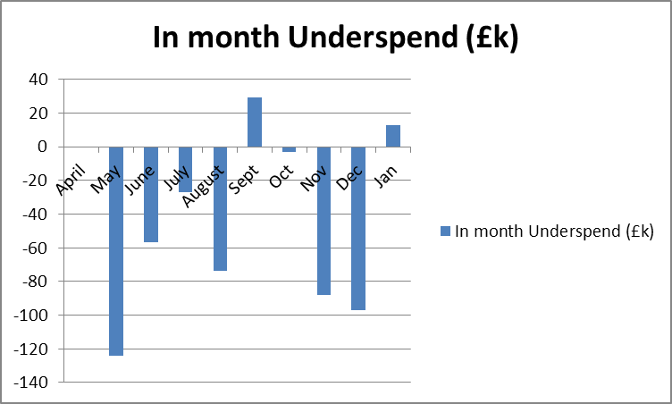

**5. Better payments performance**

Better payment performance has continued to meet the duty to pay 95% of invoices in 30 days achieving 98% based on number of invoices, and achieved the target based on value by achieving 97%. HRA are committed to paying suppliers promptly and have increased the target of paying suppliers within 10 days to 60% for 2015/16. The performance at the end of January 2016 for payments made within 10 days is 60% (number of invoices), which achieves the stretched 60% target, and 55% based on value. The escalation days for invoices awaiting approval have been reduced from 7 days to 4 days (after which invoices are escalated to line managers) and further reminders on vacation rules and the importance of checking the workflow daily, have been issued to staff. An additional payment run has also been actioned as reported in previous months to further improve performance in 2015/16.

**6. Travel costs**

Over £500k has been allocated for planned travel costs in 2015/16. Travel continues to be an area which is being intentionally monitored and managed with a view to a reduction in staff costs per head (given that costs are likely to increase overall as a result of more posts with a requirement for travel). The graph below shows that we are achieving this aim compared to a benchmark of 2013/14.

Table 5 below sets out the total travel costs position (staff, members inclusive) at the end of January and reflects an over spend of £22.6k (£25.8k over spend December). It should be noted that one explanation for the over spend is due to the number of update meetings held to discuss HRA Approval with every Research Ethics Committee. Another is due to face to face meetings being held to discuss and clarify new processes and build new teams now that recruitment to posts is well underway. The treatment of travel costs associated with training continues to be investigated and a solution planned, and could be one explanation for the over spends within Directorates as there have been staff related training (Arbinger development day across the organisation, training for new staff relating to HRA Approval and workshops for the first cohort, plus interviews ). Additionally, the arrangements for staff training are being reviewed to see if any savings can be realised from the choice of venue and methods of training provision. The estates strategy work is also encouraging greater use of video conferencing or “Lync” meetings, however this aspect is strongly dependent on the reliability and capacity of the IT service which has been subject to some failings recently.

A contributing factor to the position within Operations may be the minimal member related training events in the first 2 months of the year.

**Table 5: Travel costs and budget across the HRA by Directorate**



Year to date staff travel costs for 2015/16 are presented in Table 6 below allowing comparison with the average cost per head in 2014/15 and 2013/14. This clearly demonstrates the reductions in costs per head being achieved year to date. The peak in October results mostly from activity within the Research Systems and HRA Approval directorate and will be discussed as part of the December budget management meetings.

The lower travel costs in April and May is likely to be linked to fewer training events being held in these months. The peak in 2014/15 November is due to the All Staff Training day. Efforts continue with staff and line managers working hard to ensure costs are minimised wherever possible, for example use of telephone or video conference calls, tickets booked in advance and on timed trains.

**Table 6: Staff travel costs per head**

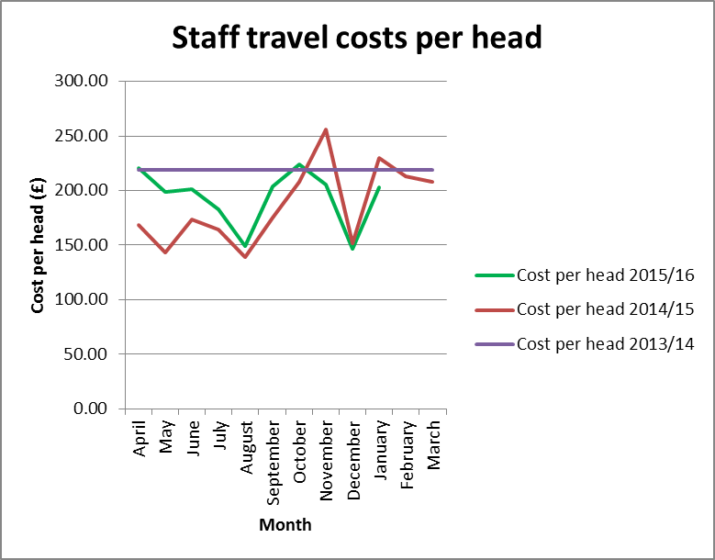

**7. Staff numbers**

Pay represents 65% of the costs incurred so far in year. The profile of our staff headcount is presented in Table 7 below for information. The expected overall upward trend has only increased slightly and is expected to continue to rise in January to March.

Permanent and fixed term headcount continues to increase slightly as does bank headcount, however the number of seconded staff has reduced.

**Table 7: Chart to show actual staff headcount so far in 2015**

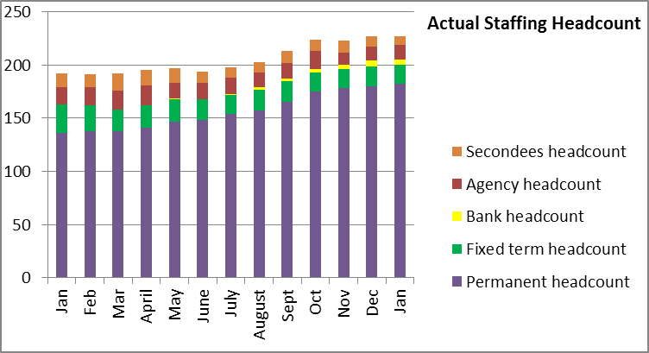

**8. Month end faster close**

The Finance team have over the last few months moved to working flexibly with most Finance team members working a proportion of their time from home. The achievement of key deadlines continues to be maintained. The 4 day close for the month end closure for January was achieved. All agreed deadlines for completion of required reports for EMT and Board were achieved.

**9. Capital**

The capital expenditure position is presented below for January 2016. The capital plan includes budget for those Information Systems posts which include an element of development or capital work within their roles. A review of these posts has been undertaken and the original assumptions remain the same.

A total of 68% of the capital budget has been spent at the end of Janaury 2016 (83% of the year).

The HRA received confirmation of the capital funding of £1.060m from the Department of Health on the 25th June 2015. The required investment in digital telephony led to a review of cost treatments of new laptops which the HRA had capitalised in previous months whilst discussions took place with the auditors to determine whether any further costs required capitalisation. Following guidance from the auditors, the £117k of costs relating to the laptops has been removed from capital and charged to revenue, due to the immaterial value of the laptops.

A report on the monthly spend against budget for each of the capital programmes has been developed and is shared with the Deputy Director – Research Information Systems. This enables us to highlight any potential forecast under spend or over spend at an early stage. Forecasts indicate that the year end position for capital will be underspent within the range of £165k to £180k. This is partly due to the transfer of the costs for the laptops from capital to revenue.

**Capital expenditure 2015/16**

|  |  |  |  |  |
| --- | --- | --- | --- | --- |
| **Plan initiative** |  | **2015/16 plan** | **2015/16 actual** | **2015/16 to go** |
|  | **£ '000** | **£ '000** | **£ '000** |
| HARP Developments |  | 275.00 | 218.5 | 56.5 |
| IRAS Developments |  | 542.00 | 375.6 | 166.4 |
| IS Team – capitalised salaries |  | 243.00 | 130.4 | 112.6 |
| IT Equipment (digital telephony) |  | 0.00 | 0.00 | 0.00 |
| **TOTAL** |  | **1,060.00** | **724.5** | **335.5** |

**10. Statement of Financial Position and cash**

To align with the quarterly accountability meetings with the Department of Health, during 2015/16 a quarterly Statement of Financial Position (formerly balance sheet) and cash flow forecast will be produced and reported to EMT. The next Statement of Financial Position and cash flow will be reported at the 31st March 2016.

At the end of the reporting period, the cash balance was £2.867m, which is broadly in line with the balance held at the end of December 2015 of £2.657m, and a reduction against the balance of £3.741m held at the end of the 2014/15 financial year. At the end of January, 67% of the total cash limit had been drawn down. In order to fulfil the duty to avoid holding excess levels of cash, the HRA will continue to monitor the cash position during 2015/16 to ensure that sufficient cash is held for future needs, but will aim to reduce the cash balances held.

**11. Cash releasing Savings**

Work on the Spending Review has completed and an indicative budget for 2016/17 shared which indicates a 6% reduction in Grant in Aid, in line with expectations.

The following areas will form the basis of ensuring that the HRA continues to remain within its financial envelope over the term of the spending review and further details will be provided as part of financial and business planning for 2016/17:

* Vacancy factor
* Saving on rental budget through closure of an office.
* Continued savings in estates costs through improved use of footprint. £900 saving per head on estates costs in 2015/16 (compared to 2014/15).
* Savings in per head travel costs to justify the investment made in digital telephony.
* Savings in introduction of Managed Print Service and roll out of this service as leases expire on current photocopier agreements.
* Savings through the use of the Member Portal
* Savings on external learning budgets
* Savings on largest information systems contract.

**12. Recommendations**

That EMT and the Board notes the final financial position and to particularly note the following:

* The under spend year to date and the ongoing work required by finance to present the under spends relating to vacancies year to date, non recurrent expenditure plans to offset and the likely forecast for the year.
* The movement in the year end forecast to a likely £1.3million to £1.0 million under spend which requires management attention and continued focus.
* The amended presentation of the profiled planned expenditure as requested by the Board and the closer match between actual monthly spend and this revised profile
* The maintained Better Payments Practice Code position to meet the 95% target based on number of invoices and the value, and the continued requirement to review invoices in the workflow on a daily basis, put invoices on hold if under dispute or set up a substitute.
* The cash position of £2.867m at the end of the period and to note the decision not to draw down the full cash limit for the year to assist with the overall system wide position and to meet our duty to draw down in line with need.
* The capital position and the forecast position for the end of the year.

**Debbie Corrigan**

**Director of Finance, Procurement and Estates**

**19 February 2016**

**Health Research Authority – Financial position as at 31 January 2016 Appendix A**

|  |  |
| --- | --- |
| **FINANCIAL RESULTS**  **HEADLINES** | * HRA is reporting an expenditure budget under spend of £428k at the end of January (£441k end of December) * 73% (£10.19million) of the annual budget has been spent after 83% of the year has passed. * A shift within the profile of underspend which has resulted in a changed forecast position. * The largest variance at month 10 (January) is the under spend within the Operations and Approval directorate cost centres. * The under spend within Operations largely relates to pay costs. The efficiencies made as a result of reducing the number of RECs has been identified and a budget adjustment undertaken in September. * Work has begun during September and continues to introduce a process to correctly capture the training related travel costs and will provide opportunity for subsequent analysis to transfer them to the training cost centres which are currently underspent along with a revised process for administering these travel costs. * The Better Payment Practice Code (BPPC) compliance for April to January was 98% for the number of invoices paid, which is in line with the overall performance for 2014/15, and is reporting 97% for value of invoices paid, which is a slight improvement against the previous year 2014/15. Having achieved the 50% target of paying invoices within 10 days during 2014/15, the HRA is aiming to pay 60% of invoices within 10 days – current performance shows 60% on the number of invoices and 55% based on invoice values. All approvers are asked to note this and to approve invoices promptly or place on hold if there is a dispute. Performance is published on our website. * Cash balance has reduced from year end £3.7 million (with liabilities to pay of £1.37million) to £2.867 million (with liabilities to pay of £1.350million). * The cash balance at the end of January 2016 was £2.867m, which is broadly in line with the balance held at the end of December of £2.657m. * The HRA has drawn down £9.650m in cash for the period April to January. This represents 67% of the total cash drawdown for the year and reflects management of cash drawdowns to match expected need. |

**Health Research Authority – Non Pay Expenditure Year to end January 2016 Appendix B**

|  |  |  |  |  |  |  |  |  |  |  |  |  |  |  |  |  |  |  |  |  |  |  |  |  |  |  |  |  |  |  |  |  |  |  |  |  |  |  |  |  |  |  |  |  |  |  |  |  |  |  |  |  |  |  |  |  |  |  |  |  |  |  |  |  |  |  |  |  |  |  |  |  |  |  |  |  |  |  |  |  |  |  |  |  |  |  |  |  |  |  |  |  |  |  |  |  |  |  |  |  |  |  |  |  |  |  |  |  |  |  |  |  |  |  |  |  |  |  |  |  |  |  |  |  |  |  |  |  |  |  |  |  |  |  |  |  |  |  |  |  |  |  |  |  |  |  |  |  |  |  |  |  |  |  |  |  |  |  |  |  |  |  |  |  |  |  |  |  |  |  |  |
| --- | --- | --- | --- | --- | --- | --- | --- | --- | --- | --- | --- | --- | --- | --- | --- | --- | --- | --- | --- | --- | --- | --- | --- | --- | --- | --- | --- | --- | --- | --- | --- | --- | --- | --- | --- | --- | --- | --- | --- | --- | --- | --- | --- | --- | --- | --- | --- | --- | --- | --- | --- | --- | --- | --- | --- | --- | --- | --- | --- | --- | --- | --- | --- | --- | --- | --- | --- | --- | --- | --- | --- | --- | --- | --- | --- | --- | --- | --- | --- | --- | --- | --- | --- | --- | --- | --- | --- | --- | --- | --- | --- | --- | --- | --- | --- | --- | --- | --- | --- | --- | --- | --- | --- | --- | --- | --- | --- | --- | --- | --- | --- | --- | --- | --- | --- | --- | --- | --- | --- | --- | --- | --- | --- | --- | --- | --- | --- | --- | --- | --- | --- | --- | --- | --- | --- | --- | --- | --- | --- | --- | --- | --- | --- | --- | --- | --- | --- | --- | --- | --- | --- | --- | --- | --- | --- | --- | --- | --- | --- | --- | --- | --- | --- | --- | --- | --- | --- | --- | --- | --- | --- |
| **Areas of Non- Pay Expenditure** | |  |  |  |  |  |  |  |  |  |  | | --- | --- | --- | --- | --- | --- | --- | --- | --- | --- | | **Subjective** | | **Annual** | **Next year** | **In month (£)** | | | **Year to date (£)** | | | | **Code** | **Name** | **budget (£)** | **plan (£)** | **Budget** | **Actual** | **Variance** | **Budget** | **Actual** | **Variance** | | **1 Meeting Rooms/Catering** | | 247,797 | 213,776 | 19,514 | 26,889 | 7,375 | 205,914 | 140,168 | (65,746) | | **2 Office equipment/Stationery/Furniture/Consumable** | | 61,314 | 59,114 | 5,240 | 32,068 | 26,828 | 50,988 | 209,459 | 158,471 | | **3 Photocopying/Printing/Postage/Storage/Waste** | | 160,850 | 161,730 | 12,845 | 18,563 | 5,718 | 131,907 | 156,300 | 24,393 | | **4 Premises - inc premise removal costs** | | 816,627 | 781,772 | 28,179 | 47,266 | 19,087 | 664,819 | 629,782 | (35,037) | | **5 Training Expenses - expenses/materials , conferences, workshops** | | 168,295 | 86,600 | 16,923 | 14,349 | (2,574) | 116,466 | 87,499 | (28,967) | | **7 Other Staff costs - Recruitment/adverts/redundancy/PILON** | | 12,000 | 12,000 | 0 | 4,735 | 4,735 | 6,000 | 10,381 | 4,381 | | **8 Travel costs - include excess mileage/interview expenses** | | 601,143 | 520,014 | 68,039 | 65,529 | (2,510) | 508,058 | 533,383 | 25,325 | | **9 Chairs/Members/Participation - activity costs** | | 290,081 | 281,854 | 24,930 | 28,552 | 3,622 | 237,667 | 217,684 | (19,983) | | **10 Publications** | | 8,000 | 1,500 | 125 | 0 | (125) | 5,750 | 6,998 | 1,248 | | **11 Mobile Phones/Mobile Data** | | 23,232 | 22,303 | 1,922 | 1,159 | (763) | 19,252 | 14,828 | (4,424) | | **12 Statutory Costs - Health & Safety/Legal/Audit Fees/Dep. & Amort.** | | 529,222 | 368,722 | 8,428 | 2,361 | (6,067) | 383,091 | 366,885 | (16,206) | | **13 Computer Costs - Software/licences/system maint./purchases** | | 337,470 | 313,597 | 28,979 | 29,169 | 190 | 285,503 | 462,194 | 176,691 | | **14 Other External Contracts - SLA's - Premises, SBS,BSA, DH IT** | | 1,318,703 | 864,610 | 84,804 | 54,036 | (30,768) | 976,197 | 697,556 | (278,641) | | **15 Other - Misc/Reserves** | | 788,580 |  | 0 | (1) | (1) | 0 | (15) | (15) | | **Grand Total** | | **5,363,314** | **3,687,592** | **299,928** | **324,675** | **24,747** | **3,591,612** | **3,533,102** | **(58,510)** |   Note: The over spend on office equipment and under spend on other contracts is due to the budget for Estates being wholly coded to other contracts and the actual expenditure being incurred against office equipment,furniture . The budgets will be adjusted to match spend type. The underspend within Premises mostly relates to confirmed rent for Nottingham Standard Court – confirmed late and below estimated cost. |

**HRA Better Payment Practice Code for the period 1 April to 31 January 2016 Appendix C**

|  |  |  |  |  |
| --- | --- | --- | --- | --- |
|  | Number | % | Value (£) | % |
| 0-5 | 220 | 6% | 748,097 | 15% |
| 6-10 Days | 1944 | 54% | 1,962,520 | 40% |
| 11-20 Days | 1302 | 36% | 1,686,679 | 35% |
| 21-30 Days | 61 | 2% | 315,397 | 6% |
| Over 30 Days | 80 | 2% | 160,289 | 3% |
| Total | 3,607 | 100% | 4,872,982 | 100% |
|  |  |  |  |  |
| **BPPC achieved** | 98% | 98% | 97% | 97% |
|  |  |  |  |  |
| **2014/15 Performance** | 98% | 98% | 97% | 97% |
| **2014/15 0-5 day performance** | 225 | 6% | 1,143,656 | 24% |

**Aged Creditors at 31 January 2016**

Headlines – clock start date is the invoice date (regardless of when the invoice is received in the system) – there are no issues of concern, the Non NHS Trade invoice over 60 days old was paid at the start of February.

|  |  |  |  |
| --- | --- | --- | --- |
|  | **Aged Creditors – (£) amounts past due date** | | |
|  | **1-30 days** | **31-60 days** | **60 + days** |
| **Non NHS Trade** | 6,624.46 | 5,474.76 | 10,036.03 |
| **Non NHS Other** | 0.00 | 40.70 | 23.40 |
| **NHS** | 11,550.42 | 0.00 | (1,928.38) |
|  |  |  |  |
| **Total** | 18,174.88 | 5,515.46 | 8,131.05 |

**HRA Revenue position for the period ended 31 January 2016 Appendix D**

|  |  |  |  |  |  |  |  |  |  |  |  |  |  |
| --- | --- | --- | --- | --- | --- | --- | --- | --- | --- | --- | --- | --- | --- |
| **Period (£'000)** | | |  | **Department** |  | **Year to date (£'000)** | | |  | **Full year (£'000)** | | | |
|  |  |  |  |  |  |  |  |  |  |  | **2015/16** | | |
| **Budget** | **Actual** | **Variance** |  | **Income** |  | **Budget** | **Actual** | **Variance** |  | **2014/15 actual** | **Initial budget** | **Latest Budget** | **Forecast** |
| 0 | 0 | 0 |  | HRA income |  | 98 | 101 | 3 |  | 327 | 196 | 196 | 196 |
| 1,042 | 1,054 | 12 |  | Grant in Aid confirmed |  | 10,351 | 9,918 | -433 |  | 10,343 | 13,346 | 13,346 | 13,346 |
| 0 | 0 | 0 |  | Grant in aid - to be confirmed CAG2 |  | 0 | 0 | 0 |  | 0 | 139 | 65 | 65 |
| 0 | 0 | 0 |  | Non cash revenue resource limit |  | 171 | 173 | 2 |  | 0 | 270 | 270 | 270 |
| **1,042** | **1,054** | **12** |  | **Total Income** |  | **10,620** | **10,192** | **-428** |  | **10,670** | **13,951** | **13,877** | **13,877** |
|  |  |  |  |  |  |  |  |  |  |  |  |  |  |
| **Budget** | **Actual** | **Variance** |  | **Expenditure** |  | **Budget** | **Actual** | **Variance** |  | **2014/15 actual** | **Initial budget** | **Latest Budget** | **Forecast** |
| 391 | 388 | -3 |  | Operations |  | 3,943 | 3,675 | -268 |  | 4,429 | 4,794 | 4,718 | 4,543 |
| 128 | 122 | -6 |  | Chief Executive inc. Corp Sec |  | 1,473 | 1,427 | -46 |  | 1,768 | 1,560 | 1,853 | 1,807 |
| 125 | 112 | -13 |  | Corporate Services |  | 1,486 | 1,443 | -43 |  | 1,984 | 1,731 | 1,858 | 1,838 |
| 57 | 103 | 46 |  | Finance, Procurement and Estates |  | 806 | 870 | 64 |  | 639 | 3,153 | 1,870 | 1,109 |
| 341 | 329 | -12 |  | Research Systems, Standards and HRA Approval Prog |  | 2,912 | 2,777 | -135 |  | 1,850 | 2,713 | 3,578 | 3,464 |
| **1,042** | **1,054** | **12** |  | **Total Expenditure** |  | **10,620** | **10,192** | **-428** |  | **10,670** | **13,951** | **13,877** | **12,761** |
|  |  |  |  |  |  |  |  |  |  |  |  |  |  |
| **0** | **0** | **0** |  | **Surplus /Deficit** |  | **0** | **0** | **0** |  | **0** | **0** | **0** | **-1,116** |

**Reconciliation of grant in aid to 2015/16 financial plan Appendix E**



CAG3 2016/17 – latest assessment is that this will not be required, however the position will be kept under review.