**Financial Plan for EMT and Board - Financial Year 2016/17**

**Health Research Authority**

1. **Introduction**

This report outlines the following:

* Income and expenditure plans for the Authority for 2016/17;
* Details of workforce plans on which the financial plan is based;
* Plans for efficiency savings for 2016/17 and beyond;
* Capital plans for 2016/17;
* Key risks to financial plans for 2016/17

**2. Income plans**

The HRA income envelope is based on the assumptions presented in table 1 below.

Table 1: HRA Income plans 2016/17



An initial indicative grant in aid and opening revenue resource limit for 2016/17 has been received which is based on the 2016/17 and beyond spending review return and subsequent business planning round. Until this is confirmed there is still a risk that this may change.

Plans are also based on additional income receipts from other government departments and the devolved administrations, the planning assumptions for which amount to a sum of £200k. This represents a small decrease of £6k on 2015/16. This is based on long standing assumptions but there is a slight risk until the position is finalised for 2016/17.

Recurrent income related to the business case for HRA Approval has reduced significantly in 2016/17 in line with plans, and all funding linked to this activity has been allocated out into expenditure budgets.

The revenue cash limit is likely to match our final agreed revenue resource limit for the year. The HRA made good progress in reducing its cash balances of £3.7 million in March 2015 down to circa £3.4 million at the end of 2015/16.

**3. Expenditure Plans**

Expenditure plans are presented in a table format to allow comparison with the prior year. The approach to budgeting this year has been a challenging one due to the following:

* Late change in forecast under spend position for 2015/16.
* HRA Approval planned funding reductions for final year of programme.
* Requirement to deliver spending review savings.
* Uncertainties until late on of the impact of the pay awards.
* New approach to portfolio prioritisation.
* Uncertainties on timings linked to organisational change plans which will be ongoing throughout 2016/17.

Table 2 presents a summary of expenditure plans based on current reporting directorates along with expected income sources.

Table 2: Summary of income and expenditure plans based on current directorates



Table 3 below presents the allocation of HRA Resources in 2016/17 across our key areas of activity.

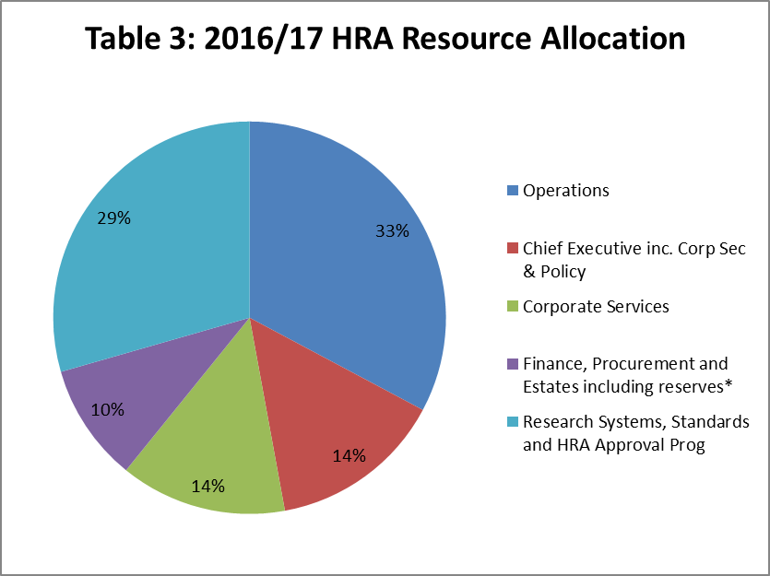

The largest share of resources (33%) continues to be invested in operations - Research Ethics committees and CAG, as we aim to maintain the high standards of performance and confidence in these services. Alongside this, significant expenditure (29%) continues to be invested in the directorate hosting HRA Approval which will have completed rollout by the end of March 2016 and will continue as a programme based activity until early 2017. HRA Approval is an integral part of our work and a dual priority will be to bed it down as a service and for further refinements to be made as required in light of learning and reflection on benefits of the new approach before we implement organisational change to align it with our other operational services.

After allocating budget to Chief Executive (Policy, corporate secretariat), important support services within the Corporate Services Directorate and Finance, Procurement and Estates services, the remaining resources have been allocated in line with our first cut priority portfolio plan which has identified key projects within the directorates, some of which have significant project costs, for example the website redesign, and monies have been retained in reserves ahead of submission of Project Initiation Documentation and further approvals .

Reserves are being retained as single allocation in 2016/17 – and will be used to fund agreed expenditure linked to business planning objectives, the above areas of prioritised activity or any unexpected cost pressures or eventualities that arise. All HRA Approval business case funding has now been allocated out.

Appendix 1 sets out the financial sections of the business plan.

1. **Pay - further focus**

The directorate pay base budgets include the unavoidable costs of the 2016/17 pay award which amounted to £60k and the increase in national insurance rates for employers as a result of the change to contracted our rules £157k. It is estimated that the latter point alone adds 4% to the on costs for staff who are members of the pension scheme. The pay budgets are also based on the Agenda for Change *2016/17* pay scales and expected increments, which are expected to cost circa £86k in 2016/17.

EMT and the Board are asked to note the following relating to the calculation of the pay budgets for 2016/17.

1. A 2% vacancy factor (£150k) has been applied so far to pay budgets within Operations, Systems and Chief Executive budget areas (including policy, corporate secretariat)
   1. Operations - £63k
   2. Systems - £62k
   3. Policy, corporate secretariat - £25k
   4. A vacancy factor for Corporate and finance areas will be agreed and notified.
2. A stock take of administrative support and capacity in this area will be completed by the end April 2016 and the budgets presented here are ahead of the findings of that work.
3. Within the operations budgets, there are 3 posts and costs of circa £100k invested in the Central Booking System ahead of decisions on developing e-booking services, the timing of which is linked to research system priorities and requirements of the Devolved Administrations.
4. Within the corporate services budgets – further work is required to ensure
   1. Organisational change plans are resourced adequately
   2. Communications services are resourced adequately, and in light of changes within the team, proposals will be presented alongside plans to develop the website.
   3. The Programme Management Office resourcing requires further review, analysis and decision.
5. Within the Chief Executive’s budget areas, there is provision for additional investment pending organisational change which may have an impact later in the year. There has also been investment in the policy area in terms of additional support for project work and administrative support.
6. Within the Finance Directorate, resources continue to be set aside for estates related and procurement advice along with a finance trainee (which may convert to an apprentice depending on timing of HRA decisions in this area). Further work is required to review capacity and resources within the finance directorate and a separate paper is being drafted for EMT Review.
7. In line with the prioritised portfolio, resource has also been invested in the following areas.
   1. Support for collaborative work – Collaboration and Development Support Officer.
   2. Research Information Systems posts with a view to bringing these important roles onto the payroll.
   3. HRA Approval Performance Manager to support the important benefits realisation work, metrics and management information.
   4. Administrative support for continued projects within the Systems, Standards and HRA Approval Directorate as fixed term posts.
8. Pay budgets for all areas have been reviewed carefully. All vacancies at the time of budget set have been adjusted to recurrent part year effect budgets to reflect recruitment activity. This is in addition to the vacancy factor.
9. Further analysis of pay budgets will be required alongside the organisational change work planned for 2016/17.
10. **Non pay Expenditure Plans**

During 2015/16 significant investment was allocated to technology such as digital telephony. In line with the HRA estates strategy and in recognition of the reduction of major change activity, staff travel budgets have been reduced.

Additionally, all staff are required to re-assess their need to travel to internal meetings and only travel if there is a valid reason for requiring a face to face meeting. Additionally, a maximum cost of internal meetings will be set which will assume more off peak travel and less travel to London, thereby enabling teams to meet but at reduced cost.

Plans to adjust the mix of training activity for external learning continue into 2016/17 and will be finalised. Budgets have been reduced to reflect plans to

* 1. Reduce the number of face to face events
  2. Availability of e-learning packages

2016/17 will be a year of continued transition for this activity and costs will be kept under review.

Further work is required to finalise project plans for the final phases of the member portal rollout project.

1. **Workforce assumptions**

Pay represents the majority of the costs incurred in year. The financial plan is based on the workforce plans summarised in table 5 below which show the estimated actual WTE in March 2016, planned WTE in March 2017 and early estimates for March 2017.

**Table 4: Workforce planning assumptions**



1. **Efficiency savings for 2016/17 and beyond.**

The HRA plans to deliver efficiency savings of at least 6% as part of the 2016/17 business plan with further savings required thereafter. The table below sets out the main savings assumptions on which this plan is based.

Table 5



With a view to **2016/17** and beyond, the following further areas for savings are proposed for investigation during 2016/17:

* Review of actual impact of e-submissions and electronic review on staffing numbers to release efficiencies linked to staff photocopying time, copying, stationery and postage costs.
* Review of timing and impact on workloads of e-booking to consider if any further efficiencies are possible.
* Organisational change to embed Approval and develop more effective organisational structures for Approval, REC and CAG.
* Estates strategy to release efficiencies with a view to achieving the 7 desks to 10 staff ratio.
* Continued focus on realising benefits from investments in video conferencing through travel, hotel, time savings.
* Review of benefits realisation work and measurement of the impact of assessment within HRA Approval on the number of REC provisional opinions and other savings from improved quality of applications received.

1. **Capital plans for 2016/17 and beyond**

The HRA opening capital resource limit has not been confirmed by DH, however the business plan for 2016/17 set out a request for circa £0.9m. The main area of investment is IRAS and includes an initial assessment of plans for including further advice and guidance through that system, in line with the remit for the HRA to support the simplification and coordination of the regulatory system for health research.

EMT and the Board are asked to review the plan and approve the high level allocation. In line with the Authority’s standing orders, the Board must approve capital expenditure in due course.

**Table 6: Capital Spend Plans.**



**9. Risks to the financial plan 2016/17**

The financial position will be much tighter this financial year. EMT and the Board are asked to note a number of risks related to this. 

To further strengthen the forecasting regime and to mitigate against the reputational risks of an unexpected shift in the financial position, it is recommended that attendance at the budget manager training provided by finance is mandated.

Additional tools ahead of the Health Group Internal Audit on budget management include:

* 1. a budget manager manual,
  2. a strengthened budget manager meeting checklist alongside a requirement for budget managers to review and agree their profiled spend plans following discussion with their Director.
  3. For cost centres which appear to be reflecting a forecast under spend but for which budget managers are predicting a break even - spend plans will also require additional review in year and formal sign off by the budget managers line manager.

**10. Cash plans and handling for 2016/17;**

The cash flow forecast for the year will be presented on agreement of the financial plan and included within quarterly financial reporting.

There will be close monitoring of both expenditure, forecasts and cash throughout the year.

**11. Recommendations**

That the Executive Management Team (EMT) approves the financial plan prior to reporting to the HRA Board.

That the EMT and the Board note the position relating to

* Income assumptions
* Expenditure assumptions.
* Workforce planning assumptions.
* High level capital plan.
* Risks associated with the financial plan.
* A reconciliation of the movement between years for the Operations Directorate will be provided shortly.
* Further information related to 2017/18 budgets and plans will begin to be compiled alongside discussions on the HRA strategy to enable a longer term strategic financial plan to be presented.

That the EMT and the Board approve the following:

* High level capital plan requirements in the context of the governance arrangements set out.
* Attendance at the budget manager training provided by finance is mandated.

**Debbie Corrigan**

**Director of Finance, Procurement & Estates**

**26 March 2016**

**Appendix 1**

