Agenda item: | 9
Attachment: | D

HRA BOARD COVER SHEET

Date of Meeting: | 13th April 2016

Title of Paper: | HRA Key Performance indicators 2016/17
Purpose of Paper: | To offer the board an opportunity to consider and comment on the proposed suite of KPI’s for 16 and 17 and discuss their suitability and effectiveness as well as the rationale for their selection described within the paper.
Reason for Submission: | It is critical that the HRA is able to demonstrate its level of performance against agreed objectives contained within the business plan
Lead reviewer: | Janet Wisely
Details: | Contained within report
Suitable for wider circulation? | When agreed will be incorporated into 16/17 Business Plan
Time required for item: | 20 mins (to include short presentation)

Recommendation / Proposed Actions: | To Approve |  | Yes
 | To Note
 | For Discussion |  | Yes
 | Comments

Name: | Ian Cook
Job Title: | Director Corporate Services
Date: | 7th April 2016

HRA Key Performance Indicators for 2016/17

- Introduction

  - A comprehensive review has been carried out on the suite of Key Performance Indicators (KPI’s) used for 2015/16 to ascertain their relevance and suitability for use in 2016/17 as well as to consider new KPI’s that will reflect the implementation of HRA Approval. This work is intended to complement the development of benefit measures (also to be considered by the board at this meeting). This short paper intends to:

- Suggest a working definition of KPI’s
- Outline a set of principles that can be used to ‘test’ existing/new indicators
- Identify the key ‘themes’ in the business plan to which KPI’s could be applied
- Offer a ‘categorisation’ model that separates out KPI’s from what may be considered Management Information (MI) and other performance evidence (Annex A).
- Propose a more detailed rationale for the implementation of KPI’s linked to HRA Approval (Annex B).

Note: The board are asked to consider this paper alongside a brief presentation which will be delivered at the meeting

- Definition of KPI

  - A broad sweep of existing literature broadly states that the function of a KPI is to:

- ‘evaluate/measure the success of an organisation or of a particular activity it engages’

  - Translating that into a working definition applicable to the HRA, the following is suggested:

    - ‘Measures by which the HRA can effectively judge its performance in contributing to improving the Health Research Economy/Environment’

- Principles

  - In determining the nature and ‘acceptability’ of indicators to be used against this definition, the following represent a set of principles that could be applied:

- Performance of HRA can be clearly identified - even when part of wider system with other stakeholders
- Has an agreed target and/or benchmark – it is important that the level of performance can be compared either with a statutory target or a HRA established one
- Measure outputs rather than inputs – to move away from routine reporting to the board what could be considered management information e.g. HR, Training, Finance data to focus on KPI’s that will clearly measure the operational impact of the HRA
- Data is readily available and can be collected monthly – unless the data can be regularly and efficiently collected, analysed and presented on a regular cycle then its value is diminshed
- Performance can be compared over time – The ability to identify trends is vital to ensure that we make timely interventions to address any issues of failing performance as well as celebrate improving or continuing good performance.

- Consistent Themes in Business Plan

  - Prior to agreeing specific KPI’s it is important that we identify what it is we want to measure. In considering the content of the business plan the following were recurring themes:

- System efficiency – processes are quicker and easier for researchers to navigate
- Quality/Consistency - to ensure that the desire for ‘speed’ is matched by the desire to achieve consistency and quality
- Transparency - that the HRA contribution to the transparency agenda has a positive impact, including public confidence in health research
- Public Involvement - That the HRA contribution to the Public Involvement agenda has a positive impact
- Participation in research – improving/increasing value of public participation in research
- Value for money - to demonstrate that the HRA represents a positive return on investment (more money on research less on bureaucracy)

- Categorisation

  - The tables in Annex A represent the outcome of a review of the 15/16 KPI’s against these definitions, principles and themes, resulting in a ‘re-assignment’ to three specific categories
KPI’s – Collected monthly and reported to the board quarterly. These are considered to be the measures which will be of greatest interest to the board as they reflect the impact that the HRA has on the wider health research economy/environment
MI – Collected monthly and considered by EMT, Important data that generally reflects internal service measures with ‘triggers’ i.e. points at which a level of performance that is below an acceptable level would be reported to the Board
Further Evidence – Considered at agreed periods during the year, in most cases this would be on an annual reporting basis generated by a particular scheduled activity to gather that evidence

- Summary

  - The existing set of KPI’s have been reviewed and re-categorised. KPI’s have been added for HRA Approval (based on the management information that is reported to the HRA Approval Programme Board). This management information will also be tabled for the Board in April given the recent full roll out of Approval. The Board is asked to consider and agree these KPI’s and the benefit measures that are presented in a separate paper

Annex A

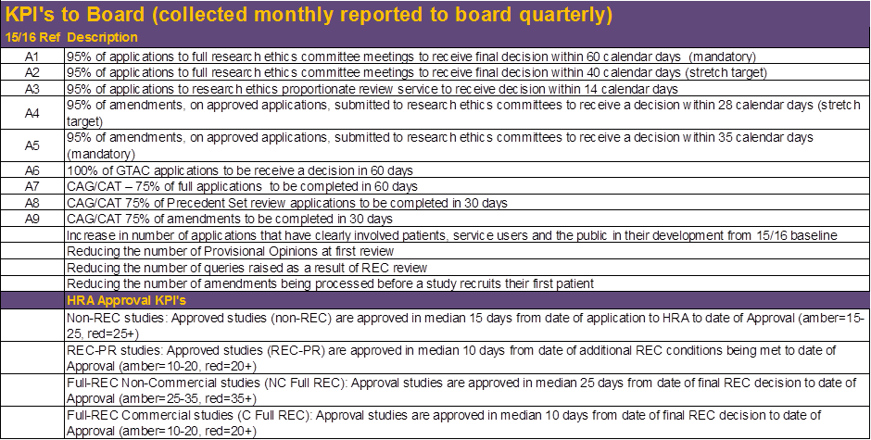
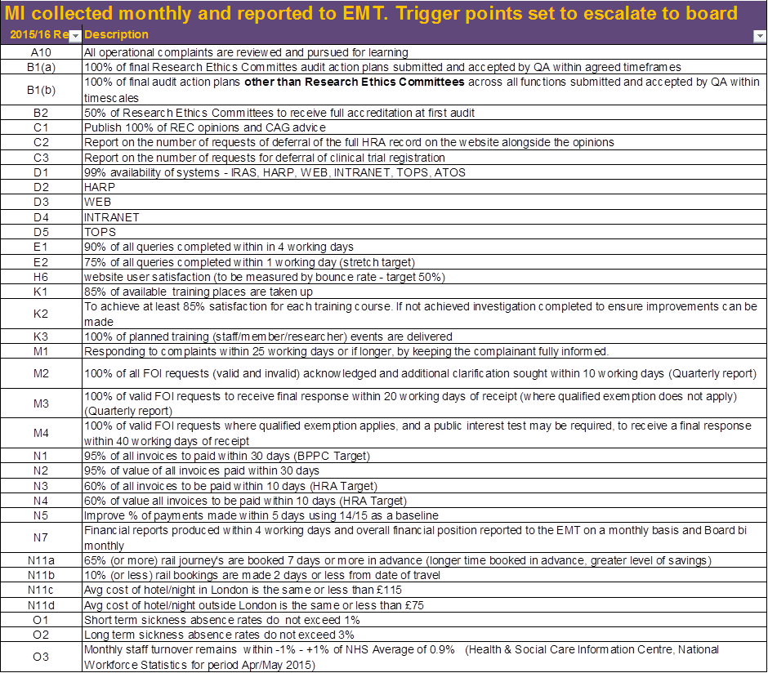

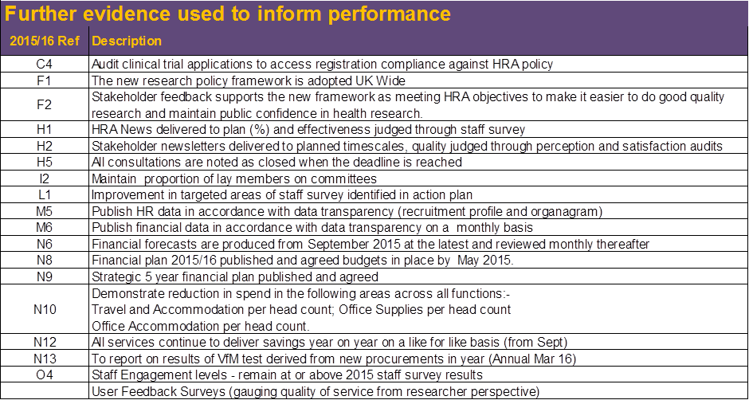

Annex B

Proposals for KPIs for HRA Approval

- Proposed metrics are based on early information and will therefore be open to review and revision with further experience.
- No overall single measure for application to Approval – metrics must reflect different study types and be proportionate
- Measuring from the point of REC favourable opinion to HRA Approval is relevant to stakeholders and avoids double-counting the Approval and REC metrics.
- We need to measure studies with full and PR REC separately as the shorter timeline for PR review reduces the potential to address all issues prior to REC opinion
- Clinical trials are of particular interest because of the benchmarks – we need to measure commercial and non-commercial separately though as industry generally respond quicker and we want to be able to show data to industry that reflects the part they are playing to improve performance.
- Propose using medians rather than percentage achieving a target. This better reflects the reality of different studies having different complexities and use of medians resonates better with applicants and industry

Suggested KPIs:

- Non-REC studies: Approved studies (non-REC) are approved in median 15 days from date of application to HRA to date of Approval (amber=15-25, red=25+)
- REC-PR studies: Approved studies (REC-PR) are approved in median 10 days from date of additional REC conditions being met to date of Approval (amber=10-20, red=20+)
- Full-REC Non-Commercial studies (NC Full REC): Approval studies are approved in median 25 days from date of final REC decision to date of Approval (amber=25-35, red=35+)
- Full-REC Commercial studies (C Full REC): Approval studies are approved in median 10 days from date of final REC decision to date of Approval (amber=10-20, red=20+)

All above figures to be calendar days without clock stops.

We will separately undertake some work to start predicting how long it will take to get a study approved, and then collect data on whether it is possible to accurately predict the approval timelines for different studies. The outcome for this may be a paper that sets out the factors identifiable in an application on receipt that make it easy to predict, or that increase the chances of it getting Approved quickly, or the features of projects that make them ‘complex’ from the perspective of getting through Approval.

